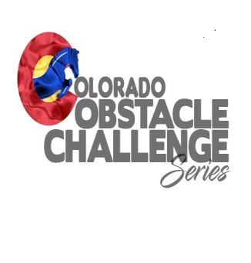Host Information
As a host / facility you are representing Colorado Obstacle Challenge Series, as such, certain standards and expectations must be met.
Minimum expectations are as follows:
- As a host, will you determine if you wish to run an Arena event, or a Trail event or a combination of both.
- You are required to sign Hold Harmless waivers provided by Colorado Obstacle Challenge Series.
- You are required and expected to have ample parking for attendees, along with restroom facilities. Porta potties will be acceptable for the event if you do not have existing facilities.
- You are NOT required to have concessions, but, the Host must make it known at time of scheduling the Event whether concessions will be available. We suggest for concessions, contacting your local 4H or FFA Club, they typically can provide hamburgers, hot dogs, etc.…This is a great fund raiser for them, and is a great way for your location to be involved with your community.
- There shall be 2 judges per arena Event, provided by Colorado Obstacle Challenge Series,. For a Trail Event or a combination of both, there shall be an adequate number of judges, with a minimum of 2.
- COCS will take care of on site registration.
- Host location will provide all obstacles, unless, prior arrangements for an obstacle(s) is made with Colorado Obstacle Challenge Series. We do have some portable items, however, there is no guarantee of availability.
- Obstacles will be safe and in good working order. If it is deemed an obstacle is unsafe, the obstacle must be made safe, or, there must be an alternate obstacle available.
- Host locations are responsible for collecting all pre-registration fees and will receive 70% of the registration fees for all divisions except for the end of day jackpot race. Colorado Obstacle Challenge Series will receive 30% of registration fees for all divisions except for the end of day jackpot race. This 30% is used by Colorado Obstacle Challenge Series for end of year awards and judge compensation.

- The end of day Jackpot race is 100% payout to the Riders registered for that Event, with no monies from this race going to EITHER the Host OR Colorado Obstacle Challenge Series. Placings are for riders 1st through 3rd, 50%, 30%, 20% of the fees collected from the entries for the Jackpot race.
- Colorado Obstacle Challenge Series will post every Event on the website calendar, and on the Facebook page. Hosts are encouraged to promote their Event as well.

- Host sites are responsible for awards for places 1st – 3rd for each Division. This may be ribbons, plaques, or? be creative!
- Once Event is approved, Hosts of Colorado Obstacle Challenge Series are responsible for providing a promotional flyer with the following minimum details:
Host name, Event Date, Registration and Start time of event, Facility location with full physical
address, if concessions will be provided, point of contact info and competitor costs.

- Host / Facility is responsible for all support staff and volunteers.

