***Children’s Menu***



***Very Wild Rice***

Wild rice with an assortment of veggie chunks.

***Teeny Weeny Linguini***

Pasta squiggles served with a tasty tomato and basil sauce.

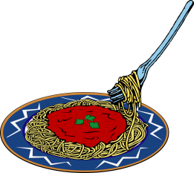



***Manor House Burger***

Built big to fill the hungriest tums! Served with beans and chips.



***Chunky Chicken Nuggets***

Served with rice or chips and a choice of sauce for dipping.

***Bangers and Mash***

Great British bangers, mash, peas and proper gravy.

***Fancy Fish Fingers***

Plaice goujons, peas and chips with a choice of sauce for dipping.

*£7.50 includes a free ice-cream! We also do half portions of the grown-ups menu for half the grown-ups price!*

***Posh Pizza***

A generous slice of Margherita pizza, chips and baked beans