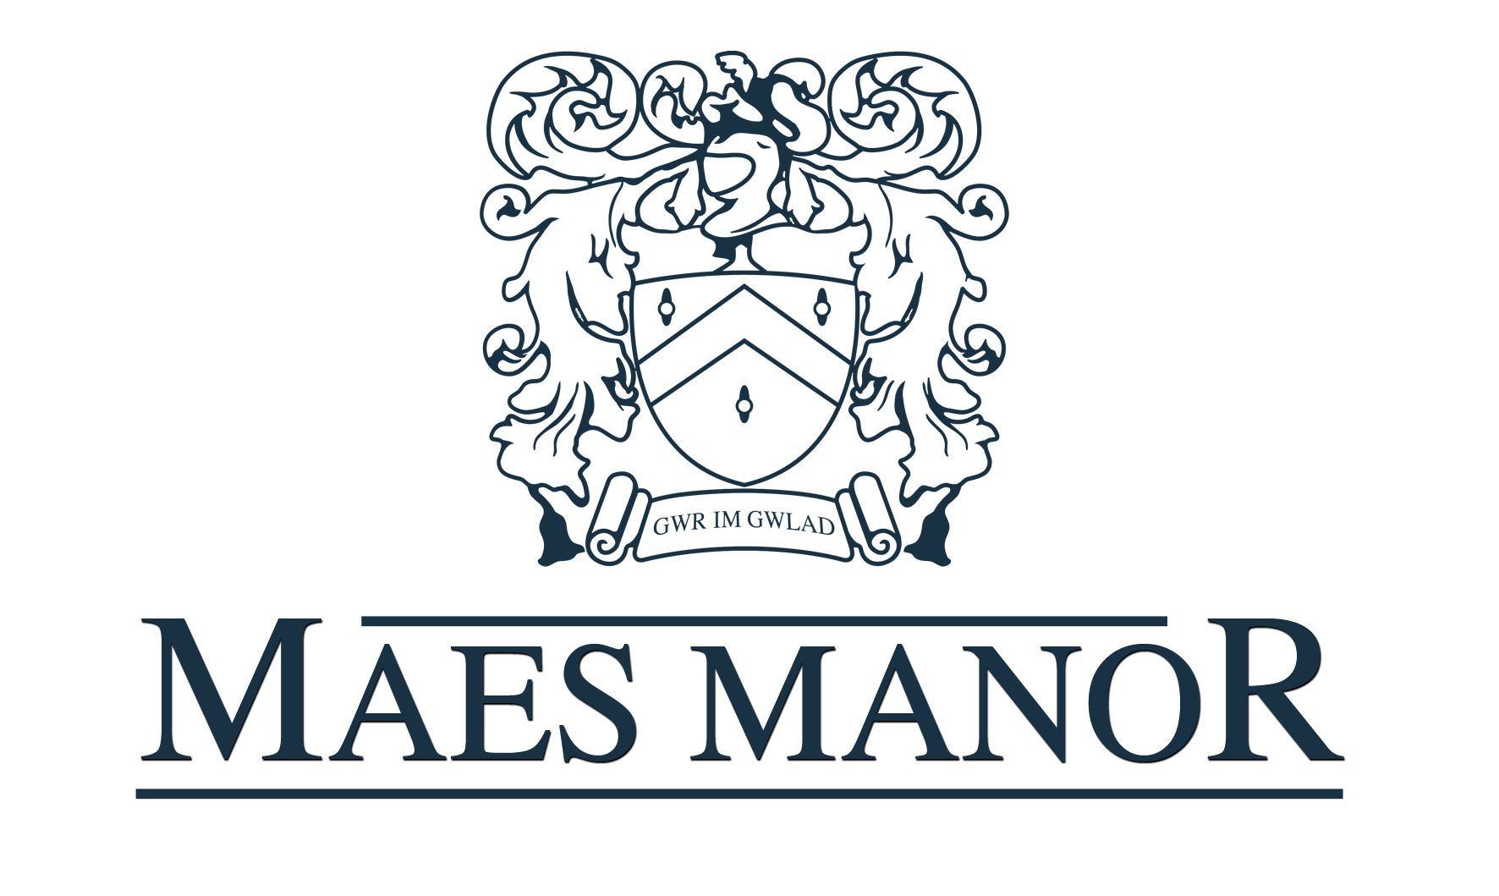
Conference Pack

Conference Information
The Maes Manor Hotel is situated in the heart of the Welsh valleys and set in nine acres of landscaped gardens and wooded areas. The hotel is easily accessible from the A4048 and just 25 minutes from both Cardiff and Newport. Built in 1890 it was converted to a hotel in 1971.
The Hotel has 28 bedrooms, a combination of doubles, singles, twins with two executive suites. All rooms are en suite and have wifi access.

Room Hire Prices
Ballroom (4 Hours) - £150.00
(8 Hours) - £300.00
*our ballroom can hold up to 220 guests*

Restaurant (4 Hours) - £100.00
(8 Hours) - £200.00
*our restaurant can hold up to 50 guests*

Extension (4 Hours) - £50.00
(8 Hours) - £100.00
*Our extension can hold up to £36 guests*

Delegate Rates
Half Day Delegate Rate (Minimum number of 10)
Room Hire
Option 1 Buffet Lunch
Jugs of Water
Two servings of Tea/Coffee and biscuits
£21.00 per delegate

Full Day Delegate Rate (Minimum Number of 10)
Room Hire
Option 1 Buffet Lunch
Three Servings of Tea/Coffee and Biscuits
Jugs of Water
Pens and Paper
One Flip Chart with Marker Pens
£28.00 per delegate

24 Hour Delegate Rate (Minimum Number of 10)
Room Hire
Option 1 Buffet Lunch
Three Servings of Tea/Coffee and Biscuits
Jugs of Water
Pens and Paper
One Flip Chart with Marker Pens
Three Course Dinner from the TDH Menu
Single room Including Breakfast
£106.00 per delegate

Equipment Hire

Flip Chart and Markers - £15.00
Screen - £20.00
TV and DVD Player - £40.00
Overhead Projector - £20.00
Laptop £70.00
Digital Projector - £70.00
Microphone - £70.00
CD Player - £25.00

Room Layouts
Boardroom Stlye
Banqueting Rounds
U-Shape
Classroom Style

Menu Options
Option 1 - £13.00 per head (Minimum Number of 12)
Mixed sandwich platter, potato salad, tomato salad and coleslaw plus five of the following options:
Chicken Drumsticks Spicy Potato Wedges
Hot Glazed Sausages quiche
Mini Spring Rolls Pork Pies
Warm Sausage Rolls Vegetable Samosas
Cold Ham Platter French Bread
Hot Pizza Fingers Pasta Salad
Warm Pasties Plaice Goujons
Crisps and Nuts Chicken Goujons
Breaded Garlic Mushrooms Home Cut Chips

Option 2 - £14.00 per head (Minimum Number of 12)
Hot Buffet Choices are served with the appropriate accompaniments:
Chilli Con Carne
Lasagne (Beef or Vegetable)
Curry and Rice
Vegetable Bake
Option 3 - £17.00 per head (Minimum Number of 50
Hog Roast with Fresh Rolls, Apple Sauce and Stuffing alongside a mix of freshly prepared salads.
Breakfast Meetings

Option 4 - £7.00 per head
Light Breakfast including Cereal, Yoghurts, Danish Pastries, Fresh Fruit with the choice of Tea/Coffee and Fruit Juice.

Option 5 - £9.00 per head
Full Welsh Breakfast
(Bacon, Sausage, Fried Egg, Tomatoes, Baked Beans, Mushrooms and Hash Browns)
Along with Cereal, Yoghurts, Danish Pastries, Fresh Fruit, Tea/Coffee and Fruit Juice.

Optional Extras
With your room hire you can also include the following refreshments. The prices are based on one serving per delegate.
Tea/Coffee - £1.60
Tea/Coffee and Biscuits - £2.60
Tea/Coffee and Welshcakes - £3.35
Tea/Coffee and Fruit Cake - £3.85
Jug of Juice (Orange or Apple) - £5.00
Mineral Water (Still or Sparkling) - £1.60
Bacon Sandwiches – £2.60

Terms and Conditions
- Contact – When booking is confirmed by the return of the booking form to the hotel a contract is deemed to exist.
- Numbers – Final numbers are required 72 hours prior to the date of the conference. This will be the minimum number charged for.
- Cancellations – in the unfortunate event of a cancellation, the following charges will apply.
A) Within one month of the event – 20% of the room hire fee
b) Within in two weeks of the event – 50% of the room hire fee
c) Within in one week of the event – 100% of the room hire fee
d) Within 48 hours of the event – Full Payment of anticipated requirements
- Times – All conference finishing times must be strictly adhered to, due to the possibility of the room being required for another function later the same day. All refreshment breaks must be at the specified times unless granted otherwise by the duty manager.
- Food and Beverages – The client will ensure that no food or drink is brought into the hotel premises for consumption. Food left over from the buffets etc cannot be removed from the hotel. The hotel cannot be deemed responsible for any allergic reactions caused by food if said allergy is not stated on the booking form.
- Equipment – Equipment brought to the hotel must comply with all current regulations including PAT testing, the client will be responsible for any damage or injury caused. The hotel cannot be held responsible for the loss or damage of any equipment.
- Health and Safety – The client agrees to take reasonable precautions to ensure that no damage occurs or injury to any person. The client will be responsible for the actions of all guests and contactors for any damage or injury caused whatsoever to persons, hotel property/fixtures or fittings.
- Agreement Governed by English Law - The contract shall be governed in all aspects by English Law.
- Insurance – After all this, you may consider arranging insurance. This can be done for a small premium and cover the cost of cancellation and other liabilities. Please note, any contract of insurance would be made by the client direct with the insurance company.

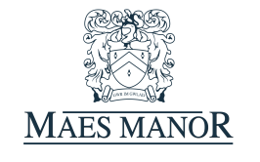
Maes Manor
Conference Confirmation Booking Form
Name: Date of Conference:
Company: Conference Name:
Address: No. of Delegates:
Signature of Organiser:

Tel No:
Email:

Room Choice: Ballroom Restaurant Extension
Start/Finish Time:

Room Layout: (please underline preferred option)
Classroom Style
Banqueting Rounds
Boardroom Style
U-Shape

Equipment Hire and Quantity:
Flip Chart
Screen
O.H.P
TV/DVD
Laptop
Digital Projector
Microphone
CD Player
Maes Manor
Conference Catering Form
Please complete the table below with your requirements for refreshments. Please note: if refreshments are required then all delegates must be catered for.
Option 1 – Buffet
Option 2 – Hot Buffet
Option 3 – Hog Roast
Option 4 – Light Breakfast
Option 5 – Full Breakfast
A – Tea/Coffee
B – Tea/Coffee and Biscuits
C – Tea/Coffee and Welshcakes
D – Tea/Coffee and Fruit Cake
E – Bacon Sandwiches
F – Mineral Water (still or sparkling)
G – Jugs of Fruit Juice (orange or apple)
Option 1 choices - Please underline 5
Chicken Drumsticks Spicy Potato Wedges
Hot Glazed Sausages quiche
Mini Spring Rolls Pork Pies
Warm Sausage Rolls Vegetable Samosas
Cold Ham Platter French Bread
Hot Pizza Fingers Pasta Salad
Warm Pasties Plaice Goujons
Crisps and Nuts Chicken Goujons
Breaded Garlic Mushrooms Home Cut Chips

Break | Time Required | Refreshment Option | Number Required
Arrival
Mid Morning
Lunch
Mid Afternoon
Finish

Any other information:
**The (please include any dietary requirements or allergies below)**

The Maes Manor Hotel
Maesrudded Lane, Blackwood, Gwent, NP12 0AG

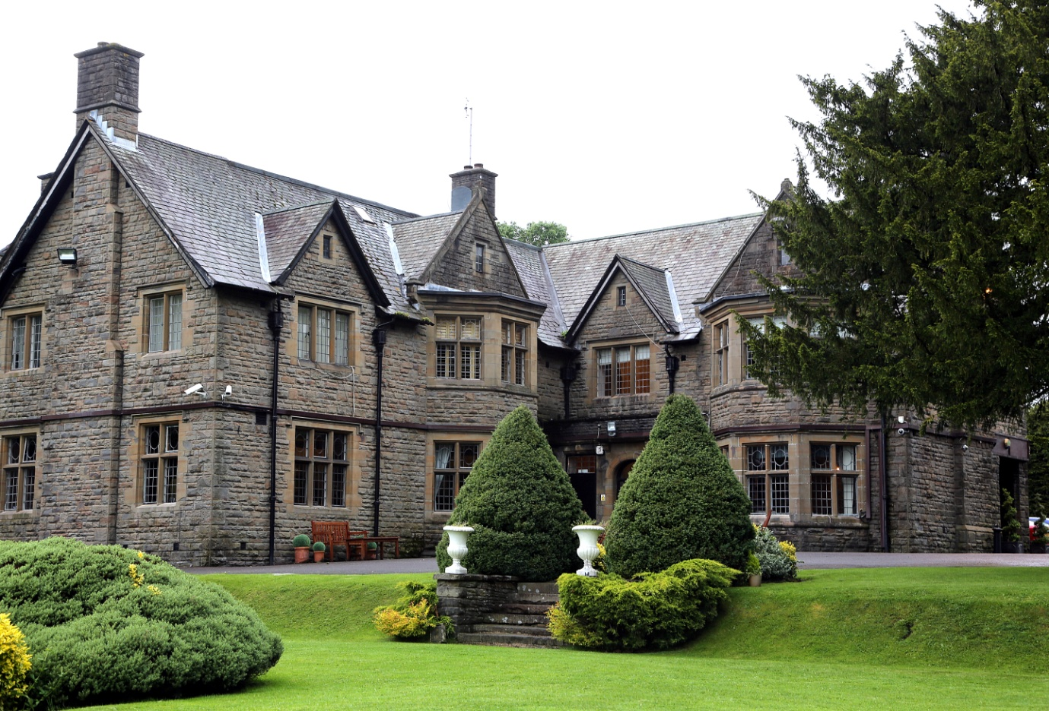
01495 220011 INFO@MAESMANOR.COM

