Function & Events Brochure
Room Hire Prices

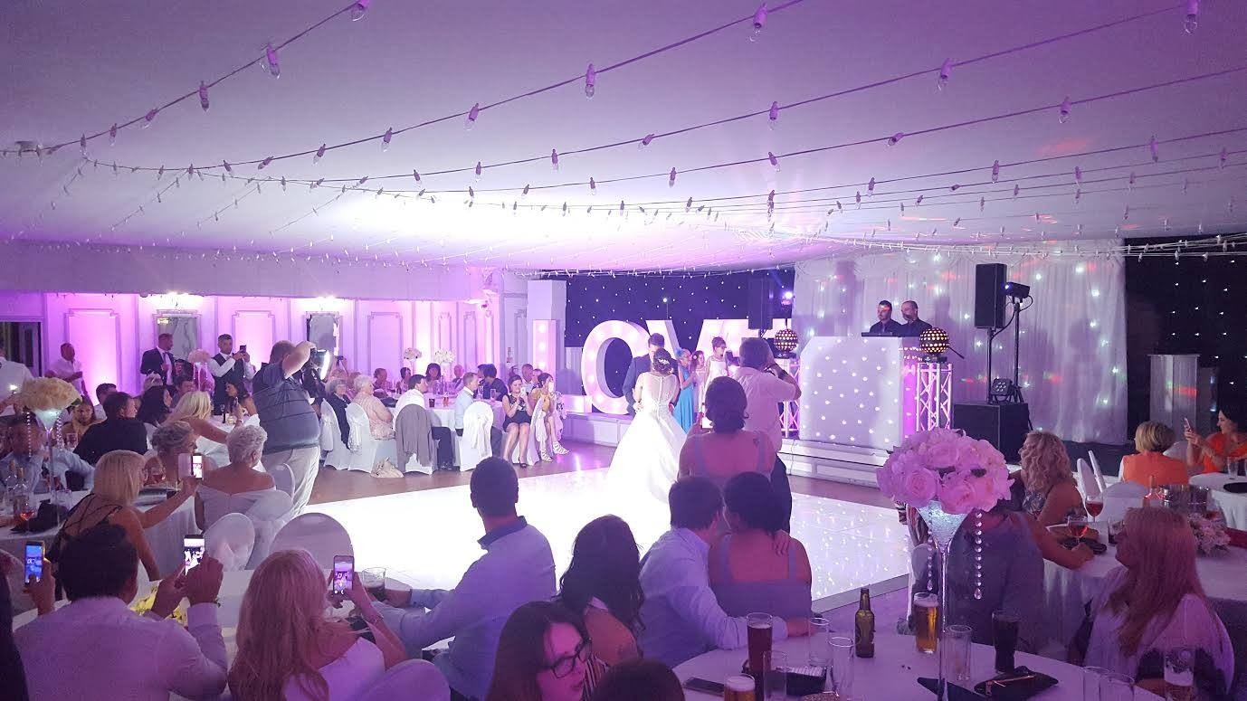
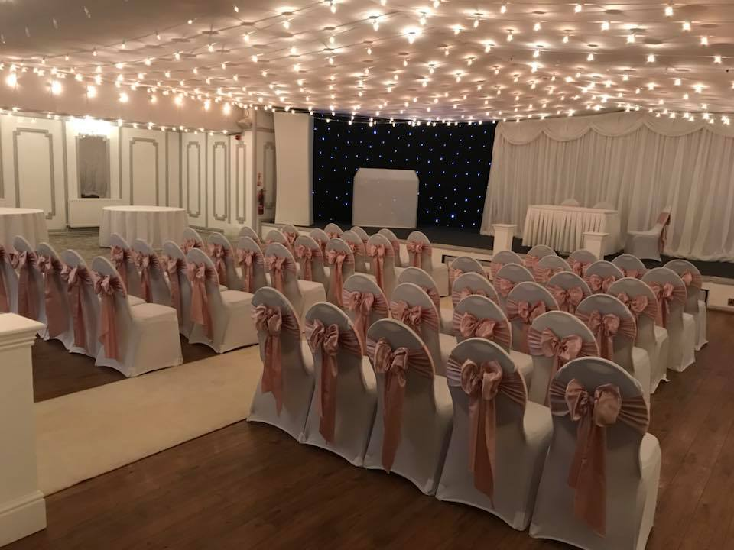

The Ballroom (Up to 220 Guests)
The Ballroom is the largest of our three function rooms.

With its breathtaking fairy light ceiling and grand original water fountain it’s the perfect area for larger parties.

It can accommodate up to two hundred and twenty
Guests and costs £500 to hire out.

The Seasons Restaurant (Up to 50 Guests)
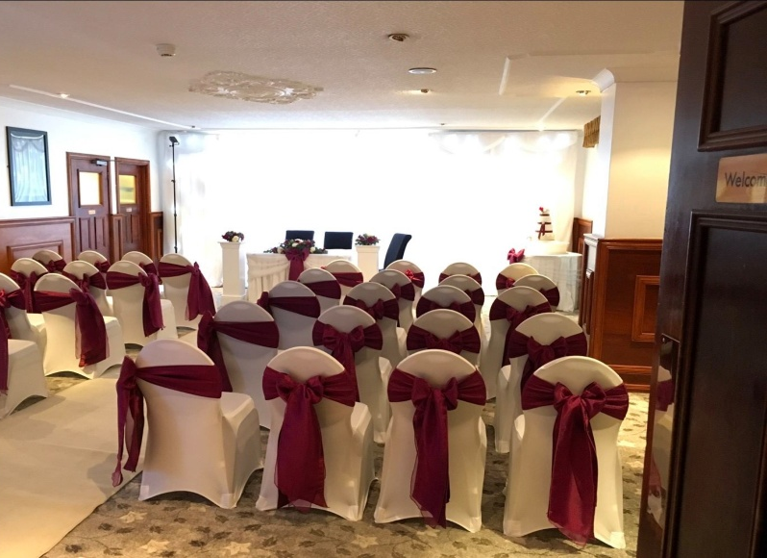
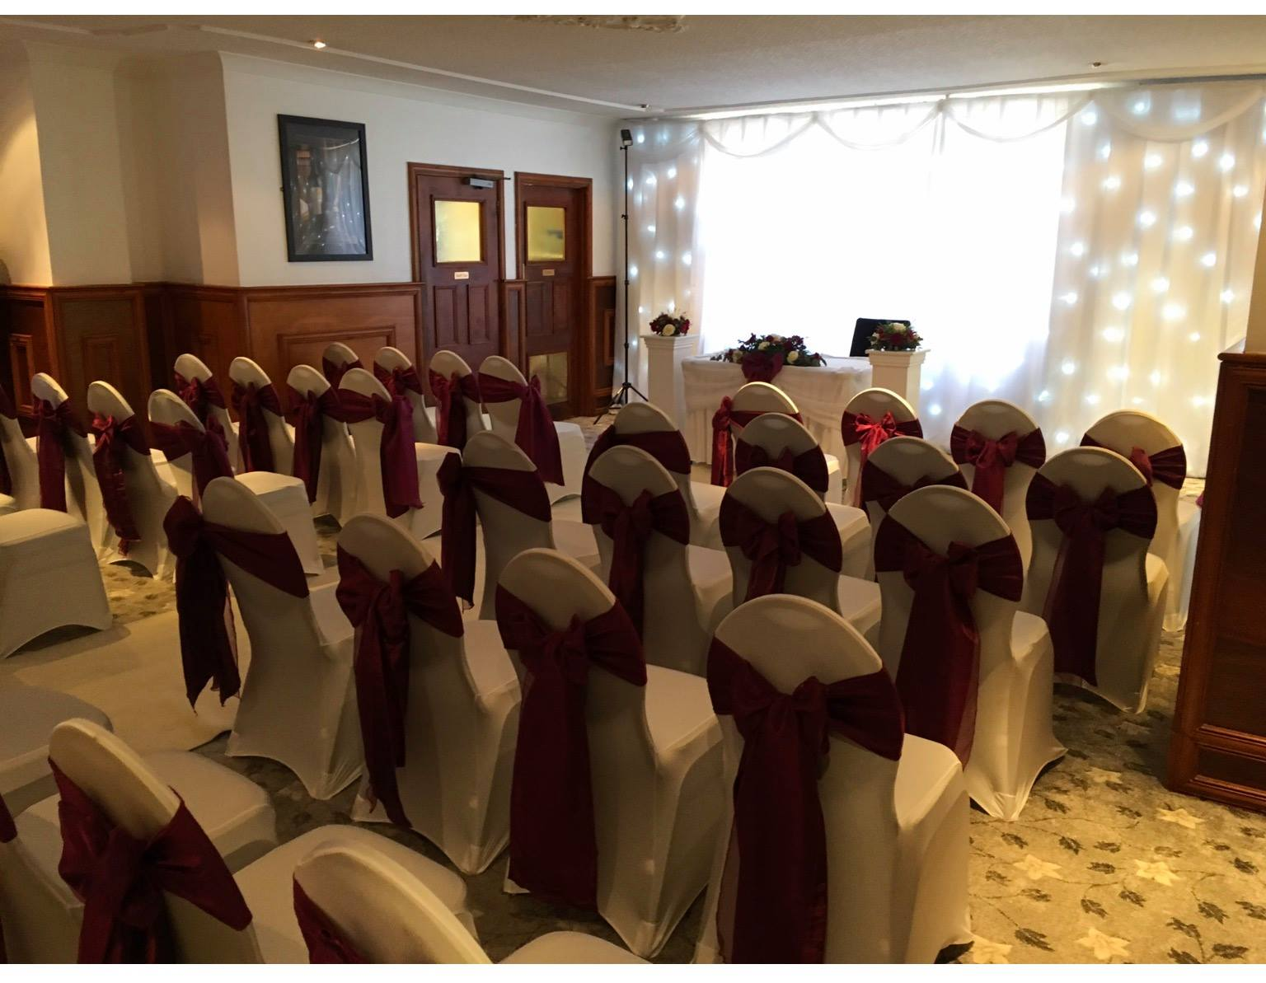
The Seasons Restaurant is tastefully decorated with a Grey and White colour scheme and is suitable for a smaller party of fifty guests and costs £100.00 to hire out.

Seasons Restaurant Extension (Up to 36 Guests)
For a smaller more intimate celebration, we have the Seasons Restaurant Extension, with a
large bay windows flooding the room with natural
light. To hire this room privately would cost £50.00.
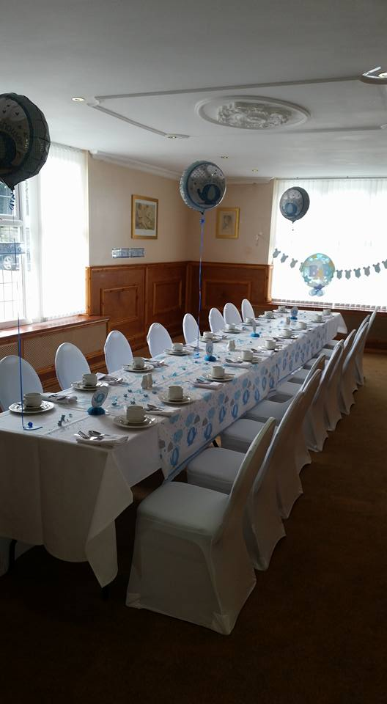
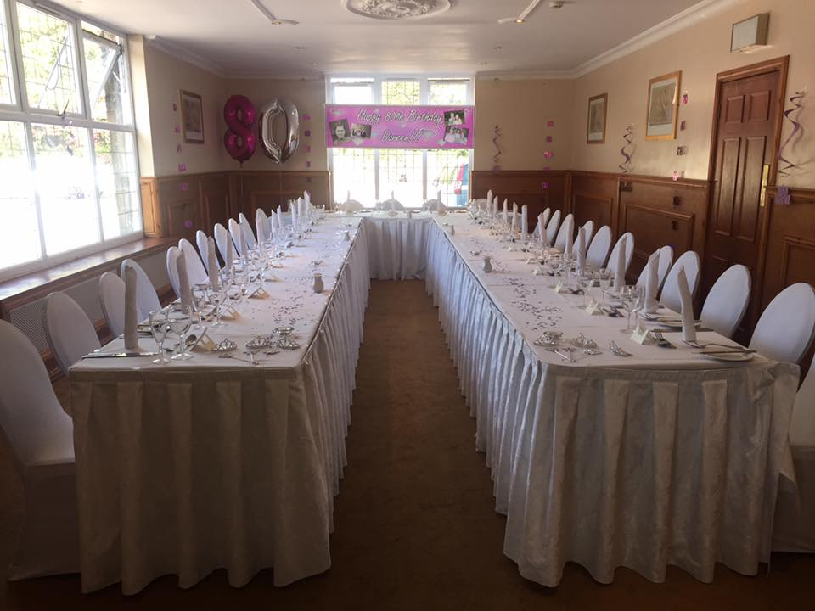

ARRIVAL & TOASTING DRINK
Arrival Drinks

Bucks Fizz..................................................... £5.25
Mulled Wine ............................................................ £5.25
Pimms and Lemonade............................................ £5.50
Sparkling Wine ....................................................... £5.95
Maes Manor Alcoholic Punch ............................ £5.50
Cava.......................................................................... £6.80
Pink Cava................................................................. £6.80
Champagne Cocktail .............................................. £8.20
Kir Royale ................................................................ £6.10
Spirit and Mixer -.................................................... £POA
Carlsberg ..................................................................£4.30
Budweiser ................................................................ £4.34
Holston Pills ............................................................ £4.20
Moet Champagne.................................................. £44.00
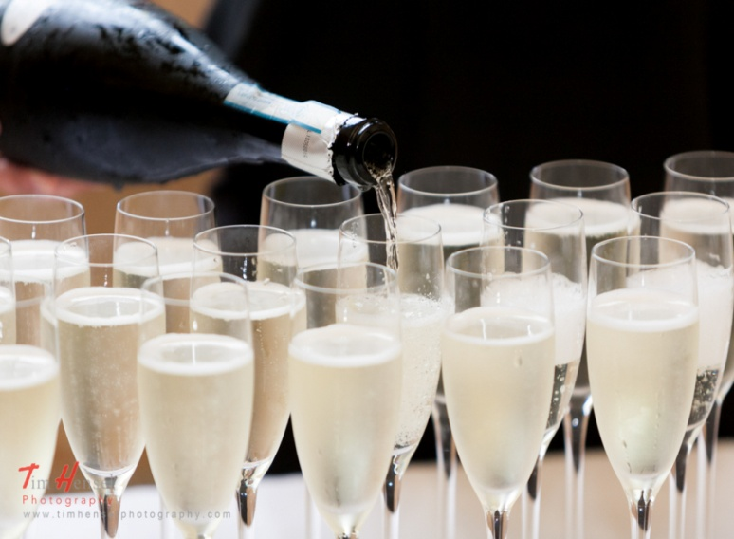
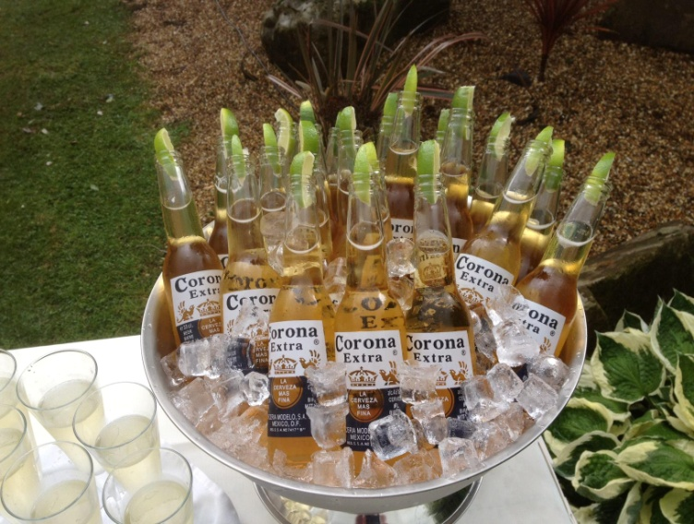
Drinks Packages

Package 1 Package 2
Bucks Fizz arrival drink Bucks Fizz Arrival Drink
Sparkling Wine for Toast Glass of White/Red/Rose
£10.95 Sparkling Wine for Toast
£16.25

CANAPE SELECTION

Canapés offer your guest something to nibble before!

The main events are usually served with drinks after arrival at the Maes Manor Hotel. An elegant canapé reception is offered to guests in the Cocktail bar, foyer and at the front of the Hotel. Please select four of the following options;
should you wish to have any more than four options, each additional item is priced at £1.50 per person thereafter.

Cold Canapés
Creamed mushroom filled vol au vents
Chicken & Liver pate on melba toast
Smoked salmon on wholegrain bread
Celery topped with cream cheese
Prawn & Marie rose filled vol au vents
Selection of mixed olives
Mixed vegetable crudités and dip
Sausage Cheetos
Vegetable curry trigons
Mini wraps

Warm Canapés
King prawns with sweet chilli dip
Cheese sesame prawn toast
Duck spring rolls with hoisin sauce
Mixed vegetable samosas & mango chutney
Hot western style seasoned wedges
Honey & mustard glazed sausage
Mini tortilla bites
Traditional Welsh Rarebit
Mini blue cheese tartlets
Deep fried garlic mushroom and garlic mayo dip
All Canapés in the selection are priced at £5.50

BUFFET OPTIONS

Hog Roast

Fresh spit roasted pig with bramley apple sauce, homemade stuffing, crackling, hot new potatoes, bread rolls, potato salad, tomato and onion salad and coleslaw.

The evening buffet is priced at £16.50 per person.

Minimum numbers of 100, multiples of 50 thereafter. Should you wish to have more options, each additional item is priced at £1.50 per person
thereafter.

DELUXE BUFFET (£29.50 per person)

Sumptuous two course buffet that includes both hot and cold items
Main course
Meat Platter – Ham, Turkey, Beef
Homemade cheese, pepper and tomato pizza
Maes Manor Hotel home cut chips
Tuna Pasta Salad
Chicken curry, chilli con carne with fluffy rice
Homemade lasagne
Golden deep fried garlic mushrooms and garlic dip
Plaice goujons with tartare sauce (Served hot)
Dessert Course
Lemon Tart with double pouring cream
Double chocolate gateaux with double pouring cream
Profiteroles with hot chocolate sauce

Signature Buffet
This buffet choice includes a mixed sandwich platter made up of ham, cheese, tuna mayonnaise
and egg mayonnaise fillings (please select whether you would like brown, white bread or a mixture of both) potato salad, tomato and onion salad, and homemade coleslaw.

Please select 4 options for £18, 6 options for £19.50 or 8 options for £21.50 from the following menu:

Barbecue/sweet and sour/tikka chicken breasts
Barbecue/sweet and sour/tikka chicken drumsticks
Breaded chicken goujons and tomato sauce
Maes Manor Hotel home cut chips
Baked jacket potato and creamy butter
Baby new minted potatos
Mini sausage rolls (hot or cold)
Fresh French bread sticks and hummus dip
Corn on the cob with creamy butter
Breaded garlic mushrooms with garlic mayo dip
King prawns in filo pastry and sweet chilli dip
Classic scotch egg
Garlic bread topped with cheese
Hot cheese and tomato pizza finger slices
Honey and mustard glazed mini sausages
Selection of Mixed crisps and nuts
Cheese and pineapple chunks
Mini pork pies
Tuna pasta salad
Battered onion rings with dip
Jellied beetroot
Barbecue spare ribs
Plaice goujons with tartare sauce
Deep fried calamari and garlic mayo dip
Mini garlic kievs and dip
Mini spring rolls
Cheese chunks and pickled onions
Mushroom/prawn marie rose/egg mayo/tuna mayo
Mixed vol au vont selection; (select two)
Hot western style wedges with sour cream and chive dip
Chinese dim sum selection and sweet chilli dip
Mini cheese and onion/corned beef pasties (hot or cold)
Platter of cold honey roast ham
Vegetable rice salad
Egg Mayonnaise
Mini duck spring rolls with hoisin sauce
Deep fried mozzarella sticks
Selection of vegetable crudities with dip
Spicy vegetable samosas
Nachos with salsa dip and guacamole
Mini onion bhajis
Lamb and Mint/Chicken curry/ prawn marie rose
sandwiches on brown or white bread
Cheese and onion/cheese & tomato/ cheese and ham
quiche

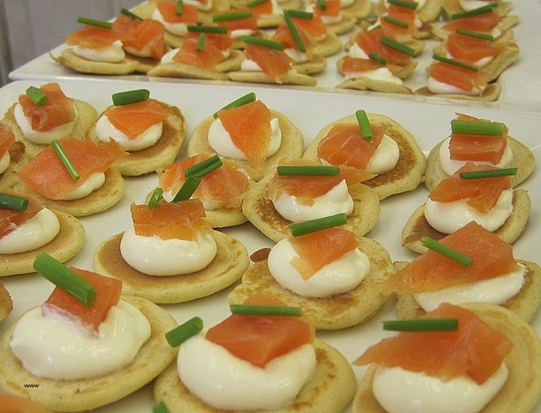
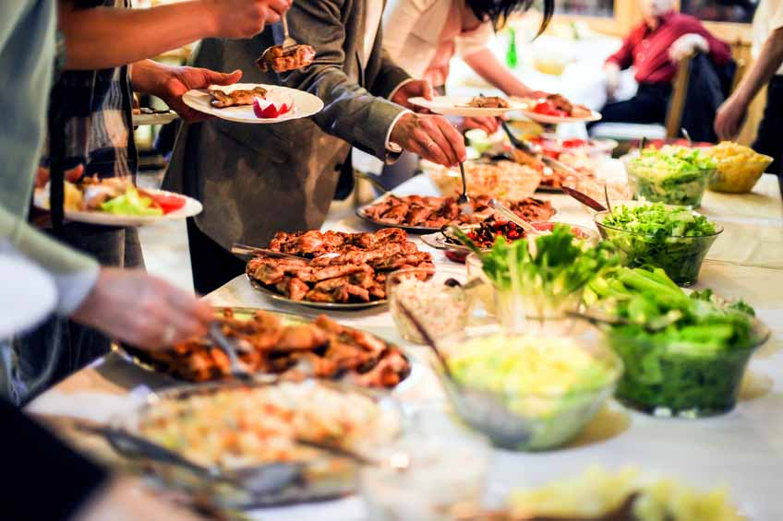
FINISHING TOUCHES

Chair covers
Complete with a coloured organza bow
£3.00 per cover

Organza Table runners
Choose from a wide range of colours to compliment your colour scheme £5.00 per table

Chocolate fountain
With a selection of accompaniments
£295.00

Resident Disco
£250.00

Coloured linen and napkin folds.
See our events coordinator for details

Tea lights & Mirrors
£2.00 per table

Centre Pieces
Candelabra, Martini Vases or Fishbowls
See our events coordinator for details

Sweet Cart & Sweets
£175.00
**Please Note - If your numbers are above 80 guests a compulsory security applies of £160**

