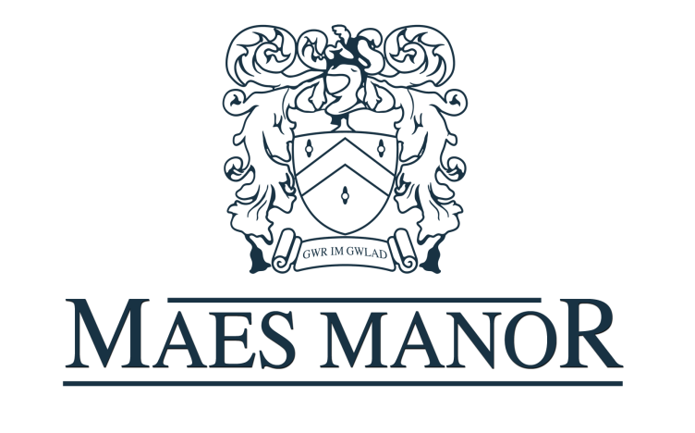

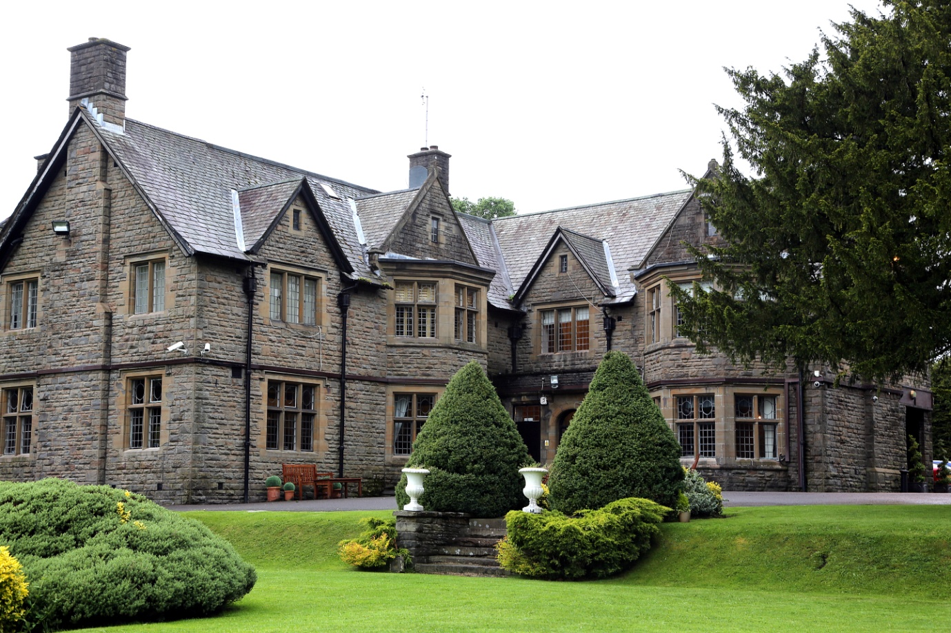
Prom Brochure 2018
Prom Information
Compulsory Security Charge - £180.00
Resident DJ - £240.00 (no outside DJ’s allowed Bands or Singers welcome)
Resident Photographer (Optional) – Priced per photo
Please choose between the dining options below

Hog Roast - £17.00 per person
Fresh spit roasted pork with bramley apple sauce, homemade stuffing, crackling hot new potatoes, bread rolls, potato salad, coleslaw and tomato & onion salad.
Signature Buffet - £17.00 (4 options) or £19.00 (6 options)
This buffet includes a mixed sandwich platter made up of ham, cheese, tuna mayonnaise and egg mayonnaise fillings, potato salad, tomato and onion salad, and homemade coleslaw. Then choose your additional options from the signature buffet menu, in our banqueting brochure.
Hot Buffet - £18.00 per person
This hot station buffet will typically include two main dishes, two accompaniment dishes plus a vegetarian option, coleslaw, potato salad and tomato and onion salad. For example, homemade lasagne, homemade chicken curry, chips, rice, popadoms, chutney, coleslaw, potato salad and tomato and onion salad. Your events coordinator will be happy to discuss dish options with you.
Deserts - £3.95
A desert option can be added to any of the above menus. Please see our banqueting brochure for full details on our desert choices.
Hot Sit down Meals
We can provide a one, two or three course sit down, served meal with all the trimmings. Full information on menu choices and prices can be found in our banqueting/wedding brochures.

Optional Extras
ITEM | PRICE
Jugs of Juice | £5.00 per jug
Non Alcoholic Arrival Drinks | £3.00 per person
Alcoholic Arrival Drinks | See Banqueting Brochure
Twin Chocolate Fountain & Various Dips | £295
Chair Covers with Coloured Sash/Bow | £3
Fairy light Curtain Backdrop | £200
Sweet Cart | £175
Fishbowl Table Centrepieces | £10
Candelabra or Martini Table Centrepieces | £15
Fireworks Display | £TBA

All Bookings will require a non refundable deposit of £500 to secure your required date.

If you would like to make a booking please contact our friendly reception team via telephone or e-mail from 7am – 11pm.

The Maes Manor Hotel
Maesrudded Lane, Blackwood, Gwent, NP12 0AG
01495 220011 info@maesmanor.com

