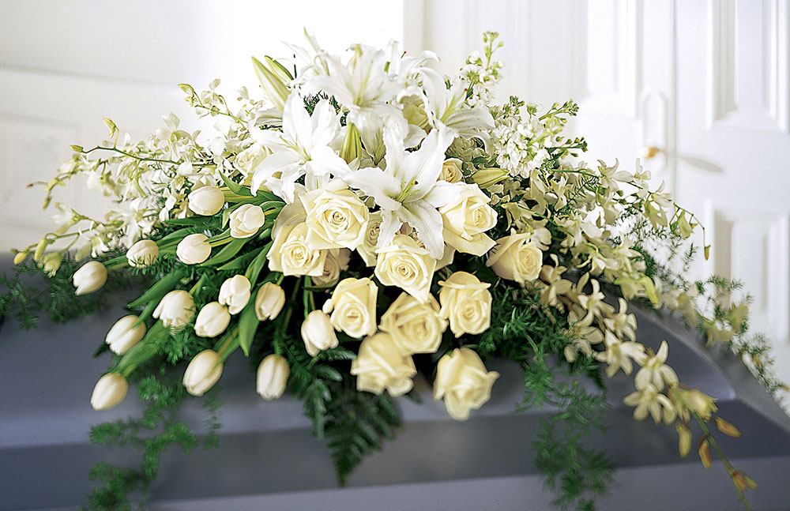
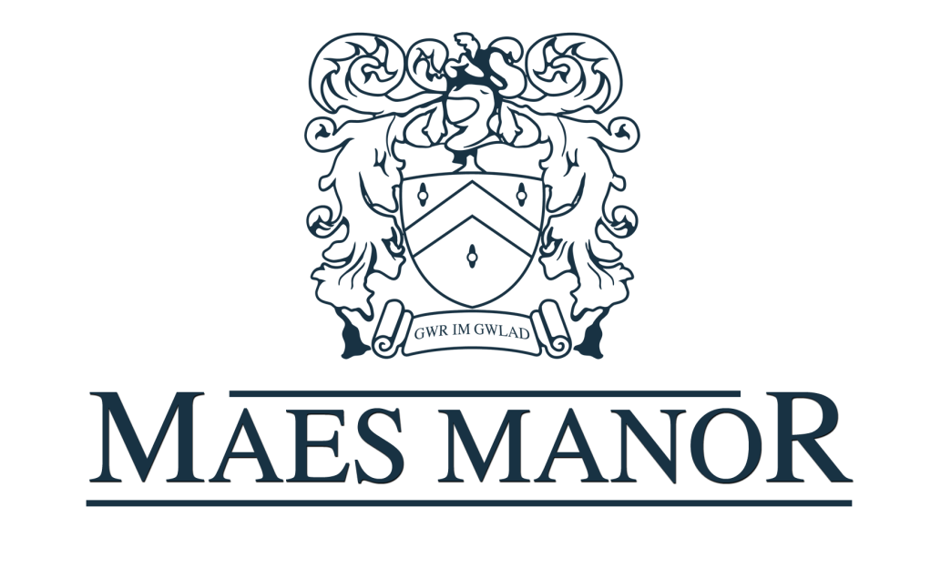
Funeral Brochure
Maes Manor Welcome

Here at the Maes Manor, we understand that organising after-funeral arrangements can add to the distress of losing a loved one.

From the moment you book, our sympathetically experienced staff will be on hand to attend to your every need with the professionalism and sensitivity you would expect.

Our friendly reception team are available from 7am – 11pm to arrange your booking with ease. We are also happy to deal directly with your funeral director should you wish for them to make the arrangements on your behalf.

Function Rooms
The hotel has several function rooms available to suit your requirements.
Ballroom
Our Islwyn Suite can comfortably seat between 30 – 220 guests.

Seasons Restaurant
Our Seasons Restaurant can comfortably seat between 10 and 50 guests and is easily accessible.

Seasons Restaurant Extension
Our Extension is a bright, airy room and can comfortably sit between 10 and 36 guests.

Cocktail Bar
Our warm and welcoming Cocktail Bar is ideally suited for groups between 15 and 40 guests with views of the gardens.

Additional Facilities
- Disabled Access
- Free Parking
- Use of in-house floral/specific arrangements by our florist
- Reduced rates on accommodation (subject to availability)
- Bar tab (up to an agreed limit)
Buffet Choices

Option F1
A selection of cakes along with fresh Tea and Coffee at £4.95 per head.

Option F2
An assorted selection of cakes and homemade sandwiches along with fresh Tea and Coffee at £6.95 per head.

Option F3
A mixed sandwich platter, potato salad, tomato salad, coleslaw along with fresh Tea and Coffee and a choice of 2 options from our buffet menu at £9.95 per head.

Option F4
A mixed sandwich platter, potato salad, tomato salad, coleslaw along with Fresh Tea and Coffee and a choice of 5 options from our buffet menu at £12.95 per head.

Option F5
Hog Roast of Hot Buffet options including Tea and Coffee at £17.00 per head – Minimum Numbers of 50.

Buffet Options

Chicken Drumsticks
Spicy Potato Wedges
Quiche
Mini Spring Rolls
Vegetable Samosas
Warm Pasties
French Stick
Breaded Garlic Mushrooms
Hot Pizza Fingers
Plaice Goujons
Chicken Goujons
Pasta Salad
Crisps and Nuts
Hot Glazed Sausages
Home Cut Chips
Pork Pies
Warm Sausage Rolls
Platter of Cold Ham

*Please make staff aware on booking of any dietary requirements or allergies*
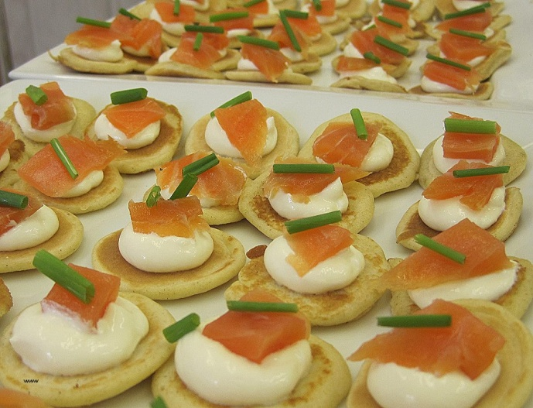
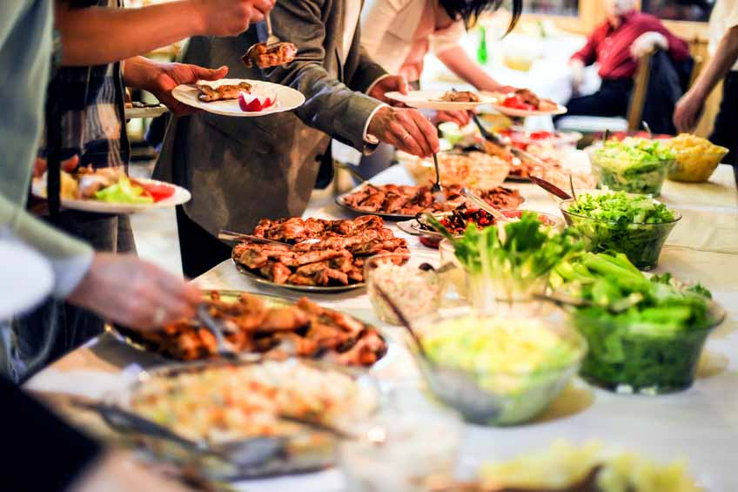

How to Book

Contact our friendly reception team via telephone or e-mail from 7am – 11pm. Prices and information are valid from January 2018 – January 2019.

If you wish to book a formal meeting with a member of our reservation team to discuss packages or see the room you wish to hire this can also be done over the phone

The Maes Manor Hotel
Maesrudded Lane, Blackwood, Gwent, NP12 0AG
01495 220011 info@maesmanor.com
