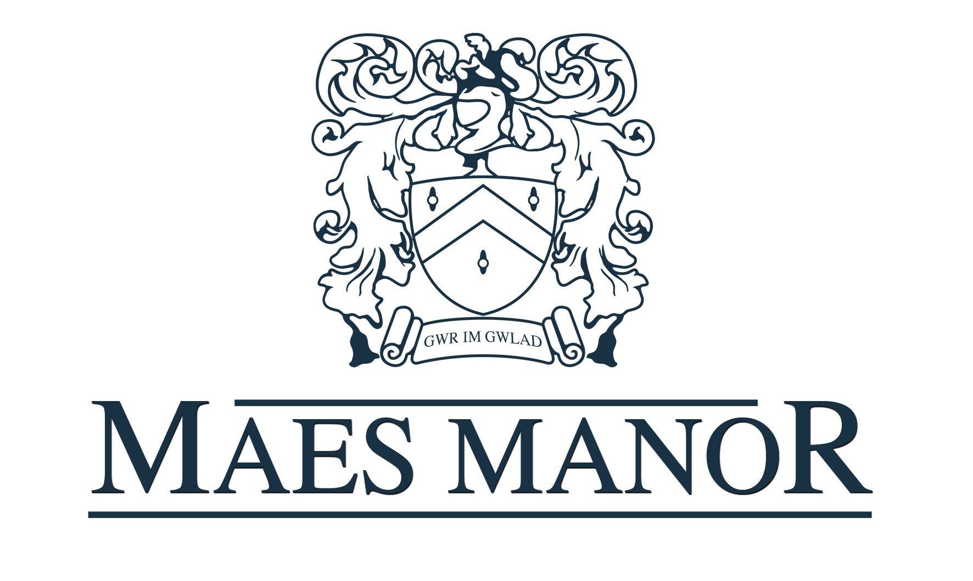

Conference Pack

*Conference Information*

*The Maes Manor Hotel is situated in the heart of the Welsh valleys and set in nine acres of landscaped gardens and wooded areas. The hotel is easily accessible from the A4048 and just 25 minutes from both Cardiff and Newport. Built in 1890 it was converted to a hotel in 1971.*

*The Hotel has 28 bedrooms, a combination of doubles, singles, and twins with two executive suites. All rooms are en suite and have wifi access.*

*Room Hire Prices*

*Ballroom (4 Hours) - £200.00  
 (8 Hours) - £400.00  
*our ballroom can hold up to 220 guests\**

*Restaurant (4 Hours) - £125.00  
 (8 Hours) - £250.00  
*our restaurant can hold up to 50 guests\**

*Extension (4 Hours) - £50.00  
 (8 Hours) - £100.00  
*Our extension can hold up to 36 guests\**

***FREE ROOM HIRE OF THE BALLROOM ON A FULL DAY PACKAGE FOR OVER 50 GUESTS***

*Delegate Rates*

*Half Day Delegate Rate (Minimum number of 10)  
Option 1 Buffet Lunch  
Jugs of Water  
Two servings of Tea/Coffee and biscuits  
£21.00 per delegate*

*Full Day Delegate Rate (Minimum Number of 10)  
Option 1 Buffet Lunch  
Three Servings of Tea/Coffee and Biscuits  
Jugs of Water  
Pens and Paper  
One Flip Chart with Marker Pens  
£28.00 per delegate*

*24 Hour Delegate Rate (Minimum Number of 10)  
Option 1 Buffet Lunch  
Three Servings of Tea/Coffee and Biscuits  
Jugs of Water  
Pens and Paper  
One Flip Chart with Marker Pens  
Three Course Dinner from the TDH Menu  
Single room Including Breakfast  
£106.00 per delegate*

*Equipment Hire*

*Screen - £20.00*

*Room Layouts*

*Boardroom Style*

*U-Shape*

*Banqueting Rounds*

*Classroom Style*

*Menu Options*

*Option 1 - (Minimum Number of 12)  
Hot Food Choices*

*Chilli Con Carne served with rice, cheese and chips or tortilla chips*

*£14.50pp*

*Lasagne (Beef or Vegetable) served with chips & salad*

*£15pp*

*Chicken Curry and Rice served with mixed samosas or chips*

*£15pp*

*Jacket potato with Tuna, Beans, Coronation Chicken & Cheese served with green salad and coleslaw.*

*£13.50pp*

*Option 2 - £18.00 per head (Minimum Number of 12)  
Mixed sandwich platter and coleslaw plus Four of the following options:*

*Chicken Drumsticks*

*Spicy Potato Wedges*

*Hot Glazed Sausages*

*Quiche  
Mini Spring Rolls*

*Pork Pies  
Warm Sausage Rolls*

*Vegetable samosas*

*Cold Ham Platter*

*Plaice Goujons   
Hot Pizza Fingers*

*Chicken Goujons  
Warm Pasties*

*Home Cut Chips  
Breaded Garlic Mushrooms*

*Option 3 - £25 per head (Minimum Number of 50  
  
Roast Turkey with cranberry sauce, homemade stuffing, Pigs in blankets, Roast potatoes with rosemary & thyme, bread rolls & a homemade rich gravy.*

*Breakfast Meetings*

*Option 4 - £8.50 per head   
Light Breakfast including Cereal, Yoghurts, Danish Pastries, Fresh Fruit with the choice of Tea/Coffee and Fruit Juice.*

*Option 5 - £11.50 per head  
Full Welsh Breakfast   
(Bacon, Sausage, Fried Egg, Tomatoes, Baked Beans, Mushrooms and Hash Browns) Along with Cereal, Yoghurts, Danish Pastries, Fresh Fruit, Tea/Coffee and Fruit Juice.*

*Optional Extras*

*With your room hire you can also include the following refreshments. The prices are based on one serving per delegate.*

*Tea/Coffee - £2.95  
Tea/Coffee and Biscuits - £4.00  
Tea/Coffee, Welsh cakes & Open Scones - £7.00*

*Orange or Apple Juice - £2.00  
Bottled Mineral Water (Still or Sparkling) - £2.50*

*Jug of Filtered still or sparkling water – £2.00*

*Bacon Roll – £4.50*

*Bacon & Egg Roll - £5.00*

*Bacon, Sausage & Egg Roll - £ 5.50*

*Terms and Conditions*

1. ***Contact*** *– When booking is confirmed by the return of the booking form to the hotel a contract is deemed to exist.*
2. ***Numbers*** *– Final numbers are required 72 hours prior to the date of the conference. This will be the minimum number charged for.*
3. ***Cancellations*** *– in the unfortunate event of a cancellation, the following charges will apply.   
   A) Within one month of the event – 20% of the room hire fee  
   b) Within in two weeks of the event – 50% of the room hire fee  
   c) Within in one week of the event – 100% of the room hire fee  
   d) Within 48 hours of the event – Full Payment of anticipated requirements*
4. ***Times*** *– All conference finishing times must be strictly adhered to, due to the possibility of the room being required for another function later the same day. All refreshment breaks must be at the specified times unless granted otherwise by the duty manager.*
5. ***Food and Beverages*** *– The client will ensure that no food or drink is brought into the hotel premises for consumption. Food left over from the buffets etc cannot be removed from the hotel. The hotel cannot be deemed responsible for any allergic reactions caused by food if said allergy is not stated on the booking form.*
6. ***Equipment*** *– Equipment brought to the hotel must comply with all current regulations including PAT testing, the client will be responsible for any damage or injury caused. The hotel cannot be held responsible for the loss or damage of any equipment.*
7. ***Health and Safety*** *– The client agrees to take reasonable precautions to ensure that no damage occurs or injury to any person. The client will be responsible for the actions of all guests and contactors for any damage or injury caused whatsoever to persons, hotel property/fixtures or fittings.*
8. ***Agreement Governed by English Law*** *- The contract shall be governed in all aspects by English Law.*
9. ***Insurance*** *– After all this, you may consider arranging insurance. This can be done for a small premium and cover the cost of cancellation and other liabilities. Please note, any contract of insurance would be made by the client direct with the insurance company.*

*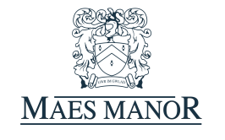Maes Manor  
 Conference Confirmation Booking Form*

*Name: Date of Conference:  
Company: Conference Name:  
Address: No. of Delegates:*

*Signature of Organiser:*

*Tel No:  
Email:*

*Room Choice: Ballroom Restaurant Extension  
Start/Finish Time:*

*Room Layout: (please underline preferred option)*

*Classroom Style  
Banqueting Rounds  
Boardroom Style  
U-Shape*

*Equipment Hire and Quantity:*

*Flip Chart  
Screen  
O.H.P  
TV/DVD  
Digital Projector  
Microphone*

*Maes Manor  
Conference Catering Form*

*Please complete the table below with your requirements for refreshments. Please note: if refreshments are required then all delegates must be catered for.*

*Option 1 – Hot Food Choice   
Option 2 – Buffet  
Option 3 – Roast Turkey   
Option 4 – Light Breakfast  
Option 5 – Full Breakfast*

*A – Tea/Coffee  
B – Tea/Coffee and Biscuits  
C – Tea/Coffee, Welsh cakes & Open Scones  
E – Bacon Sandwiches  
F – Mineral Water (still or sparkling)  
G – Jugs of Fruit Juice (orange or apple)*

*Option 1 choice - Please underline 5*

*Chicken Drumsticks Spicy Potato Wedges  
Hot Glazed Sausages Quiche  
Mini Spring Rolls Pork Pies  
Warm Sausage Rolls Vegetable Samosas  
Cold Ham Platter Hot Pizza Fingers Pasta Salad Warm Pasties Plaice Goujons Chicken Goujons Home Cut Chips Breaded Garlic Mushrooms*

|  |  |  |  |
| --- | --- | --- | --- |
| *Break* | *Time Required* | *Refreshment Option* | *Number Required* |
| *Arrival* |  |  |  |
| *Mid Morning* |  |  |  |
| *Lunch* |  |  |  |
| *Mid Afternoon* |  |  |  |
| *Finish* |  |  |  |

*Any other information:  
**The (please include any dietary requirements or allergies below)\*\**

*The Maes Manor Hotel*

*Maesrudded Lane, Blackwood, Gwent, NP12 0AG*

*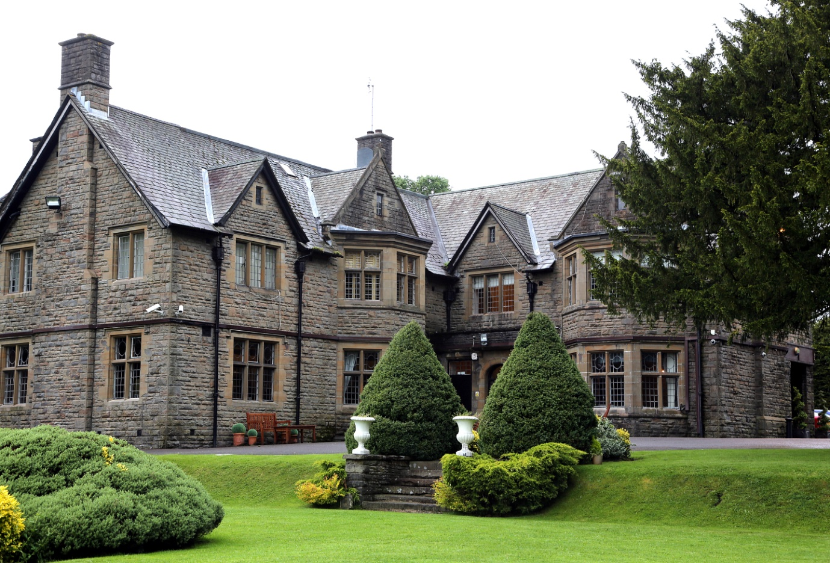01495 220011*

[*INFO@MAESMANOR.COM*](mailto:INFO@MAESMANOR.COM)