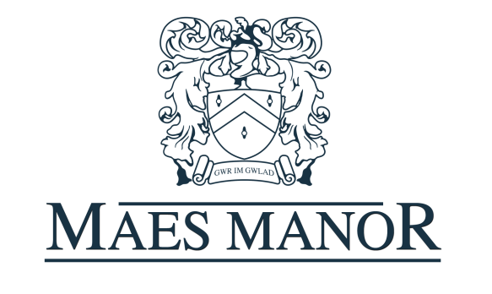

BREAKFAST MENU

Full Welsh Breakfast

Sausages, bacon, tomatoes, black pudding, mushrooms, and beans.

Please help yourself to the continental breakfast, which includes;
Cereals, fresh fruit, yoghurts, juices and toast.

Your choice of egg; poached, scrambled or fried on white or brown toast.

If you have any requests please ask and we will try to accommodate.

Have a great day and thank you for choosing the Maes Manor Hotel.

