

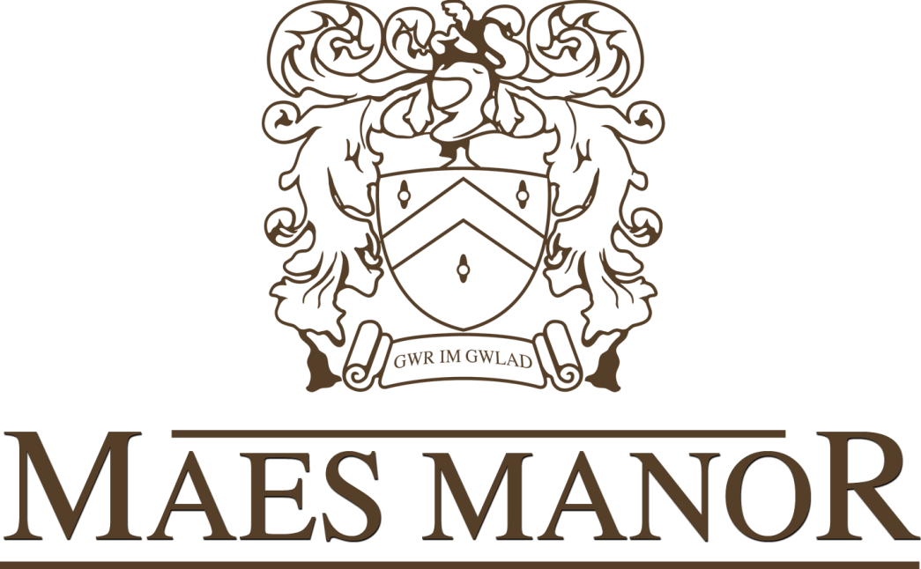



**Mother’s Day Lunch**

Starter

Soup of the Day  
Breaded Butterfly Prawns with a Sweet Chilli Sauce

Baked Garlic Mushrooms with Garlic Bread   
Duck and Orange Pate

Main Course

Slow Roasted Top Side of Beef  
Roasted Boneless Leg of Lamb  
Slow Roasted Pork  
Salmon with a Hollandaise Sauce   
Stuffed Pepper (V )

*(All of the above are served with Yorkshire pudding a selection of fresh vegetables, roast and boiled potatoes)*

Children’s Menu

Chicken Nuggets and Chips

Half Portions of Adult Meals

Desserts

Strawberry Gateaux  
Sticky Toffee Pudding  
Sherry Trifle  
Fruit Salad

(All of the above are served with fresh pouring cream or Ice-Cream)

Adults £19.95 Children £12.95