

**Mother’s Day Lunch  
Pre Order Form**

Party Name:

Number of Guests:

Time:

Starters:

|  |  |
| --- | --- |
| Soup of the Day |  |
| Butterfly Prawns |  |
| Garlic Mushrooms |  |
| Terrine of the Day |  |

Main Course:

|  |  |
| --- | --- |
| Beef |  |
| Lamb |  |
| Pork |  |
| Salmon |  |
| Stuffed Pepper |  |

Desserts:

|  |  |
| --- | --- |
| Strawberry Gateaux |  |
| Sticky Toffee Pudding |  |
| Sherry Trifle |  |
| Fruit Salad |  |

Children:

|  |  |
| --- | --- |
| Chicken Nuggets |  |
| Half Beef |  |
| Half Lamb |  |
| Half Pork |  |

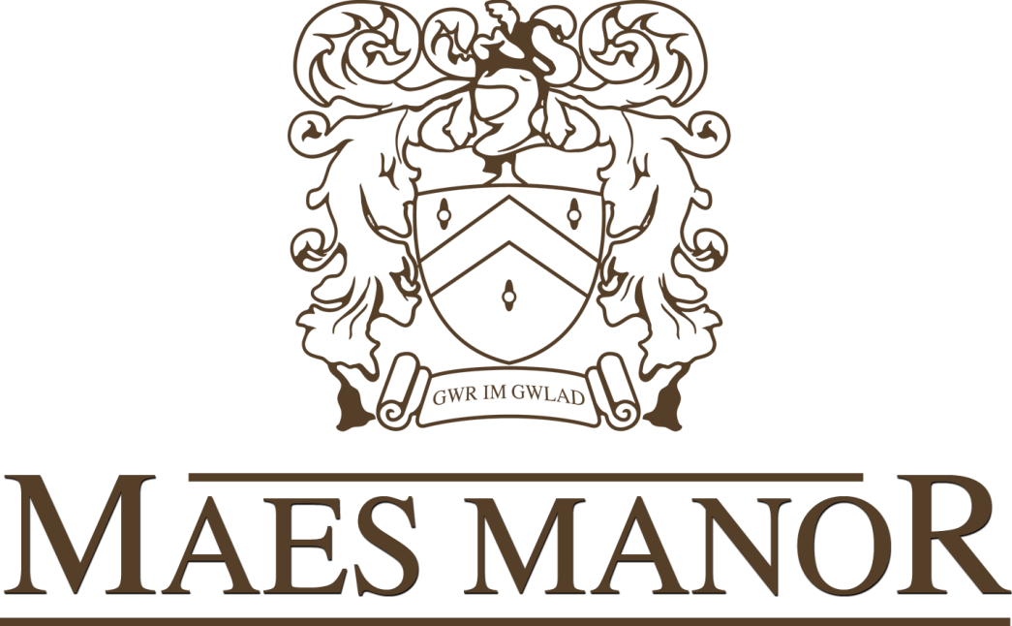

**OFFICE USE:**  
KITCHEN:   
   
DATE:   
   
SIGNED:

**Notes, Special Requests & Dietary Requirements**



**Mother’s Day Lunch**

Starter

Soup of the Day  
Classic Prawn Cocktail  
Baked Garlic Mushrooms with Garlic Bread  
Terrine of the Day

Main Course

Slow Roasted Top Side of Beef  
Roasted Boneless Leg of Lamb  
Slow Roasted Turkey  
Pan Seared Salmon  
Glamorgan Sausages (v)

*(All of the above are served with Yorkshire pudding a selection of fresh vegetables, roast and boiled potatoes)*

Children’s Menu

Chicken Nuggets and Chips

Half Portions of Adult Meals

Desserts

Strawberry Gateaux  
Sticky Toffee Pudding  
Baileys Cheesecake  
Sherry Trifle  
Profiteroles

(All of the above are served with fresh pouring cream or Ice-Cream)

Adults £19.95 Children £13.00