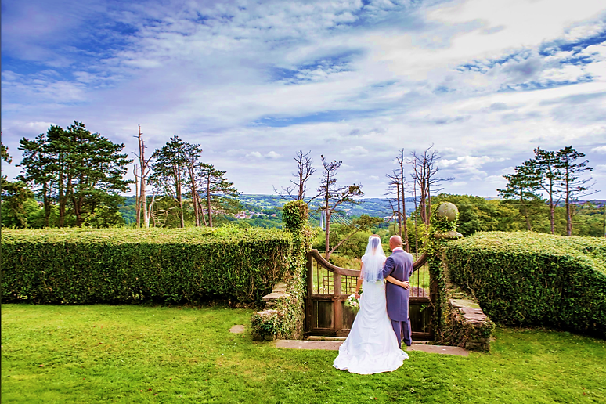

New Wedding Packages 2020/2021
Maes Manor is the perfect venue for holding a wedding reception. With our experience, quality of service, high food standards and overall value for money, we guarantee that you and your guests will have a day to remember.

From the moment you arrive, our friendly and professional team will be on hand to ensure that everything runs smoothly. Our extensive packages offer a wide range of choices for your special day, but these are only guidelines. At Maes Manor Hotel, we recognise that each wedding is individual, therefore, our packages and menus can be adapted if required.

As well as our Classic, Elegance and Supreme packages we have FOUR special offer packages…

Mid-Week Package
£3625 all inclusive
50 Day Guests
100 Evening Guests
2 Course Wedding Breakfast
Sparkling Wine for Toast
Bucks Fizz & Orange Juice upon Arrival
DJ & Security
Table Linen
Hog Roast Evening Buffet
Chair Covers & Bows
Backdrop, Aisle & Easel
Cake Stand & Cake Knife
Bridal Suite with Breakfast

Winter Wonderland
£4800 all inclusive
October-March (excluding December)
65 Day Guests
110 Evening Guests
3 Course Wedding Breakfast
Sparkling Wine for Toast
Bucks Fizz & Orange Juice upon Arrival
DJ & Security
Table Linen
Hog Roast Evening Buffet
Chair Covers & Bows
Backdrop, Aisle & Easel
Cake Stand & Cake Knife
Bridal Suite with Breakfast

All In Friday
£5999 all inclusive
80 Day Guests
120 Evening Guests
3 Course Wedding Breakfast
Sparkling Wine for Toast
Bucks Fizz & Orange Juice upon Arrival
DJ & Security
Table Linen
Hog Roast Evening Buffet
Chair Covers & Bows
Backdrop, Aisle & Easel
Cake Stand & Cake Knife
Bridal Suite with Breakfast

Super Sunday
Simply choose one of our popular packages

Classic
Elegance
Supreme

And save 10% off the package cost (excluding Bank Holiday)

If your numbers go above the limit in the package, there will be an additional charge of £50 per guest.
To discuss your ideas or to arrange a tour, please call our Wedding Coordinator on 01495 220 011 or email mmweddingandevents@gmail.com You can also download our Wedding Brochure at www.maesmanorhotel.com.

Wedding Breakfast Options
The following options are for the Wedding Breakfast advertised in the Mid-Week package, All In Friday package and Winter Package.

Starters
Prawn Cocktail in Marie Rose sauce and brown bread
Smooth Chicken and Liver Pate with a warm bread roll
Homemade Soup (Vegetable, Leek and Potato, French Onion or Tomato and Basil)

Main Course
Roast Breast of Chicken with Traditional Garnish
Roast Tenderloin of Pork with Bramley Apple sauce and rich gravy
Roast Beef and Yorkshire Pudding with rich gravy
Roast Breast of Chicken cooked in a White wine and mushroom sauce
Roast Turkey with Traditional Garnish
Poached Salmon with Hollandaise Sauce and Lemon Wedge
Cheese and Broccoli Pie (V)
Mushroom and Pea Risotto (Suitable for Vegans)

Desserts
Strawberry Gateaux
Profiteroles with Chocolate Sauce
Raspberry Cheesecake
New York Style Vanilla Cheesecake
Salted Caramel Chocolate Torte
Lemon Tart

(One option from each course must be chosen for the whole wedding party)

Evening Buffet
Hog Roast with a selection of salads, apple sauce, stuffing, fresh bread rolls and new potatoes or chips.
(Additional evening guests can be added at a rate of £16.70 in 2020/2021)

