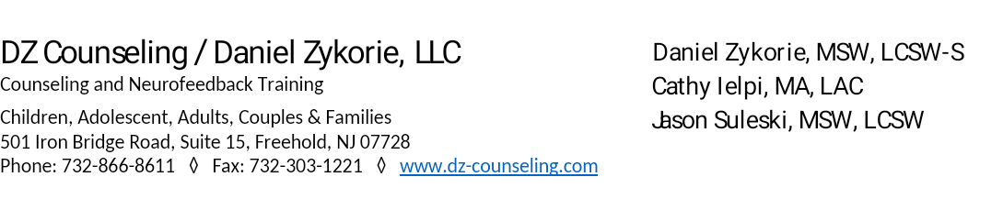
Client Authorization to Release/Receive Confidential Information

Client’s full name: ____________________________________________ Client’s date of birth: _______________________
Counselor's Name: ____________________________________________
AUTHORIZATION GRANTS THE FOLLOWONG PERSON(S) TO: (Please Check All that Apply)
- ACCESS MY CLIENT PORTAL
- COMPLETE MY FORMS AND DOCUMENTS
- MAKE PAYMENTS/ACCESS PAYMENT INFORMATION
- CONSULT WITH MY HEALTH CARE PROVIDER OR EDUCATOR
- RELEASE/RECEIVE CONFIDENTIAL INFORMATION-RECORDS TO/FROM THOSE SPECIFIED BELOW
I authorize my counselor and the following person/agency/facility/school to function as circled above and
described below on my behalf:
Full Name, Title, Contact Information, Relationship to Client, and any Limitations of your consent:
__________________________________________________________________________________________________________
__________________________________________________________________________________________________________
__________________________________________________________________________________________________________
My signature indicates my authorization and consent of counselor to share and/or receive confidential
information or the permission of identified persons/others to perform above specified actions on my behalf.

Client's Printed Name: ______________________________________________
Client's Signature (14 yrs. or older): _____________________________________ Date: _______________________
Parent’s/Legal Guardian's Printed Name: ______________________________________________________________
Parent’s/ Legal Guardian's Signature: ___________________________________ Date: _______________________

**This Authorization will expire one year from date signed or when expressly (written) terminated by Client or Client's Parent/Legal Guardian (if under 14 yrs.) or 60 days following last date of service at DZ Counseling/Daniel Zykorie, LLC

