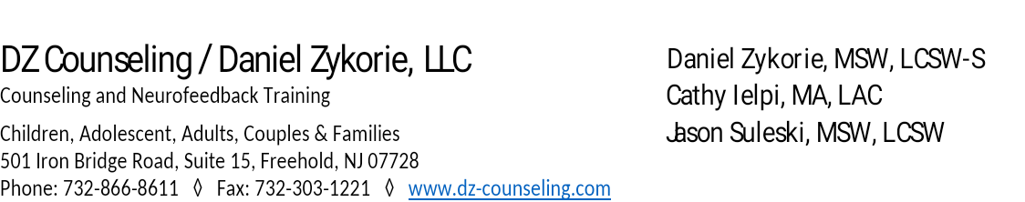

**FAMILY/COUPLES COUNSELING INTAKE FORM**

***PLEASE PRINT CLEARLY. THANK YOU***

Today’s Date: ________________________________

**Here to see: Daniel Zykorie, LCSW**

**Cathy Ielpi, LAC**

**Jason Suleski, LCSW **

**Client’s Full Name**: __________________________________________________________________________

**Client’s Full Address**: ________________________________________________________________________

_________________________________________________________________________________________

**Client’s date of birth**: ______________________ **Age:** ___________

**Client’s preferred personal contact phone number:** __________________________ Leave Message. Y.___ N___

**Client’s email address:** _______________________________________________________________

**Partner’s full name attending counseling with you**: ______________________________________________

**By signing below, you are acknowledging the information contained on this form is accurate.**

**Print Client’s Name: ______________________________________________**

**Client’s Signature: _______________________________________________**

**Date: _____________________________**

1. Relationship status (check all that apply):

Married  Separated  Divorced  Dating  Committed/Monogamous

 Living apart  Cohabitating/living together

**2.** Length of time in current relationship: _______________________________________________

**3.** As you think about the primary reason that brings you here, how frequently does it occur?

 No occurrence  Occurs rarely  Occurs sometimes

 Occurs frequently  Occurs nearly always

**4.** As you think about the primary reason that brings you here, how would you rate your overall concern?

 No concern  Little concern  Moderate concern

 Serious concern  Very serious concern

**5**. What do you hope to accomplish through counseling?

______________________________________________________________________________________________________________________

**6.** What have you already done to deal with the difficulties?

______________________________________________________________________________________________________________________

**7.** What are your greatest strengths as a couple?

_____________________________________________________________________________________________________________________

**8.** Please rate your current level of relationship happiness by selecting the number that corresponds with your current feelings about the relationship: (circle the number that applies)

1 = Extremely unhappy 2 3 4 5 6 7 8 9 10 = Extremely happy

**9.** Have you received prior couples counseling related to any of the above problems? Y_____ N______

**10.** Please make at least one suggestion as to something you could personally do to improve the relationship regardless of what your partner does: ______________________________________________________

_________________________________________________________________________________________________________________

**11**. If you have received prior couples counseling:  N/A

When did this occur? ______________________ Where did this occur? ______________________________

Who counseled you and for how long? ___________________________________________________________

What were the problems that were addressed and what was the outcome? ___________________

**12**. Have either you or your partner been in individual counseling before? Yes______ No _________

**13.** Do either you or your partner drink alcohol to intoxication or take drugs to intoxication?

You: Alcohol- Yes _______ No _______ Drugs- Yes _________ No _________

Partner: Alcohol – Yes______ No _______ Drugs- Yes _______ No ________

**14.** If married, has either of you threatened to separate or divorce because of the current relationship problems? Yes ________ No _________ N/A ________

**15**. Have either you or your partner struck, physically restrained, used violence against, or injured the other person? Yes _______ No _______

**16**. Do you perceive that either you or your partner has withdrawn from the relationship?

Yes_____ Who ______________ No_____

**17**. If married, have either you or your partner consulted with a lawyer about divorce?

Yes _____ No______ N/A _______

**18**. How frequently have you had sexual relations during the last month? _________________________________

**19**. How satisfied are you with the frequency of your sexual relations?

1 = Extremely unsatisfied 2 3 4 5 6 7 8 9 10 = Extremely satisfied

**20.** How enjoyable is your sexual relationship?

1 = Extremely unpleasant 2 3 4 5 6 7 8 9 10 = Extremely pleasant

**21.** What is your current level of stress (overall)?

1 = No stress 2 3 4 5 6 7 8 9 10 = High stress

**22**. What is your current level of stress (in the relationship)?

1 = no stress 2 3 4 5 6 7 8 9 10 = high stress

**23**. List your top three concerns that you have in your relationship with your partner

(1 being the most problematic):

**1**.________________________________________

**2**.________________________________________

**3**.________________________________________

Thank you for completing this questionnaire. Please note that you will be asked to talk about your answers in appointments, but your partner will not be shown this form.

**Client’s Name: _________________________________________________________**

**Client’s Signature: _____________________________________________________Date: _________________________**

**Couples Counseling Policy**

**If you are here to address partner relationship challenges, it’s important for you to understand what I, as your counselor, believe about relationships and marriage.**

**I do not have preconceived notions about whether you should stay together or part ways. I believe it is important to explore such questions openly, honestly, and thoroughly. Once your goals are established, I will work diligently to support you in achieving them, whatever they may be. You are entrusting me to use my professional judgment as it relates to individual confidences.**

**By signing this form, you are acknowledging that anything you communicate to me individually by phone, email, or any other means may be important to bring up and work on in a couples counseling sessions, and I reserve the right (but not the obligation) to do so.**

**Your Provider's Name: ___________________________________________________**

**Client’s Name: _____________________________________________________________**

**Client’s Signature: _________________________________________________________**

**Partner’s Name: ___________________________________________________________**

**Date: _____________________________**