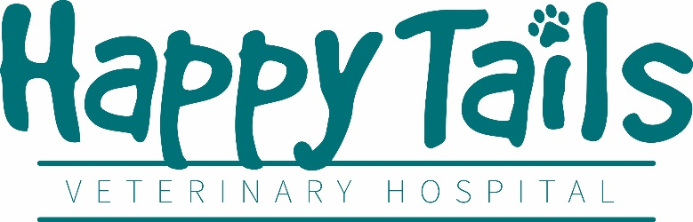
Receptionist
Job Type: Full-Time, 35 to 40 hours a week or Part-Time 20 to 25 hours a week
Starting hourly wage based upon experience
Must have at least 1 year experience in reception and at least 3 years’ experience in customer service. Experience in a veterinary hospital setting preferred but not required
Our Hospital
Happy Tails is a two-doctor practice owned by Dr. Vera Calpeno. We have been in business since 2014 and pride ourselves in our exponential growth as far as client base, revenue, and square footage. Our rapidly expanding hospital needs experienced technicians to take our practice to the next level and realize its full potential.
It is important to our hospital that our staff enjoy their workplace. Because of our business hours, staff members regularly have three-day weekends and are rarely asked to go into overtime. We have a probationary period of only three months and provide competitive compensation. We also provide discounts on all products and services for your own pets including free Wellness Plans. We provide paid vacation and sick time, medical insurance stipends, and we are preparing to provide retirement benefits to full time staff.
Our philosophy is that our staff are our most important resource which is why we invest in continued education courses at no cost to you as well as regular “Lunch and Learns” with our vendors to expand your knowledge of veterinary medicine.
We consider ourselves to be more than just a hospital, we feel like a member of our local community and have a majority client base that has been with us since we were just starting out.
What we are looking for
We are looking for a bright and enthusiastic receptionist that is willing to learn and grow along with the hospital itself. We are looking for a team player that can work independently and confidently. It is important that candidates for this position are clear communicators with proper phone etiquette.
The type of skills we are looking for are:
- Good written and verbal communication skills
- Able to learn medical terminology quickly
- Attention to detail and multi-tasking
- Knowledge of Impromed veterinary management software preferred but not required
- Computer literacy including Microsoft Office Suite
- Phone etiquette
- Compassion towards patients as well as clients
- Knowledge of social media - Facebook, Twitter, Google, Yelp, Instagram
- Typing speed of 35wpm or higher with accuracy of 95%
- Ability to draft memos, letters and notices with proper grammar
Your daily duties include:
- Answer phone and take messages as well as make daily appointment
- Communicate appointment times with clients and confirm existing appointments
- Draft letters and notices for clients and staff
- Filing and upkeep of daily papers - electronically and hard copy
- Record keeping
- Communications with clients and staff
- Assisting with marketing and promotional planning
- Working with computerized medical records
- Assisting in cleaning the clinic at the end of each shift
If this sounds like the job for you, please email your resume and three references to administrator@happytailsvethospital.com or call our office administrator at (410)437-7514 option 3

