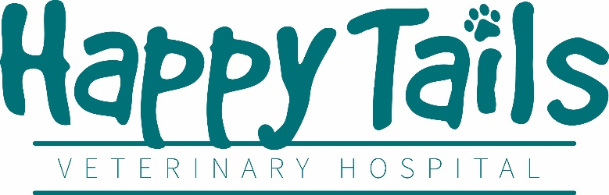
Veterinary Technician Assistant
Job Type: Full-Time, 35 to 40 hours a week
Starting hourly wage based upon experience
Must have at least 1 year experience in a veterinary hospital. Experience with exotic animals preferred but not required.
Our Hospital
Happy Tails is a two-doctor practice owned by Dr. Vera Calpeno. We have been in business since 2014 and pride ourselves in our exponential growth as far as client base, revenue, and square footage. Our rapidly expanding hospital needs experienced technicians to take our practice to the next level and realize its full potential.
It is important to our hospital that our staff enjoy their workplace. Because of our business hours, staff members regularly have three-day weekends and are rarely asked to go into overtime. We have a probationary period of only three months and provide competitive compensation. We also provide discounts on all products and services for your own pets including free Wellness Plans. We provide paid vacation and sick time, medical insurance stipends, and we are preparing to provide retirement benefits to full time staff.
Our philosophy is that our staff are our most important resource which is why we invest in continued education courses at no cost to you as well as regular “Lunch and Learns” with our vendors to expand your knowledge of veterinary medicine.
We consider ourselves to be more than just a hospital, we feel like a member of our local community and have a majority client base that has been with us since we were just starting out.
What we are looking for
We are looking for an experienced veterinary technician that is willing to learn and grow along with the hospital itself. We are looking for a team player that can work independently and confidently. It is important that candidates for this position are friendly and easy to talk to as well as knowledgeable about veterinary medicine.
The type of skills we are looking for are:
- Knowledge of Animal Behavior and husbandry
- Good written and verbal communication skills
- Use of medical terminology
- Attention to detail and multi-tasking
- Knowledge of Impromed veterinary management software preferred but not required
- Computer literacy including Microsoft Office Suite
- Phone etiquette
- Compassion towards patients as well as clients
Your daily duties include:
- Assisting the veterinarian and technicians in dentistry, anesthesia, surgery, and general hospital operations
- Managing and logging computerized medical records
- Making phone calls to clients about their animals
- Restraining animals for administration of treatments and examinations
- Maintaining cleanliness of exam rooms
- Stocking and receiving inventory

If this sounds like the job for you, please email your resume and three references to administrator@happytailsvethospital.com or call our office administrator at (410)437-7514 option 3

