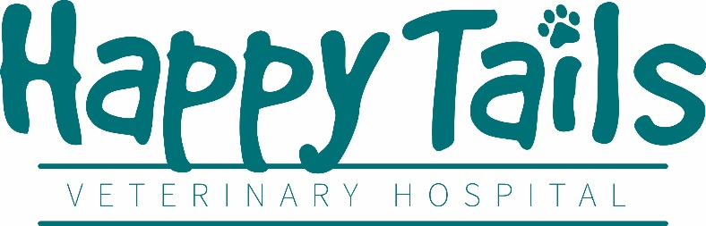
Experienced Veterinary Technician
Job Type: Full-Time, 35 to 40 hours a week
Starting hourly wage commiserate with experience
Must be a Licensed, Registered, or Credentialed Veterinary Technician OR have at least 5 years’ experience in small animal medicine. Experience with exotic animals preferred but not required.
Our Hospital
Happy Tails is a two-doctor practice owned by Dr. Vera Calpeno. We have been in business since 2014 and pride ourselves in our exponential growth as far as client base, revenue, and square footage. Our rapidly expanding hospital needs experienced technicians to take our practice to the next level and realize its full potential.
It is important to our hospital that our staff enjoy their workplace. Because of our business hours, staff members regularly have three-day weekends and are rarely asked to go into overtime. We have a probationary period of only three months and provide competitive compensation. We also provide discounts on all products and services for your own pets including free Wellness Plans. We provide paid vacation and sick time, medical insurance stipends, and we are preparing to provide retirement benefits to full time staff.
Our philosophy is that our staff are our most important resource which is why we invest in continued education courses at no cost to you as well as regular “Lunch and Learns” with our vendors to expand your knowledge of veterinary medicine.
We consider ourselves to be more than just a hospital, we feel like a member of our local community and have a majority client base that has been with us since we were just starting out.
What we are looking for
We are looking for a veterinary technician assistant that is willing to learn and grow along with the hospital itself. We are looking for a team player that can work independently and confidently. It is important that candidates for this position are friendly and easy to talk to as well as learn quickly and work efficiently.
The type of skills we are looking for are:
- Knowledge of Animal Behavior and husbandry
- Good written and verbal communication skills
- Use of medical terminology
- Attention to detail and multi-tasking
- Knowledge of Impromed veterinary management software preferred but not required
- Computer literacy including Microsoft Office Suite
- Phone etiquette
- Compassion towards patients as well as clients
Your daily duties include:
- Managing the tech assistants and guide them in their training
- Knowledge of current veterinary medical and dentistry standards
- Extensive experience required in Anesthesia, Dentistry, Exam Rooms, and general hospital operations.
- Preparation of animals for anesthesia and surgery, including placement of IV catheters and monitoring anesthesia
- Properly restrain animals for examination and administration of treatments
- Taking blood and other lab samples from dogs, cats, and exotics (mammals, avian, reptiles, amphibians)
- Assist the veterinarian in the exam room as well as lead exam rooms
- Run a variety of lab tests and assist in taking x-rays
- Microscope use and interpretation of various cytology (urine, skin, FNA)
- Logging and managing computerized medical records

If this sounds like the job for you, please email your resume and three references to administrator@happytailsvethospital.com or call our office administrator at (410)437-7514 option 3

