AMARILLO MARTIAL ARTS ACADEMY
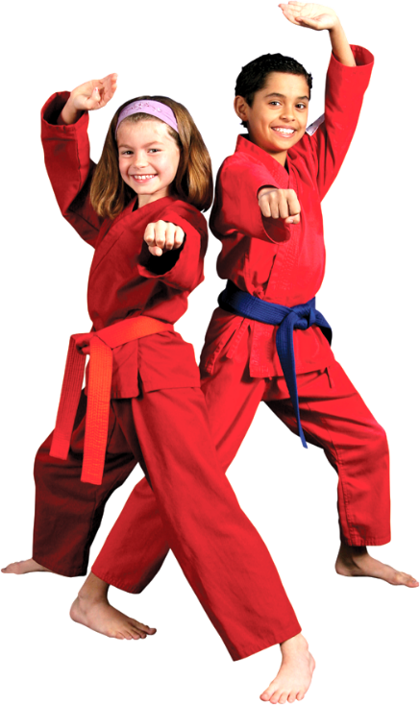
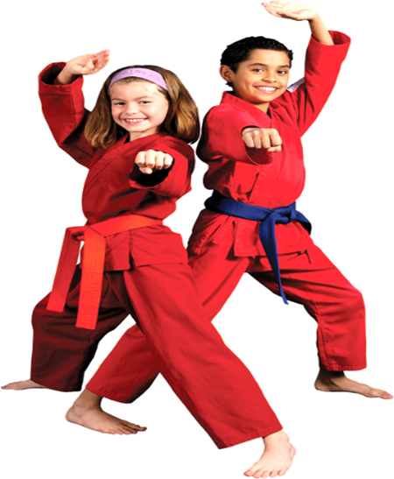

OUR ‘BLACK BELT’ STUDENTS ARE CERTIFIED, NATIONALLY AND INTERNATIONALLY.
AMARILLO KARATE.COM
SCHOOL MERITS
38 years in Amarillo. INSTRUCTED OVER
13,000 CONFIDENT STUDENTS.
99.9% Finished High School, &
28% finished College. MD’s, PhD’s, & even a Lawyer or two.

OUR “HEAD INSTRUCTOR” IS A 6 TIME, WINNER, IN THE PRESTIGIOUS U.S. OPEN KARATE CHAMPIONSHIPS, (Over)
HAS INSTRUCTED SWAT, FBI, POLICE, SECURITY, MILITARY, AND IS TCOLE, & PPCT, TRAINED. HE HAS 60 YEARS IN TRAINING, AND IS A 9TH DEGREE BLACK BELT, IN MUTIPLE DICIPLINES.

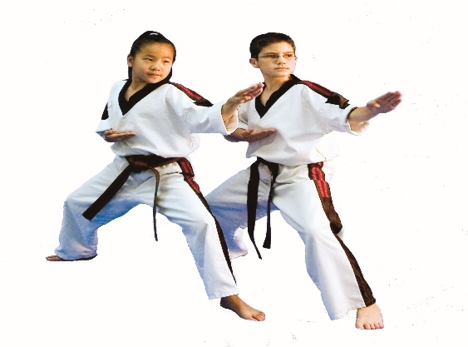
WE INSTRUCT: KARATE, JUDO, AKIDO, TAEKWONDO, KUNG FU, MMA, BOXING, KYUSHO JITSU, AND ISRAELI MILITARY SPECIAL FORCES TACTICS. (KRAV MAGA™)

WE LIMIT OUR ENROLLMENT TO
50 STUDENTS.
EACH STUDENT RECEIVES PERSONALIZED INSTRUCTION.

WE WANT TO HELP YOU RAISE AN HONORABLE ADULT.
WE BELIEVE, “AS THE TWIG IS BENT-SO GROWS THE TREE”.
SELF CONTROL, IS THE KEY TO NOT HAVING PROBLEMS”.

OUR STUDENT CREED: “I PROMISE TO TREAT ALL OTHERS, THE WAY I WOULD LIKE TO BE TREATED”
“I WILL LEAD BY EXAMPLE”

CLASS SCHEDULE:
MONDAYS-
4:30-Beginners, White, and Gold Belts.
5:30-Orange, Green, and Purple Belts.
6:30 Blue, Brown and Black Belts.

TUESDAY
4:30-Orange, Green, and Purple Belts.
5:30-Blue, Brown, and Black Belts.
6:30-Beginners, White, and Gold Belts.

WEDNESDAY
4:30-Blue, Brown, and Black Belts.
5:30-Beginners, White, and Gold Belts.
6:30-Orange, Green and Purple Belts.

THURSDAY-
4:30-Beginners, White, and Gold Belts.
5:30-Orange, Green, and Purple Belts.
6:30-Blue, Brown, and Black Belts.

FORMAL RANK EXAMS FRIDAYS AT 6:00 PM. (Over)

PRICES;
WE OFFER A FULL, 30 DAY, 100% MONEY BACK GUARANTEE.
ONE STUDENT, $89.00 Monthly. Up to 4 Classes Weekly. A Six Month Program.

FAMILIES
WE HAVE GREAT FAMILY RATES. $89.00-First Member, ½ off 2nd Member, ¾ off, 3rd Member, 4th Member, $11.00.

ISRAELI KRAV MAGA™
$99.00 MONTH
THREE MONTH PROGRAM

WE WILL WRITE A SPECIAL PROGRAM FOR YOUR SPECIFIC NEEDS, SUCH AS TIME, COST, OR EQUIPMENT? ASK.

HERE’S OUR NUMBER 1 PROGRAM.
IT WILL SAVE YOU TIME, AND $$$, at 99.00 Monthly.
THIS “BLACK BELT”, 6 MONTH PROGRAM, GIVES YOU; UP TO FOUR CLASES A WEEK,
& OUR “KARATE ENROLLMENT UNIFORM PACKAGE” 100% FREE. ENROLLMENT PACKAGE INCLUDES:
A REGULATION EMBOSSED UNIFORM, ($34.99)
REQUIRED 3 PIECE PATCH SET, ($31.49)
A KARATE GROIN GUARD, MALE or FEMALE, ($13.99) AND,
A KARATE T-SHIRT, ($15.99) WEAR IT ON THURSDAYS.
A $104.43 RETAIL VALUE; ALL
100% FREE!
YOU MAY PREPAY ANY PROGRAM, AND SAVE 10%.

YOU CAN
ALSO RECEIVE YOUR
SPARRING GEAR PACKAGE,
A $184.43 VALUE, TAX INCLUDED,
100% FREE!
WITH A 12 MONTH PROGRAM. (99.00 Monthly)

SPARRING GEAR PACKAGE INCLUDES;
KARATE CARRY BAG, ($29.99) HAND PADS, $32.99) (Over)
FOOT PADS, ($32.99) SHIN PADS, ($27.99) AND
A MOUTH GUARD. ($2.49) A $184.43 VALUE.
100% FREE!
THIS EQUIPMENT IS REQUIRED AT ORANGE BELT.
ALWAYS BRING YOUR SPARRING GEAR TO EVERY CLASS.
OUR 24 MONTH PROGRAM, INCLUDES EIGHT MORE BELT RANK EXAMS, PRE-PAID. A $176.00 VALUE.

IF YOU ARE A MEMBER AND ALREADY HAVE YOUR UNIFORM PACKAGE,
JOIN OUR 12 MONTH PROGRAM, AND RECEIVE
THE SPARRING GEAR PACKAGE, A $184.43 VALUE
AND FOUR BELT RANK EXAMS, A $88.OO VALUE, A 272.43 TOTAL VALUE---FREE!

OPTIONAL ACCESSORIES;
YOU ALWAYS RECEIVE A 15% DISCOUNT ON ALL GEAR PURCHASES.
HEAD GEAR 37.99
BLACK PANTS, ELASTIC 8 OZ. 34.99. OR
12 OZ. BLACK DRAW STRING, 44.99.
AVAILABLE FOR BROWN BELT & ABOVE, NO DISCOUNT.
EMBROIDERED UNIFORM 99.98 (NO DISCOUNT)
FEMALE BREAST GUARD 49.95, OR
DELUXE 72.95.
TESTS;
BELT RANK CERTIFICATION EXAMS, BELT & DIPLOMA,-$22.00.
ALWAYS TRY TO BRING A FRIEND TO CLASS. MAKE $$$$$$$$$.
WHEN THEY JOIN ON OUR REGULAR PROGRAM, YOU RECEIVE $20.OO CASH.
PATCH PLACEMENT:
PUT UNIFORM ON FIRST!
FOLD LEFT SIDE OVER RIGHT.
AMERICAN FLAG ON RIGHT SHOULDER
“TEXAS BLACK BELT COMMISSION” ON LEFT SHOULDER.
HARVEY’S KARATE PATCH ON UPPER LEFT CHEST.
ALL OTHER AWARD PATCHES UNDER THE HARVEY’S KARATE PATCH, ON UPPER LEFT CHEST.
WHEN THIS AREA IS FILLED, PUT OTHERS DOWN LEFT SLEEVE, BELOW ELBOW. (Over)

BLACK BELT SKILLS; LAST A LIFETIME.
THEY BRING SUCCESS, IN
EDUCATION, SPORTS, JOBS, BUSINESS, & MARRIAGE.
FOR EACH EXAM (BELT TEST) 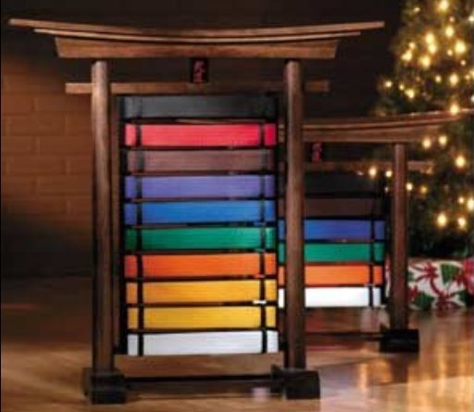
PLAN, PREPARE, AND PRACTICE.
MEMORIZE THE MATERIAL. IT MAY SAVE YOUR LIFE, OR YOUR FAMILIES’.
YOUR CERTIFIED RANK OF “BLACK BELT” CAN MAKE YOU A LIVING, PAY FOR COLLEGE, OR GREATLY IMPROVE YOUR SPORTING CAREER.
INVITE FAMILY AND FRIENDS TO WATCH THE TEST, AND TAKE PICTURES. THE TEST WILL BEGIN WITH “ONE LINE”.YOU SHOULD ARRIVE EARLY AND WARM UP ON YOUR OWN.
PROTEIN FOOD, EATEN BEFORE THE TEST WILL BE BETTER THAN CARBOHYDRATES. Bring water and food for energy.
THE TEST WILL COVER; BLOCKS, KATAS, COMBINATIONS,
SELF-DEFENSE, SPARRING, WEAPONS, BOARD BREAKING AND SPECIALTIES.
YOU WILL BE GRADED THROUGHOUT TESTING. THE SAME RULES APPLY AS BEFORE, YOU ARE ALLOWED THREE MISTAKES, AND STILL PASS.
ALL TECHNIQUES ARE REQUIRED, FROM WHITE BELT AND UP.
BEGINNERS WILL TEST FOR WHITE BELT DURING REGULAR CLASS, THERE IS NO CHARGE.
AT THE END OF TESTING, YOU WILL BE PRESENTED WITH YOUR NEW BELT, AND RANK CERTIFICATE. YOU MAY RE-TEST IN ONE MONTH, WITHOUT CHARGE, IF NECESSARY. (Over)
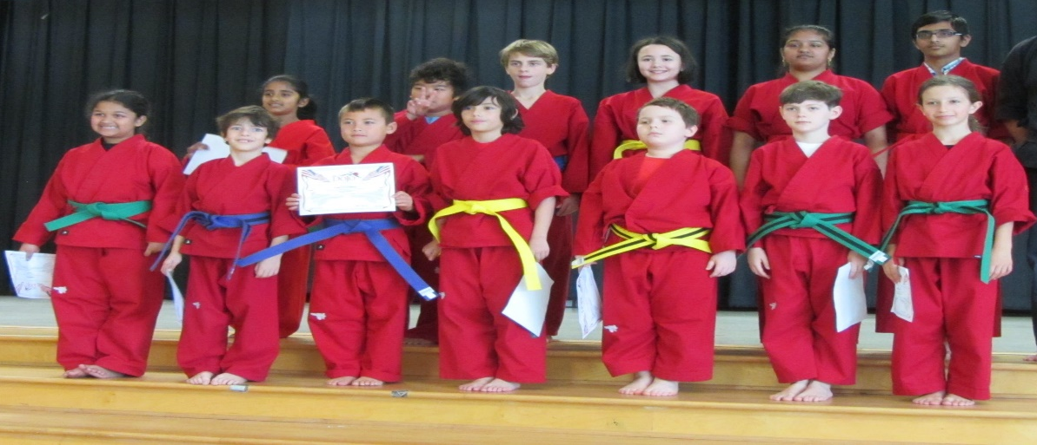
SOME OF YOU MAY BE ASKED TO ATTEND TESTING, EVEN IF YOU ARE NOT TAKING THE TEST. THIS IS SO YOU CAN HELP WITH THE TEST, AND SPARRING. THESE WILL COUNT AS THE ‘TEACHING CREDITS’ YOU NEED TO RECEIVE YOUR BLACK BELT.
TO BE QUALIFIED FOR TESTING, YOU MUST HAVE PASSED THREE-PRE-TESTS.
EARNING, AND RECEIVING YOUR
“BLACK BELT STATUS”
IS ONE OF THE MOST HONORABLE THINGS YOU WILL ACHIEVE IN YOUR LIFETIME!
WE ENJOY CELEBRATING WITH YOU, EVERY TIME YOU PASS AN EXAM!
A BLACK BELT, IS A WHITE BELT
THAT NEVER QUIT TRYING!
HARVEY SENSEI

