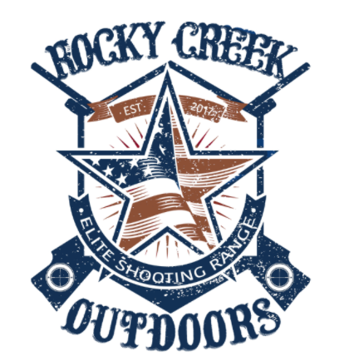

Effective May 2, 2021

All non-profit, SCTP, 4-H, FFA and fundraiser pricing

* .45/Target for skeet, trap, 5-stand and sporting clays courses
* $1200 Clubhouse and Pavilion Rental
* $750 minimum labor charge for two employees; $350 each additional employee
* $25 per person on rifle, pistol and archery ranges
* $50/Golf cart rental

All printing, laminating, and administrative preparation will be an additional cost.

Thank you,

Lance Keen

9032788780

[rockycreekoutdoorsusa@gmail.com](mailto:rockycreekoutdoorsusa@gmail.com)

Website: Rockycreekoutdoorsusa.com