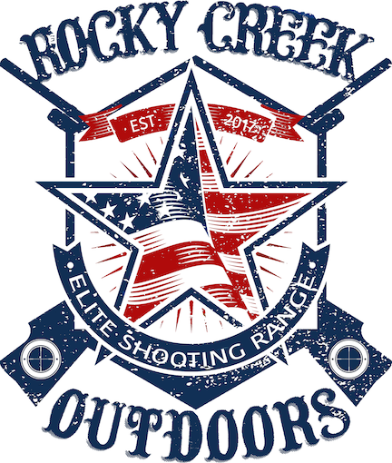

Name:

Address:

City:

State/Zip:

Phone:

E-Mail:

The Undersigned Participant hereby covenants, contracts, and agrees with Rocky Creek Outdoors LLC., (hereafter Club) as following:

- The Participant fully understands and acknowledges that shooting sports carries an inherent risk and agrees to follow all instructions and directions of Club staff.
- The Participant covenants and agrees to hold the Club harmless and indemnify the Club from and all losses, claims, suites, injuries or property damage suffered by the participants with caused or occasioned by intention or negligent act or omission of any party during their visit to the Club.
- The Participants warrant that any and all equipment brought into the Club Property to the best of their knowledge are in safe and operational conditions.
- The safety on all firearms brought onto the Club property must be in proper working and proper operating condition.
- The Participant covenants and agrees that in addition to matters identified herein, that Participant agrees to hold harmless and identify the Club for any and all expense including but not limited to attorney fees, court cost, and expenses associated with the defense of any claim or suit brought by the participant.
- The participant, being fully aware of these dangers and inherent risk associated with shooting sports, firearm and hunting in general, hereby assume all risk associated therewith freely, knowingly, and voluntarily.
- The Participant has ____ years of experiance using firearms and _____ years of hunting experience.
- The Participant would rank his/her shooting level as (please circle):
- Beginner
- Intermediate
- Skilled
- That the participants are 18-years old or older, if the Participants is under 18 years of age, a parent or Guardian must sign on Participant’s behalf.

___________ ____________________________________________
Date Signature of Participant, Parent, or Guardian

