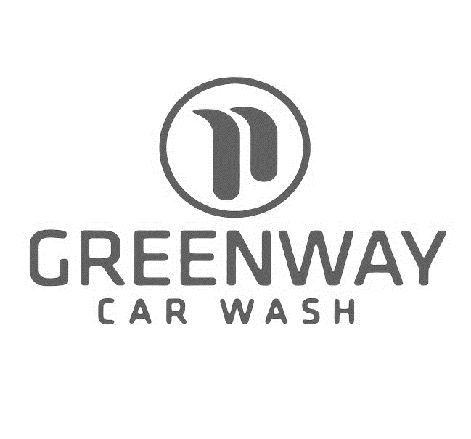
Unlimited Wash Pass
Terms and Conditions

Unlimited monthly car washes… you can get a car wash every day of the month!
Terms, Conditions, and Purchase Agreement

Membership
Membership automatically renews each month on the same day of the month of your initial sign-up. You may discontinue at any time by giving us written notice at least 5 days prior to your billing date. You can reach us by mail or email:
535 US-22
Whitehouse Station, NJ 08889
908-534-8776
No partial refunds are available.

Vehicle
Your membership is vehicle specific by barcode.

Upgrade
Members may upgrade to a higher wash and pay the difference at time of each wash.

Conditions
Membership is per vehicle and for personal use only. Taxis, limos, and any type of commercial or fleet are prohibited.

Cannot be used in conjunction with any other coupons or discounts.

By enrolling in the Unlimited Wash Pass, the member waives any and all rights to withhold or delay payment of the related credit card charges.

Greenway Car Wash reserves the right to cancel or amend this program at any time

