September 30, 2014
Parents,
I am very excited about the completion of our Outdoor Classroom and will have much to share about the subject and the opportunity we have here at Little Tot’s to become a certified nature school! As you have probably noticed we have been adding lots of new components to our outdoor classroom over the last several months. We teachers have noticed quite a change in the play and learning we are observing outside, even in this short period of time, and are so happy for the opportunities that the children now have to experience the outdoors much in the same way that we did when we were kids.
To make the most of this experience it is essential that everyone is properly dressed so that the children are kept as warm and dry as possible, and so that parents are not stuck at the washing machine all night:0)
Below are a few suggestions for appropriate school clothing. Taken from our Parent Handbook:
Seasonally appropriate outdoor play clothes, brought to school each day, even for babies, to be used for outdoor play. Hat, coat, gloves, snowpants (or snowsuit) and boots brought each day during the winter months. A pair of rain-boots and a rain-jacket for spring and late fall. A bathing suit, towel, swimmer pants, and sunblock for your child each day during summer months. Some parents prefer to bring a duffle bag to put these supplies in, especially during winter months. FYI: We get dirty:0) It is a fun enjoyable part of being a kid! Please bring your child comfortable play clothes that you don’t mind getting stained or dirty. Also, a towel for the seat in your car might be a good idea too in the event you don’t want the fun (dirt) to rub off onto your carseats.

Further Ideas for Fall:
- Rainboots or Snowboots to be left at school
- Water proof pants, rain jacket or rainsuit to be left at school
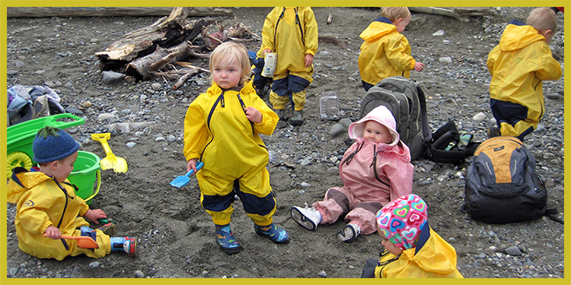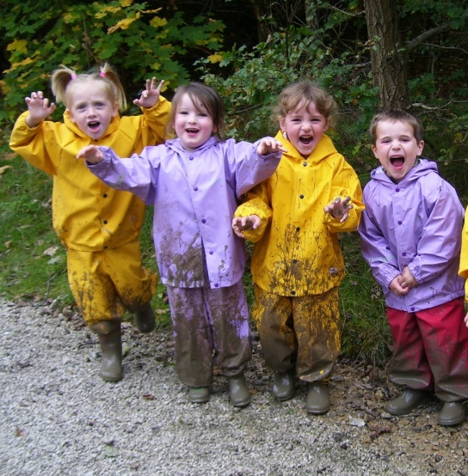
(muddy buddy coverall by Tuffo) http://www.amazon.com/Tuffo-Little-Overalls-Yellow-Toddler/dp/B001AHXAUY/ref=sr_1_2?ie=UTF8&qid=1412121489&sr=8-2&keywords=tuffo+muddy

http://www.amazon.com/Tuffo-Muddy-Buddy-Coveralls-Months/dp/B00KL1LE80/ref=sr_1_4?ie=UTF8&qid=1412121489&sr=8-4&keywords=tuffo+muddy
- Long sleeved top
- Warm socks, and a spare pair
- Extra clothes (just in case)

Thank you for your support! I can’t wait for all of the memorable experiences we are about to have! Lisa~

