Bulletin Information 

|  |  |  |  |  |  |
| --- | --- | --- | --- | --- | --- |
|  | April 30, 2020  , | TYPE: | Information | NUMBER: | LR-006-20 |
| SUBJECT: | **Work Train Tie-up Guide** | | | | |

**Attention – All Canadian T&E Employees**

Below is a guide to assist crews when tieing up work trains as per Article 12 of the Consolidated ollective Agreement.

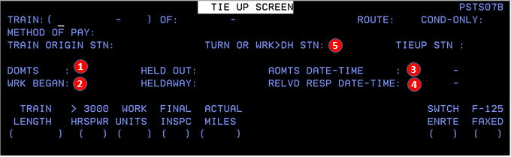

1. **DOMTS –** If departed OMTS with train at initial terminal enter time here.
2. **WRK BEGAN –** If taxied into service outside of the origin terminal enter time here.
3. **AOMTS –** If arrived OMTS with train at final terminal enter date and time here.
4. **RELVD RESP –** If picked up / relieved by taxi enter date and time here.
5. **TURN STN –** If relieved enroute, station number of relief point or work point is required here.

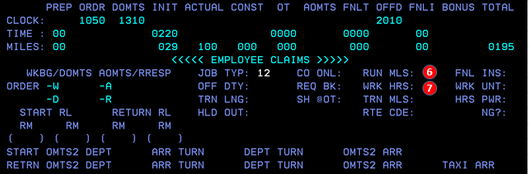

1. **RUN MLS –** Enter run miles (track miles traveled on your train going to and from work location). Does not include mileage while occupied in work train service.
2. **WRK HRS –** Enter time occupied in work train service (Maintenance or betterment work, wrecking train, snowplowing, or spreader service. Note: work hours go into the minimum day).

**Claim Entitlement (by indicated Claim Code)**

**CT / EC –** Co-only premiums such as terminal and enroute switching are allowed if applicable.

**OM –** As per Art. 3.01 off main claims are not payable in work train service.

**TJ –** Turn time cannot overlap, or be combined with work hours.

**HR –** As per Art. 12.10 crews are entitled to 100 miles for handling revenue cars. Revenue cars must have nothing to do with work train, or be in connection with the work service performed. Sufficient comments must be entered to support HR payment.

**EM –** As per Art. 12.12 Engineers are entitled to 15 minutes of pay when laid up at any point without any regular shop staff. This is to cover any necessary repairs and get engine ready. This payment only applies in work train service.

**Important Note:** The above information is current as of April 30, 2020 however, you are your own timekeeper and therefore responsible for your timeslips (even if submitted by a fellow employee). You must make every effort to understand and correctly apply the Collective Agreement, Method of Pay and Local Agreements in effect.

Labour Relations

T&E Payroll Audit

**Canadian Pacific**