Bulletin Information 

|  |  |  |  |  |  |
| --- | --- | --- | --- | --- | --- |
|  | May 15, 2020  , | TYPE: | Information | NUMBER: | LR-007-20 |
| SUBJECT: | **How To Claim Overtime Correctly Tie-up Guide** | | | | |

**Attention – All Canadian T&E Employees**

Below is a guide to assist crews when tieing up tours of duty that are to be paid at overtime rates.

If you did not use the correct procedure to claim over time on your initial tie-up you can correct this on your secondary tie-up screen – instructions are below.

Note: Overtime pay for time worked in in excess of, but continuous with a single shift is calculated by CMA automatically.

**Yard Service**

When claiming an entire yard shift at overtime rates use the following procedure.

**“H” for General Holiday | “W” for Entire shift at OT on other than GH**

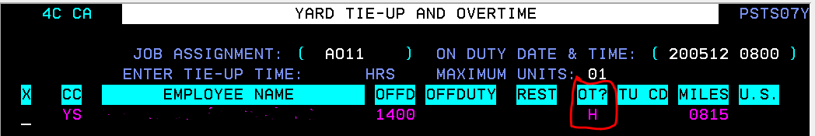

Under the “OT” field enter:

* “H” if working on a general holiday, or
* “W” if claiming entire shift at overtime rates.

Either method will result in pay for the entire shift at time and a half

To add overtime on a ticket after tie-up it can be adjusted from the main menu using the timeslip adjustment screen (#17). Enter the appropriate OT code (Either “H” or “W”) in the SH @ OT field.

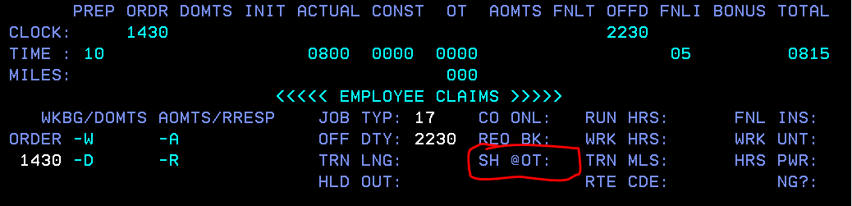

**Roadswitcher Service**

When claiming the entire shift at overtime rates on a Road Switcher Assignment use the following procedure:

Upon tie-up in the PF11 claims screen, enter the claim code OT for the below mileage amount.

8 hour assignment = 50 miles

10 hour assignment = 63 miles

12 hour assignment = 75 miles

This can also be adjusted from the main menu using the timeslip adjustment screen (#17) after tie-up.

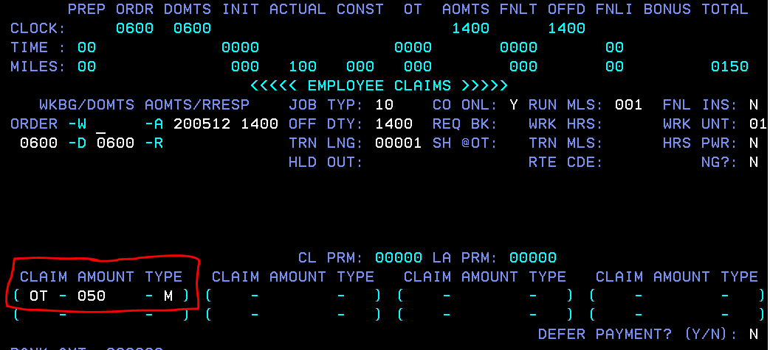

**Important Note:** You are your own timekeeper and therefore responsible for your timeslips (even if submitted by a fellow employee). You must make every effort to understand and correctly apply the Collective Agreement, Method of Pay and Local Agreements in effect.

Labour Relations

T&E Payroll Audit

**Canadian Pacific**