**Welcome to Choi Kwang Do!**

You are now a student of CKD, one of the fastest growing Martial Arts in the world!

We are very pleased to have you a part of Adapt Choi Kwang Do. We aim to develop practical and self-defence skills in a non-competitive, friendly and controlled environment. Students will learn with a positive reinforced approach.

We aim to produce true Martial Artists and well prepared learners. Choi Kwang Do reduces vulnerability by having a non-contact, non- competitive curriculum.

Congratulations on beginning your journey towards Black Belt!

**A Message to New Students from Grandmaster Kwang Jo Choi**

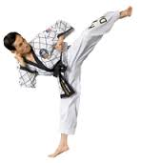

As President and Founder of Choi Kwang-Do Martial Art International, I would like to welcome you, the student, to the study of Choi Kwang-Do. From a lifetime of studying and teaching martial arts, I have developed Choi Kwang-Do as a superior form of exercise, self-defence training, and as a means towards realising one's highest mental and physical potential. With time and dedicated training, I am sure that you will find the benefits from your commitment to Choi Kwang-Do to be great and the rewards many.

As a member of an international association, you can take pride in the fact that you are receiving the most thorough and professional martial arts instruction available. You will find each of my Instructors to be helpful, courteous, and glad to answer your questions. Through your Instructor, you will have access to videos and written literature being developed, as well as information on seminars, workshops, and other events sponsored by your organization. If your goal is to become a professional Instructor, consult with your Instructor concerning eligibility requirements and special training regarding this.

In closing, I again welcome you and give my best wishes for a long and rewarding membership.



**CHOI KWANG DO BELT RANK SYSTEM**

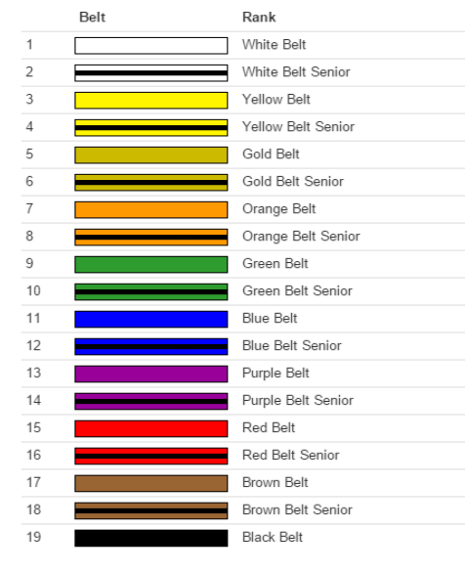

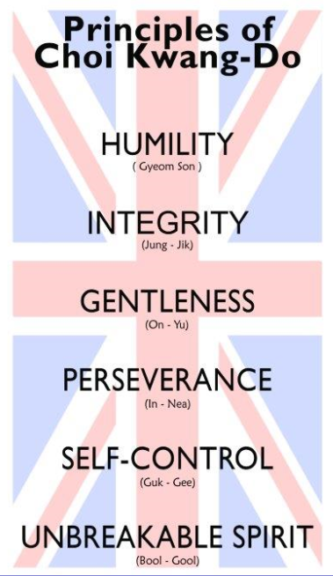Below are our CKD Junior Promise, Adult Pledge and Principles – We recite these at the beginning of each class and encourage you to review regularly to ensure you’re abiding by them as much as possible in your everyday life.

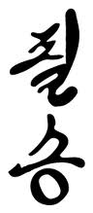



**RULES OF THE DO JAHNG**

* No Jewellery is to be worn in the Do Jahng.
* Smoking and chewing gum are prohibited in the Do Jahng.
* Everyone must remove their shoes before entering the Do Jang. Shoes and other personal belongings are to be kept neatly in a designated area.
* Students should bow towards flags when entering and leaving the Do Jahng.
* Students should always bow before and after speaking to an Instructor or senior student and use terms of respect such as ‘Yes, Ma’am/Sir’ or ‘No Ma’am/Sir’. Any Instructors commands should be answered with a ‘Yes, Sir/Ma’am’ or ‘No, Sir/Ma’am’.
* Students must not face the Instructor or Flags when adjusting their Do Boks.
* Students should maintain common standards of hygiene.



|  |  |  |  |  |  |  |
| --- | --- | --- | --- | --- | --- | --- |
| Sunday | Monday | Tuesday | Wednesday | Thursday | Friday | Saturday |
|  | KID’S CLASS  4:00-4:50 |  |  |  | KID’S CLASS  4:00-4:50 | OPEN CLASS  2:30-3:30 |
|  | KID’S CLASS  4:50-5:50 |  |  |  | KID’S CLASS  4:50-5:50 |  |
|  | OPEN CLASS  6:30-7:30 |  |  |  | OPEN CLASS  6:30-7:30 |  |

|  |  |
| --- | --- |
|  | **TUDOR DRIVE KT2 5QH** |
|  | **TIFFIN SPORTS CENTRE** |
|  | **TIFFIN GIRLS SCHOOL** |

**CLASS SCHEDULE**