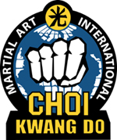
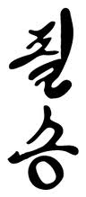
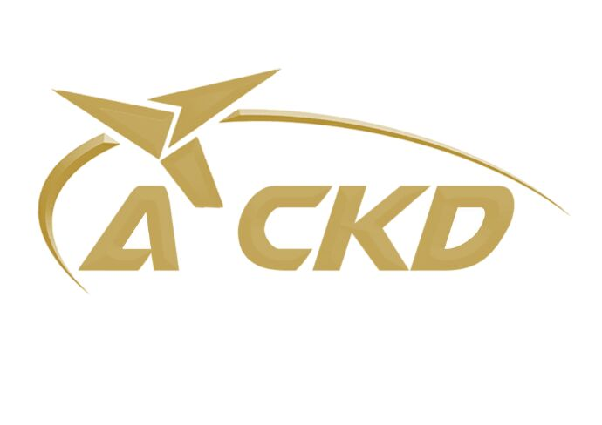

KOREAN TERMINOLOGY

CHARRIOT-ATTENTION
KYUNG YAE- BOW
CHUN BI- READY STANCE
SEJAK- BEGIN
GOMAN- STOP
PARO- BACK TO READY STANCE
SHI UH- AT EASE
KOO RYUNG OP SEE- IN YOUR OWN TIME
DWIRO DORA- TURN AROUND
HAI SUN- CLASS DISMISSED

COUNTING

HANA- ONE
DOOL- TWO
SET- THREE
NET- FOUR
TASUT- FIVE
YASUT- SIX
ILGOP- SEVEN
YODOL- EIGHT
AHOP- NINE
YOL- TEN

GENERAL

PIL SEUNG- ‘Certain Victory’ - SCHOOL MOTTO
DO JAHNG- HOUSE OF DISCIPLINE
DO BOK- UNIFORM
SABUMNIM- INSTRUCTOR
SAHJUNIM- FOUNDER “GRAND MASTER CHOI”

