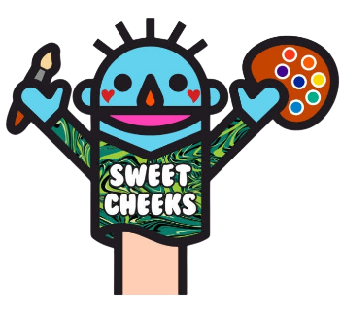
Sweet Cheeks Mobile
Catherine Light, owner www.SweetCheeksMobile.com 472 Kings Rd., Schenectady, NY 12304 / 518-605-3668
SERVICE AGREEMENT

SERVICE AGREEMENT
Please complete, sign and mail agreement promptly. Receipt of deposit and signed service agreement will hold your date and time. Deposit may be in the form of credit card, business check, money order, or certified check, payable to Catherine Light, owner. Payment may also be made on our website…
NAME ____________________________________________________________________________________
GUEST OF HONOR (if applicable) ____________________________________ Age of Child ________________
AGE RANGE OF YOUR GUESTS _________________________________________________________________
ADDRESS __________________________________________________________________________________
HOME PHONE _____________________________MOBILE ________________ Additional ________________
E-MAIL ADDRESS ____________________________________________________________________________
TIME AND DATE OF EVENT ___________________________________________________________________
TYPE OF EVENT _________________________________Details ______________________________________
IF THIS IS A THEMED EVENT, PLEASE SPECIFY _____________________________________________________
APPROXIMATE ATTENDANCE EXPECTED _________________________________________________________
LOCATION IF PARTY IF DIFFERENT FROM ABOVE __________________________________________________
__________________________________________________________________________________________
MAY WE PUT OUT A TIP JAR? Yes ___ No____ May we put out business cards? Yes___ No____
MAY WE POST PHOTOS ON SOCIAL MEDIA and/or use for promotional purposes? _______________________
(If appreciated, we will happily help promote your event)
HOW DID YOU HEAR ABOUT SWEET CHEEKS MOBILE? ______________________________________________
__________________________________________________________________________________________
Hourly Rate: $100 hourly (two hour minimum) and/or negotiated personally with owner
Travel Rate: Free within 30 miles of my home studio located at 472 Kings Rd., Schenectady, NY and $50 (or $1 per mile) for areas beyond 30 miles from Schenectady, New York 12304 (Whichever is Less)
PAYMENT TERMS: Both booking fee and travel fee must be paid in full before event. Otherwise, another event would likely be scheduled on the day of your event. Half of total plus mileage to reserve date) Balance due day of event, BEFORE services are rendered).
Commercial and Non-Profit Organizations: $100 Deposit is due within five days of submitting this SERVICE AGREEMENT. The balance is payable upon completion of the event. If you need an invoice, to whom should it be addressed? ___________________________________________________________________________
CANCELLATION TERMS: Should you need to reschedule your event, please do so within three days of the event, and we will do everything possible to meet your needs. Cancellation within ten days of your scheduled event forfeits the full deposit. Should the artist get sick, every effort will be made to find a replacement.

SET-UP FOR BOTH INDOOR AND OUTDOOR EVENTS
This may vary, however it is essential that we bring the correct gear we may need. Please specify below.
TABLE (minimum of 4 feet) Provided by host _____ Provided by Sweet Cheeks Mobile ____
4 CHAIRS: Provided by host _____ Provided by Sweet Cheeks Mobile ____
10 x10 ft. Tent ($30 Additional Fee) Provided by host _____ Provided by Sweet Cheeks _____
WEATHER CONDITIONS
For the comfort and safety of your guests, the client agrees to provide an area with protection from extreme temperatures, sun, rain, snow and excessive wind, on a level surface. Client is responsible for providing an alternate indoor location in the event of inclement weather. In case of rain, client agrees to pay the full amount contracted once the painter has arrived, even if it is raining.
Alternate Indoor Location: ____________________________________________________
EXTREME working conditions: The artist has the right to cease painting and leave without refunding money if there are extreme adverse working conditions and the client has not failed to remedy the situation. These situations include but are not limited to: destructive, violent or estremely inappropriate behavior of child, pet or adult, illegal activities, or extreme weather conditions, such as violent wind, lightning or otherwise dangerous weather conditions.

INSURANCE: Sweet Cheeks Mobile carries $3,000,000 General Liability Insurance by Great American Alliance Insurance, # BW1470536 (Bodyworks Insurance) for your peace of mind.

I have read, understand and accept the above liability statement and the conditions of this agreement. I accept the details of this agreement as accurate.
CLIENT SIGNATURE _____________________________ DATE: _____________________
Sweet Cheeks Mobile uses professional cosmetic grade paints and products, including biodegradable glitters. All the products used can be removed safely from the skin with either makeup wipes and/or SOAP -First - and water on a cloth. Parents/clients are encouraged to remove paint at night, or if the paint causes itching (very rare) to remove immediately.
___________ PLEASE NOTE ____________

Client has the right to refuse service if child/adult is exhibiting illness or inappropriate behavior that may jeopardize the ability to safely complete a service. To speed the line along, children and adults are to choose their design prior to sitting. Clean faces, with hair pinned back, if possible are appreciated. We will provide wipes and headbands to assist these efforts.
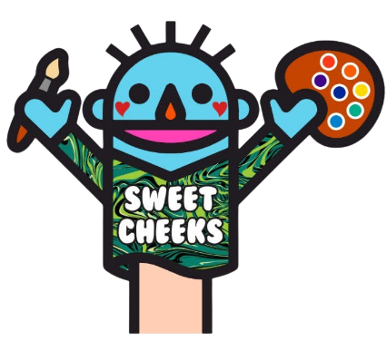

www.sweetcheeksmobile.com
We Look Forward To Working Together To Provide An Imaginative Service To Your Guests, appreciate your recommendations and promise to exchange photos of our work together.

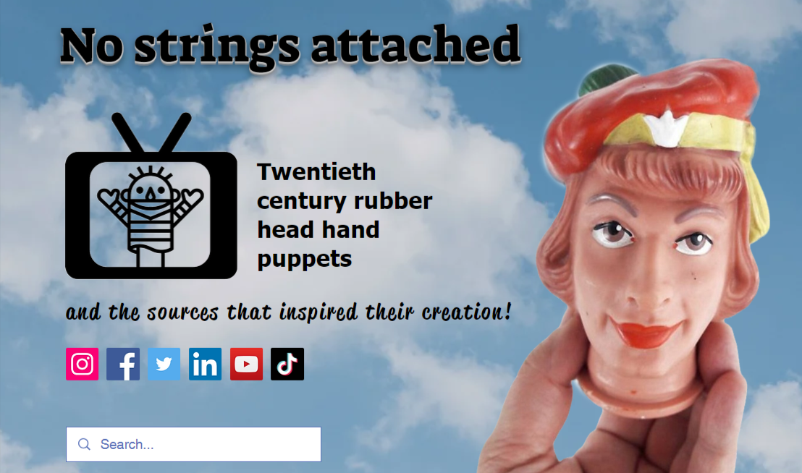
Coming This Fall

“No Strings Attached Mobile”
A Unique Portable Puppet Museum Housed In A Vintage Camper Accompanied by Face Painting Services by Sweet Cheeks!

Catherine Light, Owner – 472 Kings Road, Schenectady, NY 12304 (518-605-3668)

