Session 3: Name Your Business
One of the most important decisions for your business is choosing your company’s name. Your name will be used in all of your marketing, advertising, customer recruitment, etc.
☐ Decide on the name for your business
  - Come up with three names you are comfortable running your business as
  - It is important to lookup the availability of the web domain for your chosen names. A name may be available to register for your business in BC, but the domain may not be. Check whether the domain is in use or not here
  - Search the BC name choice database to ensure no BC businesses have the same or similar names
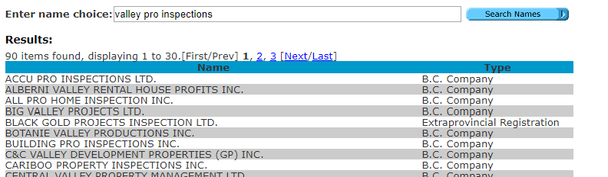
Example: Valley Pro Inspections Name Search
  - Check the Canadian Trademarks Database for trade name or trademark matches
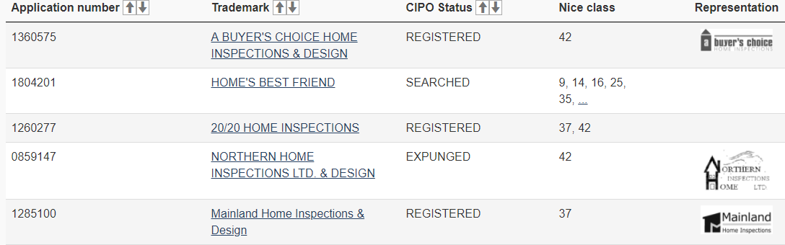
Example: "Home Inspections" trademark search
  - If incorporating, also search the Canada-wide name database to see if your chosen name is available. It costs $13.80 per lookup report and is usually required by the provincial/federal government before name approval. Pre-search is free (bottom of page) and will provide you with some information before buying a report. As seen below, “Valley Pro Inspections” already has trademarks on it in Ontario, so it may be advisable to choose a different name
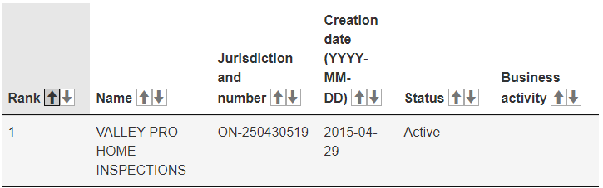
Example: "Valley Pro Inspections" corporation search
  - Keep in mind that you should have at least three choices to avoid processing delays, additional resubmission fees, and disappointment
☐ Submit your name request for approval
  - Businesses must have their name approved and reserved for use before you can register the business
  - Once you have decided on your three name choices, review the name approval request instructions
    - The name must contain a distinctive element (E.g. Valley Pro), a descriptive element (E.g. Home Inspections), and a corporate designation if incorporating (E.g. Ltd. or Inc.)
    - Well-known names will not be allowed (E.g. Exxon, Coke, etc.)
    - Special characters (I.e. %,*, or @) should be avoided
    - Absolutely no suggestion to a government or crown connection (E.g. Royal Albert Home Inspections)
    - If you name is approved, it will be reserved for 56 days
  - Submit your name request for approval. This can be submitted online, by mail, or in person at Service BC location. It is a $30 fee for a name request and an additional $1.50 if submitting online
    - Use Name Request Online and pay by credit card
    - Download and complete a paper form to mail
    - Find a Service BC location to drop off your form
☐ Register the domain name for your business
  - Once the name approval process is complete, you should immediately register the domain (I.e. “CompanyName”.ca, “CompanyName”.com, etc.)
  - Prices for domain registration will vary, but are generally quite inexpensive, and will usually renew monthly or yearly
  - This will be the website address you advertise to customers. Make sure the website domain is easy to type and not too long; it does not have to be the exact name as your business (E.g. Comox Valley Pro Inspections and www.ComoxPro.ca)
  - List of domain registrars:
    - https://ca.godaddy.com
    - https://register.ca
    - https://www.sibername.com
    - https://www.weebly.com/ca
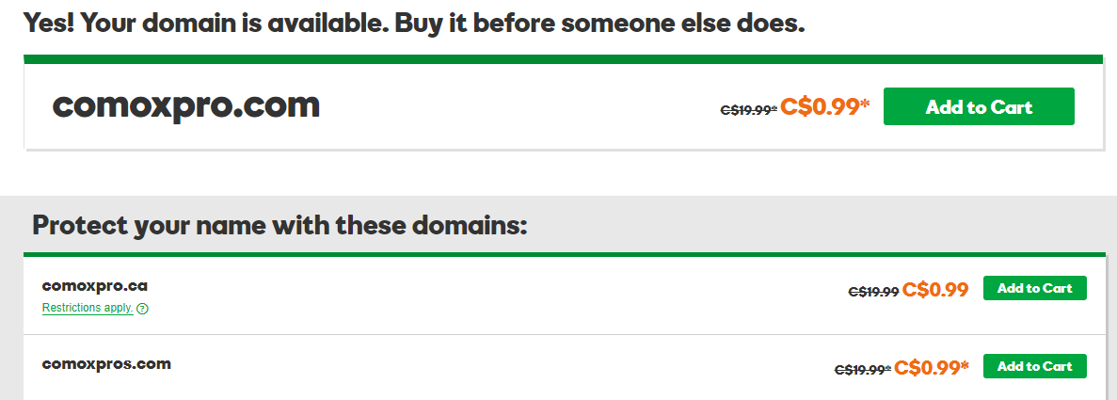
Example: "ComoxPro" domain search
  - Once you purchase a domain, you become the legal owner of that website. A domain will be needed prior to creating a website (See Marketing section for website building)
  - It should be noted that you can purchase multiple domains. This has a few uses: (1) it limits anyone else trying copy or steal your name, (2) it can redirect users to your main website (E.g. using a “.ca” domain can be confused with “.com”. If a customer types “ComoxPro.com” but your website is “.ca”, the customer will see the website as non-existent. However, owning both domains allows customers to type either “.com” or “.ca” to reach your website)

NOTES ____________________________________________________________________________________________________________________________________________________________________________________________________________________________________________________________________________________________________________________________________________________________________________________________________________________________________________________________________________________________________________________________________________________________________________________________
____________________________________________________________________________________________________________________________________________________________________________________________________________________________________________________________________________________________________________________________________________________________________________________________________________________________________________________________________________________________________________________________________________________________________________________________________________________________________________________________________________________________________

