Dawson County Fair
dcfair@dawsoncountymontan.com
dawsonfair.com
Lindsay Tennant Fair Manager
406-478-2657 (cell)
406-377-6781 (office)

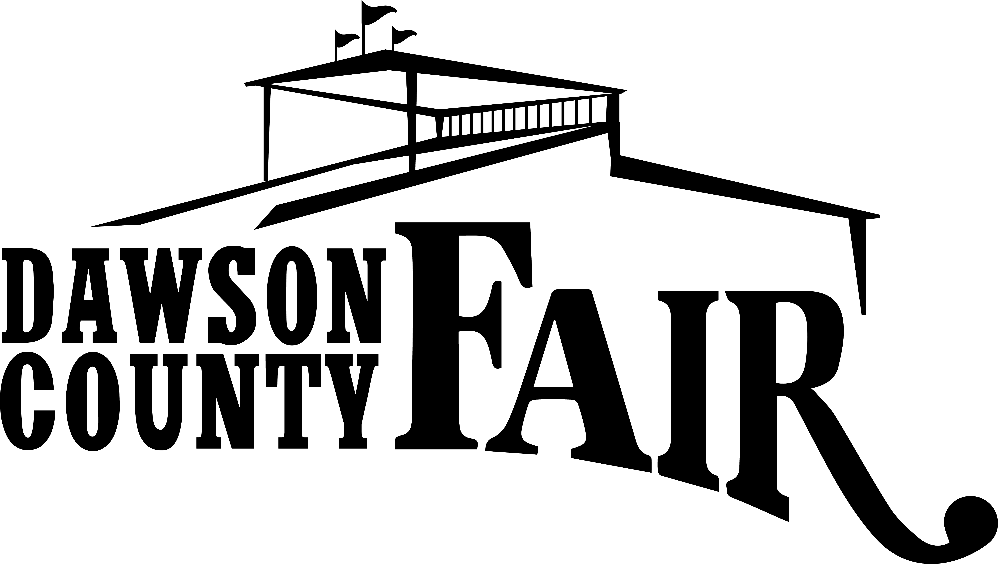
207 W Bell
Glendive MT 59330
406-377-6781

2023 Grandstands & Outdoor Commercial Vendor Application
July 27th- July 29th, 2023

PLEASE PRINT/TYPE:

Business/ Company Name:______________________________________

Contact Name:________________________________________________

Address:_____________________________________________________

City:_________________________ State:_________ Zip Code:_________

Phone:____________________ Fax:______________

Email: ______________________________________________________

*Were you a concessionaire at the 2022 Dawson County Fair?*
Yes______ No______

COMMERCIAL VENDOR RATES
Indicate number of Spaces Needed

INSIDE SPACE (UNDER THE GRANDSTANDS)
(11.5’ x 13’) AND (11.5’ x 18’) $125 ________

DESCRIBE YOUR BOOTH OPERATION BY MARKING ALL THAT APPLY
___Demonstration Booth ___Selling over the counter ___Information Samples
___Outdoor Vendor Trailer ___Outdoor Tent ___Outdoor Table(s) Only
Please List Products And / Or Services

____________________________________________________________________________________________________________________________________________________________________________________________________________________________________________________________________________

- Dawson County Fair reserves the right to require removal of objects that are hazardous, offensive or otherwise detrimental to the fairs image.
- No Exclusivity Will Be Granted. We do make an effort not to duplicate items. Our goal is for our vendors to be successful.
- Spaces are assigned with the consideration of the vendor in mind, as well as availability to power. We reserve the right to place vendors at our discretion.
- Is your product tied to a MLM or Franchise? _____ Yes ______ No
- Do you have insurance? _____ If yes, please send a copy of rider with this application.

PAYMENT AND COMPLETED APPLICATION MUST BE RECEIVED BEFORE Monday, July 10, 2023.

The Applicant understands this is an application for exhibit/vendor space at the Dawson County Fair. Should the application be denied due to lack of space or undesirable content of sales, the payment will be promptly refunded.

Applicants Signature:_________________________________________________

Date: ___________________________

Return this Application to: OFFICE USE ONLY:
Dawson County Fair
207 West Bell St. DATE PAYMENT RECEIVED_____________
Glendive, MT 59330
Or email: dcfair@dawsoncountymontana.com

