Dawson County Fair
dcfair@dawsonmt.gov
dawsonfair.com
Lindsay Tennant Fair Manager
406-478-2657 (cell)
406-377-6781 (office)

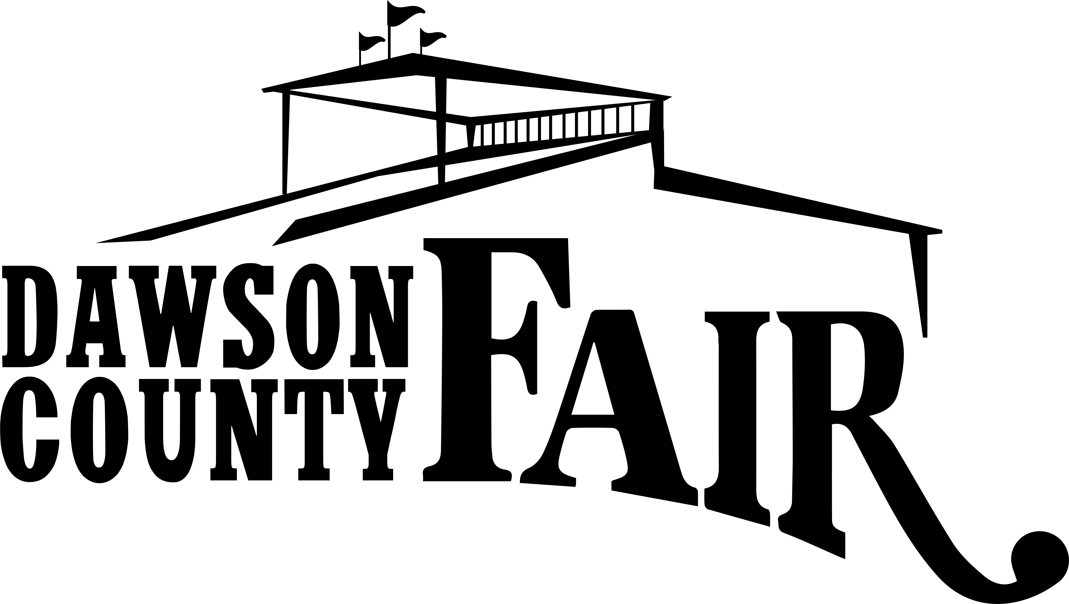
207 W Bell
Glendive MT 59330
406-377-6781

Name of Exhibitor: ________________________________

Age: ___________________________________________

Address: __________________________________________

Email: ___________________________________________

Phone Number: ____________________________________

Please fill out the following information for anything you wish to enter in open class. Incomplete forms will result in items not being entered. Additional sheet is attached.
Department: Open Class | Division | Description if needed

Registration can be completed online through EZ-fair.com. Otherwise please return this completed form to the extension office in the courthouse by the deadline July 13, 2026.

Department: Open Class | Division | Description if needed

