www.dawsonfair.com


DAWSON COUNTY FAIR
207 WEST BELL STREET
GLENDIVE, MT 59330
406-377-6781
dcfair@dawsonmt.gov

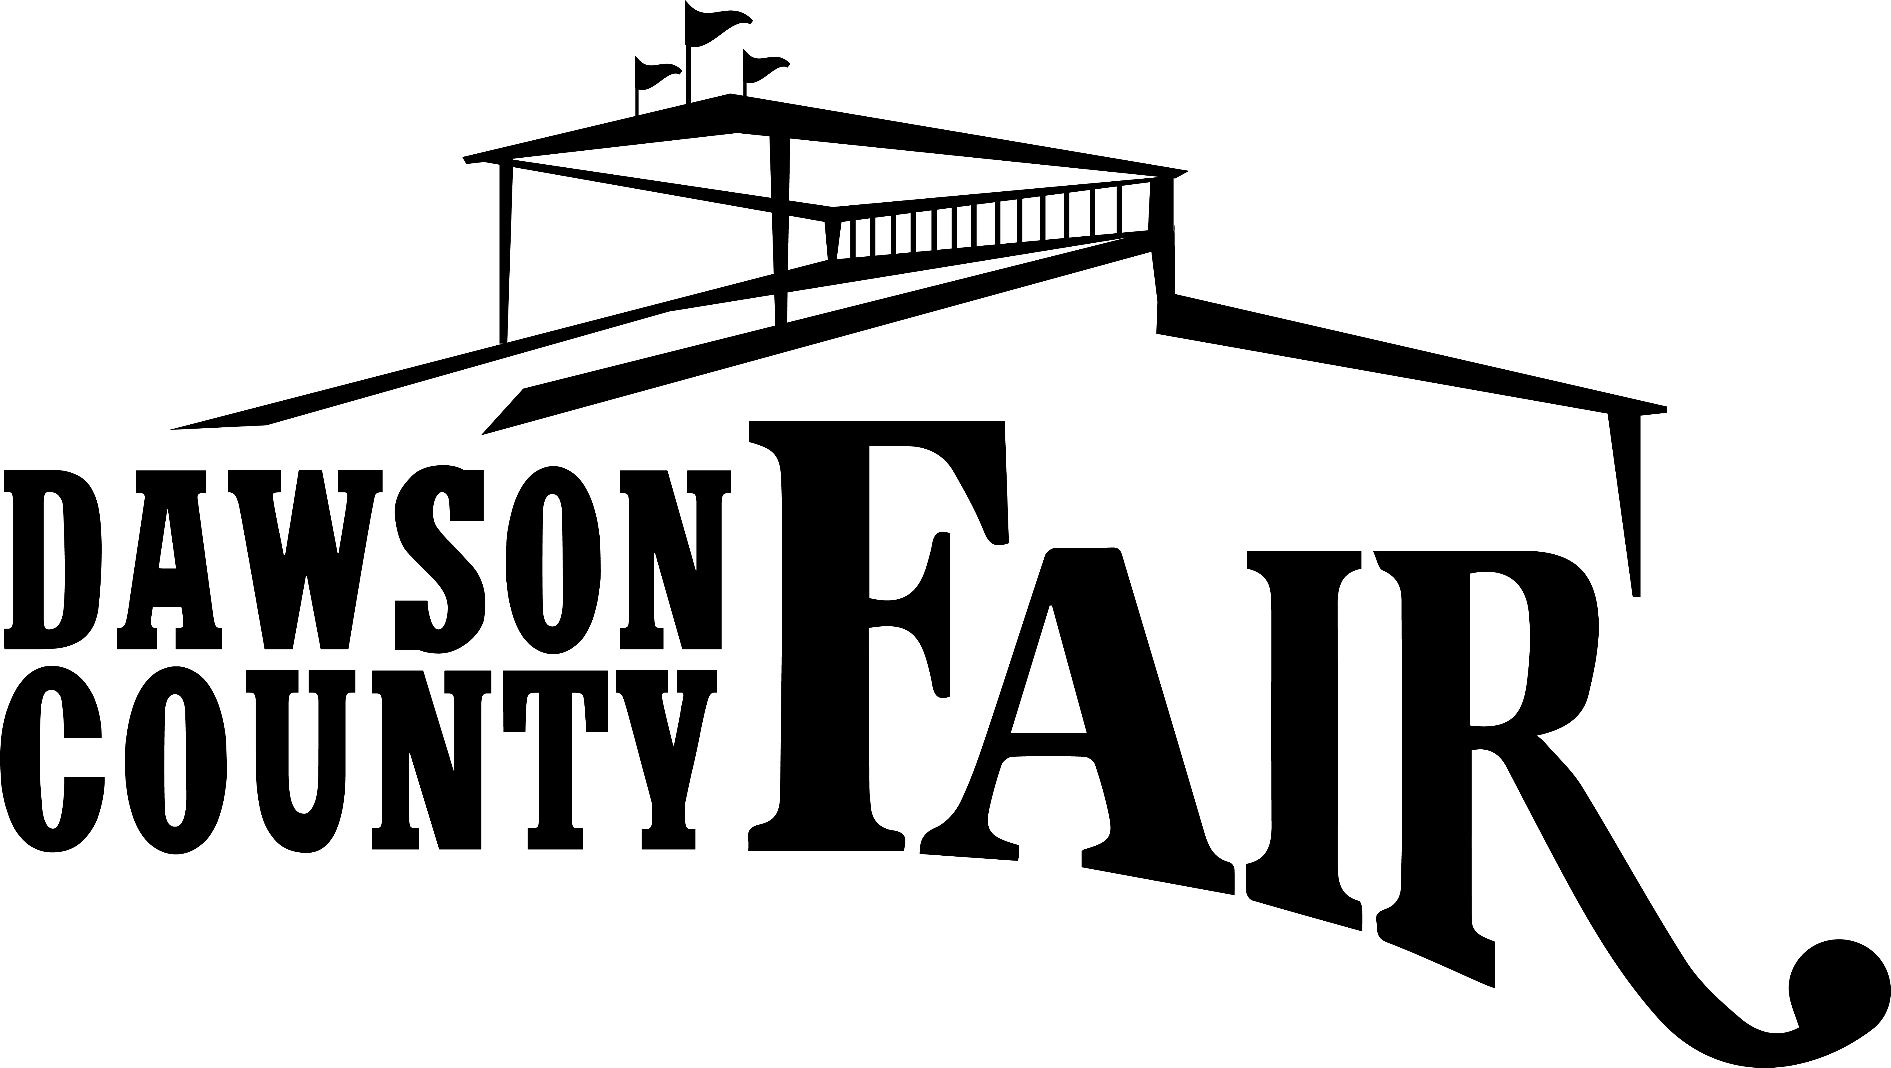

2026 Mobile Concessions Application
July 23 – July 25, 2025

PLEASE PRINT/TYPE:

Business / Company Name:
______________________________________________________________________________________
Contact Name:
______________________________________________________________________________________
Address: ______________________________________________________________
City: _____________________________ St: ______ Zip: _________
Phone: ________________________________________ Fax: _____________________
Email: __________________________________________________

**Were you a concessionaire at the 2025 Dawson County Fair? ____yes ____no
MOBILE CONCESSIONS VENDOR RATES
Indicate number of Spaces Needed

Mobile Concession Rates $175 ________
Additional Space or Trailer/Freezer $25 ________
Additional Space w/Electricity $50 ________

Total ________

***Your site will be assigned by the Fair Board based on availability, size, power needs, and arrival time. ***

My concessions are vended from:
A vendor Trailer/Van _____ (dimensions) ______ x ______ (Left, Right and End Vend) ________
Other: (Tent, Open) ______ (dimensions) ______ x ______ (Left, Right and End Vend) ________
Additional Supply Truck or Trailer ______ (dimensions) ______ x ______

IMPORTANT: Electrical Requirements
220 Service _______ 110 Service _______ # Plugins _______ Amps Requires

PLEASE LIST PRODUCTS AND/OR SERVICES

- No Exclusivity shall be granted. We do make an effort not to duplicate items; our goal is for our vendors to be successful.
- Spaces are assigned with the consideration of the vendor in mind, as well as the availability to power. We reserve the right to place vendors at our discretion.
- Proper licenses, permits, must be obtained prior to opening of fair.
- REQUIRED: COPY OF FOOD LICENSE
__________________________________________________________________________
__________________________________________________________________________
__________________________________________________________________________
__________________________________________________________________________
__________________________________________________________________________

- Is your product tied to MLM or a Franchise? ____________
- If yes, Please Name _______________________________________________________
- Do you have insurance? _____________ Please send copy

***Were you an Exhibitor/Vendor at the 2025 Dawson County Fair? _______

PAYMENT AND COMPLETED APPLICATION MUST BE RECEIVED BEFORE WEDNESDAY, July 8, 2026.
The Applicant understands this is an application for exhibit/vendor space at the Dawson County Fair. Should the application be denied due to lack of space or undesirable content of sales, the payment will be promptly refunded.

Applicant’s Signature ________________________________________________

Date: _________________________

OFFICE USE ONLY:
Accepted: Space/Area Reserved _______________________________
Reason Denied
_______________________________
Date Notified:___________________
PAID:__________________________
RETURN THIS APPLICATION
WITH PAYMENT TO:
Dawson County Fair
207 West Bell
Glendive, MT 59330
For more info call: (406) 377-6781
Or e-mail: DCFair@dawsonmt.gov

