The #1 Secret To Licensing Your Cannabis Business – Miss This & You Could Kiss It All GoodBye

What's the secret to licensing your cannabis business and staying compliant? It's keeping an organized and accurate Operations Manual. An Operations Manual is going to be a summary of the daily operations of your business. This includes quality control, security protocols, financial documentation and of course control of inventory.
With the recent changes in California, requiring applicants to seek licensure to run their cannabis business, there has been a crucial need for operations manuals. A lot of business owners have found this to be tedious, boring and perhaps a bit invasive to their business.

What Is The Purpose of an Operations Manual?
The purpose of such manual is that it lets you demonstrate to the city officials and county officials that you are a professional, law abiding, responsible business operator. This is the key criteria the city looks for, when issuing these licenses. In addition, an operations manual can help you gain deep insight into the flow of your business and help you avoid common problems.

Your operations manual should not be confused with a business plan, a list of goals for your business, resume, or a pitch to investors. Therefore, you should not include your mission statement, desired returns, or financial projections. Remember who your target audience is. It is the city and the county, and the only thing they care about is whether or not you fit their compliance criteria.

What Should Your Operations Manual Include?

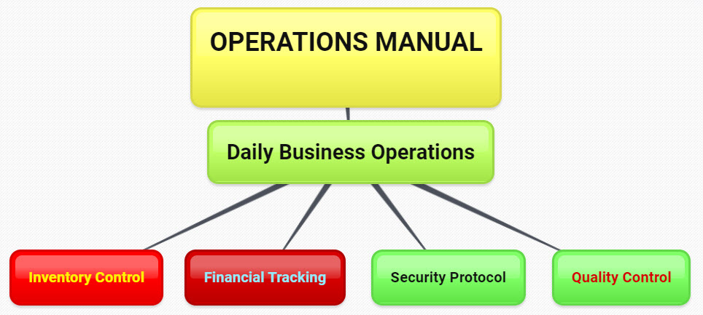
You want to cover what your business will actually do throughout the course of every day in enough detail to satisfy the regulator. Include your method of tracking the cannabis inventory. Document all financial transactions. Next, you'll want to detail how you will ensure your employees' safety, as well as the quality control of inventory.
How will you comply with state and local laws and what is your plan in case there is an emergency? What will be your plans in case inventory goes missing? If you're a grower, you'll want to pay special attention as to how you explain your methods of ensuring plant and cultivation safety. You'll want to be sure to include information on the types of soil, fertilizers, pesticides and odor containment you use.

Above and beyond all of this, the most crucial element of your Operations Manual is detailed procedures to track your financial matters and your inventory. In this section of the Operations Manual, you'll want to detail how your employees and you track every single gram of cannabis and every financial transaction down to the penny. Here, you'll detail your storing of the inventory, procedures involving packaging, and your computer tracking methods. You'll also need to detail how you will track when your cannabis product has to be discarded. What will be your procedures for cash drops and bookkeeping?

Security is another necessary element of the Operations Manual. In this section, you'll detail how you will comply with local laws on the security of your business. This will include lighting, background checks, cameras, and business alarm systems. Remember, this includes safe storage, prepping for transportation of product, and the admission of visitors to the business.

Also, remember that you must be detailed. You cannot make general, vague statements like, “We are going to track all of the product inventory and make sure that there will be nothing missing.” Instead, you'll describe the kind of computer software you're using to track your inventory. You'll detail what kind of information you'll enter into the computer for every item. You'll detail who is responsible for making sure that information is accurately checked and how you're going to resolve any discrepancies that may arise.

Why Is An Operations Manual So Crucial ?

You still may be thinking that an operations manual is boring and tedious. A lot of cannabis business owners aren't very comfortable writing down mundane tasks, such as tracking inventory. But keep in mind that you're dealing with regulators who don't have much knowledge or familiarity with the cannabis industry. Imagine that you're having to educate yourself about these regulations and evaluate all of the applicants that compete for licenses. The officials you're dealing with have a lot of responsibility on their shoulders, and often, misunderstandings can arise from these complex situations.
These misunderstandings can translate into shut downs, lost business, lost revenue, and lost dreams. A simple, but effective operations manual would help to avoid all of that. In addition, a well-written and clear operations manual would not only be interesting, important and new for the regulator, but also help him/her be a better regulator. He or she would understand that your business is going to be compliant, safe, efficiently-run and a great value to the community. When you look at it this way, an operations manual is a doorway to new opportunity.

