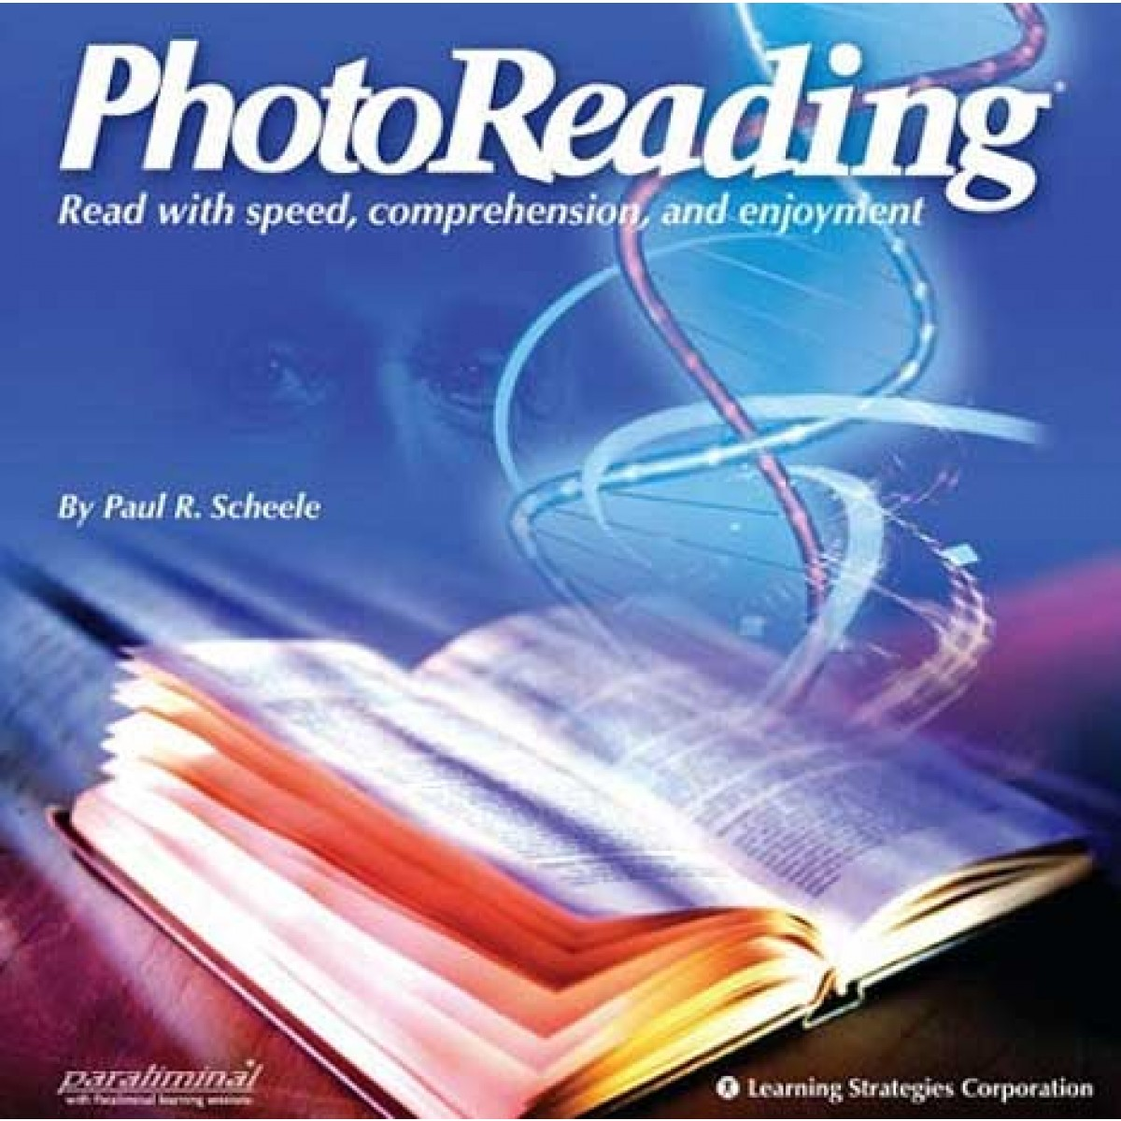
Dear Reader,
On a beautiful late summer evening, twenty years ago, two young men graduated from the same college. They were both very much alike.
Both had excelled academically, both were personable, and both were filled with dreams for the future.
Recently, these two returned to their college for their 25th reunion.
They were still very much alike.
Both were happily married. Both had three kids. And both, it turned out, had gone to work for the same Midwestern manufacturing company after graduation, and were still there to this day.
But there was a difference. One of the men was manager of a small department of that company. The other was its president.
What Made The Difference?
Have you ever wondered, as I have, what makes this kind of difference in people's lives? It isn't always a native intelligence or talent or dedication. It isn't that one person wants success and the other doesn't.
The difference lies in what each person knows and how he or she makes use of that knowledge.
And that is why I am writing to you and to people like you about The Photoreading Whole Mind System. The whole purpose of The Photoreading Whole Mind System is to empower you to have more choices in life.
You see, Photoreading is unique method of absorbing entire books in just minutes. It is much more powerful than speed reading. Photoreading enables you to learn and absorb reading material 3 times faster than you can now.
Knowledge Is Power
Photoreading is easy for anyone to learn and apply. Hundreds of thousands of people just like you have done it. And from every profession and walk of life. Best of all, it doesn't require a huge time commitment to learn.
Easily use PhotoReading on all types of material, including books, magazines, trade journals, technical reports, web pages, email, electronic files, novels and newspapers.
Whether you're reading for pleasure, business or school you can use PhotoReading on all subjects. It doesn't matter if you're learning about gardening, geophysics, business management, calculus, computer information systems, or finances, this system can boost your learning curve tremendously.
Photoreading is a super-fast learning technology that quickly activates your natural ability to effortlessly absorb information three times faster. Whether you want increased productivity, more clarity, focus, sharper thinking, better grades, increased income or more enjoyment out of life, PhotoReading can help you get there.
If you've never heard of PhotoReading before, you cannot imagine how useful it is.
A $19.99 Book Of Knowledge & Empowerment
Put our statements to the proof by ordering your trial version of PhotoReading today for just $19.99. You get to keep the book for 45 days. If after 45 days, you don't feel PhotoReading has opened up new doors of success for you, then simply return the book for a full no-questions-asked refund.
Simply fill out the enclosed order card and mail it in the postage-paid envelope provided. And here's The PhotoReading Whole Mind System Guarantee: Should PhotoReading not measure up to your expectations, you may cancel this trial at any time and receive a full refund.
If you feel as we do that this is fair and reasonable proposition, then you will want to find out without delay if The Photoreading Whole Mind System can do for you what it is doing for hundreds of thousands of others. So please mail the enclosd order card now, and we will start serving you immediately.
About those two college classmates, I mention at the beginning of this letter. They graduated from college together and together got started in the business world. So what made their lives in business different?
Knowledge. Useful knowlege. And its application.
An Investment In Success
I cannot promise you that success will be instantly yours if you start using The PhotoReading Whole Mind System. But I can guarantee that you will find The Photoreading Whole Mind System always interesting, reliable and always useful.
Sincerely Yours,
Photoreading.com
(Please Note: Sample mock-up idea for a sales letter on a book called “Photoreading” by Paul Scheele. Similar to speed reading and memory boosting. Audience: Middle class income families who are looking to either return to college or start college. Also upper income individuals who read financial publications)

