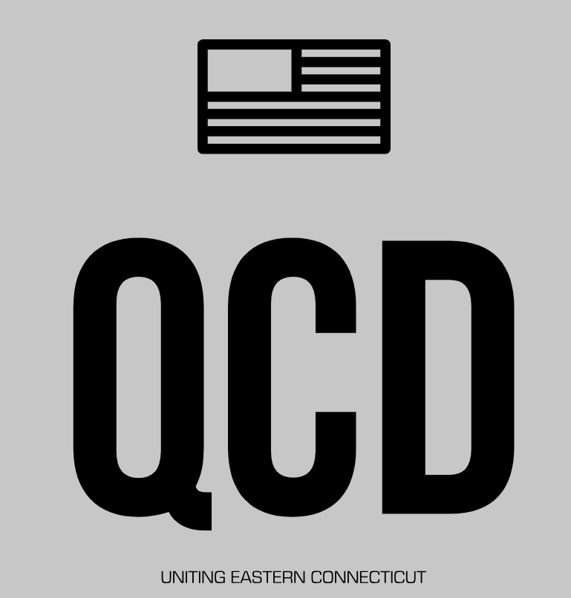

Links from Political Intelligence 2021

Zoning Reform: An opportunity for the Quiet Corner
Zoning Atlas: www.desegregatect.org/atlas
Rearch: www.desegregatect.org/data.

