# Water Quality Analysis – Chemistry (Phosphorus, Nitrogen, E-Coli, Coliforms) – 2008 through 2019

Prepared by Ian Mackenzie

## Total Coliforms

Analysis of 5 sets of data 2008, 2011, 2014, 2017 and 2019 are provided below.

Two sets of charts are presented. The first set uses four ‘lake zones’ I created simply to allow grouping and averaging for comparison purposes. Definition of which of the 21 sites are in what zone is Appendix 1.

### Zone Averages

Total Coliform counts don’t lend themselves to averages as the numbers vary wildly. However it is useful to see the trends over time in the 4 zones.

The overall trendlines are pretty stable for Coliforms. South end locations indicate a steep increase but the locations sampled have increased from 3 in 2008, 5 in 2011 and 2014 up to 6 in 2017 and 2019. Two of the locations added in ’17 and ’19, namely inflow to the lake past 4 Loons and deep in Smith Marina bay have added to the counts… so they may have been just as high in 2008 and 2011 but weren’t measured.

Because of this, I don’t believe we have an increasing trend in Total Coliforms.

### Lake Zone Averages by Year. Note: Scale varies CONSIDERABLY

Overall, I don’t see an increasing trend, with the caveat on the South End noted in the previous section.

Averages aren’t the best way to show this data, APPENDIX 2 shows the Raw Coliforms data which you can see varies a LOT.

**SO WHAT? For Context, the recommended maximum for swimming is 200 cfu/100ml, and the maximum we’ve ever measured was 144 cfu/100ml in 2017 at one location - the inflow to the lake past 4 Loons.**

### Detailed Coliform Results by Lake Zone – measured in cfu/100ml

# E-Coli

We’ve Sampled for E-Coli each time and in all years there have been very few sites having measurable amounts.

The standard for Recreational Waters in Ontario as of 2018 is <400 E-Coli count / 100 ml. **We have been well below that in all locations, all years.**

# Total Phosphorus

The Results for Total Phosphorus appear well within the Target levels of between 0.02 and 0.5 mg/litre, however the trend is increasing.

It is interesting that Otter Lake saw a spike of Phosphorus in the 2019 sample; before that the Otter Lake samples had been consistent with findings in the rest of the lake.

On the following page you’ll find a chart for each year showing the averages by zone.

The following charts show individual phosphorus readings by location, by year. Grouped into ‘Zones’ simply to get them all displayed.

Otter Lake had the highest reading in the history of our sampling in 2019. This sample was taken in the middle of the main channel.

# Nitrogen (Total Kjeldhal Nitrogen mg/l)

Nitrogen levels have been quite stable over the years of testing, however in all cases well above the target for freshwater lakes of 0.02 mg/l.

Nitrogen samples in 2019: 16 samples were 0.3 mg/l and 5 samples were 0.4 mg/l; very little variance and a small Standard Deviation.

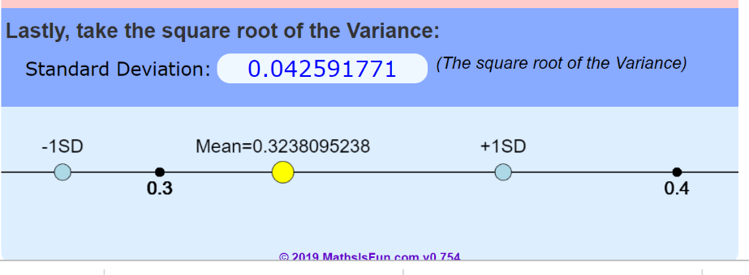

# Appendix 1

Definition of lake ‘Zones’ used in presentation of averages and to show groups of data of a reasonable size. C = ‘Central’, S = South End, N = North End and O = Otter Lake:

|  |  |  |
| --- | --- | --- |
| 1 | entrance west bay | C |
| 2 | off squaw point | C |
| 3 | lighthouse | S |
| 4 | 4 loons | S |
| 5 | near 800/810 (Dan Derumaux) | C |
| 6 | end of Mackie bay | N |
| 7 | off Elmardon, North end of island | C |
| 8 | end of Regina bay | N |
| 9 | 210, 213, 920, entry to Squally Bay from South | N |
| 10 | north end narrows, lake side of narrows | N |
| 11 | north end - dam | N |
| 12 | Otter Lk - potholes | O |
| 13 | Otter - main channel centre left on entry to Otter | O |
| 14 | Otter narrows, Weslemkoon side | O |
| 15 | near Wes. Marina, across channel NE of marina | S |
| 16 | end of West bay near 627, 626 | C |
| 17 | inflow past 4 loons as far as a boat can go | S |
| 18 | Seymour creek past 395 up the creek | S |
| 19 | near 519, 520, 521, Smith’s Marina bay | S |
| 20 | north end NW passg | N |
| 21 | Squally bay | N |

# APPENDIX 2 – Raw Data from Caducean Labs

