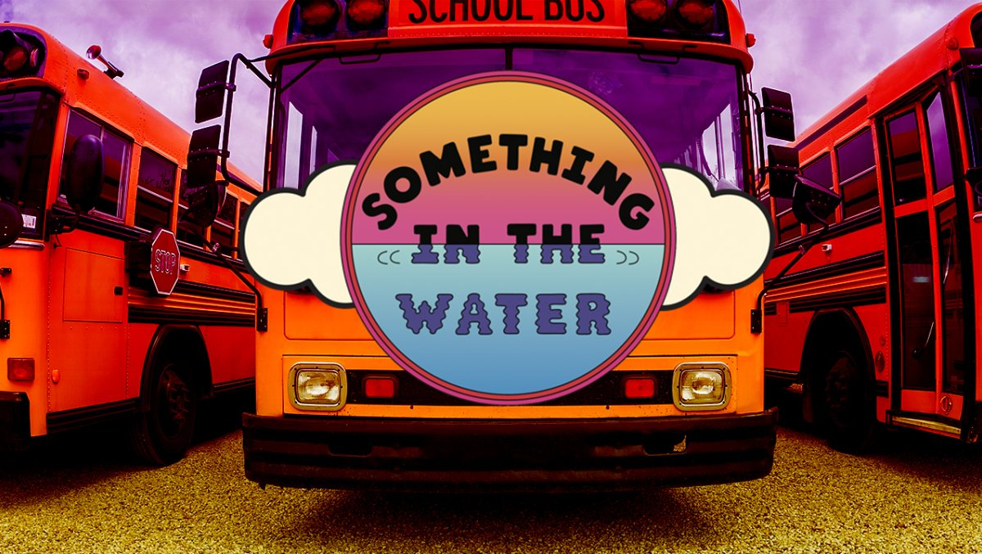
HAPPY DAYCARE
- OFFERING 3 DAY
- FESTIVAL CAMP
- 6WEEKS TO 12 YEARS OLD
- FRIDAY 1-12 MIDNIGHT
- SAT.11AM-11PM
- SUN. 11AM-11PM

1 DAY$75
3DAY PACKAGE $200
INCLUDE :MEALS,ACTIVITIES
MOVIES,AND GIFT BAGS

2548 VIRGINA BEACH BLVD. 23452 :757-962-7050….TEXT NOW: 757-309-2288 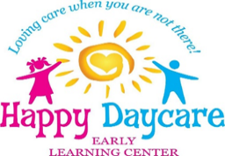
EARLY LEARNING CENTER 2

