
City of Stamford

Risk Management Department

Office Ergonomics & Work Station Set-up Program
There are four areas that a computer user interfaces with: the monitor, the keyboard and mouse, the chair, and the lighting of the environment. Setting up the interfaces with these ergonomic guidelines as well as maintaining a good posture will enhance your comfort and efficiency as well as prevent repetitive stress injuries.

The Monitor
- Position the monitor to minimize glare by placing it at a right angle to light sources or windows
- Place the monitor as far away from you as possible while maintaining the ability to read without consciously focusing. Keep a minimum distance of 20 inches.
- Place the center of the screen at a 15 degree down angle from your eyes with your neck only slightly bent holding your head perpendicular to the floor.
- Align the monitor and the keyboard / mouse
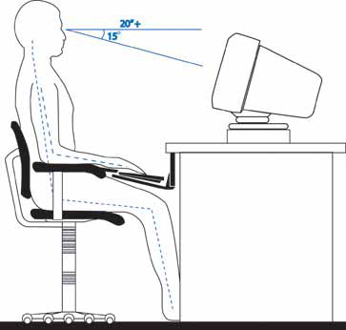

Lighting
- The office should be moderately bright (20-50 foot candles or equal to a nice day where sunglasses aren’t needed).
- Do not use task lighting for computer work.
- A mix of incandescent and fluorescent lights reduces flicker and provides good light color.

The Keyboard & Mouse
- Position the keyboard / mouse slightly below the elbow and at a negative angle to allow the wrists to remain straight
- Do NOT use a wrist rest while actively typing. It’s meant to rest on. Hold your hands and arms off of any supports while typing.
- Place the mouse next to and at the same level as the keyboard.
- Do NOT use the keyboard supports to raise the back up. Do NOT tilt the keyboard tray so that the back of the keyboard is higher than the front. Though design and a lot of prevailing information say you should tilt the keyboard to a positive angle like this, it is wrong. A negative angle that allows the wrists to stay in their natural position is proper. A positive angle is an injury waiting to happen.
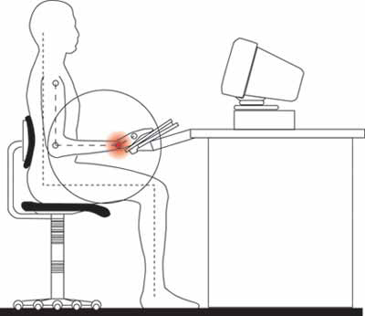

The Chair
- Use arm rests.
- Place the lumbar support slightly below the waist line.
- Adjust the height of the chair so your feet can rest completely on the floor.
- Allow 1-3 inches between the edge of the seat and the back of your knees.
- Use a high back chair that supports your shoulder blades if at all possible

Posture
- Position your hips so that they are slightly higher than your knees while your feet are flat on the floor.
- Don’t keep your feet flat on the floor. Move them around often. Use a foot rest if you have one, but only part of the time. Do NOT cross your ankles.
- Lean back slightly. Leaning the trunk back to somewhere between 100-130 degrees from parallel to the floor will open up the hips and ease pressure on the pelvis. I like 104 degrees myself. Make sure your chair back will support your shoulders at this angle while still providing good lumbar support.
- Hold your head slightly up so that it is roughly perpendicular to the floor.
- Let your upper arms hang naturally from your shoulders.
- Let your lower arms rest on the arm rests of your chair either parallel or slightly below, to the floor.
- Keep your wrists straight.
- Take frequent breaks. 10 minutes for every hour of work and 30 second micro-breaks every 10 minutes is a good schedule.
- Stretch during those breaks.
- Change your position frequently. Move your feet, lift your arms, adjust your hips, and just make sure to subtly alter your posture continuously throughout the work day.
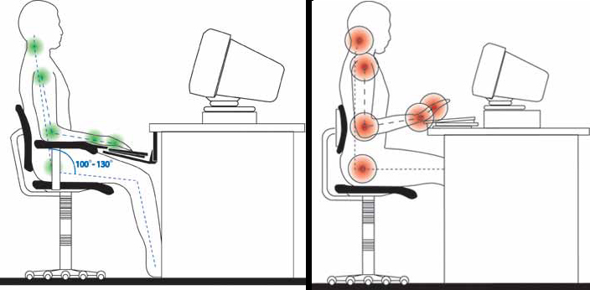

OFFICE WORKERS

DO'S AND DON'TS FOR SAFE WORK PRACTICES
DO…..
- Report any concerns to your supervisor early.
- Maintain neutral postures for different body parts as much as possible
- While performing deskwork or computer work, be conscious of your sitting posture, your chair position, and how your arms are aligned with your work surface.
- Keep your wrists in neutral and avoid excessive deviations when typing or performing manual tasks.
- Position the keyboard at or below elbow height.
- Adjust your chair as your tasks change through the day. Use forward tilt for desk work; recline while on the telephone conversing, maintain lumbar support.
- Use a headset for telephone work.
- Keep your work area well organized. Avoid cluttering the area around your legs and feet.
- Keep commonly used items within near reach (14" to 24") and arranged in a half circle around you.
- Monitor how hard you are gripping your hand tools or keying and lighten up.
- Float your hands and wrists over the keyboard. Lift from the elbow to reach the mouse.
- Move from the shoulders when typing and using the mouse to activate large muscle groups.
- Change your position often (every 30 minutes to hourly).
- Alternate your work tasks throughout your workday.
- Make adjustments to your workstation to suit your position.
- Recognize early signs of muscle fatigue, and stretch or change your task.
- Rest your eye muscles.
- Maintain good flexibility and strength. Stretch while at work and walk around the department. Stretch every 30 minutes for up to 5 minutes during a repetitive task. (see stretching below)
- Ice an area if it is aching during or after work for at least 20 minutes/day.

DON’T…..
- Sit in the same position for more than 60 minutes.
- Wait until you feel pain or discomfort to stop an activity.
- Sit with slouched posture over your desk.
- Do a repetitive task all at once.
- Pinch or grip excessively or pound your keyboard.
- Cradle the phone between your neck and shoulder.
- Keep your body, arms or legs in an awkward position for any length of time.
- Poise in extension or lean your hands or forearms on a hard edge, surface or wrist rest.
- Hold onto your mouse or leave your hands at the keyboard if you are not actively using the tools.
- Over reach with your fingers, arms or back.

If you have questions about your workstation ask your supervisor or your safety officer immediately. You can request a work station evaluation by filling out the top part of the following form and fax it to 977-5072.

COMPUTER WORKSTATION EVALUATION REQUEST

Employee’s Name: ___________________________ Request Date: __________________

Department: _____________________________ Location: ________________________

Supervisor: ______________________________ Computer Usage: ______ Hours a Day

Primary Concern(s):__________________________________________________________ ____________________________________________________________________________________________________________________________________________________________________________________________________________________________________

To be filled out by Evaluator

Evaluator: _______________________________ Date: _____________________________

Yes |  | No | WORKSURFACE
 |  |  | Work surface height allows adequate leg room underneath (4 to 6 inches).
Work surface height allows shoulders to be relaxed and elbows at angle of
approximately 90ø.
 |  |  | Work surface edges are rounded or padded. User does not rest arms on sharp edges.
Recommendation:
Yes |  | No | CHAIR
 |  |  | Chair height allows feet to be flat on the floor or resting on a footrest.
 |  |  | Chair height allows knees to be level with the hips, or thighs parallel to the floor.
 |  |  | Angle between back and thighs is between 90ø and 110ø and is comfortable for the sitter.
 |  |  | Chair back provides lumbar support to maintain proper "S" curvature of the back.
Recommendations:
Yes |  | No | MONITOR
 |  |  | Monitor is about arm's length away from the user, and is tilted slightly back.
 |  |  | The top line of the screen is approximately eye level, user's head sits squarely on the shoulders. For users with bifocals, monitor height is adjusted to allow comfortable viewing.
 |  |  | There is only minimal glare reflected from the screen.
Recommendations:
Yes | No |  | WORK PRACTICES
 |  |  | Wrists are straight (from the side to side perspective) during typing. User does not "plant and pivot" wrists, but moves his/her arms to reach function keys and numeric keypad.
 |  |  | User maintains a neutral wrist posture (from the up and down perspective). In a neutral wrist posture, the wrists are bent very slightly upward.
 |  |  | The user does not strain his or her neck to look at documents.
 |  |  | User uses a light touch on the keyboard and does not pound the keys.
 |  |  | User takes breaks from the keyboard & mouse. Performs stretches. Breaks include regular 15 minute breaks in the morning and afternoon, and frequent "eye breaks" where the user closes eyes for a few seconds, then looks away to a distant point for a few seconds.
Recommendations:
MISCELLANEOUS |  |  | Look around the work area for other occurrences of excessive repetition, excessive force, or awkward postures. Look for awkward reaches required to answer the phone or retrieve frequently used books, etc.
Recommendations:

