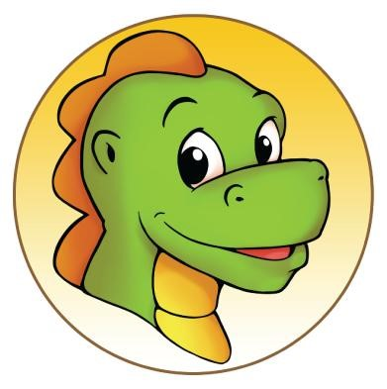
Blazing Bouncers LLC – 1306 FM 1585 Lubbock, Tx 79423
806-412-0014
In Consideration of being allowed to enter the play area and/or participate in any party and/or program at Blazing Bouncers LLC, the undersigned, on his or her behalf, and on the behalf of the participant(s) identified below, acknowledges, appreciates and agrees to the following conditions: I represent that I am the parent or legal guardian of the participant(s) named below, or I have obtained permission from the parent/legal guardian of the participant(s) named below to execute this agreement on their behalf. I agree that the participant(s) named below and I shall comply with all stated and customary terms, posted safety signs, rules, and verbal instructions as conditions for participation in any party and/or program at Blazing Bouncers. Any child that has a medical condition that could inhibit them from playing/jumping should not participate in any open jumps, fundraisers, activities, parties and or use of play area. In addition, if I observe any hazard during our participation, I will bring it to the attention of the nearest Blazing Bouncer employee or official immediately; I am aware that there are inherent risks associated with participation in Blazing Bouncers open jumps, fundraisers, activities, parties, and/or use of the play area and inflatable equipment and I, on behalf of myself and the participant(s) named below, knowingly and freely assume all such risk, both known and unknown, including those that may arise out of the negligence of other participants; and, I, for myself and the participant(s) named below, and our respective heirs, assigns, administrators, personal representatives, and next of kin, hereby release and hold harmless, Blazing Bouncers LLC, their affiliates, officers, members, agents, employees, other participants, and sponsoring agencies from and against any and all claims, injuries, liabilities or damages arising out of or related to our participation in any and all Blazing Bouncer open jumps, fundraisers, activities, parties, the use of the play area and/or inflatable equipment.
Participant(s)
Name: ________________________________________DOB:___________________________________
Name: ________________________________________DOB:___________________________________
Name: ________________________________________DOB:___________________________________
Name: ________________________________________DOB:___________________________________
Name: ________________________________________DOB:___________________________________
The undersigned Parent/guardian acknowledges
Parent Guardian/Signature: ________________________________________________________ Date: __________________
Address: __________________________City:___________________Zip Code___________________
Print Name:____________________________________________________________________
Email Address:_________________________________________________________________
Emergency Contact phone #_______________________________________________________

