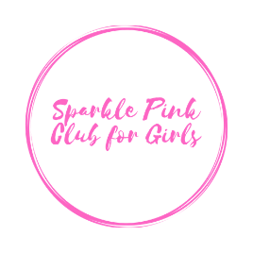Sparkle Pink Club Chapter Leader
Dos & Don’ts

In order to provide a safe, uniform and orderly club experience for every Sparkle Pink Club member and leader around the world we must keep the following guidelines in place.

- Do make a point to meet parents and caregivers. Connecting is community.
- Do make time to elevate and recognize the accomplishments of the girls in Pink Club.
- Do not use the club, its members or parent list to share business opportunities, invite to events or otherwise gain from their membership.
- Do not hold the meetings longer than scheduled.
- Do not reprimand or discipline volunteers and helps members.
- Do not discipline or reprimand girls. If there is a behavior issue share it with the parent or caregiver.
- Do not collect, keep and use Chapter Dues for personal gain, expenses or reimbursements.
- Do not compete with Sparkle Pink Clubs by forming your own exact or similar group. (See Non-Compete Agreement)
- Do not allow Sparkle Pink Club members to sleep over, take up residence or otherwise habitate with you or any member of your family.
- Do enjoy every moment you invest in the lives of girls.

