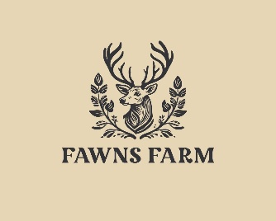

01 Health and safety procedures
01.18 Animals and pets
- Staff will be aware of any allergies or issues individual people may have with any animals/creatures.
- A risk assessment is conducted and considers any hygiene and safety risks posed by the animal or creature.
- Suitable housing for the animals is provided and is regularly cleaned and maintained.
- The correct food is offered at the right times and staff are knowledgeable of the pet’s welfare and dietary needs.
- Arrangements are made for weekend and holiday care for the animal/creature.
- There is appropriate pet health care insurance or other contingencies agreed and put in place to pay for veterinary care and the animal is registered with a local vet.
- All vaccinations and health measures such as de-worming are up to date.
- People are taught correct handling of the animals and are always supervised.
- Everyone washes their hands after handling the animals and do not have contact with animal faeces, or soiled bedding.
- Members of staff wear single use vinyl/latex free gloves when cleaning/handling soiled bedding..
Animals brought in by visitors
- The owner of the animal/creature maintains responsibility for it on the farm.
- The owner carries out a risk assessment detailing how the animal/creature is to be handled and how any safety or hygiene issues will be addressed.
- No dogs on the Government’s Banned Dogs list are to be brought on site at any time. All other dogs brought on site by parents during arrivals and departure times must be on a lead and under control. The manager reserves the right to request that a dog is not brought on site, if the animal appears to be out of control, or likely to pose a risk.
https://www.gov.uk/control-dog-public/banned-dogs

