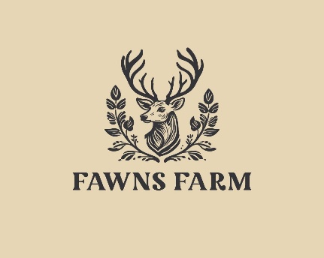

07 Record keeping policy

Aim
We have record keeping systems in place for the safe and efficient management of the farm and to meet the needs of the visitors; that meet legal requirements for the storing and sharing of information within the framework of the GDPR and the Human Rights Act.

Objectives
- Records are kept in farm files
- Confidentiality is maintained by secure storage of files in a locked cabinet with access restricted to those who need to know.

Records
The following information and documentation are also held:
- name, address and contact details of the provider and all staff employed on the premises
- records of risk assessments
- record of complaints
Legal references
General Data Protection Regulation 2018
Freedom of Information Act 2000
Human Rights Act 1998
Data Protection Act 2018

