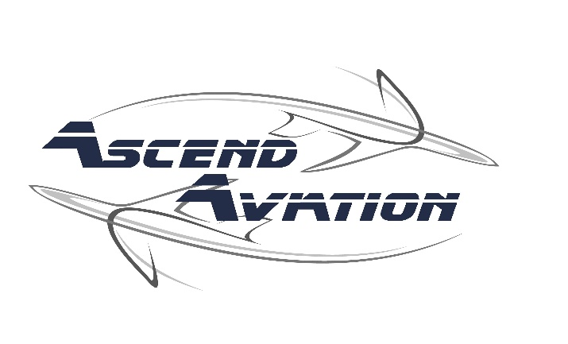

General Waiver and Release Form

Renter & Parent/ Guardian Release Form
The undersigned herby acknowledges and assumes all risk associated with and releases Ascend Aviation LLC, instructors, independent instructors, pilots, and employees from all liability related to or arising out of the flight training at Ascend Aviation LLC. The undersigned warrants that they are in good health and are suffering from no debilitating ailment that would affect his or her performance in any manner or jeopardize the health or safety of other persons at Ascend Aviation LLC or in an aircraft.
Without limiting the foregoing, the undersigned warrants that he or she is not affected by high blood pressure, a heart condition, asthma, arthritis, diabetes, or any other health impairment. The undersigned acknowledges that he or she may be subject to exposure to some hazardous aviation materials such as oil, aviation gasoline, and may come in contact with high performance engine parts, as well as traveling and performing maneuvers at high speeds and altitudes. These examples are meant to establish that the undersigned has knowledge of some of the many risks being assumed.
In signing hereunder, the undersigned assumes the entire risk for any injury, liability or other consequences involved with flight training. In doing so, the undersigned hereby waives and releases Ascend Aviation LLC and its officers, instructors, independent instructors and employees from any and all liability arising out of the training, known and unknown, including without limitation medical expenses, legal fees, loss of services, etc., and shall indemnify and hold all of them harmless from and against any such item.

IN WITNESS THEREOF, the undersigned has executed this assumption of risk.

Release this the day of ____________________________ (date)

Signature of Participant____________________ Printed Name________________________

Date______________________

If the participant is under 18 years of age, a parent/guardian must also sign:
I am the legal parent/guardian of _______________. I have read and understood the complete Waiver and General Release form and hereby give permission to my child (ren)/ward(s) to participate in the flight training provided by Ascend Aviation LLC.

Signature of Parent/Guardian _______________________Printed Name__________________

Date ________________

Ascend Aviation LLC Rep. Witness Signature___________________________ Date____________

