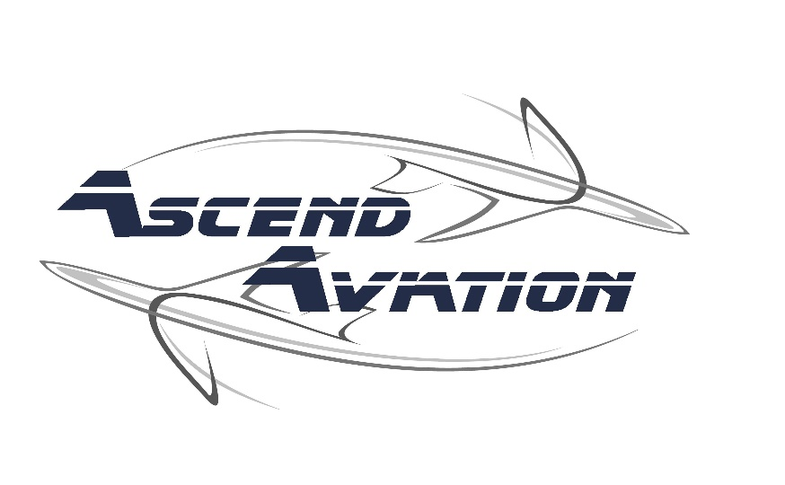

Rental Agreement

(Terms of aircraft use and rental agreement)

THIS AGREEMENT is entered into between Ascend Aviation LLC and

Name: _________________________________________

Address: ____________________________________________

City: _____________________________ State: __________ ZIP: ________________

Renter and shall be effective as of ____________________________ (date)

Recitals

WHEREAS, Ascend Aviation LLC is engaged in the business of providing services involving aircraft rental and instruction;

WHEREAS, Renter desires to rent Ascend Aviation LLC’s aircraft for the purpose of attaining their pilot certification, additional ratings, or leisure.

NOW THEREFORE, Ascend Aviation LLC and Renter agrees as follows:

Scheduling and Cancellations

- Cancellations

  - Flight instructor time: when cancelling a session with a flight instructor, every effort should be made to do so at least 24 hours in advance. We reserve the right to charge a 50% cancellation fee of the total reserved time whenever a scheduled event is cancelled with less than 24-hour advance notice.
  - Aircraft time: When cancelling reservations for an aircraft, every effort should be made to cancel the reservation at least 24 hours in advance. We reserve the right to charge a 50% cancellation fee of the total reserved time whenever an aircraft reservation is cancelled with less than 24-hour advance notice.

- Unused Reservations: Both the Flight Instructor and Aircraft reservations which go unused will be treated in the same manner as the cancellation policy within a 24-hour notice as described in “a.” and “b.” above.

- Aircraft Rental

  - Basis of Charge: All charges for use of an aircraft will be based on operation time accrued as measured by the aircraft Hobbs meter time, on an overnight rental or reservation for more than 6 hours, the minimum specified below, whichever is greater.
  - Hourly Rates: Aircraft rental rates are for the use of the aircraft on a “WET” basis. Renters are not responsible for fuel costs.
  - Honoring Schedules: Safe operations notwithstanding, all aircraft should be returned in the scheduled time frame. Should circumstances prevent returning at or before the end of the scheduled rental period, every effort should be made to notify Ascend Aviation LLC as soon as possible.
  - Minimum Rental Fees: All multi-day rentals are subject to a 2-hour rental charge for every night the aircraft is away or reserved for more than 8 hours. Charges for multi-day rental will be the GREATER of the actual total time or 2 hours per night away.

- Flight Rules and Restrictions

- Renters accept full and sole responsibility for the operation of the aircraft and for the compliance with all Federal Air Regulations as well as any/all applicable state and local rules and regulations.
- Renters understand that flights outside of the United States of America are strictly prohibited.
- Renter accepts sole responsibility for any and all charges and fees including, but not limited to, fueling and defueling fees, landing fees, ramp fees, servicing charges, incurred or ascribed to the operation of the aircraft, from the time the aircraft is checked out, until it is returned. Fuel will be reimbursed upon return if purchased elsewhere.
- Smoking in or near aircraft is prohibited.
- Operating an aircraft in any manner (starting, taxiing, or flying) while under the influence of alcohol or drugs as defined by FAR’s is prohibited. If such event occurs, renter will no longer be allowed the privilege to rent aircraft at Ascend Aviation LLC.
- Landing at non-public use airports is strictly prohibited.

- Instruction

  - Basis of Charge: Instructors are billed on the basis of time scheduled. Instruction billing time begins at the pre-appointed start time, and ends at the completion of the post lesson debriefing. (For example, a 4-hour lesson ends a half hour early, the client is only billed for 3.5 hours. If the lesson goes 20 minutes over, the student is billed for 4.3 hours.) Hours billed are rounded to the tenth of an hour.
  - Authorized Instructors: Renter understands that Ascend Aviation LLC flight instructors are the ONLY individuals authorized to instruct in an Ascend Aviation LLC aircraft. Giving or receiving flight instruction by or from any flight instructor not specifically authorized by Ascend Aviation LLC is prohibited.

- Documentation

  - Renter is required to maintain the following on file with Ascend Aviation LLC:
    - Pilot Certificate
    - Current FAA Medical Certificate (Or Driver’s License for Sport Pilots)
    - Proof of citizenship for student pilots, either
      - Valid, unexpired passport
      - Sealed copy of birth certificate accompanied by an unexpired government issued photo ID (i.e. State Driver’s License, military ID, other valid government ID)
      - TSA authorization, if required.

- Pilot Requirements

  - Check-out: Renter must demonstrate sound working knowledge of and ability to proficiently and safely operate each aircraft make/model to be rented PRIOR to renting any Ascend Aviation LLC aircraft for solo/non-instructional flight.
  - Currency: Renter must meet the currency requirements of the Federal Aviation Regulations. Additionally, whenever a Renter has not flown a previously authorized make/model with Ascend Aviation LLC within the previous 6 months, a flight checkout is required.
  - Commercial Use: Renter understands that commercial use (as defined by FARS) of any Ascend Aviation LLC aircraft is strictly prohibited.

- Right to Refuse Service

Ascend Aviation LLC has the right to refuse aircraft rental and flight instruction to our customers. Customers demonstrating dangerous decision making skills, display signs of anger management problems, are disrespectful to Ascend Aviation LLC staff, refuse to follow company policies or are involved in an accident or incident may be asked to take their business elsewhere. It is not our intention to refuse service, however, safety and the well-being of our staff and loyal customers is our number one priority.

- Maintenance

  - Discrepancies: Renter will report/record any maintenance discrepancies or inoperative equipment when returning the aircraft. If a renter discovers damage to any part of the aircraft during preflight, he/she must immediately notify Ascend Aviation LLC prior to flight to insure proper documentation.
  - Malfunctions and Repairs: Any repairs away from home airport requires approval from Ascend Aviation LLC’s Management (1-801-638-1612) in advance of any such repairs/maintenance.
  - Renter agrees to notify Ascend Aviation LLC immediately if involved in an accident or incident.
  - Renter agrees not to leave/abandon the aircraft at any airport other than where it was rented. The Renter will be charged pilot expenses plus flight time to return the aircraft if needed.
  - Renter agrees to pay the repair and/or replacement costs for any damages caused solely by the Renter through negligence, failure to comply with the FARs, the AIM, and/or failure to follow proper procedures stipulated in the aircraft pilot operating handbook or flight operations manual. (see insurance policy requirements below).

- Fuel and Oil

  - Fuel: Fuel is included in the hourly rental fees.
  - Engine Oil: Oil is included in the rental. Any oil needed prior to departure can be acquired from the FBO. Should oil be needed right away, a receipt for the purchased oil should be submitted for reimbursement/credit when returning the aircraft.

- Securing the Aircraft

Renter agrees to properly secure the aircraft utilizing available tie downs, ensuring that flight control surfaces are secured as recommended by the manufacturer and by locking all doors and windows. Failure to properly secure the aircraft may lead to damage for which the Renter will be held responsible.

Renter agrees to treat the aircraft properly, keep it clean and return it to the line in a clean condition (cockpit cleaned of debris, etc.…). Renter further agrees to reimburse Ascend Aviation LLC for any and all costs associated with remedying the situation should the aircraft not be returned in proper condition.

- Insurance Policy

Ascend Aviation requires non-owned renters’ insurance.
  - Minimum Bodily Injury coverage is $25,000 per person
  - Minimum Property Damage coverage is $250,000
  - With the Maximum payout of at least $250,000 per incident.
  - Minimum Hull value coverage for the aircraft is $25,000

- Payment

Payment for rental and instructional services are due upon completion of the flight or ground training session.

On past due accounts or returned checks, the Renter shall pay interest from the payment due date to the date of payment at the maximum annual percentage rate allowable by law, together with Ascend Aviation LLC costs of collection (including reasonable attorney’s fees).

A 5% fee will be charged for any refund on an account. Refunds may take up to 30 days to process.

In the event Ascend Aviation LLC needs to engage in the legal service to enforce the terms and conditions set forth herein, the Renter agrees that he/she is responsible for all reasonable attorney fees and costs until the dispute is resolved.

I HAVE READ AND I UNDERSTAND THE ABOVE COVENANTS, RESTRICTIONS, AND REQUIREMNTS OF THE RENTAL AGREEMENT. I ACKNOWLEDGE THAT I HAVE RECEIVED A COPY OF THIS AGREEMENT.

The agreement is entered into upon execution by each party’s duly authorized representative, as set forth below.

Renter’s Signature: ________________________________ Date: __________________

Ascend Aviation LLC Rep. Witness: ______________________ Date: _________________

