**MEDICATIONS AND SUPPLEMENT INSTRUCTIONS**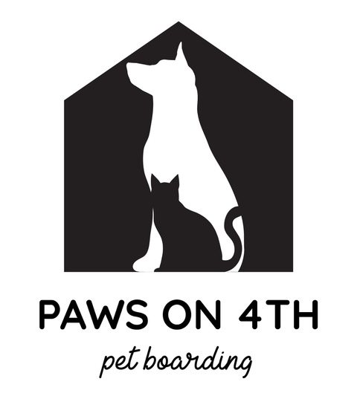

Pet’s Name:____________________________ Prescribing Vet Clinic:____________________  
Owner’s Name:_________________________

**Name of Medication/ Supplement**:_________________________________________________

| Dosage | How Often-Circle all that apply | How to Administer | First date/time of Adminster | Last Date/Time of Administer |
| --- | --- | --- | --- | --- |
|  | Morning  Afternoon  Evening  Other: (please specify) | Pill Pocket  Wet food  Sprinkle on food  Other:________ |  |  |

**Refrigerate? Yes / No Pre-mixed in food by you? Yes / No Do we cut pills? Yes/ No**

**Additional Instructions/Notes:__________________________________________________  
____________________________________________________________________________  
____________________________________________________________________________**

**Name of Medication/ Supplement**:_________________________________________________

| Dosage | How Often-Circle all that apply | How to Administer | First date/time of Adminster | Last Date/Time of Administer |
| --- | --- | --- | --- | --- |
|  | Morning  Afternoon  Evening  Other: (please specify) | Pill Pocket  Wet food  Sprinkle on food  Other:________ |  |  |

**Refrigerate? Yes / No Pre-mixed in food by you? Yes / No Do we cut pills? Yes/ No**

**Additional Instructions/Notes:__________________________________________________  
____________________________________________________________________________  
____________________________________________________________________________**

* **IF PET IS RECEIVING MORE THAN MORE THAN 2 MEDICATIONS PLEASE USE ADDITIONAL FORMS**
* **WE STRIVE TO DISTRIBUTE MEDICATIONS AS IF YOU DO AT HOME AND ON YOUR INSTRUCTIONS PROVIDED & NOT BASED ON THE LABEL OF THE BOTTLE**

***IMPORTANT NOTE: WE DO NOT ACCEPT DIABETIC PETS***

Owner Signature:__________________________ Date:_______________