Pediatric Vaccine Information Sheet for Parents and Caregivers
- Are the covid vaccines FDA approved for children ages 5-11?
No, they are not currently FDA approved. As of 11/6, the Pfizer’s vaccine is in the investigational stages and authorized under EUA (emergency use authorization) for ages 5-11.
https://www.fda.gov/media/153447/download

- What is the death rate for covid in healthy children?
The death rate among health children is unknown, as the CDC has not differentiated between children with severe medical conditions who died with or from covid and healthy children who died from covid.
According to the Fact sheet from American Association of Pediatrics:
“Among states reporting, children were 0.00%-0.26% of all COVID-19 deaths, and 7 states reported zero child deaths
In states reporting, 0.00%-0.03% of all child COVID-19 cases resulted in death”
https://www.aap.org/en/pages/2019-novel-coronavirus-covid-19-infections/children-and-covid-19-state-level-data-report/

- Is the risk of adverse cardiac adverse event higher in children who are naturally infected with covid19 or from the covid19 vaccines?
According to a study from Israel: “boys, 12-17 the risk of being hospitalized for CAE (cardiac adverse event) from the vaccine is 3.7 to 6.1 times higher than their 120-day COVID-19 hospitalization risk as of August 21).
(the risk of hospitalization post vaccination has not been studied in children younger than 12)
https://www.medrxiv.org/content/10.1101/2021.08.30.21262866v1?fbclid=IwAR0pnT5SUnLN8ci16InTc3lbFympbPm4UKLV9R3IKkyd4AKpxzHSz3aj6RQ

According to Pfizer’s FDA EUA for children 5-11
“At the lowest evaluated COVID-19 incidence (corresponding to the June 2021 nadir), the predicted number of vaccine-associated myocarditis cases was greater than the predicted number of COVID-19 hospitalizations prevented for males and for both sexes combined.” However, the FDA concludes, “the overall benefits of the vaccine may still outweigh the risks under this low incidence scenario.” https://www.fda.gov/media/153447/download

- Do vaccines prevent or reduce transmission of the virus?
According to the Pfizer EUA, Covid-19 vaccines can prevent covid19 (disease symptoms) for an unknown duration and data is limited on the effects vaccination has on transmission of sars-cov2 (the infection)
Source: https://www.fda.gov/media/153447/download
“Increases in covid-19 are unrelated to levels of vaccination across 68 countries and 2947 counties in the United States.” https://www.ncbi.nlm.nih.gov/pmc/articles/PMC8481107/
*The CDC only collects data from vaccine breakthrough cases if the person is hospitalized and dies. They consider individuals to be “unvaccinated until 2 weeks after their second dose of 2 dose series or 2 weeks post 1st shot of 1 shot series.* https://www.cdc.gov/mmwr/volumes/70/wr/mm7021e3.htm
- If my child is unvaccinated, will he/she contribute to more variants?
According to a recent study from San Francisco: the vaccinated population are more likely to be infection with mutated variants https://www.medrxiv.org/content/10.1101/2021.08.19.21262139v1?fbclid=IwAR1iA8GpJccD0t-YKFe-4kZESkcqCYhbY2iBtzZv1yNcPMtydHClaYh-Hs4
- What are the long-term effects of covid19 vaccination?
Long term effects are unable to be determined at this time as in Pfizer’s trial for 5-11 year olds with around 1,500 children in the treatment group, 95.1% of corhort 1 was followed for 2 months or less and cohort 2 was monitored for adverse events for 17 days.
https://www.fda.gov/media/153447/download

- Is mRNA new technology?
mRNA technology is not new. It has been studied for decades however the mRNA covid vaccines are the first time mRNA technology has been made widely available to the public.
https://www.cdc.gov/coronavirus/2019-ncov/vaccines/different-vaccines/mRNA.html?s_cid=11347:%2BmRNA%20%2Bvaccine%20%2Btechnology:sem.b:p:RG:GM:gen:PTN:FY21

- If my child has antibodies from natural infection, are they protected from covid 19?
The CDC does not recognize natural immunity as being durable and long-lasting however there have been over 90 studies on natural immunity and the vast majority of the scientific studies and data show that natural immunity is robust, complete and durable.
Source: Compilation of studies on natural immunity https://brownstone.org/articles/natural-immunity-and-covid-19-twenty-nine-scientific-studies-to-share-with-employers-health-officials-and-politicians/?fbclid=IwAR39tMTBJOvzYDe7XCNYXJdPhNe22RYMxpJ5dw0ivaxCMFzlRYI0hh8F-io

- As of 11/6/2021, more deaths and injuries have been reported from covid vaccines than all vaccines on the CDC schedule combined for the past 20 years. Is this data reliable?
A report to the VAERS (Vaccine Adverse Events Reporting System) does not verify causation. However, VAERS is the CDC’s only capture system for vaccine adverse events and serves as a safety signal. Healthcare workers are mandated by law to report to VAERS and filing a false VAERS report is violation of federal law. As of 11/6/21, the CDC has not conducted a comprehensive investigational review of deaths and injuries reported to VAERS from covid vaccines.

The Harvard Pilgrimage study found that approximately 1% of adverse events are ever reported to VAERS

chrome-extension://efaidnbmnnnibpcajpcglclefindmkaj/viewer.html?pdfurl=https%3A%2F%2Fdigital.ahrq.gov%2Fsites%2Fdefault%2Ffiles%2Fdocs%2Fpublication%2Fr18hs017045-lazarus-final-report-2011.pdf%3Ffbclid%3DIwAR034Qay7th0I0FC3JT_0rS5DgdfyJiQzQ5BGq22iAmG3VqVc6lIHB4wk_c&clen=98501&chunk=true

A recent study at Mass General Brigham found “severe reactions consistent with anaphylaxis occurred at a rate of 2.47 per 10,000 vaccinations.” (This is equivalent to 50 to 120 times more cases than what VAERS and the CDC are reporting.)
https://jamanetwork.com/journals/jama/fullarticle/2777417

- Is the delta variant more of a risk to children than the original covid19 variant (alpha)?

“Our data confirms that COVID-19 in UK school-aged children is usually of short duration and similar symptom burden, whether due to Delta or Alpha.”
https://www.medrxiv.org/content/10.1101/2021.10.06.21264467v1

- Were there reports of fraud in the Pfizer’s trial of children ages 5-11? Does Pfizer have a history of healthcare fraud?
According to the British Medical Journal who spoke to a whistle blower at Pfizer, the organization falsified data in their phase III trial, and fired those who complained about unethical practices to the FDA
https://www.bmj.com/content/375/bmj.n2635
Pfizer has paid one of the largest healthcare fraud settlements in history ($2.3 billion) for fraudulent marketing.
https://www.justice.gov/opa/pr/justice-department-announces-largest-health-care-fraud-settlement-its-history?fbclid=IwAR3kPQ5C1WFWgznDT5w32ieJyZwD0t_KdeMt9E0eIeiDnG6t1F5cwG2ZScw
- Is there safe and effective early treatment for severe symptoms of covid19 in children?
There are several long-term FDA approved medications that have shown promising results in clinical trials for the treatment of covid19 and are successfully used around the country for off label use. However, the FDA has not approved any long-standing FDA approved therapeutics for early treatment of covid19. Approval of FDA approved medication for use in early treatment would void the EUA for vaccinations.

Budesonide is a corticosteroid inhaler that is especially safe for children as young as 2 years old.
The most recent study by Oxford University (randomized control trial) showed a 90% reduction in hospitalization for people with COVIDhttps://www.ox.ac.uk/news/2021-02-09-common-asthma-treatment-reduces-need-hospitalisation-covid-19-patients-study

You can view a compilation of studies on other early treatment options here https://c19early.com/

Additional Resources:
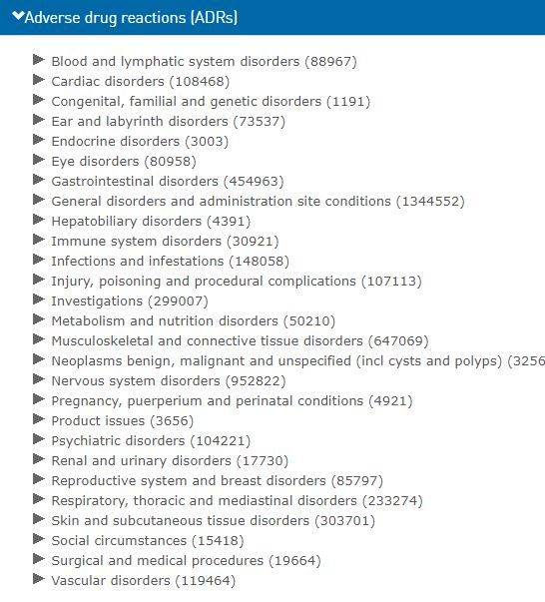
The following is a screen shot of potential adverse reactions from the WHO site http://Vigiaccess.org
1) Type in COVID-19 Vaccine
2) Click on adverse reactions.
The total for adverse reactions submitted is >2.2 million.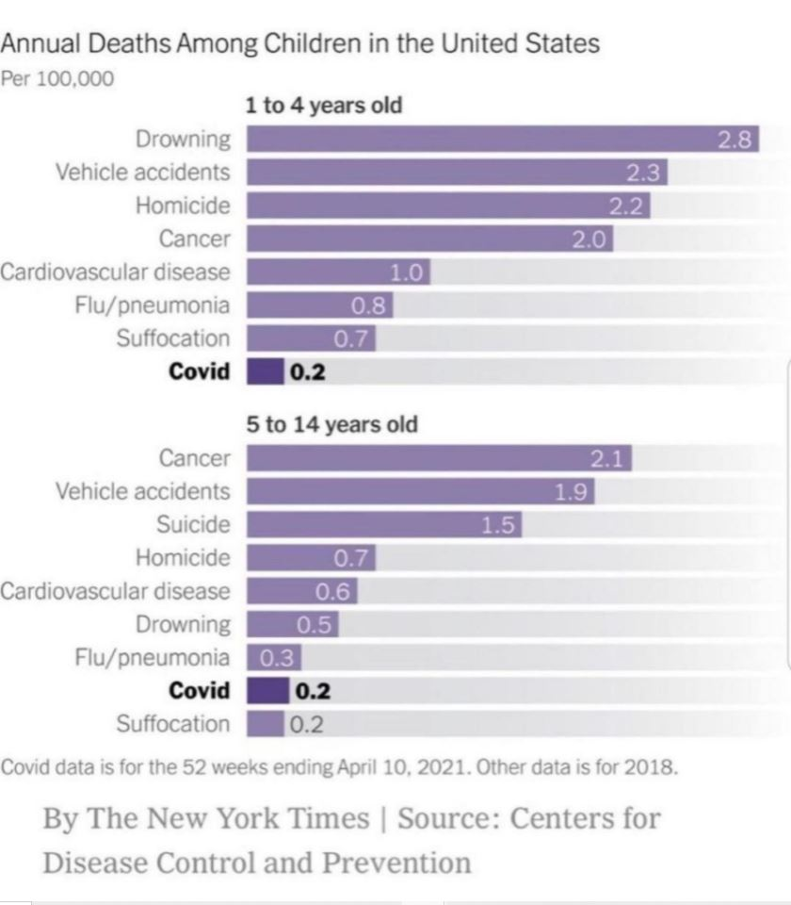

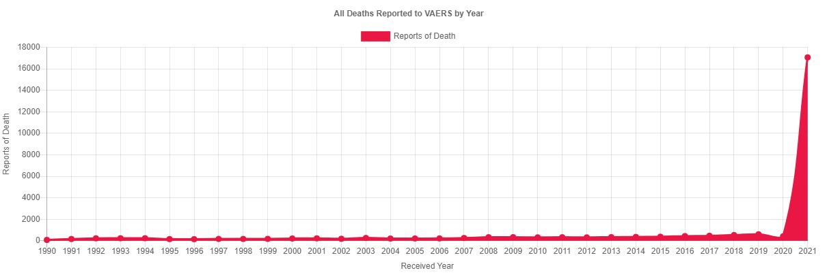
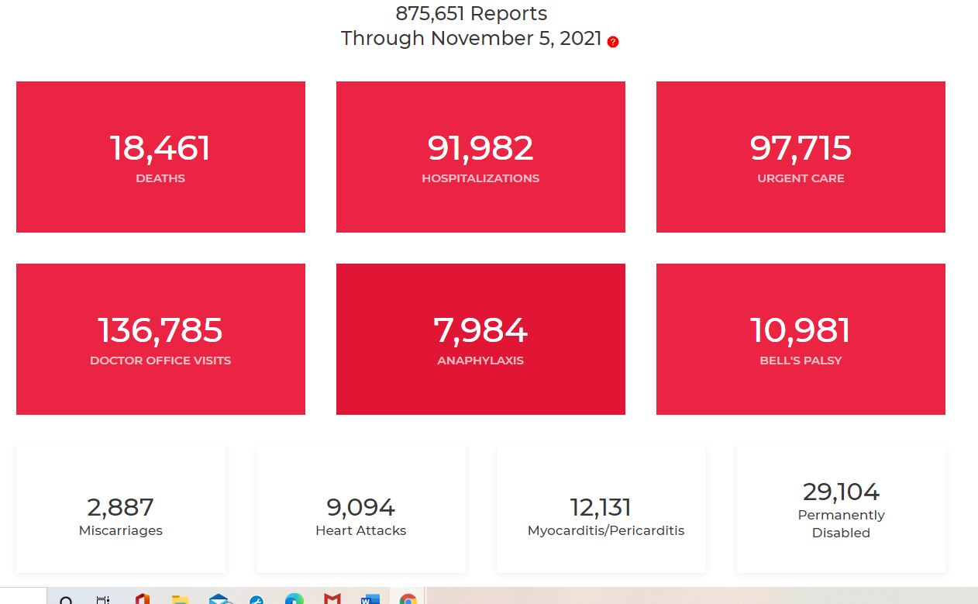
The above 2 screen shots are sources from the CDC’s VAERS database (CDC’s only capture system for injuries and deaths) A report to VAERS is not definitive causation but serves as a safety signal.
Source: www.openvaers.com
https://www.cdc.gov/vaccinesafety/ensuringsafety/monitoring/vaers/index.html

