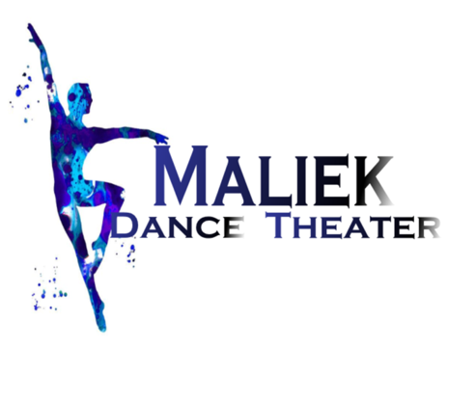
CONSENT TO RELEASE PHOTO/IMAGE/VIDEO
My Childs picture may be published in a Newspaper, Social Media, Flyers, website and Ads.
(Yes No)
Dear Parent/Guardian:
While your child’s name may accompany the photo, no last name or address will be included with your child’s picture when publishing on the Web.
During the school year, your child’s image/photograph/video or work may be included in a classroom or school project that could be used in one of the following ways:
Used as a demonstration project/activity in education workshops/classes/conferences
Used as a sample project/activity. Posted in the school or on Maliek Dance Theater Social Media platform web pages on the Internet. Used in a printed publication such as a newspaper or magazine
Please sign the release form below and return this sheet. Your permission grants us approval to publicize without prior notification and remains in effect until revoked. Thanks!

Release Form

________I/We DO give permission for___________________________________________’s
(Parent Initial) (Child’s full name)
image/photograph/video or work to be used as described above. We are willing to release this into the public domain and understand that no monetary compensation will be given for the use of the materials.
________I/We DO NOT give permission for _____________________________________’s
(Parent Initial) (Child’s full name)
image/photograph or work to be used as described above.

Parent/Guardian Name_________________________________________________________
(Please print clearly)
Parent/Guardian Signature ______________________________________________________

