RISING STARS EQUESTRIAN THERAPY INC.

Who is Rising Stars: A new non-profit company, founded in September 2020 to bring therapeutic riding to the community of Williston and surrounding communities for those with disabilities. Licensed in the state of ND, currently in the process of applying for 501(c)3.

What is Equestrian Therapy? Where a horse is used to help individual with neurological/physical disabilities, movement, or balance problems. There are different types of therapy, the one Rising Stars focuses on is Therapeutic horseback riding, where the rider has a chance to bond with the horse. Benefits with interaction and riding a horse, improves muscle tone, helps rider to relax as well as gain confidence in their ability to ride a horse and learn how to “control” the horse. Each session/encounter is individualized to the ability of the individual with special needs.

**Goal for 2021 for Rising Stars Equestrian Therapy is to raise funds for an indoor arena-so equestrian therapy can be done year-round, tractor to maintain arena and assist with hay bale moving and other needs, sponsorship for riders, and other needs of the organization.**

Indoor Riding Arena- Materials estimated cost $150,000.00

Tractor - $30,000

Rider Sponsorship- $200.00 for 8 sessions

General Fund Donations-for Rising Stars Equestrian Therapy Inc.

Rising Stars Horses

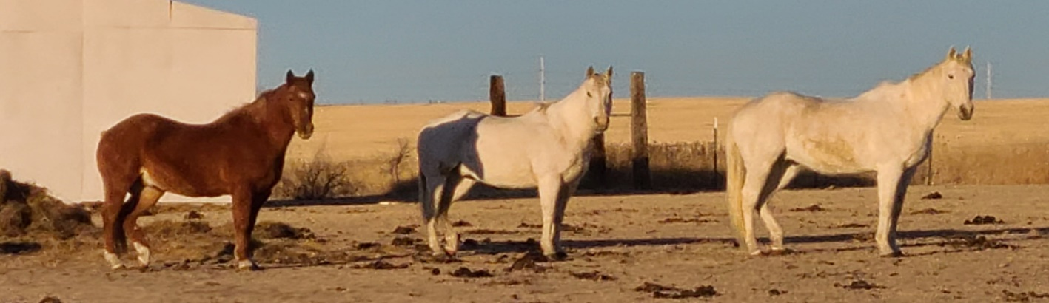

Joey Shorty Tyler

**Donations**: checks made out to Rising Stars Equestrian Therapy Inc., mail to Rising Stars Equestrian Therapy c/o Katrina Mitchell, 5549 123rd Ave. NW, Epping, ND 58843

Any questions please call Katrina at 760-265-1128

Testimonial: “hello I just wanted to share some of my pondering thoughts with you, I sign the girls up for riding the horse with you thinking this would be good for Cadence, which I do think is. It is even better for Karianna, she is not good with socializing and she’s just blossom with the horse she loves going to tell people about it afterwards which is really unusual for her, she would rather be left alone to do her drawing or TV show, and she just loves talking about riding the horse been awesome, thank you” Kimberly Walker