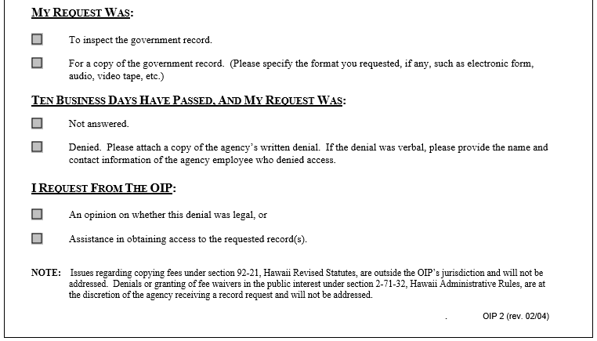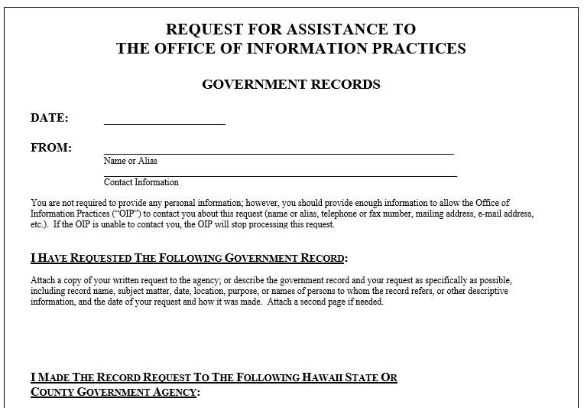

See Attachments.

EnterEmailPhoneAddress (808)



EnterDateHere

EnterYourNameHere



**X**

**X**

You can click on the text boxes with **X**s above and move them to the appropriate box.

In this box, explain what you want the OIP to do.

AttachCopyOfYourOriginalRequest

