Correspondence Master re: RLSMS SY 2019-2020
Semester 1

This document is a chronological list of correspondence generated concerning Tevita Ahomana’s education during Semester 1 of School Year 2019-202 compiled by Vanessa Ott on behalf of Tevita’s mother, Feketi Huahulu. All the correspondence in this document is copied verbatim to the best of Ms. Ott’s ability as of January 2020. The Headers before each email from which the annotated Table of Contents is auto-generated were written by Ms. Ott.

Table of Contents
Table of Contents 1
8/5/19: Students’ 1st Day of School Year 2019-2020 12
1st Semester Calendar SY 2019-20 12
8/9/19 – Huahulu (Ahomana): Signed letter hand-delivered to school authorizing Vanessa Ott’s involvement in all matters concerning her son. 13
8/9/19 – Ott: When is next SCC meeting at Stevenson Middle School? 14
8/16/19 – Ott: When is next SCC meeting at Stevenson Middle School 14
8/17/19 – Ott: (1) What curricula are teachers using? (2) How do we find out what T is learning in each of his classes? (3) Requesting T’s i-Ready data. 14
8/20/19 – Yasuda: Forwarded Ott’s email to Matsushige 15
8/21/19 – Ott: May we please have Mr. Matsushige’s email address? 16
8/22/19 – Ott to Principal: RLSMS is not in compliance with HAR §8-5-8 16
8/22/19 – Open House 21
8/22/19 – Yasuda: Mr. Matsushige has been cc:’ed on this email. 21
8/23/19 – Balatico: I will look into your concern about communication 21
8/23/19 – Ott: Please give me a date when SCC meetings will be posted 22
8/25/19 – Balatico: SCC schedule up by August 30 22
8/26/19 – Ott to Matsushige: We will contact T’s teachers directly to get answers to curriculum and home-to-school communication; please send i-Ready data ASAP. 23
8/26/19 – Ott to Kazarian: May Tevita rename his Google Drive files in order to organize them? 23
8/26/19 – Matsushige: Here are T’s i-Ready Math and Reading results 25
8/26/19 – Ott to Matsushige: You sent another student’s Math results 26
8/26/19 – Matsushige: I will send T’s Math i-Ready results later today 26
8/26/19 – Matsushige: I didn’t bring laptop home; will send i-Ready Math results tomorrow 26
8/27/19 – Matsushige: Here are Math results 27
8/27/19 – Ott to Matsushige, Teachers, and Principal: Tevita’s i-Ready results alarmingly low; he probably should be retested in a nondistracted environment 27
8/28/19 – Matsushige: T will be retested. Soonest dates for IEP meeting are next week. We can discuss school communication/coordination at that meeting. 29
8/28/19 – Ott: We have to work out home to school connection with each teacher in their classrooms, not an IEP. 30
8/28/19 @ 6:33 am – Ott to T’s Teachers, cc: Matsushige: We request a meeting with you in your classroom. 31
8/29/19 after 8:00 pm – Ott: To Tsujioka – I have not received a response yet; when can we meet? 32
8/29/19 after 8:00 pm – Ott: To Yamana – I have not received a response yet; when can we meet? 32
8/29/19 after 8:00 pm – Ott: To Carrigan – I have not received a response yet; when can we meet? 33
8/29/19 after 8:00 pm – Ott: To Asuncion – I have not received a response yet; when can we meet? 33
8/29/19 after 8:00 pm – Ott: To Visaya – I have not received a response yet; when can we meet? 33
8/30/19 – Visaya: I am available next week to meet 34
8/30/19 – Ott: Can we meet next Thursday morning? 34
8/30/19 – Ott: To Kazarian – I have not received a response yet; when can we meet? 34
8/30/19 – Ott: To Wong – I have not received a response yet; when can we meet? 35
8/30/19 – Ott: To Carlton – I have not received a response yet; when can we meet? 35
8/30/19 – Matsushige: I agree we should wait to have IEP meeting until T is retested. I will get back to you about contacting teachers. 36
8/30/19 – Ott to Matsushige and Principal: I don’t understand why we can’t make appointments with the teachers to meet with them. Please be clearer about what’s going on. 36
8/30/19 – Ott checks SCC web site for meeting dates. Apparently Q1 meeting was held earlier in the day. Only 3 more meetings for the rest of the year. 37
8/31/19 – Ott to Kazarian: I have not received a response to my 8/26 email. 38
8/31/19 – Balatico: I will follow up with Mr. Kazarian on Monday re: filenames 38
9/4/19 – Kazarian: Yes, Tevita may rename his Google Drive files 39
9/5/19 – Ott: Please send i-Ready new results 39
9/5/19 – Ott to Balatico: We want to meet with Tevita’s teachers; please arrange this. 40
9/5/19 – Matsushige: I am responsible for coordinating communication. Not all teachers give homework. Tevita writes his homework in is planner. 41
9/5/19 – Ott: You are effectively refusing to let us meet with the teachers. Tevita has not brought home any work from school. We still don’t know the curricula the teachers are using. Tevita cannot remember what his homework entries mean. This is unacceptable. Requesting meeting with Principal, Care Coordinator, and CAS. 42
9/5/19 – Balatico: I will make appointments with teachers. What are your concerns and questions for them? 43
9/5/19 – Ott: Here are our questions. 43
9/10/19 – Balatico: All the teachers can meet with you on September 19th, and we will conduct the IEP meeting at that time. 45
9/10/19 – Ott: We need to discuss Tevita’s curriculum, see his work for each individual class, establish procedures for home-to-school communication, and have time to process the information before having an IEP meeting. Since you won’t schedule a meeting with the CAS, we will request this ourselves. 46
9/11/19 – Ott: Requesting a Meeting with the CAS and Principal to discuss why we’re not being permitted to meet with Tevita’s teachers. 46
9/11/19 – Ott: Our meeting availability. 47
9/11/19 – CAS Dilwith: I am not involved in IEP process. I believe Principal Balatico has a good plan. I encourage you to open lines of communication. 48
9/11/19 – Ott: I said earlier I was not asking CAS to be involved in IEP. I disagree with your assessment of Principal Balatico’s plan. 49
9/11/19 – Balatico: Confirming meeting on September 19, 2019. 50
9/11/19 – Ott: Questions regarding Language Arts Assignment. 50
9/12/19 – Ott: To prep for meeting, please bring Tevita’s classwork and send a list of attendees. 51
9/12/19 – Kazarian: Assignments are “turned in” but there is no due date. Students are working on narratives. 52
9/12/19 – Ott: Update on Tevita’s Independent Reading 53
9/17/19 – Matsushige: Here is a list of attendees. 54
9/19/19 – MEETING @ 2:30 – 3:00 pm 55
9/20/19 – Ott: Please remember to send home Tevita’s work today. 56
9/20/19 – Ott to Office of Curriculum & ID: Requesting a list DOE approved curricula for Grades K-8. 56
9/20/19 – Kazarian: I gave you Tevita’s work to date in yesterday’s meeting. 57
9/20/19 – Matsushige: I put everything that needs to be returned on Monday in a manila envelope. 57
9/21/19 – Ott: Cannot log into Infinite Campus. 58
9/21/19 – Wong: I forwarded your email to Julia Smith. A change of contact info verification form was sent home but hasn’t been returned; sending another. 60
9/21/19 – Ott: I’ve forwarded a copy of your response to Mr. Matsushige and Tevita’s mom. 60
9/24/19 – Ott: I have concerns about current writing assignments. There are some errors. When student hits “Turn In” button, he cannot edit. 61
9/24/19 – Ott: Tevita’s classwork has been scanned and uploaded to his Google Drive. Per our agreements as of 9/19 meeting, here is a workflow document. Please review for accuracy. 63
9/25/19 – Kazarian: Thank you for bringing the errors to my attention. Students do “Turn In” writing assignments at the end of class. 70
9/25/19 – Ott to Curriculum Associates: Parent wants to purchase a Ready Teacher Toolbox license. 70
9/25/19 – Curriulum Associates: We do no t sell directly to parents/consumers. Ready Teacher Toolbox can only be purchased by the school. 71
9/27/19 – Matsushige: Hopefully workflow will help with what Ott and Mom want Tevita to do at home. 72
9/27/19 – Matsushige: Social Studies and Art can’t sent home ongoing project work this week. Language Arts and ESOL work is in his Google drive. Do not help Tevita correct his writing. 72
9/27/19 – Asuncion: Attached is worksheet Tevita needs to finish. 73
9/28/19 – Ott: Thank you for clearing up confusion about assignment. 73
9/30/19 – Asuncion: Thank you. Hope he completed the assignment. 74
10/4/19 – Ott: Please no more coloring exercises in Math. Please continue to reinforce paper-dating routine. 75
10/4/19 – Matsushige: Contents of this week’s envelope and assignment update. 76
10/5/19 – Ott: We did not find Science notebook in envelope. 76
10/5/19 – Ott: Science notebook was located in Tevita’s backpack. 77
10/6/19 – Ott: Social Studies Vocabulary is in a Google doc. Please have him use a computer during class for building vocabulary. 77
10/6/19 – Schatz: DOE provides guidance and tools for reviewing instructional materials. Schools are empowered to make instructional material selections that match their school designs and communities. 81
10/9/19 – Matsushige: Glad notebook found. 82
10/10/19 – Ott: Tevita did not bring home any Art classwork for Q1. When will the work be sent home? 82
10/12/19 – Ott: Improvement Plans for Q2. Requesting meetings regarding Math and Language Arts curricula to prepare for IEP. 83
10/13/19 – Ott: Here is our availability for a meeting. 84
10/15/19 – Ott: Tevita wasted class time re-copying definitions because he could not find the paper (that had been scanned and stored in his Social Studies folder in Google Drive). 85
10/15/19 – Visaya: Thank you for continued support. Tevita will be using newspapers and magazines for his poster. 89
10/15/19 – Ott: What are you doing to teach Tevita to check his Math work? 90
10/16/19 – Ott: The planner is for documenting homework; the agenda is for documenting classwork. 94
10/16/19 – Carrigan: I will have him check his work. 95
10/16/19 – Ott: I’m guess Tevita is now working on plurals. Have you given him the rules? Where would we find that? 95
10/16/19 – Yamana: Our work on inflected endings was student-generated on a whiteboard so there is no handout. 96
10/17/19 – Ott: Students can do word sorts online. I’ve created samples and put them on Tevita’s drive. Do you want to partner and have me create more? 97
10/17/19 – Matsushige: I will get back to you when I have more information to share with you. 99
10/20/19 – Ott: Please schedule a time for us to look at Ready and Springboard curricula. 99
10/22/19 – Ott: I do not understand the purpose of having students cut out strips of paper with Math skills problems on them and gluing them in a different order. Seems like a waste of time. 100
10/22/19 – Ott: Here is a good article to explain the dot multiplication symbol. 102
10/23/19 – Carrigan: Manipulatives are effective when learning Math. 103
10/24/19 – Ott: When Tevita is taught a new concept, it needs to be written down somewhere. He is not an aural learner. Manipulatives need to serve a purpose in understanding a new concept. Simply cutting out pieces of papers with hands does not make an appropriate math manipulative. 104
10/25/19 – Ott: Tevita was absent Friday. Please send last week’s work with this week’s work in the “Return on Monday” envelope. 106
10/25/19 – Matsushige: Contents of this week’s “Return on Monday” envelope 106
10/25/19 – Ott: We would like your help teaching Tevita how to take notes in class. Per his last IEP, he should have access to a computer in every class so he can type class notes. 107
10/28/19 – Ott: It has been 2 weeks since we requested access to curricula and have not received a response. We are very concerned about the quality of Tevita’s Math and Language Arts education 108
10/28/19 – Ott: Tevita’s mom will bring his Social Studies poster to school. Why did the aid tell him to make 5 circles when there are only 4 terms to illustrate? 109
10/28/19 – Ott: I meant to say there were 6 circles and only 5 terms. 109
10/28/19 – Visaya: The 6th circle was for the assignment title. 110
10/28/19 – Ott: I hope he remember to put his name and date on poster. 110
10/28/19 – Visaya: Name and date is on poster. 111
11/1/19 – Ott: Requesting counseling services for Tevita to overcome learned helplessness and low motivation. 111
11/1/19 – Matsushige: Contents of this week’s “Return on Monday” envelope. 112
11/1/19 – Balatico: You can find overviews of the curriculum online. Can you meet for Tevita’s IEP revision meeting on Nov 12? 113
11/3/19 – Ott: We confirm the November 12 meeting. 114
11/3/19 – Balatico: Out of office until 11/12/19. 115
11/4/19 – Ott to CAS: – Please enable us to purchase the Math and LA curricula RLSMS is using. Please create a clear mission, vision, and guidelines for parent engagement in your district. 116
11/4/19 – Dilwith: Out of Office until November 14 2019. 117
11/5/19 – Ott: Tevita is taking same Social Studies text for the 5th or 6th time. I think he has a misunderstanding of what’s wrong because incorrect answer was not marked incorrect. 117
11/5/19 – Visaya: All students are taking the Geography quiz again unless they are able to get it all correct. 118
11/5/19 – Ott: Thank you for the information, Mr. Visaya. Please remember to make it clear to Tevita what he got wrong on the test. 119
11/5/19 – Ott: Tevita’s planner indicated there was a Math word problem for homework. Where is the word problem? 119
11/5/19 – Ott: Tevita is having a difficult time in Music class accurately copying notes from the white board while trying to pay attention to the content. 121
11/8/19 – Matsushige: The music teacher will address your concerns at the 11/12 IEP meeting. 124
11/8/19 – Matsushige: Contents of this week’s “Return on Monday” envelope. 125
11/11/19 – Ott: To prepare for IEP meeting please send list of attendees, internet guest password. 125
11/11/19 – Matsushige: Here is information you requested. 126
11/12/19 – Ott: Needs charts and data for today’s IEP meeting. 127
Family Engagement 128
Curriculum 129
11/12/19 – MEETING @ 7:30 – 8:30 am 133
11/13/19 – Huahulu: When Vanessa speaks, she speaks for me, the parent. We have to have the freedom to talk about Tevita’s learning disabilities with him. 133
11/14/19 – Matsushige: New IEP Goal for approval. 134
11/14/19 – Ott: If that’s your best offer, we will purchase the student workbooks, though we prefer to purchase teachers’ editions of curriculum. 134
11/15/19 – Matsushige: Weekly Work 135
11/17/19 – Ott: The data does not support your claims that Tevita is learning the ReadyMath curricululm 136
11/18/19 – Balatico: Workbooks can be purchased at school office. Here are Tevita’s login and passwords to access curriculum. 137
11/21/19 – Ott: ASAP after next round of diagnostic testing, we request an IEP meeting to discuss his progress and address concerns about curriculum. 138
11/21/19 – Carrigan: The Ready curriculum is being used as a supplement. 139
11/21/19 – Ott: Thank you we will see you tomorrow @ 7:30. 139
11/22/19 – Ott: I misread the time you wrote. We’ll be there @ 7:15. 140
11/22/19 – MEETING @ 7:30 – 7:55 am 140
11/22/19 – Matsushige: I will discuss a meeting with Principal Balatico. 141
11/27/19 – Matsushige: We can schedule meetings with Math and Language Arts teachers to discuss i-Ready results. 141
11/19/19 – Ott: What is Tevita’s user name for Springboard? 142
11/19/19 – Ott: Forwarding previous email to Julia Smith. 143
11/19/19 – Balatico: To log into Springboard, log into Clever first. 143
11/21/19 – Ott: Please explain the Social Studies assignment. What is the purpose in cutting up the picture? Please send a digital copy of the picture. 144
11/21/19 – Ott: We would like to meet with you and Tevita in your classroom to discuss where he is in the Math curriculum. 145
11/21/19 – Visaya: The purpose of the cut-up puzzle is to spark interest in the assignment. As for geography test, I have him continue to do it to retain the information. 146
11/21/19 – Ott: Would like to meet in Mr. Kaz’s classroom to discuss Language Arts curriculum. 147
11/21/19 – Kazarian: I will check with Mr. Matsushige and get back to you. 147
11/21/19 – Tevita: I don’t remember having an explanation on the Problem Based Learning worksheet. 148
11/22/19 – Asuncion: Tevita has a Science assignment to complete. 148
11/22/19 – Matsushige: Friday take home work. 149
11/23/19 – Ott: Tevita doesn’t understand a lot of the words in the Science article, so he’s been copying answers from “a friend” without understanding. Tevita is timid about asking questions. 150
11/23/19 – Asuncion: Tevita can watch Brain Pop at home to increase understanding. 151
11/23/19 – Ott: Tevita, read what Ms. Asuncion wrote. 152
11/25/19 – Ott to CAS: Request CAS oversight in problems at RLSMS: student not learning school approved curriculum; no family engagement to improve outcomes. 152
11/25/19 – Kazarian: Are there any specific questions you want answered when we meet? 156
11/25/19 – Ott: Want to discuss why Tevita isn’t learning the Springboard curriculum. 157
11/26/19 – Kazarian: I will get back to you. 157
11/26/19 – Ott: We would like to meet in Mr. Visaya’s classroom to discuss Tevita’s Social Studies curriculum. 158
11/26/19 – Visaya: I will get back to you about a meeting. 158
11/27/19 – Kim: It is my understanding the school has offered parent/teacher meetings. CAS Dilwith will not provide oversight. 159
11/28/19 – Ott to Office of Curriculum and ID: What are requirements that a school follow a selected curriculum? Are there any requirements for the vetting process to adopt adapted materials? 160
11/30/19 – Ott: To be clear, it is our understanding CAS is refusing to meet with parent regarding complaints of Principal’s decisions because student is a SpEd student. 162
11/30/19 – Ott: Mr. Kim’s understandings in his 11/27 email are based on hearsay and not facts. 164
11/30/19 – Dilwith: Out of office until 12/2. 165
12/2/19 – Kazarian: Principal Balatico will join us for a meeting on Tuesday 12/3. 166
12/2/19 – Araki: Regarding 11/1 email, I am 6th grade counselor. I will call Tevita in this week. 166
12/3/19 – Ott: How does counseling work? Will the parent receive a summary of outcomes when you meet with her son? 167
12/3/19 – Ott: Following up on 11/22/19 meeting. You were going to consider and discuss our requests and get back to me. 167
12/3/19 – Ott: We will be there for tomorrow’s meeting. 169
12/3/19 – Kazarian: We cannot meet this morning. Need to reschedule. 169
12/3/19 – Ott: More advance notice is helpful, but we can often accommodate meetings with less than 12-hours notice. 170
12/4/19 – Araki: Counseling sessions are confidential, but I can email the mom to let her know when I’ve met with Tevita. 170
12/4/19 – Dilwith: Since I am not on Tevita’s IEP Team, I am prohibited from making IEP decisions. Contact CollegeBoard and Curriculum Associates to purchase curriculum materials. Stevenson school has been more than responsive to your inquiries about Tevita’s education. I have directed Honolulu District's Education Specialist Stuart Kim and Resource Teacher Wade Okuma to consult on Tevita's case each week. 171
12/4/19 – Ott: The legal right to confidentiality belongs to the parents of minors. We ask that you not proceed with counseling unless a reasonable level of family engagement and information sharing is going to be part of the process. 173
12/5/19 – Ott to Taguchi: We’ve been instructed that our next step to ensure the DOE provides a FAPE is to contact you concerning our complaints. 178
12/5/19 – Taguchi to Ott: FERPA prohibits me from releasing confidential information about a student’s educational record without written permission from the parent. Consent form is attached. 179
12/5/19 – Ott: I’m sorry if you misunderstood. Parent wants to file a complaint and I am helping her. Will you arrange a time to speak with us? 181
12/5/19 – Ott to Kim and Okuma: Per CAS’s directive, when do you want to schedule weekly consultations? 181
12/6/19 – Matsushige: Friday take home work. 182
12/8/19 – Ott: Waiting for response to 11/28 email. 182
12/8/19 – Ott: Please send recent i-Ready Math and Language Arts diagnostic results and schedule and IEP revision meeting. 183
12/9/19 – Asuncion: Here is the worksheet Tevita missed today because he wasn’t in class due to testing. 184
12/9/19 – Ott: Please cc: Tevita in correspondence regarding his assignments. 185
12/10/19 – Ott: Following up on CAS 12/4 email. We’ve received no response from Kim or Okuma about consultations. We can only purchase Curriculum Associates curriculum materials through the DOE. Following a professional curriculum and family engagement are proven practices that aren’t being implemented. 185
12/10/19 – Dilwith: Out of office until 12/16/19. 187
12/10/19 – Ott: i-Ready testing was last week. Why was Tevita pulled from Science class yesterday to do more testing? 188
12/10/19 – Ott to Taguchi: Will you arrange a time to meet with us or is there someone else we should contact? 189
12/10/19 – Huahulu: Signed letter hand-delivered to school authorizing Vanessa Ott’s involvement in all matters concerning her son. 190
12/11/19 – Nagamine: Responding to 11/28/19 email from Ott. We will send information by Friday 12/13/19. 191
12/11/19 – Kim: Mr. Okuma and myself [sic] will be providing support to RLSMS. You should continue to work with the school. 192
12/11/19 – Ott to Taguchi: Attached is parent’s signed HAR form. What is the next step? 192
attachment: HAR34Consent-TAhomana-signed.pdf 193
12/12/19 – Taguchi to Ott: I sent you links for information how to file a complaint. The State written complaint must have a wet signature and a hard copy sent to the DOE 194
12/12/19 – Ott: When are we going to receive recent diagnostic data and have a meeting to discuss? 194
12/12 /19 – Taguchi to Huahulu: Thank you for your email address. When you answer the following questions, I will send you important information. 195
12/12/19 – Huahulu to Taguchi: Here are the answers you requested. 196
12/12/19 – Taguchi to Huahulu: Is Vanessa Ott an attorney? Please send a paper copy of HAR 34 with a wet signature. The state written complaint is limited to investigations of noncompliance of IDEO 197
12/12/19 – Huahulu to Taguchi: Vanessa helps me. She is my interpreter. I want her to be involved in everything. Please communicate with Vanessa and send copies to me. 199
12/12/19 – Balatico to Huahulu: Communicate only with me. I have instructed teachers and counselors to ignore any communication from you or Vanessa Ott that does not come through me. Ms. Ott is not a licensed attorney, nor is she a trained advocate in a public agency. 199
12/13/19 – Taguchi to Huahulu: Your English is perfect. 201
12/13/19 – Matsushige: Tevita’s Friday take home work. 201
12/13/19 – Nagamine: The responsibility for developing and delivering the instructional program shall rest primarily with the schools. 202
12/14/19 – Huahulu: I prefer that Tevita not be pulled out of class to take diagnostic tests. Tevita is supposed to have a computer in class to take notes, but substitute denied him access. 204
12/14/19 – Ott: Mr. Matsushige is using an incorrect email address for Tevita’s mother. 205
12/13/19 – Huahulu: Please email me Tevita's i-Ready Math and Language Arts scores. 205
12/15/19 – Huahulu to Balatico: Please change incorrect information in Tevita’s IEP to read, “Mother has chosen Vanessa Ott, a family friend, to be her interpreter and speak for her as needed for future meetings at Stevenson Middle School and with other DOE personnel.” 206
12/15/19 – Huahulu/Ott to Taguchi: Ms. Huahulu’s English is not perfect. She wants me to assist with matters involving English. Is there a form we can sign to put this issue to rest once and for all? 207
12/15/19 – Taguchi: Out of the office through 1/2/20. 208
12/15/19 – Taguchi to Huahulu: I will not use your email address to communicate with you anymore because someone is pretending to be you. 209

______________________________________

8/5/19: Students’ 1st Day of School Year 2019-2020

1st Semester Calendar SY 2019-20

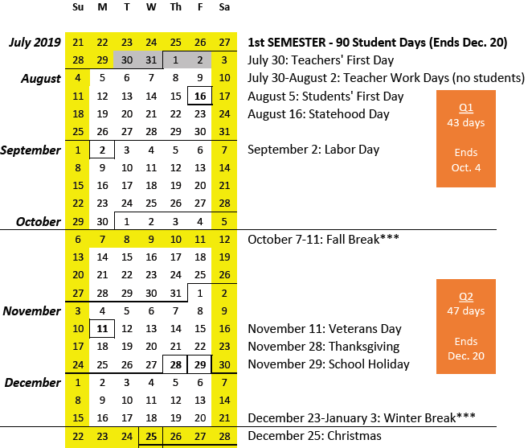

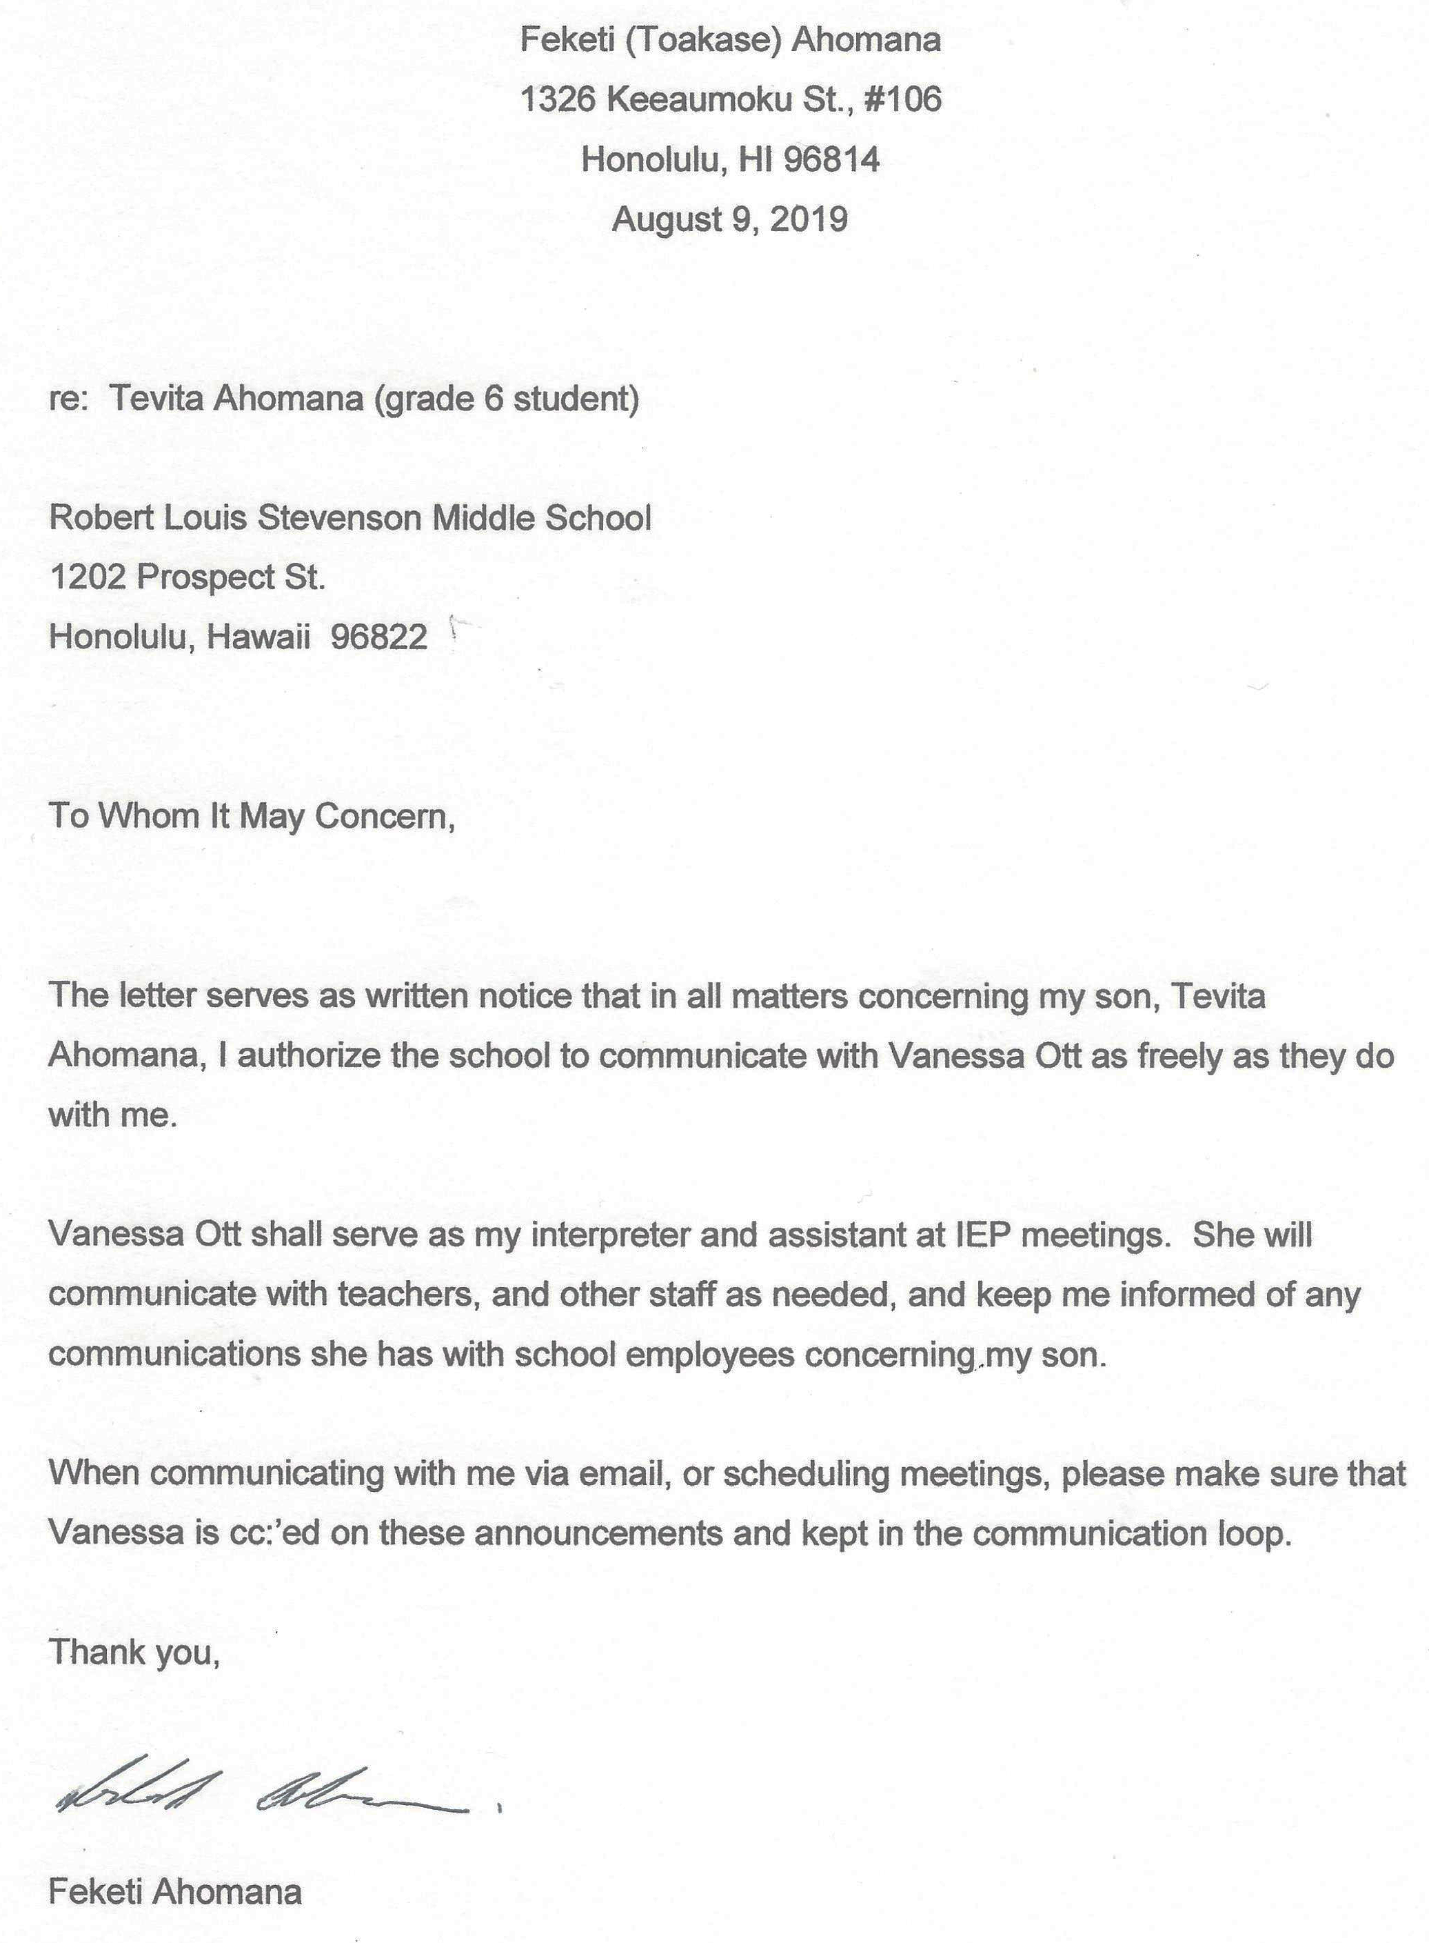
8/9/19 – Huahulu (Ahomana): Signed letter hand-delivered to school authorizing Vanessa Ott’s involvement in all matters concerning her son.
Note: Tevita Ahomana’s mother started the school year with her married name, but later returned to her maiden name, Huahulu. See 12/10/19 for the same letter signed with Ms. Huahulu’s maiden name.

8/9/19 – Ott: When is next SCC meeting at Stevenson Middle School?

From: Vanessa Ott <msvott@gmail.com>
Date: Fri, Aug 9, 2019 at 5:54 PM
Subject: When is the next SCC meeting?
To: <Ted_Mura/STVSON/HIDOE@notes.k12.hi.us>, <grace_makaimoku-young@notes.k12.hi.us>

Aloha Mr. Mura,

When and where is the next SCC meeting at Stevenson Middle School?

Mahalo,
Vanessa Ott
808 - 854 -1018
_________________________

8/16/19 – Ott: When is next SCC meeting at Stevenson Middle School

From: Vanessa Ott <msvott@gmail.com>
Date: Fri, Aug 16, 2019 at 7:49 PM
Subject: Re: When is the next SCC meeting?
To: <Ted_Mura/STVSON/HIDOE@notes.k12.hi.us>, <grace_makaimoku-young@notes.k12.hi.us>, Katherine Balatico <Katherine_Balatico@notes.k12.hi.us>

Aloha,

When and where is the next SCC meeting at Stevenson Middle School?

Mahalo,
Vanessa Ott
808 - 854 -1018
_________________________

8/17/19 – Ott: (1) What curricula are teachers using? (2) How do we find out what T is learning in each of his classes? (3) Requesting T’s i-Ready data.

From: Vanessa Ott <msvott@gmail.com>
Date: Sat, Aug 17, 2019 at 4:31 PM
Subject: Questions concerning T. Ahomana's education
To: Malcolm Yasuda <Malcolm_Yasuda/STVSON/HIDOE@notes.k12.hi.us>
Cc: Toakase Ahomana <FeketiAhomana@gmail.com>, Katherine Balatico <Katherine_Balatico@notes.k12.hi.us>

Aloha Mr. Yasuda,

I am writing on behalf of Feketi Ahomana concerning Tevita Ahomana's education. (Student Number 11281600637) A signed letter confirming this arrangement has been delivered to the school, and a copy is attached.

We have some questions.

1) What are the names of the Math and Language Arts curricula Tevita's Math, Language Arts and ELL teachers will be using this year?

2) Tevita has always struggled to answer the question, "What did you learn in school today?" He says he writes this down in notebooks in each class, but he's not allowed to bring the notebooks home. We would like for him to bring his notes home for study and review. How should we proceed in establishing a process for home-to-school communication? Should we contact each teacher individually?

3) May we please have electronic copies of Tevita's recent i-Ready Math and Reading results? I've attached samples from last year of different types of reports. We are looking for data on current levels of performance in the Math and Reading domains, and a growth report to see how much he improved (or not) over the summer.

Mahalo,
Vanessa Ott
808 - 854 -1018
______________________________________

8/20/19 – Yasuda: Forwarded Ott’s email to Matsushige

From: Malcolm Yasuda <malcolm.yasuda@k12.hi.us>
Date: Tue, Aug 20, 2019 at 2:02 PM
Subject: Tevita
To: Toakase Ahomana <FeketiAhomana@gmail.com>, Katherine Balatico <Katherine_Balatico@notes.k12.hi.us>, <msvott@gmail.com>

I have forwarded your questions/concerns to Tevita's Care Coordinator, Ron Matsushige.

Malcolm Yasuda
Student Services Coordinator (SSC)
Stevenson Middle School
Ph: (808) 587-4520 Fax: (808) 587-4523
______________________________________

8/21/19 – Ott: May we please have Mr. Matsushige’s email address?

From: Vanessa Ott <msvott@gmail.com>
Date: Wed, Aug 21, 2019 at 8:10 AM
Subject: Re: Tevita
To: Malcolm Yasuda <malcolm.yasuda@k12.hi.us>
Cc: Toakase Ahomana <FeketiAhomana@gmail.com>, Katherine Balatico <Katherine_Balatico@notes.k12.hi.us>

Thank you for forwarding my message to Ron Matsushige. May we please have Mr. Matsushige's email address? I could not find him in the school's online faculty directory.

Mahalo,
Vanessa Ott
808 - 854 -1018

______________________________________

8/22/19 – Ott to Principal: RLSMS is not in compliance with HAR §8-5-8

From: Vanessa Ott <msvott@gmail.com>
Date: Thu, Aug 22, 2019 at 9:23 AM
Subject: RLSMS not in compliance with HAR §8-5-8
To: Katherine Balatico <Katherine_Balatico@notes.k12.hi.us>
Cc: Toakase Ahomana <FeketiAhomana@gmail.com>

Aloha Principal Balatico,

HAR §8-5-8 states that requests for information will be answered in 1 to 3 days or a mutually reasonable time shall be determined for reply. It is taking longer than three days to get the information I recently requested.

Please see the attached letter for details.

Mahalo,
Vanessa Ott
808 - 854 -1018

attachment: 2019-08-22-Balatico-HAR-8-5-8.pdf (4 pages)


Attachment to 8/22/19 email to Balatico:
2019-08-22-Balatico-HAR-8-5-8.pdf
Vanessa Ott
2825 S. King St., #2901, Honolulu, HI 96826
msvott@gmail.com

(808) 854-1018
August 22, 2019

Katherine Balatico, Principal
Robert Louis Stevenson Middle School
katherine.balatico@k12.hi.us

re: RLSMS not in compliance with HAR §8-5-8

Aloha Principal Balatico,

HAR §8-5-8 states that requests for information will be answered in 1 to 3 days or a mutually reasonable time shall be determined for reply.

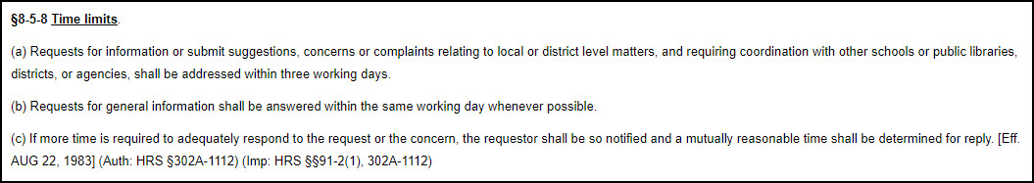

It is taking longer than three days to get the information I recently requested. I hope this is only an anomaly, and not a trend. Perhaps a friendly reminder for how to handle correspondence professionally (as described in HAR §8-5-8) in an email to “All-Staff” would be helpful in setting RLSMS communications expectations for the rest of the school year.

Mahalo,


Vanessa Ott

attachments: (2)
- CORRESPONDENCE re: School Community Council
Current Status: The question of when and where the SCC will meet next is still unanswered.
- CORRESPONDENCE re: Tevita’s Education
Current Status: Apparently, our email sat around for 2 days before being forwarded to the appropriate party, the Care Coordinator. We are still waiting for the requested Care Coordinator’s email address and the information we originally requestedfs.

Attachment to 8/22/19 email to Balatico:
2019-08-22-Balatico-HAR-8-5-8.pdf

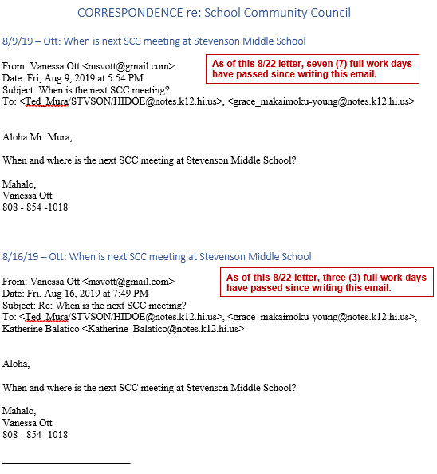

Attachment to 8/22/19 email to Balatico:
2019-08-22-Balatico-HAR-8-5-8.pdf

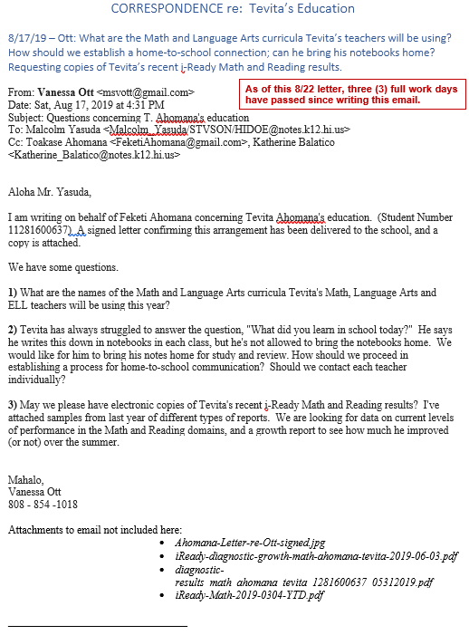

Attachment to 8/22/19 email to Balatico:
2019-08-22-Balatico-HAR-8-5-8.pdf

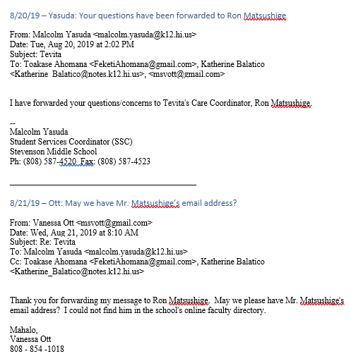

______________________________________

8/22/19 – Open House

Got to meet all Tevita’s teachers except Mr. Visaya wasn’t there (met him in summer as Tevita’s 1st ESY teacher) and Mr. Carlton wasn’t there.
______________________________________

8/22/19 – Yasuda: Mr. Matsushige has been cc:’ed on this email.

From: Malcolm Yasuda <malcolm.yasuda@k12.hi.us>
Date: Thu, Aug 22, 2019 at 10:40 AM
Subject: email
To: <msvott@gmail.com>
Cc: Ronald Matsushige <Ronald.Matsushige@k12.hi.us>

Mr. Matsushige has been cc'd on this email for your contact info.
--
Malcolm Yasuda
Student Services Coordinator (SSC)
Stevenson Middle School
Ph: (808) 587-4520 Fax: (808) 587-4523
______________________________________

8/23/19 – Balatico: I will look into your concern about communication

From: Katherine Balatico <katherine.balatico@k12.hi.us>
Date: Fri, Aug 23, 2019 at 12:51 AM
Subject: SCC Meeting
To: <msvott@gmail.com>
Cc: <FeketiAhomana@gmail.com>

Good morning, Ms. Ott -

Thank you for bringing your concern about communication to my attention for me to look into.

Thank you also for your interest in our SCC. Once we finalize our meeting dates, they will be posted on our website. SCC meetings are held in the Front Office.

Thank you,
Katherine Balatico
Principal
R.L. Stevenson Middle School
Office (808) 587-4520
Fax (808) 587-4523
______________________________________

8/23/19 – Ott: Please give me a date when SCC meetings will be posted

From: Vanessa Ott <msvott@gmail.com>
Date: Fri, Aug 23, 2019 at 6:17 AM
Subject: Re: SCC Meeting
To: Katherine Balatico <katherine.balatico@k12.hi.us>
Cc: Toakase Ahomana <FeketiAhomana@gmail.com>

Thank you for responding. Can you please give me a firm date when SCC meeting dates will be posted online so that I don't waste time checking each day waiting for the information to appear?

Mahalo,
Vanessa Ott
808 - 854 -1018

______________________________________

8/25/19 – Balatico: SCC schedule up by August 30

From: Katherine Balatico <katherine.balatico@k12.hi.us>
Date: Sun, Aug 25, 2019 at 8:41 PM
Subject: Re: SCC Meeting
To: Vanessa Ott <msvott@gmail.com>
Cc: Toakase Ahomana <FeketiAhomana@gmail.com>

Ms. Ott --

It should be up by Friday, 8/30.

Thank you,
Katherine Balatico
Principal
R.L. Stevenson Middle School
Office (808) 587-4520
Fax (808) 587-4523

______________________________________

8/26/19 – Ott to Matsushige: We will contact T’s teachers directly to get answers to curriculum and home-to-school communication; please send i-Ready data ASAP.

From: Vanessa Ott <msvott@gmail.com>
Date: Mon, Aug 26, 2019 at 7:13 AM
Subject: T. Ahomana's i-Ready reports
To: Ron Matsushige <Ronald.Matsushige@k12.hi.us>

Aloha Mr. Matsushige,

Per the email I sent to Mr. Yasuda on 8/17 (copied below), we will contact Tevita's teachers directly to get the answers to items #1 and #2.

So, at this juncture, please address item #3 as soon as possible. We would like comprehensive data from Tevita's recent i-Ready assessments. Knowing what his current performance capabilities are a is a high priority for me and his private tutor at this time so we can move forward.

Mahalo,
Vanessa Ott
808 - 854 -1018

______________________________________

8/26/19 – Ott to Kazarian: May Tevita rename his Google Drive files in order to organize them?

From: Vanessa Ott <msvott@gmail.com>
Date: Mon, Aug 26, 2019 at 8:34 AM
Subject: A sortable naming convention for Tevita's Google docs
To: Scott Kazarian <Scott.Kazarian@k12.hi.us>

Aloha Mr. Kaz,

Thank you for letting me know about Tevita's Google account. I'm very happy that you have him using Google Docs. He's pretty good at using Google Docs, though I'm sure he forgot a lot over the summer.

We looked over Tevita's Google drive contents this weekend. I noticed he'd not done some Free Write assignments so we brainstormed answers to the prompts and he worked on the following at home:
- Made a small edit to 8/15 Free Write
- 8/19 Free Write
- Free Write #3
May I suggest a file naming convention that is easy for kids to read, easy for teachers to individualize, and sorts files in assignment type >> chronological order? The formula is:

<Title> <(yyyy-mm-dd)> - P<#>: <Student Name>

For example, the most recent Free Write assignment would have this title (the date is when it was assigned):

#05 Free Write (2019-08-25) - P2: Tevita Ahomana

Then, when you're creating the files and naming them, you can
- Put the beginning of the title in the copy buffer, e.g.:
#05 Free Write (2019-08-25) - P2:
- Paste it into a Google doc title.
- the cursor should be at the end of the pasted text so you can type the student name
Or if you have some automated way to generate files for the kids then the names can be appended to the filename easily.

There are reasons for my suggested file naming convention formula. It's a philosophy I've shared with many over the years and honed over time.
- Files need to be able to be sorted either by topic or date (depending on user's needs)
- The beginning of the file name is sometimes only what a user sees on a tab or a list, so make it unique.
- The hierarchy of information needs to be from left to right in order to to sort files either by topic or date.
- In order to sort chronologically with a filename, dates must be: yyyy-mm-dd
- If you put the individualized information at the end of a group of files with the same beginning, then the cursor is in the right place to just start typing the individualized information at the end of the file name template for the series.
Right now, Tevita's files in your Period 2 classroom folder are difficult to sort out,
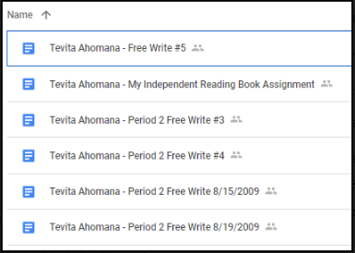

and because the all the file names begin with the same text (his name) he can't distinguish between one file or another very easily by looking at the tabs when he has more than one file open:
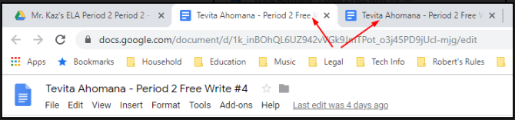

If you aren't interested in adopting the suggested naming convention, is it okay if Tevita renames his files so he can keep them organized?

Mahalo,
Vanessa Ott
808 - 854 -1018
______________________________________

8/26/19 – Matsushige: Here are T’s i-Ready Math and Reading results

From: Ronald Matsushige <ronald.matsushige@k12.hi.us>
Date: Mon, Aug 26, 2019 at 2:55 PM
Subject: Re: T. Ahomana's i-Ready reports
To: Vanessa Ott <msvott@gmail.com>

Good afternoon!

Here are Tevita's results for the iReady Math and Reading Diagnostic tests he completed recently. I hope this helps you when you tutor him!
Thank you so much for your hard work!

Ronald Matsushige
Special Education Teacher
R.L. Stevenson Middle School
______________________________________

8/26/19 – Ott to Matsushige: You sent another student’s Math results

From: Vanessa Ott <msvott@gmail.com>
Date: Mon, Aug 26, 2019 at 5:01 PM
Subject: Re: T. Ahomana's i-Ready reports
To: Ronald Matsushige <ronald.matsushige@k12.hi.us>

Thank you. Unfortunately, you sent me an 8th Grade student’s Math results— not Tevita’s.

Vanessa
______________________________________

8/26/19 – Matsushige: I will send T’s Math i-Ready results later today

From: Ronald Matsushige <ronald.matsushige@k12.hi.us>
Date: Mon, Aug 26, 2019 at 5:14 PM
Subject: Re: T. Ahomana's i-Ready reports
To: Vanessa Ott <msvott@gmail.com>

Oh my gosh. I’m so sorry! They have the same initials so I got confused!
I’ll go look up Tevita’s math score and send it later today.

______________________________________

8/26/19 – Matsushige: I didn’t bring laptop home; will send i-Ready Math results tomorrow

From: Ronald Matsushige <ronald.matsushige@k12.hi.us>
Date: Mon, Aug 26, 2019 at 5:21 PM
Subject: Re: T. Ahomana's i-Ready reports
To: Vanessa Ott <msvott@gmail.com>

I didn't bring my work laptop home with me so I'll send the math scores to you tomorrow.
Thank you so much!

Ronald
______________________________________

8/27/19 – Matsushige: Here are Math results

From: Ronald Matsushige <ronald.matsushige@k12.hi.us>
Date: Tue, Aug 27, 2019 at 7:22 AM
Subject: Re: T. Ahomana's i-Ready reports
To: Vanessa Ott <msvott@gmail.com>

Good Morning Vanessa,
Here is Tevita's Math Diagnostic Report. I apologize again for the mix up!
Thank you!

Ronald
______________________________________

8/27/19 – Ott to Matsushige, Teachers, and Principal: Tevita’s i-Ready results alarmingly low; he probably should be retested in a nondistracted environment

From: Vanessa Ott <msvott@gmail.com>
Date: Tue, Aug 27, 2019 at 9:38 AM
Subject: Tevita's alarmingly low i-Ready diagnostics may be inaccurate due to testing environment
To: Ron Matsushige <Ronald.Matsushige@k12.hi.us>
Cc: Toakase Ahomana <FeketiAhomana@gmail.com>, Katherine Balatico <katherine.balatico@k12.hi.us>, Scott Kazarian <Scott.Kazarian@k12.hi.us>, Blake Carrigan <Blake.Carrigan@k12.hi.us>, Anna Yamana <Anna.Yamana@k12.hi.us>

Aloha Ronald,

Thank you for sending Tevita's i-Ready diagnostics. It was alarming how low they were compared to last year's final results, and I suspect they may not accurately reflect Tevita's true academic abilities in Math and Reading. If Tevita was not tested in a quiet environment with minimal distractions he would not have been able to concentrate, and his scores would be much lower than his true performance ability; this is due to his Attention Deficit Disorder (of the non-attentive type). I think it says something in his IEP about needing a quiet, nondistracted testing environment. If he was in a classroom with a lot of kids taking the test and/or doing anything other than sitting quietly taking a test it would have had considerable negative effect on his performance.

I think Tevita should be retested in a nondistracted environment so that we can get an accurate assessment of his true abilities at this time. A small room with a cubicle, nothing on the walls, and no one bustling about doing other things would be ideal. He can stay after school to do this which is preferable so that he doesn't miss any class time.

To support this request, here's a picture of Tevita's i-Ready Growth diagnostics for last school year. The three columns (L to R) are for these testing dates:
MATH:
(1) August 16, 2018
(2) May 17, 2019
(3) May 30, 2019
READING:
(1) August 16, 2018
(2) May 16, 2019
(3) May 24, 2019

When the school's i-Ready coordinator saw that Tevita had performed far worse at the end of the year (May 16 and 17) than at the beginning, she knew the scores did not reflect his capabilities. We'd all seen lots of growth by the end of the year compared to the beginning. So she retested him on May 24 (Reading) and May 30 (Math) in a nondistracted environment and the difference was dramatic!

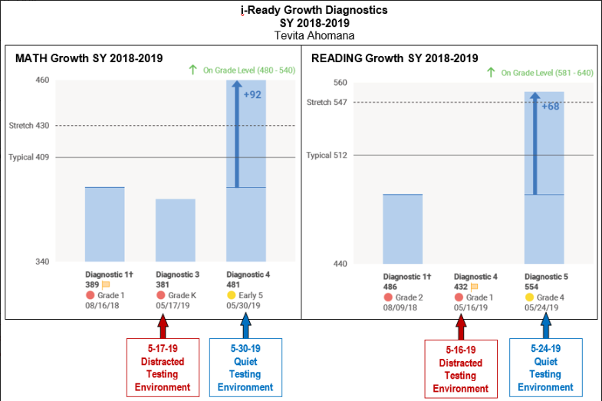

Please let's get Tevita re-tested ASAP.

Mahalo,
Vanessa Ott
808 - 854 -1018
_______________________________________________________

Attachments: Comparing Tevita's May 2019 i-Ready results to August 2019

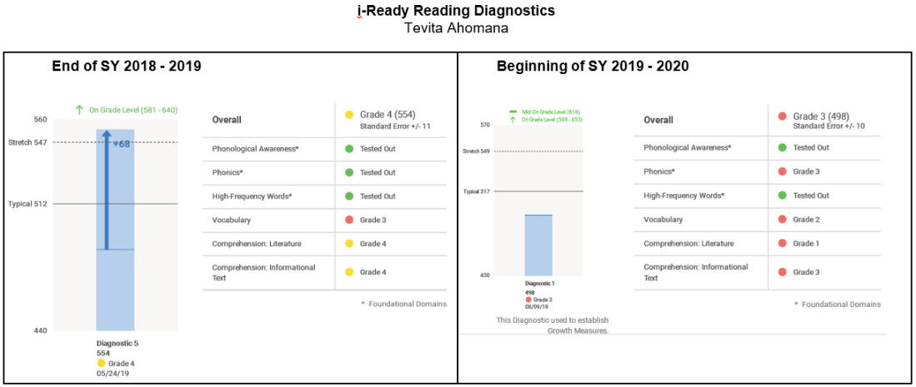
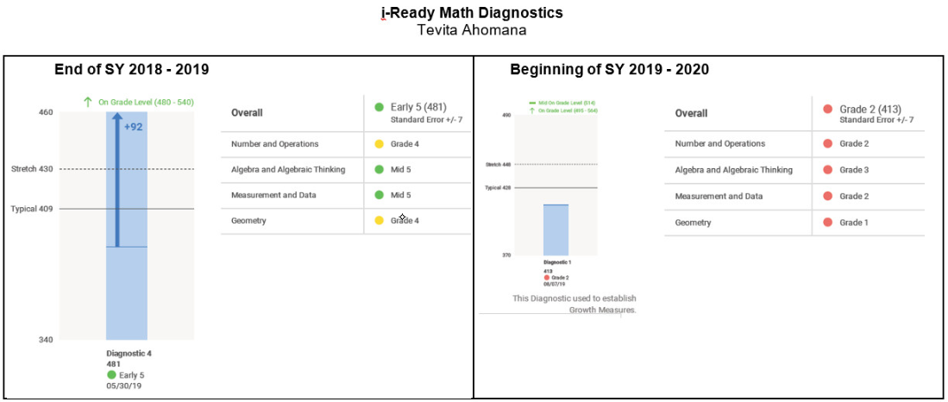
______________________________________

8/28/19 – Matsushige: T will be retested. Soonest dates for IEP meeting are next week. We can discuss school communication/coordination at that meeting.

From: Ronald Matsushige <ronald.matsushige@k12.hi.us>
Date: Wed, Aug 28, 2019 at 4:58 PM
Subject: Meeting and Testing
To: <FeketiAhomana@gmail.com>, Vanessa Ott <msvott@gmail.com>, Katherine Balatico <Katherine.Balatico@k12.hi.us>

Hi Feketi and Vanessa!

Thank you for letting me know your concerns!

At the open house I had mentioned that I wanted to amend Tevita's IEP so that we could add 6th grade goals. So I thought it would work out well if we could meet for that, as well as to address your concerns about home to school communication/coordination.

The soonest dates that are available for the meeting would be either next week Wednesday 9/4 at 3:15 pm, or Thursday 9/5 at 2:30 pm. Please let me know which date works best for you.

As for the testing, I was also concerned when I saw the drop in Tevita's scores. Our usual protocol when we see a big change like that is to retest the student to make sure it wasn't just a bad day, or some other factor.
So Tevita's tests have been reset, and I will schedule for him to test in my classroom. It will only be him testing so it will be quiet, with no other distractions.

Thank you, and looking forward to hearing from you again!

Ronald Matsushige
______________________________________

8/28/19 – Ott: We have to work out home to school connection with each teacher in their classrooms, not an IEP.

From: Vanessa Ott <msvott@gmail.com>
Date: Wed, Aug 28, 2019 at 6:09 PM
Subject: Re: Meeting and Testing
To: Ronald Matsushige <ronald.matsushige@k12.hi.us>
Cc: Toakase Ahomana <FeketiAhomana@gmail.com>, Katherine Balatico <Katherine.Balatico@k12.hi.us>

Aloha Ronald,

Thank you for getting back to me.

I'd like to have Tevita's new test scores a reasonable number of days in advance of the meeting. If you can get those results to me by this Friday, then Wed 9/4 @ 3:15 or Thu 9/5 @ 2:30 are fine meeting times, and we can attend either one. If I won't get the scores until next week, then whether or not those dates/times will work depends on when I do get them. However, right now, finding out what Tevita's supposed to be learning in school and why he isn't getting any homework is a higher priority for us than setting Grade 6 goals.

The home to school connection is something we have to work out with each individual teacher. We need to figure out how we are going to find out, on an ongoing basis, what Tevita is working on, see his work, see how each classroom functions, find out the curriculum each teacher is using, and discuss what we can do at home to support his advancement. That is why I sent the email to all of his teachers today and copied you on that. I'm asking for a time to meet with each teacher. I don't think an IEP meeting will accomplish that objective. Since I need to work this out with each teacher per classroom, I don't think it's a good use of everyone's time to try and do this en masse.

We're not seeing much, if any work at all coming home, and we're very concerned about that. Figuring out how we support his weekly learning at home is actually a much higher priority for us at this time than setting IEP goals. So, anything you can do to nudge the teachers to respond to us soon, and set up a time to meet with us in their classroom would be appreciated.

Mahalo,
Vanessa Ott
808 - 854 -1018
______________________________________

8/28/19 @ 6:33 am – Ott to T’s Teachers, cc: Matsushige: We request a meeting with you in your classroom.

From: Vanessa Ott <msvott@gmail.com>
Date: Wed, Aug 28, 2019 at 6:43 AM
Subject: Requesting a Meeting as soon as possible
To: Amy Tsujioka <Amy.Tsujioka@k12.hi.us>, Anna Yamana <Anna.Yamana@k12.hi.us>, Blake Carrigan <Blake.Carrigan@k12.hi.us>, Christine Asuncion <Christine.Asuncion@k12.hi.us>, Jay Visaya <Jay.Visaya@k12.hi.us>, Linda Wong <Linda.Wong@k12.hi.us>, Lou Carlton <Carlton.Lou@k12.hi.us>, Ron Matsushige <Ronald.Matsushige@k12.hi.us>, Scott Kazarian <Scott.Kazarian@k12.hi.us>
Cc: Toakase Ahomana <FeketiAhomana@gmail.com>, Ron Matsushige <Ronald.Matsushige@k12.hi.us>

Aloha to Tevita's Teachers,

Tevita's mother and I would like to meet with you to discuss Tevita's school work and develop a plan for home-to-school coordination. Tevita has two outside school tutors (me and another DOE teacher) to help him with his school work, but we cannot depend on Tevita to be able to tll us what he's working on.

We are available any day before school. We are available after school on most Wednesdays, Thursdays and Fridays. Please let us know the earliest date/time that works for you.

Mahalo,
Vanessa Ott
808 - 854 -1018
freespeech4us.com

p.s. The attached letter giving me authorization to contact you regarding Tevita has been filed with the school administration. A copy is attached.

______________________________________

8/29/19 after 8:00 pm – Ott: To Tsujioka – I have not received a response yet; when can we meet?

From: Vanessa Ott <msvott@gmail.com>
Date: Thu, Aug 29, 2019 at 8:08 PM
Subject: Fwd: Requesting a Meeting as soon as possible
To: Amy Tsujioka <Amy.Tsujioka@k12.hi.us>

Aloha Ms. Tsujioka,

I have not received a response from you yet. When are you available to meet with me and Tevita's mom?

Mahalo,
Vanessa Ott
808 - 854 -1018

______________________________________

8/29/19 after 8:00 pm – Ott: To Yamana – I have not received a response yet; when can we meet?

From: Vanessa Ott <msvott@gmail.com>
Date: Thu, Aug 29, 2019 at 8:09 PM
Subject: Fwd: Requesting a Meeting as soon as possible
To: Anna Yamana <Anna.Yamana@k12.hi.us>

Aloha Ms. Yamana,

I have not received a response from you yet. When are you available to meet with me and Tevita's mom?

Mahalo,
Vanessa Ott
808 - 854 -1018
______________________________________

8/29/19 after 8:00 pm – Ott: To Carrigan – I have not received a response yet; when can we meet?

From: Vanessa Ott <msvott@gmail.com>
Date: Thu, Aug 29, 2019 at 8:10 PM
Subject: Fwd: Requesting a Meeting as soon as possible
To: Blake Carrigan <Blake.Carrigan@k12.hi.us>

Aloha Ms. Carrigan,

I have not received a response from you yet. When are you available to meet with me and Tevita's mom?

Mahalo,
Vanessa Ott
808 - 854 -1018
______________________________________

8/29/19 after 8:00 pm – Ott: To Asuncion – I have not received a response yet; when can we meet?

From: Vanessa Ott <msvott@gmail.com>
Date: Thu, Aug 29, 2019 at 8:15 PM
Subject: Fwd: Requesting a Meeting as soon as possible
To: Christine Asuncion <Christine.Asuncion@k12.hi.us>

Aloha Ms. Asuncion,

I have not received a response from you yet. When are you available to meet with me and Tevita's mom?

Mahalo,
Vanessa Ott
808 - 854 -1018

______________________________________

8/29/19 after 8:00 pm – Ott: To Visaya – I have not received a response yet; when can we meet?

From: Vanessa Ott <msvott@gmail.com>
Date: Thu, Aug 29, 2019 at 8:18 PM
Subject: Fwd: Requesting a Meeting as soon as possible
To: Jay Visaya <Jay.Visaya@k12.hi.us>

Aloha Mr. Visaya,

I have not received a response from you yet. When are you available to meet with me and Tevita's mom?

Mahalo,
Vanessa Ott
808 - 854 -1018

______________________________________

8/30/19 – Visaya: I am available next week to meet

From: Jay Visaya <jay.visaya@k12.hi.us>
Date: Fri, Aug 30, 2019 at 6:34 AM
Subject: Re: Requesting a Meeting as soon as possible
To: Vanessa Ott <msvott@gmail.com>

Morning, my apologies for not getting back as I was away on workshops but, I am available next week mornings as well as Thursday afternoon. The following week mornings as well as Monday & Thursday afternoon.

Mr. Visaya
______________________________________

8/30/19 – Ott: Can we meet next Thursday morning?

From: Vanessa Ott <msvott@gmail.com>
Date: Fri, Aug 30, 2019 at 6:38 AM
Subject: Re: Requesting a Meeting as soon as possible
To: Jay Visaya <jay.visaya@k12.hi.us>

How about next Thursday morning, September 5th at 7:15 am?

Mahalo,
Vanessa Ott
808 - 854 -1018
______________________________________

8/30/19 – Ott: To Kazarian – I have not received a response yet; when can we meet?

From: Vanessa Ott <msvott@gmail.com>
Date: Fri, Aug 30, 2019 at 6:45 AM
Subject: Fwd: Requesting a Meeting as soon as possible
To: Scott Kazarian <Scott.Kazarian@k12.hi.us>

Aloha Mr. Kazarian,

I have not received a response from you yet. When are you available to meet with me and Tevita's mom?

Mahalo,
Vanessa Ott
808 - 854 -1018
______________________________________

8/30/19 – Ott: To Wong – I have not received a response yet; when can we meet?

From: Vanessa Ott <msvott@gmail.com>
Date: Fri, Aug 30, 2019 at 6:51 AM
Subject: Fwd: Requesting a Meeting as soon as possible
To: Linda Wong <Linda.Wong@k12.hi.us>

Aloha Ms Wong,

I have not received a response from you yet. When are you available to meet with me and Tevita's mom?

Mahalo,
Vanessa Ott
808 - 854 -1018
______________________________________

8/30/19 – Ott: To Carlton – I have not received a response yet; when can we meet?

From: Vanessa Ott <msvott@gmail.com>
Date: Fri, Aug 30, 2019 at 6:59 AM
Subject: Fwd: Requesting a Meeting as soon as possible
To: Lou Carlton <Carlton.Lou@k12.hi.us>

Aloha Mr. Carlton,

I have not received a response from you yet. When are you available to meet with me and Tevita's mom?

Mahalo,
Vanessa Ott
808 - 854 -1018

______________________________________

8/30/19 – Matsushige: I agree we should wait to have IEP meeting until T is retested. I will get back to you about contacting teachers.

From: Ronald Matsushige <ronald.matsushige@k12.hi.us>
Date: Fri, Aug 30, 2019 at 4:12 PM
Subject: Testing Progress
To: <FeketiAhomana@gmail.com>, Vanessa Ott <msvott@gmail.com>, Katherine Balatico <Katherine.Balatico@k12.hi.us>, Blake Carrigan <Blake.Carrigan@k12.hi.us>, Christine Asuncion <Christine.Asuncion@k12.hi.us>, Jay Visaya <Jay.Visaya@k12.hi.us>, Scott Kazarian <scott.kazarian@k12.hi.us>, Anna Yamana <Anna.Yamana@k12.hi.us>, Amy Tsujioka <Amy.Tsujioka@k12.hi.us>

Good afternoon Feketi and Vanessa,

I completely agree that we should wait for the results of the iReady Reading and Math diagnostic tests before holding the IEP revision meeting. He is testing in my class with no other students, and I have been encouraging him to take his time and do his best so we can get more accurate data on his current abilities. I will let you know when he is done so we can reschedule the meeting.

Also, I am contacting teachers, and am gathering info for you, and will get back to you after I have put it all together.

Thank you very much and have a great long weekend!

Ronald Matsushige

______________________________________

8/30/19 – Ott to Matsushige and Principal: I don’t understand why we can’t make appointments with the teachers to meet with them. Please be clearer about what’s going on.

From: Vanessa Ott <msvott@gmail.com>
Date: Fri, Aug 30, 2019 at 7:03 PM
Subject: Re: Testing Progress
To: Ronald Matsushige <ronald.matsushige@k12.hi.us>
Cc: Katherine Balatico <Katherine.Balatico@k12.hi.us>, Toakase Ahomana <toahuahulu@gmail.com>

Aloha Mr. Matsushige and Principal Balatico,

I don't understand why Toakase and I can't make appointments with each teacher to meet in their classrooms and discuss what and how Tevita is learning in each individual class, and how we're going to keep informed about this as the year progresses. Only Mr. Visaya responded today to my 8/28 email (below) asking to make an appointment, but I haven't heard back from him.

Are the teachers not responding because you're going to set up a visitation schedule? Why are you "gathering information" and getting back to me? Why can't Toakase and I make meetings with the teachers and talk to them directly in their classrooms?

Since we contacted SCC Mr. Yasuda two weeks ago, we've been trying to move forward with this, but all we've been able to get were a few bits of information at Open House along with lots of invitations to contact the teachers with questions, which we've done, but have not gotten responses.

Please be clearer about what's going on and why meeting with teachers and getting responses from them is so difficult to accomplish.

Mahalo,
Vanessa Ott
808 - 854 -1018

______________________________________

8/30/19 – Ott checks SCC web site for meeting dates. Apparently Q1 meeting was held earlier in the day. Only 3 more meetings for the rest of the year.

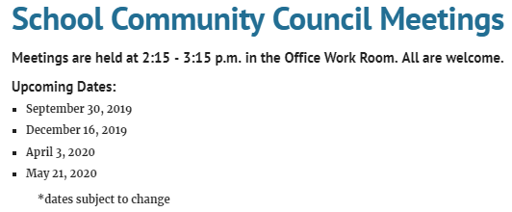
from: https://www.rlsms.k12.hi.us/parent-resources/school-community-council
downloaded 8/30/19

______________________________________

8/31/19 – Ott to Kazarian: I have not received a response to my 8/26 email.

From: Vanessa Ott <msvott@gmail.com>
Date: Sat, Aug 31, 2019 at 6:17 AM
Subject: A sortable naming convention for Tevita's Google docs
To: Scott Kazarian <Scott.Kazarian@k12.hi.us>
Cc: Katherine Balatico <Katherine_Balatico@notes.k12.hi.us>, Toakase Ahomana <toahuahulu@gmail.com>

Aloha Mr. Kazarian,

Five working days have passed since I sent my 8/26 email to you (copied below). Please answer the question, "If you aren't interested in adopting the suggested naming convention, is it okay if Tevita renames his files so he can keep them organized?"

Mahalo,
Vanessa Ott
808 - 854 -1018

______________________________________

8/31/19 – Balatico: I will follow up with Mr. Kazarian on Monday re: filenames

From: Katherine Balatico <katherine.balatico@k12.hi.us>
Date: Sat, Aug 31, 2019 at 9:13 AM
Subject: Re: A sortable naming convention for Tevita's Google docs
To: Vanessa Ott <msvott@gmail.com>
Cc: Toakase Ahomana <toahuahulu@gmail.com>

Good morning, Ms. Ott --

Thank you for including me in your request to Mr. Kazarian. I can follow-up with Mr. Kazarian on Monday regarding Tevita's Google account.

Thank you,
Katherine Balatico
Principal
R.L. Stevenson Middle School
Office (808) 587-4520
Fax (808) 587-4523
______________________________________

9/4/19 – Kazarian: Yes, Tevita may rename his Google Drive files

From: Scott Kazarian <scott.kazarian@k12.hi.us>
Date: Wed, Sep 4, 2019 at 4:37 PM
Subject: Google Classroom Assignments
To: <msvott@gmail.com>
Cc: Katherine Balatico <katherine.balatico@k12.hi.us>, Ronald Matsushige <Ronald.Matsushige@k12.hi.us>

Aloha Ms. Ott

I apologize for not getting back to you sooner. In regards to Google Classroom and Tevita’s Google Docs, I have spoken to Tevita’s other teachers (who use Google Docs) and we agree that you are more than welcome to modify Google Doc titles in a way that Tevita is familiar with and can understand.

Mahalo

SK :)

Scott Kazarian
English Language Arts | Stevenson Middle School
Scott.Kazarian@k12.hi.us

_____________________________________

9/5/19 – Ott: Please send i-Ready new results

From: Vanessa Ott <msvott@gmail.com>
Date: Thu, Sep 5, 2019 at 6:38 AM
Subject: Please send Tevitat's i-Ready results
To: Ron Matsushige <Ronald.Matsushige@k12.hi.us>
Cc: Katherine Balatico <Katherine_Balatico@notes.k12.hi.us>, Toa Ahomana <toahuahulu@gmail.com>

Mr. Matsushige,

Please send Tevita's new i-Ready Math and Reading results as soon as possible.

Mahalo,
Vanessa Ott
808 - 854 -1018
_____________________________________

9/5/19 – Ott to Balatico: We want to meet with Tevita’s teachers; please arrange this.

From: Vanessa Ott <msvott@gmail.com>
Date: Thu, Sep 5, 2019 at 8:25 AM
Subject: We've been trying for weeks to meet with teachers and nothing has been arranged
To: Katherine Balatico <katherine.balatico@k12.hi.us>
Cc: Toa Ahomana <toahuahulu@gmail.com>, Ron Matsushige <Ronald.Matsushige@k12.hi.us>

Aloha Principal Balatico,

We have been trying for two and a half weeks to meet with Tevita's teachers and still not one single meeting has been arranged. It's not for our lack of trying. The attachment shows 25 pages of emails related to this issue.

Only Mr. Visaya responded to my email to Tevita's teachers last week (and the reminder I sent 2 days later) requesting a time to meet in their classroom. I tried to schedule a time with Mr. Visaya but have heard nothing since. All the other teachers have been silent and not responded to me.

I think we've been very patient. Out of courtesy and patience, we waited until after the first 2 weeks of school had passed before starting this process on 8/17/19, but it's almost 3 weeks later and we haven't even had any meeting even scheduled yet! We are already halfway through Q1, Tevita is not bringing any work home, we have no idea what he's supposed to be learning. We have a tutor standing by to help him, but we've been stalled by the delays in getting responses from your staff.

Please rectify this situation, and arrange meetings with each of the teachers in their classrooms ASAP. We are available M-F before school, and usually W - F after school, though I have an appointment next Thursday 9/12 after school so that day is not available.

Mahalo,
Vanessa Ott
808 - 854 -1018

attachment: Correspondence-Tevita-School-Work.pdf
(compilation of emails 8-17-19 to 9-4-19)
_____________________________________

9/5/19 – Matsushige: I am responsible for coordinating communication. Not all teachers give homework. Tevita writes his homework in is planner.

From: Ronald Matsushige <ronald.matsushige@k12.hi.us>
Date: Thu, Sep 5, 2019 at 4:48 PM
Subject: RE: Homework
To: Toakase <toahuahulu@gmail.com>, Vanessa Ott <msvott@gmail.com>, Katherine Balatico <Katherine.Balatico@k12.hi.us>

Hi Toakase and Vanessa,

As Tevita’s care coordinator, whenever possible I am responsible for coordinating communication for him, especially when there are concerns that may extend into multiple classes. To best support Tevita and to have him develop the habit of writing in his planner daily and staying organized, all of his teachers will use his planner to make sure that he knows what (if any) homework he has each night. I will review the planner procedure with Tevita on Friday:

Each teacher has his homework posted on their boards

Tevita is to copy down his homework

If there is no homework, Tevita will write, “No Homework”

Tevita will show his teacher his planner

Tevita’s teachers will initial or stamp his planner before he leaves class.

Not all of Tevita’s teachers assign homework every night. Math might have homework several times a week. Social Studies has one quiz a week, which he can study for as homework. English and Science generally have students complete their work in class and rarely give homework. ELL has vocabulary study words written into his planner.

If you have any follow up questions for teachers after looking at his planner, you are welcome to email them for more details. If you would also please cc me on those emails so I can be kept in the loop I would appreciate it. It helps me to help Tevita if I know of any potential issues he might be having.

Thank you very much!

Ronald Matsushige
_____________________________________

9/5/19 – Ott: You are effectively refusing to let us meet with the teachers. Tevita has not brought home any work from school. We still don’t know the curricula the teachers are using. Tevita cannot remember what his homework entries mean. This is unacceptable. Requesting meeting with Principal, Care Coordinator, and CAS.

From: Vanessa Ott <msvott@gmail.com>
Date: Thu, Sep 5, 2019 at 9:55 PM
Subject: We are requesting a meeting with Principal, Care Coordinator, and Complex Area Superintendent
To: Ronald Matsushige <ronald.matsushige@k12.hi.us>, Katherine Balatico <Katherine_Balatico@notes.k12.hi.us>
Cc: Toakase <toahuahulu@gmail.com>

Principal Balatico and Mr. Matsushige,

It is quite apparent that at best you are doing nothing to help us meet with Tevita's teachers and at worst your are refusing to allow this to happen.

We have no idea what he is learning in school because there are NO papers or notes or anything that comes home. The only work we've been able to see are a few Free Write outlines for Mr. Kazarian's class in Tevita's Google Drive (the work quality of which leave A LOT to be desired).

We want to know the curriculum the teachers are using and where Tevita is in each curriculum. Are the teachers even used a professionally written, state approved curriculum? We have no evidence of this.

As for Tevita's planner, there's practically nothing written in there, and when there is, Tevita cannot explain what the homework is.

We have a lot of questions that aren't getting answered. This isn't acceptable, so I assume we should arrange a meeting to discuss, face-to-face, how we are going to move forward. I think it's important for the Complex Area to attend.

Please arrange the meeting.

Mahalo,
Vanessa Ott
808 - 854 -1018

_____________________________________

9/5/19 – Balatico: I will make appointments with teachers. What are your concerns and questions for them?

From: Katherine Balatico <katherine.balatico@k12.hi.us>
Date: Thu, Sep 5, 2019 at 10:28 PM
Subject: Re: We've been trying for weeks to meet with teachers and nothing has been arranged
To: Vanessa Ott <msvott@gmail.com>
Cc: Toa Ahomana <toahuahulu@gmail.com>, Ron Matsushige <Ronald.Matsushige@k12.hi.us>

Mrs. Ahomana and Ms. Ott --

Thank you for sending me your availability. I will check with Tevita's teachers tomorrow to schedule meetings with you next week. I see that Mr. Visaya had sent you his availability. Have you scheduled a meeting with Mr. Visaya already? Are there particular concerns or questions you have regarding his individual classes?

In regards to homework assignments Tevita can work on with his tutor, I see that Mr. Matsushige sent an email this afternoon about Tevita's use of his planner so his homework is documented daily. With this in place, his tutor can assist him with any coursework he's assigned each day.

I will send you a meeting schedule on Friday.

Thank you,
Katherine Balatico
Principal
R.L. Stevenson Middle School
Office (808) 587-4520
Fax (808) 587-4523

_____________________________________

9/5/19 – Ott: Here are our questions.

From: Vanessa Ott <msvott@gmail.com>
Date: Thu, Sep 5, 2019 at 11:12 PM
Subject: Re: We've been trying for weeks to meet with teachers and nothing has been arranged
To: Katherine Balatico <katherine.balatico@k12.hi.us>
Cc: Toa Ahomana <toahuahulu@gmail.com>, Ron Matsushige <Ronald.Matsushige@k12.hi.us>

Principal Balatico,

We have the same general questions for all of his teachers:
- What curriculum are you using? What is he learning in your class? How are we going to be kept informed of this on an ongoing basis? (periodic classroom visits like last year?)
- Why aren't we seeing any work coming home?
- Does he have any textbooks, notebooks, or study materials? Where are they? What are they?
- What is the percentage of students in the class with IEPs?
- Tevita does better writing with his computer. What kind of writing assignments will he have in your class that he can do on the computer.
- Tevita is very unclear about homework assignments. In addition to putting the cryptic entry in his planner, can we have a procedure whereby he enters the information into an online document so he can type a few more details, and the teacher assist him with clarifying what he needs to type or write or understand?
- Do you practice Direct instruction model (and Danielson) whereby you state what the student is learning that day, and reiterate that at the end of the class? If so, can we have Tevita type that into a daily journal online?
- If we have questions, should we call, send email?, attach letters into Tevita's planner? What is the most efficient and effective communication method for the teacher should we have any questions?
- How can Tevita, who is so far behind his peers in everything, ever catch up if he's not assigned independent work at home?
And, as things unfold, more questions may arise.
-----------------

No I was not able to schedule a time to meet with Mr. Visaya. Last Friday early morning I responded to him with a proposed meeting time that met his criteria and mine, Thursday 9/5 @ 7:30 am (see p.23 of the attachment I sent), but he never got back to me.

The tutor cannot help Tevita because we don't know what he's working on, and he's not being assigned any work or projects or anything that we can help him with at home. I have major doubts that a SpEd student is going to progress without an extra push and the support that goes with a bit more rigor than what we're seeing now which has been just about nothing to date.

Mahalo,
Vanessa Ott
808 - 854 -1018

_____________________________________

9/10/19 – Balatico: All the teachers can meet with you on September 19th, and we will conduct the IEP meeting at that time.

From: Katherine Balatico <katherine.balatico@k12.hi.us>
Date: Tue, Sep 10, 2019 at 2:42 PM
Subject: Scheduling a Teacher Meeting
To: Vanessa Ott <msvott@gmail.com>, Toakase Ahomana <toahuahulu@gmail.com>
Cc: Ronald Matsushige <Ronald.Matsushige@k12.hi.us>

Mrs. Ahomana and Ms. Ott -

Thank you for sending me your availability for meeting with Tevita's teachers. It is our goal that Tevita be successful in all of his classes and that he has a positive experience in middle school. Tevita's teacher team is committed to communicating with you to make sure he knows what his homework is each day and that you are informed of what happens in each of his classes.

I expect that all of Tevita's teachers be on the same page and that they assist Tevita in building independence, so Tevita and his teachers will use his planner to document homework and communicate between home and school (per Mr. Matsushige's email last week, 9/5).

As Tevita gets used to Stevenson, it's understandable that you have similar questions for all of his teachers. All of Tevita's teachers are available to meet next week Thursday, Sept. 19 at 2:30 p.m. The benefit to bringing all of Tevita's teachers together in one meeting is to hear how each will be supporting him and so that we all hear one message in our expectations for him. Thank you for sending your questions. I have sent all of his teachers your questions so that his teachers may address them at our meeting.

On Sept. 6, Mr. Matsushige also sent Tevita's August 2019 i-Ready Diagnostic scores to you. Please take some time to review them. On Sept. 19, after you have had a chance to speak to Tevita's teachers, we will conduct Tevita's IEP meeting to address his 6th grade goals and services. Complex Area Superintendent Dilwith is not a part of the school team and will not be in attendance.

I look forward to meeting you with you next week. Please confirm if you are available to meet on Thursday, Sept. 19 at 2:30 p.m.

Thank you,
Katherine Balatico
Principal
R.L. Stevenson Middle School
Office (808) 587-4520
Fax (808) 587-4523

_____________________________________

9/10/19 – Ott: We need to discuss Tevita’s curriculum, see his work for each individual class, establish procedures for home-to-school communication, and have time to process the information before having an IEP meeting. Since you won’t schedule a meeting with the CAS, we will request this ourselves.

From: Vanessa Ott <msvott@gmail.com>
Date: Tue, Sep 10, 2019 at 3:42 PM
Subject: Re: Scheduling a Teacher Meeting
To: Katherine Balatico <katherine.balatico@k12.hi.us>
Cc: Toakase Ahomana <toahuahulu@gmail.com>, Ronald Matsushige <Ronald.Matsushige@k12.hi.us>

Thank you for arranging a meeting with Tevita's teachers.

We do NOT want to have an IEP meeting until we have talked to Tevita's teachers, we learn what curriculum they're using, how they intend to improve home-to-school communication about what Tevita is learning, and shared with them Tevita's strengths and weaknesses. That is more than enough to cover in one meeting, and we need time to process the information we receive before having an IEP meeting. I hope during the 9/19 meeting that when we ask to see Tevita's work and the curriculum he's using for that class we won't have to all tromp over to someone's classroom to see the answers. And I hope all the other teachers are not bored when we talk to each teacher individually about what exactly they are teaching, and they show us what he's been doing for the past month and a half.

Once we've had that opportunity with all the teachers, then we can schedule an IEP meeting.

We did not ask to have a meeting with the Complex Area Superintendent about Tevita's IEP. We asked to have a meeting with the CAS to find out why we are not permitted to meet with the teachers in their classrooms to discuss Tevita's classwork. Since that still seems to be an issue, we will ask to meet with the CAS ourselves.

Mahalo,
Vanessa Ott
808 - 854 -1018

_____________________________________

9/11/19 – Ott: Requesting a Meeting with the CAS and Principal to discuss why we’re not being permitted to meet with Tevita’s teachers.

From: Vanessa Ott <msvott@gmail.com>
Date: Wed, Sep 11, 2019 at 12:09 AM
Subject: Requesting a meeting to discuss why we aren't permitted to meet with teachers in their classrooms
To: Linell Dilwith <linell.dilwith@k12.hi.us>
Cc: Katherine Balatico <Katherine_Balatico@notes.k12.hi.us>, Feketi (Toakase) Huahulu <huahulufeketi@gmail.com>, Ron Matsushige <Ronald.Matsushige@k12.hi.us>

Aloha Superintendent Dilwith,

I am writing on behalf of Feketi Huahulu and her son, Tevita Ahomana, who is a Grade 6 SpEd/ELL student at Robert Louis Stevenson Middle School. We have been trying for over 3 weeks to meet with Tevita's teachers in their classrooms to see what he is doing in school. He brings home no books, no assignments, and almost no work. We don't know what curriculum they're using. And, we're not allowed to go to their classrooms to find out because, in spite of our numerous efforts to meet with teachers in their classrooms and discuss their curriculum, Principal Balatico has not allowed this to happen.

Instead she has arranged a meeting next week with all the teachers at once in the same room, and she wants to do an IEP meeting after this! While I agree that getting all the teachers in one place, and working out how to coordinate home-to-school communication is a good idea, I don't think it's a good use of everyone's time for us to sit there and discuss each teacher's subject matter and look at Tevita's work (which they'll have to drag from their classrooms). Also, we also want to get a lot of our questions answered and have time to process the information before we have an IEP meeting.

Therefore, we are requesting a meeting with you, Principal Balatica, and Care Coordinator Ron Matsushige (if you deem appropriate) to discuss why we are not allowed to meet with teachers individually in their classrooms.

All the details of my correspondence with the school on this matter are in the attachment.

Mahalo,
Vanessa Ott
808 - 854 -1018

attachment: Correspondence-Tevita-School-Work-2019-09-10.pdf

[[Note: The attachment is a compilation of correspondence as documented above from 8/17/19 – 9/10/19]
_____________________________________

9/11/19 – Ott: Our meeting availability.

From: Vanessa Ott <msvott@gmail.com>
Date: Wed, Sep 11, 2019 at 9:06 AM
Subject: Fwd: Requesting a meeting to discuss why we aren't permitted to meet with teachers in their classrooms
To: Linell Dilwith <linell.dilwith@k12.hi.us>
Cc: Donna Annoura <donna.annoura@k12.hi.us>, Feketi (Toakase) Huahulu <huahulufeketi@gmail.com>, Katherine Balatico <Katherine_Balatico@notes.k12.hi.us>, Ron Matsushige <Ronald.Matsushige@k12.hi.us>

Aloha Superintendent Dilwith,

Per our request to meet (copied below), Feketi and I are available to meet Mondays until 2:00 pm, and all day most Wednesdays, Thursdays and Fridays except:
- Thursday, 9/19 afternoon
Mahalo,
Vanessa Ott
808 - 854 -1018

_____________________________________

9/11/19 – CAS Dilwith: I am not involved in IEP process. I believe Principal Balatico has a good plan. I encourage you to open lines of communication.

From: Linell Dilwith <linell.dilwith@k12.hi.us>
Date: Wed, Sep 11, 2019 at 4:31 PM
Subject: Re: Requesting a meeting to discuss why we aren't permitted to meet with teachers in their classrooms
To: Vanessa Ott <msvott@gmail.com>
Cc: Katherine Balatico <Katherine_Balatico@notes.k12.hi.us>, Feketi (Toakase) Huahulu <huahulufeketi@gmail.com>, Ron Matsushige <Ronald.Matsushige@k12.hi.us>, Stuart Kim <Stuart.kim@k12.hi.us>

Aloha Ms. Ott,

Thank you for your email. As you probably already know, I am not a member of the school's IEP team and I do not involve myself in the day to day operations at the school.

In my conversation with Principal Balatico, I believe she has made a good faith effort to address your concerns. She has made a reasonable plan to afford you and Ms. Huahulu an opportunity to pose your questions to each of Tevita's teachers. The meeting will allow everyone to come to a common understanding as to how the school team and parent will communicate questions, concerns, and information. I encourage you to meet with the school team in order to open the lines of communication and avoid miscommunication.

Should you have any questions or concerns about the IEP process, please contact:
Taren Taguchi, Educational Specialist
IDEA Complaints Management Program
Monitoring and Compliance Branch
Office of the Deputy Superintendent
Hawaii Department of Education
P.O. Box 2360
Honolulu, HI 96804
Cell: 808-853-0261

Mahalo,

Linell Dilwith
Complex Area Superintendent
Kaimuki-McKinley-Roosevelt Complexes

"Don't fear failure.
Fear being in the exact same place next year as you are today."
-unknown-

_____________________________________

9/11/19 – Ott: I said earlier I was not asking CAS to be involved in IEP. I disagree with your assessment of Principal Balatico’s plan.

From: Vanessa Ott <msvott@gmail.com>
Date: Wed, Sep 11, 2019 at 5:36 PM
Subject: Re: Requesting a meeting to discuss why we aren't permitted to meet with teachers in their classrooms
To: Linell Dilwith <linell.dilwith@k12.hi.us>
Cc: Katherine Balatico <Katherine_Balatico@notes.k12.hi.us>, Feketi (Toakase) Huahulu <huahulufeketi@gmail.com>, Ron Matsushige <Ronald.Matsushige@k12.hi.us>, Stuart Kim <Stuart.kim@k12.hi.us>

Aloha Superintendent Dilwith,

I did not ask you to be involved in Tevita's IEP process. Please let's all be clear about that. I said this in my email to Principal Balatico (documented in the correspondence I sent to you).

I did ask you to clear up why we are not allowed to meet with Tevita's teachers in their classrooms to see the work he's doing there, and discuss the curriculum they are using to teach. I do not think it is reasonable for all the teachers to sit in a room while each one shows me Tevita's work and discusses their subject curriculum while everyone else does what? Sit there and twiddle their thumbs? Isn't that an awfully inefficient way for busy teachers to spend their time?

Well, if you think this is reasonable, I disagree. I will have to take up the issue with the policy makers to ensure that parents are given the right to meet with their child's teacher in their classrooms to discuss the student's work and curriculum.

Mahalo,
Vanessa Ott
808 - 854 -1018

_____________________________________

9/11/19 – Balatico: Confirming meeting on September 19, 2019.

From: Katherine Balatico <katherine.balatico@k12.hi.us>
Date: Wed, Sep 11, 2019 at 9:26 PM
Subject: Re: Scheduling a Teacher Meeting
To: Vanessa Ott <msvott@gmail.com>
Cc: Toakase Ahomana <toahuahulu@gmail.com>, Ronald Matsushige <Ronald.Matsushige@k12.hi.us>

Mrs. Ahomana and Ms. Ott --

Thank you for confirming parent-teachers meeting on Sept. 19 at 2:30 p.m. I understand that you would like to hold off on Tevita's IEP until a later time. We look forward to meeting with you on the 19th.

Thank you,
Katherine Balatico
Principal
R.L. Stevenson Middle School
Office (808) 587-4520
Fax (808) 587-4523

_____________________________________

9/11/19 – Ott: Questions regarding Language Arts Assignment.

From: Vanessa Ott <msvott@gmail.com>
Date: Wed, Sep 11, 2019 at 3:57 PM
Subject: Questions re: 1 - Intro Paragraph Pop Super Hero Comic
To: Scott Kazarian <Scott.Kazarian@k12.hi.us>
Cc: Feketi (Toakase) Huahulu <huahulufeketi@gmail.com>, Tevita <AhomTevi19@rlsms.k12.hi.us>

I see that Tevita was assigned a new project today:

1 - Intro Paragraph Pop Super Hero Comic

Was this assignment due today? There is no due date on the assignment. It would be helpful to have a due date listed on the assignments

If it wasn't due today, and Tevita had more time to work on it, he should not have submitted the assignment, but I assume he must've pushed the submit button because the file is now "Read Only." I asked him to not do this until he and I had time to review his writing so, did you tell him to submit it, or did he make a mistake and I have to remind him?

I told him I didn't want to submit his written work until we'd had time to look it over together. He obviously needs someone to work with him because the quality of the writing he has been turning so far this year is well below what he is capable of doing with guidance and suggestions. It looks like he didn't understand the assignment at all.

If the assignment is not due for a while, please give Tevita edit access so he can improve it, and let me know when that's done.

Mahalo,
Vanessa Ott
808 - 854 -1018

_____________________________________

9/12/19 – Ott: To prep for meeting, please bring Tevita’s classwork and send a list of attendees.

From: Vanessa Ott <msvott@gmail.com>
Date: Thu, Sep 12, 2019 at 12:58 AM
Subject: Re: Scheduling a Teacher Meeting
To: Katherine Balatico <katherine.balatico@k12.hi.us>
Cc: Toakase Ahomana <toahuahulu@gmail.com>, Ronald Matsushige <Ronald.Matsushige@k12.hi.us>

Please make sure that teachers are prepared and bring the necessary materials. We want to see and discuss:
- the work that Tevita has done in each teacher's class since the beginning of the year;
- the curriculum the teachers are using (which, if they are using the Curriculum Associates Ready Math, Reading, or Writing would include the Ready Teacher Toolbox, so they may need to bring a laptop).
Prior to the meeting we will need:
- a list of the names of everyone who will be attending so we can make name cards for Tevita to hold up while we record the meeting to indicate who is speaking.
At the meeting we will need:
- Internet access (the login and password for the guest account at the school);
Mahalo,
Vanessa Ott
808 - 854 -1018

_____________________________________

9/12/19 – Kazarian: Assignments are “turned in” but there is no due date. Students are working on narratives.

From: Scott Kazarian <scott.kazarian@k12.hi.us>
Date: Thu, Sep 12, 2019 at 7:32 AM
Subject: Re: Questions re: 1 - Intro Paragraph Pop Super Hero Comic
To: Vanessa Ott <msvott@gmail.com>
Cc: Ronald Matsushige <Ronald.Matsushige@k12.hi.us>

Good morning Ms. Ott. Thanks for the email and the questions.

We've transitioned to writing our narratives (Standard 6.w.3-6.w.6) and so our students will be regularly writing in the google classroom assignments using all the work we've done up until this point. I do have them turn it in at the end of class. Then I go in and make edit suggestions and they will go back and edit.

Tevita did turn it in, but it is not "due". This is an ongoing in-class project through the narrative unit.

A great homework assignment for Tevita would be to ready 20 minutes a day in his independent reading book.

Mahalo!

SK :)

Scott Kazarian
English Language Arts | Stevenson Middle School
Scott.Kazarian@k12.hi.us | (808) 729-8329

_____________________________________

9/12/19 – Ott: Update on Tevita’s Independent Reading

From: Vanessa Ott <msvott@gmail.com>
Date: Thu, Sep 12, 2019 at 10:13 AM
Subject: Tevita's independent reading book and tying it to his writing projects
To: Scott Kazarian <Scott.Kazarian@k12.hi.us>
Cc: Ron Matsushige <Ronald.Matsushige@k12.hi.us>, Feketi (Toakase) Huahulu <huahulufeketi@gmail.com>

Aloha Mr. Kazarian,

Thank you for getting back to me about Tevita's narrative writing project.

Tevita has been doing a lot of work on his independent reading book. It would be very helpful if you tell Tevita to write in his planner his homework assignment on every day that says "Independent Reading." It would be helpful because otherwise, he thinks *I'm* the one assigning this, and it's not part of this daily school work. He needs reminders like this otherwise he tells his mom he doesn't have any homework when in reality, he's supposed to be working on his independent reading every day. Yes, I tell him this, but it carries more weight when you tell him to put in his assignments, and reemphasize its importance.

Here's what we've been doing, and the reading process we've developed:
- Tevita is reading the 1938 Caldecott Winner, The Cat Who Went to Heaven.
- Because his vocabulary is so low, there a lot of words he doesn't know. So, time he comes across a word he doesn't know, he's supposed to:
  - Look up the word (he uses dictionary.com, wordsmyth.net, and sometimes a paper children's dictionary)
  - Put an appropriate definition into his Vocabulary-Words-2019 spreadsheet on Google Drive (a picture is below).
  - Enter the source of the word, the page number and or sentence where he saw the word, pronunciation (if needed), part of speech, definition, and then write his own sentence. (When he and I get together, we thoroughly discuss the new words he's learning and edit the spreadsheet as needed).
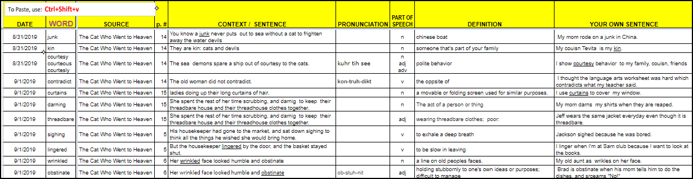
  - Re-read the sentence or paragraph containing the new word to understand what the book is saying.

- After reading a paragraph or chapter, write a summary in his reading composition book
  - For each paragraph (or a set of small paragraphs), write one sentence to summarize the paragraph(s).
  - At the end of each chapter, write a paragraph (with the aid of the paragraph summaries) to summarize the chapter.
He is almost finished with Chapter 2.

It would be great if you encourage Tevita to use some of the new words he's learning in his classroom writing projects. That way he can incorporate his vocabulary building from his reading in with his writing. I will encourage him to do this, too. I keep telling him that a word doesn't enter his vocabulary by simply looking up the word, he has to use it in his daily life to really make it part of his working vocabulary. It helps when others tell him the same thing.

Mahalo,
Vanessa Ott
808 - 854 -1018

_____________________________________

9/17/19 – Matsushige: Here is a list of attendees.

From: Ronald Matsushige <ronald.matsushige@k12.hi.us>
Date: Tue, Sep 17, 2019 at 8:50 AM
Subject: Re: Scheduling a Teacher Meeting
To: Vanessa Ott <msvott@gmail.com>
Cc: Katherine Balatico <katherine.balatico@k12.hi.us>, Toakase Ahomana <toahuahulu@gmail.com>

Good Morning Mrs. Ahomana and Ms. Ott!

Per your request, here is a list of the names of everyone that will be attending the meeting:
Katherine Balatico – Principal
Wade Okuma – Honolulu District SPED RT
Ronald Matsushige – Care Coordinator
Blake Carrigan – Math Teacher
Jay Visaya – Social Studies Teacher
Christine Asuncion – Science Teacher
Scott Kazarian – English/Language Arts Teacher
Anna Yamana – ELL Teacher
Carlton Lou – P.E. Teacher
Amy Tsujioka – Art Teacher

Thank you and see you Thursday!

Ronald Matsushige
_____________________________________

9/19/19 – MEETING @ 2:30 – 3:00 pm

location: RLSMS conference room

Attendees:
- Wade Okuma, Kaimuki-McKinley-Roosevelt Complex SpEd Resource Teacher [Meeting Facilitator]
- Anna Yamana, RLSMS ELL Coordinator
- Ronald Matsushige, RLSMS Care Coordinator for Tevita
- Blake Carrigan, RLSMS Math Teacher
- Katherine Balatico, RLSMS Principal
- Malcolm Yasuda, RLSMS Student Services Coordinator
- Amy Tsujioka, RLSMS Art Teacher
- Christine Asuncion, RLSMS Science Teacher
- Scott Kazarian, English/Language Arts Teacher
- Jay Visaya, RLSMS Social Studies Teacher
- Vanessa Ott, Tutor & Parent Assistant
- Feketi Huahulu, Parent
- Tevita Ahomana, Student
At the end of the meeting, Principal Balatico stated the following concerning communication:

“I just want to also state that I think what’s reasonable for me to be able to do within in a reasonable time frame when communicating back to you over email is one time a week.”

(See recording: 2019-09-19-Mtg-Part2.MP4 [01:08])
_____________________________________

9/20/19 – Ott: Please remember to send home Tevita’s work today.

From: Vanessa Ott <msvott@gmail.com>
Date: Fri, Sep 20, 2019 at 4:40 AM
Subject: Reminder: Friday Folder with Tevita's work
To: Amy Tsujioka <Amy.Tsujioka@k12.hi.us>, Anna Yamana <Anna.Yamana@k12.hi.us>, Blake Carrigan <Blake.Carrigan@k12.hi.us>, Christine Asuncion <Christine.Asuncion@k12.hi.us>, Jay Visaya <Jay.Visaya@k12.hi.us>, Linda Wong <Linda.Wong@k12.hi.us>, Scott Kazarian <Scott.Kazarian@k12.hi.us>
Cc: Ron Matsushige <Ronald.Matsushige@k12.hi.us>, Feketi (Toakase) Huahulu <huahulufeketi@gmail.com>, Tevita <AhomTevi19@rlsms.k12.hi.us>

Aloha,

Please remember to send home Tevita's work from the past week. Anything you want returned, please put in a folder which his mom will send back to school with him Monday morning.

Regarding the work which going to stay in the classroom that he's done this quarter prior to this week, please send this home today(Friday, 9/20) or next Friday (9/27) if you don't have time to put it together today.
Mahalo,
Vanessa Ott
808 - 854 -1018
_____________________________________

9/20/19 – Ott to Office of Curriculum & ID: Requesting a list DOE approved curricula for Grades K-8.

From: Vanessa Ott <msvott@gmail.com>
Date: Fri, Sep 20, 2019 at 7:29 AM
Subject: Requesting List of State-Approved Curricula for Grades K-8
To: <Donna.Kagawa@k12.hi.us>, <Iris.Kim@k12.hi.us>, <Angela.Pahia@k12.hi.us>

Aloha Office of Curriculum & Instructional Design Administration,

I am requesting a list of all State of Hawaii DOE-approved curricula for grades K-8.

If the information is online, please send the URL. I looked, but couldn't find the information. If not online, a PDF file with copyable text will do nicely.
Mahalo,
Vanessa Ott
808 - 854 -1018
_____________________________________

9/20/19 – Kazarian: I gave you Tevita’s work to date in yesterday’s meeting.

From: Scott Kazarian <scott.kazarian@k12.hi.us>
Date: Fri, Sep 20, 2019 at 7:56 AM
Subject: Re: Reminder: Friday Folder with Tevita's work
To: Vanessa Ott <msvott@gmail.com>

Thanks Ms. Ott. Great to see you again yesterday.

You have everything up to date for me in that folder from yesterday.

I'll have more next Friday

Mahalo!

SK :)

Scott Kazarian
English Language Arts | Stevenson Middle School
Scott.Kazarian@k12.hi.us

_____________________________________

9/20/19 – Matsushige: I put everything that needs to be returned on Monday in a manila envelope.

From: Ronald Matsushige <ronald.matsushige@k12.hi.us>
Date: Fri, Sep 20, 2019 at 3:27 PM
Subject: Re: Reminder: Friday Folder with Tevita's work
To: Vanessa Ott <msvott@gmail.com>
Cc: Feketi (Toakase) Huahulu <huahulufeketi@gmail.com>, Tevita <AhomTevi19@rlsms.k12.hi.us>

Hi Toakase, Vanessa, and Tevita,

I just wanted to let you know that Mr. Kazarian was not in school today so he isn't able to send anything home this week. However, I believe he gave you a copy of all Tevita's work yesterday for you to keep. I double checked with Mr. Kazarian's substitute teacher to make sure that what Tevita wrote in his journal was accurate.

Also, to make things easier, I put everything that needs to be returned on Monday in a large manila envelope. It's labeled "Please Return on Monday" so it's easy to find. Anything else should be in his binder.

Thank you very much, and have a great weekend!

Ronald Matsushige
_____________________________________

9/21/19 – Ott: Cannot log into Infinite Campus.

From: Vanessa Ott <msvott@gmail.com>
Date: Sat, Sep 21, 2019 at 3:10 AM
Subject: Tevita's Mom cannot log into Infinite Campus
To: Linda Wong <Linda.Wong@k12.hi.us>
Cc: Ron Matsushige <Ronald.Matsushige@k12.hi.us>, Feketi (Toakase) Huahulu <huahulufeketi@gmail.com>

Aloha,

Feketi Huahulu, Tevita Ahomana's mom, is unable to log into Infinite campus. There were no instructions with the card on how to log in, so we tried both the parent's phone number and email address, but neither worked. (See error messages below)

Perhaps the problem is because Tevita's mom changed her email address and phone number after the start of school. She did inform the office of the changes. Maybe the new information didn't make it to whomever sets up access accounts for infinite campus. Feketi's contact information is:

email: huahulufeketi@gmail.com
phone: 808-308-8977

If this information already is correct in the Infinite campus system, then we need someone to help us get logged in.

Mahalo,
Vanessa Ott
808 - 854 -1018

P.S. when we tried to get in with phone number, we got the confirmation code, but then got this error message:

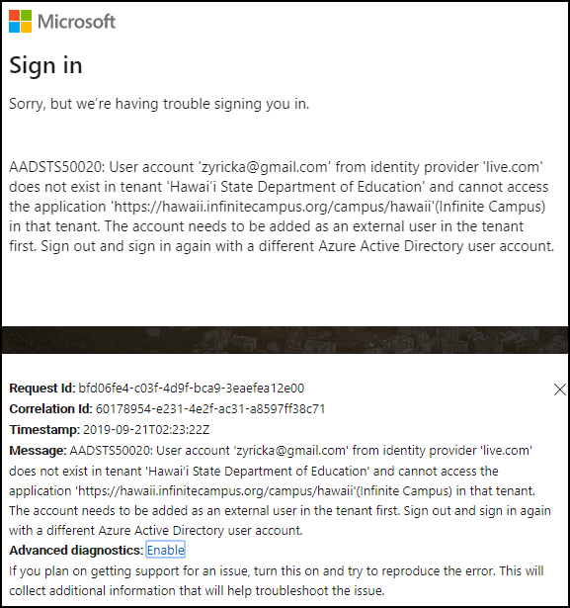

When we tried the email address, Feketi never received any email with password recovery information:

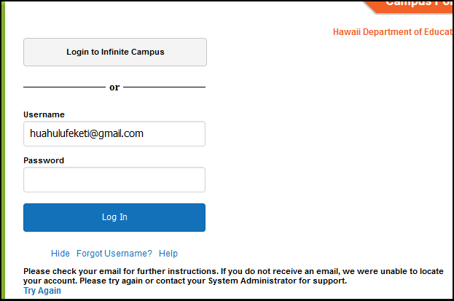

_____________________________________

9/21/19 – Wong: I forwarded your email to Julia Smith. A change of contact info verification form was sent home but hasn’t been returned; sending another.

From: Linda Wong <linda.wong@k12.hi.us>
Date: Sat, Sep 21, 2019 at 3:21 PM
Subject: Re: Tevita's Mom cannot log into Infinite Campus
To: Vanessa Ott <msvott@gmail.com>

I forwarded your email to Julia Smith who takes care of IC. As far as change of info, the school sent home a Verification form to check on any changes and duds not receive it yet. Several reminders were written to home via Tevtita’s planner. We just sent home another form on Friday.

_____________________________________

9/21/19 – Ott: I’ve forwarded a copy of your response to Mr. Matsushige and Tevita’s mom.

From: Vanessa Ott <msvott@gmail.com>
Date: Sat, Sep 21, 2019 at 6:17 PM
Subject: Fwd: Tevita's Mom cannot log into Infinite Campus
To: Linda Wong <Linda.Wong@k12.hi.us>
Cc: Ron Matsushige <Ronald.Matsushige@k12.hi.us>, Feketi (Toakase) Huahulu <huahulufeketi@gmail.com>

Aloha Ms. Wong,

Thank you for your prompt response. I am forwarding your message to Tevita's mom and cc:'ing Mr. Matsushige because he asked to be copied on all correspondence regarding Tevita.

Toakase,

Ms. Wong says that you have not returned the Change of Address form yet. So let's get that back to the school as soon as possible.

Mahalo,
Vanessa Ott
808 - 854 -1018

_____________________________________

9/24/19 – Ott: I have concerns about current writing assignments. There are some errors. When student hits “Turn In” button, he cannot edit.

From: Vanessa Ott <msvott@gmail.com>
Date: Tue, Sep 24, 2019 at 7:02 AM
Subject: Concerns about Tevita's writing assignments
To: Scott Kazarian <Scott.Kazarian@k12.hi.us>
Cc: Ron Matsushige <Ronald.Matsushige@k12.hi.us>, Feketi (Toakase) Huahulu <huahulufeketi@gmail.com>

Aloha Mr. Kazarian,

I have some concerns and a question about Tevita's current writing assignments.

1) There are a lot of grammatical errors in the instructions for: "Tevita Ahomana - 2 - HERO Adjectives Paragraph - Pop Super Comic" and "Tevita Ahomana - 3 - VILLAIN Adjectives Paragraph - Pop Super Comic":

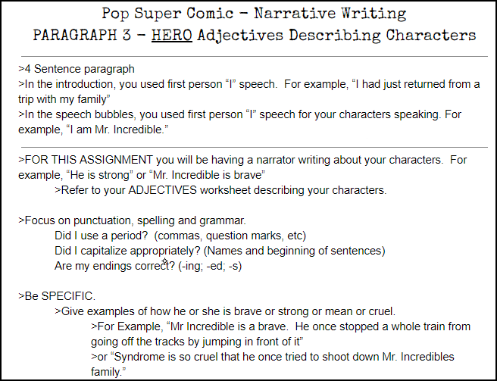

These are the grammatical errors:

No ending punctuation in the example.
...>4 Sentence paragraph
>...For example, “I had just returned from a trip with my family”

No ending punctuation in the example.
>FOR THIS ASSIGNMENT... For example, “He is strong” or “Mr. Incredible is brave”

The addition of the article "a" turns "brave" into a noun when it's supposed to be an example of the adjective "brave." No ending punctuation in the second example.
>Be SPECIFIC....For Example, “Mr Incredible is a brave. He once stopped a whole train from going off the tracks by jumping in front of it”

Missing apostrophe. Should be "...Mr. Incredible's family."
“Syndrome is so cruel that he once tried to shoot down Mr. Incredibles family.”

2) The instructions state that his previous Super Hero writing was in 1st person point of view and alludes to 3rd person point of view as this new assignment's objective. But, "3rd person" is not specifically mentioned or described. Tevita needs instruction in point of view. I've taught him this before (more than once), but his memory is not good and he has a developmental delay. So, I don't think it has fully sunk in. Plus, I don't think he's ever had clear instruction on the topic in school. Certainly not last year because it wasn't in the 5th grade curriculum. Now that he's older, he may have the maturity to understand 1st and 3rd person point of view, be able to remember what it is, and grasp why it's important to understand point of view (because it affects the verb form that's should be used with the subject). I assume SpringBoard has intervention lessons on the topic.

3) There are two assignments with the same name: Tevita Ahomana - 3 - VILLAIN Adjectives Paragraph - Pop Super Comic

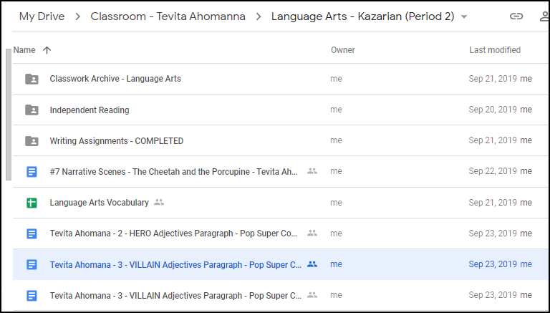

I notice the difference was that one was enabled with the "TURN IN" button and one was not. To avoid confusion for Tevita, I put the one without the TURN IN button in the trash. I hope that's okay.

4.) I don't see Tevita everyday, so I don't see his planner everyday. I see that he has 3 writing assignments to turn in. Is it correct to assume that once an assignment appears in his Language Arts folder, and he receives an email from you about this, that he should start working on it?
If that is correct, I will talk to him about this process this afternoon, and get him in the habit of checking his email and writing the assignments in his planner so he doesn't forget.
I'll also help him work on the writing assignments. I've asked him to not hit the "TURN IN" button until he edits and proofreads it with my supervision first.

Mahalo,
Vanessa Ott
808 - 854 -1018

_____________________________________

9/24/19 – Ott: Tevita’s classwork has been scanned and uploaded to his Google Drive. Per our agreements as of 9/19 meeting, here is a workflow document. Please review for accuracy.

From: Vanessa Ott <msvott@gmail.com>
Date: Tue, Sep 24, 2019 at 11:08 AM
Subject: Tevita's workflow system
To: Amy Tsujioka <Amy.Tsujioka@k12.hi.us>, Anna Yamana <Anna.Yamana@k12.hi.us>, Blake Carrigan <Blake.Carrigan@k12.hi.us>, Christine Asuncion <Christine.Asuncion@k12.hi.us>, Feketi (Toakase) Huahulu <huahulufeketi@gmail.com>, Jay Visaya <Jay.Visaya@k12.hi.us>, Linda Wong <Linda.Wong@k12.hi.us>, Lou Carlton <Carlton.Lou@k12.hi.us>, Ron Matsushige <Ronald.Matsushige@k12.hi.us>, Scott Kazarian <Scott.Kazarian@k12.hi.us>, Tevita <AhomTevi19@rlsms.k12.hi.us>

Aloha Tevita's Learning Community,

Thank you for sending home Tevita's work last Friday. We scanned his work documents and put them in his Google Drive so he can refer to them and study them without having to carry around a lot of paper. Tevita doesn't yet know how to study what he learns in school to implant it into his memory. Achieving greater success with studying is one of our goals this year.

Per our agreements at last Thursday's meeting (9/19), I constructed a draft of Tevita's workflow system (attached). Tevita does well in a structured environment with specific checklists for him to remember what to do. Toakase and I are the same.

Please review the document and let me know if there are any changes that need to be made. As you will see on p. 5 (PERMISSIONS), we're going to share Tevita's entire "Classroom" folder on his Google drive (read only), and share each subject-specific folder with edit privileges for that subject's teacher. If you don't want us to share Tevita's online folders with you, or if you want us to un-share once we do, please let me know.

Mahalo,
Vanessa Ott
808 - 854 -1018

attachment: Workflow-Tevita-20019-10-04.pdf
(5 pages total)

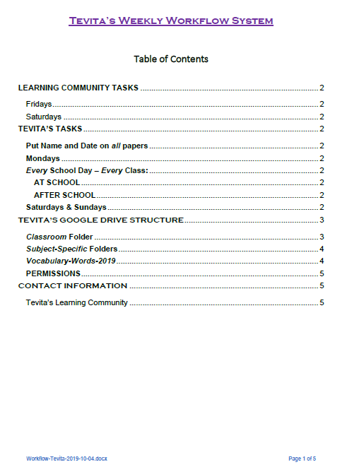
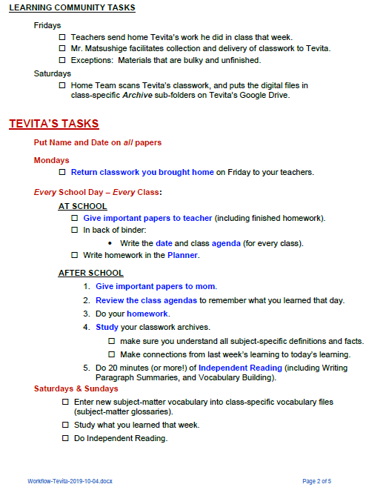
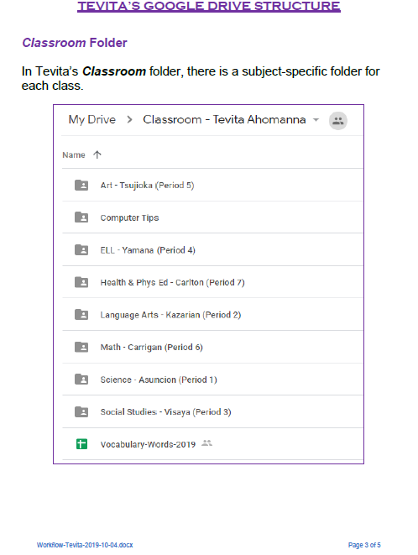
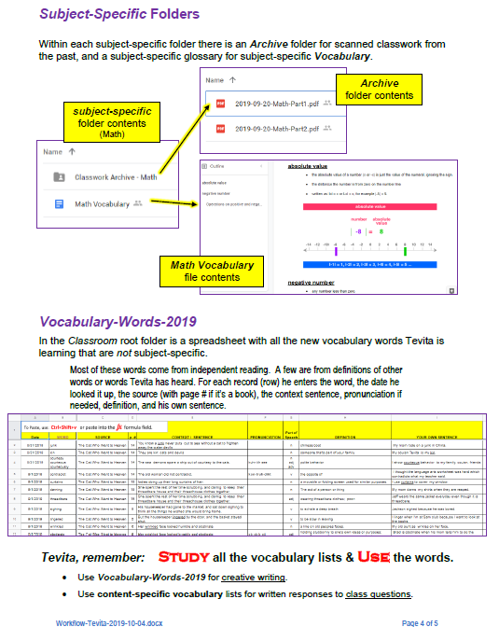
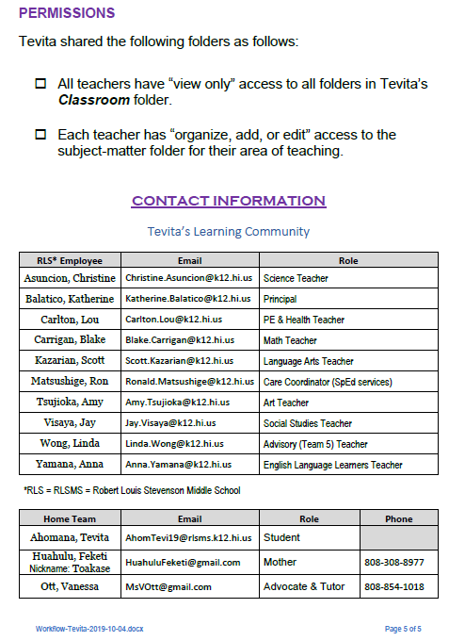
_____________________________________

9/25/19 – Kazarian: Thank you for bringing the errors to my attention. Students do “Turn In” writing assignments at the end of class.

From: Scott Kazarian <scott.kazarian@k12.hi.us>
Date: Wed, Sep 25, 2019 at 7:27 AM
Subject: Re: Concerns about Tevita's writing assignments
To: Vanessa Ott <msvott@gmail.com>
Cc: Ronald Matsushige Ronald.Matsushige@k12.hi.us

Good morning Ms. Ott,

Thank you for emailing me. I believe I have addressed your concerns #1 and #2 from your email in the google document that Tevita is working on.

#3 was probably just a google classroom error in the creation of the document and I appreciate you bringing it to my attention and also deleting it.

For #4, I have added in-class assignments as some students are finishing current work and are continuing on to the next assignment when they are ready. I believe the emails you're referring to are generated by Google as I create the assignments. For Tevita, we have added 20 minutes of independent reading as his homework. They do turn in their assignments at the end of the period and I do go in and give constructive feedback as we work through the revising/editing portion of the writing process. In the next class time together, I conference with each student as they work through the feedback I've provided as we work towards our final paragraphs.

Mahalo!

SK :)

Scott Kazarian
English Language Arts | Stevenson Middle School
Scott.Kazarian@k12.hi.us

_____________________________________

9/25/19 – Ott to Curriculum Associates: Parent wants to purchase a Ready Teacher Toolbox license.

From: Vanessa Ott <msvott@gmail.com>
Date: Wed, Sep 25, 2019 at 8:40 AM
Subject: How much does a Ready Teacher Toolbox license cost?
To: <MCho@cainc.com>
Cc: Feketi (Toakase) Huahulu <huahulufeketi@gmail.com>

Aloha Mr. Cho,

I live in Hawaii and volunteer my time to help a Special Education / English Language Learner Tongan-American boy and his mom, Feketi Huahulu. Feketi is interested in purchasing a license to the Ready Teacher Toolbox because her son's school, Robert Louis Stevenson Middle School, uses Ready as their Math curriculum.

Last year we purchased the Origo Stepping Stones Digital Teacher Edition which I'm sure is similar to the Ready Teacher Toolbox. Access to all the Stepping Stones intervention materials at home helped considerably with home-to-school collaboration. Feketi's son achieved considerable academic growth by the end of last school year considering his learning disabilities and language limitations.

We look forward to hearing from you.

Mahalo,
Vanessa Ott
808 - 854 -1018
freespeech4us.com

_____________________________________

9/25/19 – Curriulum Associates: We do no t sell directly to parents/consumers. Ready Teacher Toolbox can only be purchased by the school.

From: Matt Cho <MCho@cainc.com>
Date: Wed, Sep 25, 2019 at 10:31 AM
Subject: RE: How much does a Ready Teacher Toolbox license cost?
To: Vanessa Ott <msvott@gmail.com>
Cc: Feketi (Toakase) Huahulu <huahulufeketi@gmail.com>
Hi Vanessa,
Thank you for your email. I’m sorry, but we do not sell directly to parents/consumers. Ready Teacher Toolbox can only be purchased by the school.
I’ve attached the trial access code for Toolbox. It’s good for two months and if you still want access afterwards, let me know.
Thanks,
Matt
Matthew Cho | Hawaii Partnership Manager
Curriculum Associates | mcho@cainc.com
C: (808) 321-8966
F: 1-800-605-9348
––––––––––––––––––––––––––
Ready® | i-Ready® | BRIGANCE®

_____________________________________

9/27/19 – Matsushige: Hopefully workflow will help with what Ott and Mom want Tevita to do at home.

From: Ronald Matsushige <ronald.matsushige@k12.hi.us>
Date: Fri, Sep 27, 2019 at 2:44 PM
Subject: Re: Tevita's workflow system
To: Vanessa Ott <msvott@gmail.com>
Cc: Amy Tsujioka <Amy.Tsujioka@k12.hi.us>, Anna Yamana <Anna.Yamana@k12.hi.us>, Blake Carrigan <Blake.Carrigan@k12.hi.us>, Christine Asuncion <Christine.Asuncion@k12.hi.us>, Feketi (Toakase) Huahulu <huahulufeketi@gmail.com>, Jay Visaya <Jay.Visaya@k12.hi.us>, Linda Wong <Linda.Wong@k12.hi.us>, Lou Carlton <Carlton.Lou@k12.hi.us>, Scott Kazarian <Scott.Kazarian@k12.hi.us>, Tevita AhomTevi19@rlsms.k12.hi.us

Good Afternoon Ms. Ott,

Thank you for sharing Tevita's workflow system. Hopefully, it will help Tevita with what you and Mom would like to have him doing at home.

Have a great weekend!

Ronald Matsushige
_____________________________________

9/27/19 – Matsushige: Social Studies and Art can’t sent home ongoing project work this week. Language Arts and ESOL work is in his Google drive. Do not help Tevita correct his writing.

From: Ronald Matsushige <ronald.matsushige@k12.hi.us>
Date: Fri, Sep 27, 2019 at 3:27 PM
Subject: Work Collection
To: Toakase <toahuahulu@gmail.com>, Vanessa Ott msvott@gmail.com

Good Afternoon,

Just wanted to let you know, Social Studies and Art are working on projects so they can't send anything home this week. For ELA and ESOL the work is on google so you can see it there. However, they are both going over the editing process for writing in class so they ask that you do not help him correct his writing. He can of course continue to write, but he will be correcting any errors he makes in class with his teachers. Science and Math have included things in the "Please Return on Monday" envelope.

Thank you!
Ronald Matsushige
_____________________________________

9/27/19 – Asuncion: Attached is worksheet Tevita needs to finish.

From: Christine Asuncion <christine.asuncion@k12.hi.us>
Date: Fri, Sep 27, 2019 at 7:42 PM
Subject: Interdependence worksheet
To: <msvott@gmail.com>, Ronald Matsushige ronald.matsushige@k12.hi.us

Good evening,

I am attaching the interdependence worksheet that Tevita needs to finish.

Thank you,
Mrs. Asuncion

attachment: interdependence.pdf
_____________________________________

9/28/19 – Ott: Thank you for clearing up confusion about assignment.

From: Vanessa Ott <msvott@gmail.com>
Date: Sat, Sep 28, 2019 at 7:16 AM
Subject: Re: Interdependence worksheet
To: Christine Asuncion <christine.asuncion@k12.hi.us>
Cc: Ron Matsushige <Ronald.Matsushige@k12.hi.us>, Feketi (Toakase) Huahulu huahulufeketi@gmail.com

Aloha Mrs. Asuncion,

Thank you for writing to me about this. I saw your post-it note on the paper yesterday:

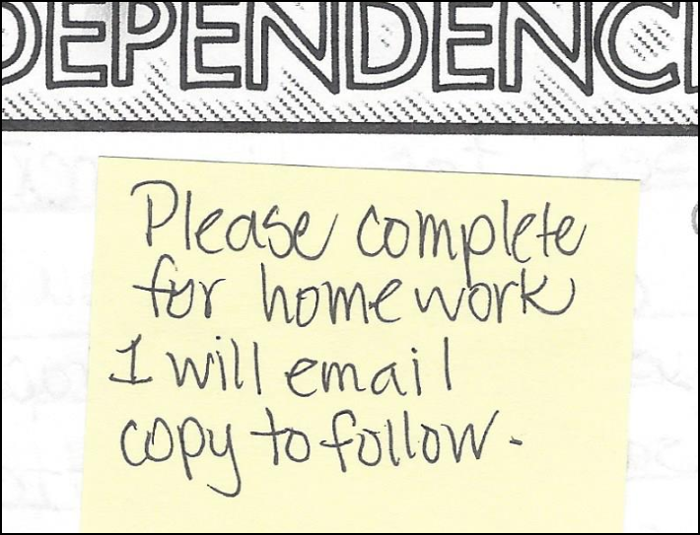

When I questioned Tevita about this, he said that he couldn't complete the page without viewing some material that had been projected in class. I was confused until I got your email. Thank you for sending the material.

The assignment wasn't written in his planner, though, so we had a disagreement about whether or not he was supposed to be doing this for homework. Now that we have the material it's clearer now what he's supposed to do.

I don't know if you had a chance to look at the Workflow document we sent. We are trying to get Tevita in the habit of writing down the day's agenda (he has a spiral-bound notebook in his binder for this purpose), and his homework.

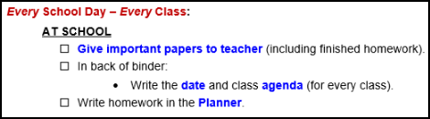

Tevita is capable of learning routines, but he seems to need A LOT of reminders until routines become habits. Please remind him to write the agenda at the beginning of class and his homework assignment (with enough information so it's clear to those of us at home what he's supposed to be doing). Also, please remind him first thing to put his name and date on all his papers. He had this routine down by the middle of last school year, but without his teachers reminding him this year, the practice has fallen out of habit.

Mahalo,
Vanessa Ott
808 - 854 -1018

_____________________________________

9/30/19 – Asuncion: Thank you. Hope he completed the assignment.

From: Christine Asuncion <christine.asuncion@k12.hi.us>
Date: Mon, Sep 30, 2019 at 8:25 AM
Subject: Re: Interdependence worksheet
To: Vanessa Ott <msvott@gmail.com>
Cc: Ron Matsushige <Ronald.Matsushige@k12.hi.us>, Feketi (Toakase) Huahulu <huahulufeketi@gmail.com>

Thank you! I am glad that you received my email. I hope that he was able to complete his assignment. I will remind him to write his assignments but it it posted on my board for him to copy.

Thanks,
Mrs. Asuncion

_____________________________________

10/4/19 – Ott: Please no more coloring exercises in Math. Please continue to reinforce paper-dating routine.

From: Vanessa Ott <msvott@gmail.com>
Date: Fri, Oct 4, 2019 at 5:11 AM
Subject: Please, no more coloring exercises in Math, and make sure papers are dated
To: Blake Carrigan <Blake.Carrigan@k12.hi.us>
Cc: Ron Matsushige <Ronald.Matsushige@k12.hi.us>, Feketi (Toakase) Huahulu <huahulufeketi@gmail.com>, Tevita <AhomTevi19@rlsms.k12.hi.us>

Aloha Ms. Carrigan,

Tevita's exponent Math exercises last night concluded with a coloring exercise. I told Tevita to not do the coloring page because his time would be better spent doing his independent reading. Also, I see no pedagogical value to this coloring exercise. It seems quite below the intelligence of a 12-year-old boy. It would be better to enhance his Math learning with a word problem. I haven't seen much evidence of applied math with word problems in any of his work and this concerns me.

I acknowledge that coloring has value in that it teaches fine motor and art skills. So his mom and I worked out a day to do coloring and drawing. That will be his Sunday, after church, weekly activity. If there is a Math project that involves coloring related to what Tevita is learning in Math, he can do it on Sunday.

I've asked him to date all his papers. Please make sure that as soon as he receives any papers, he puts his name and the date on all of them. He's still not doing this. Tevita needs routines, and until they become habits, he needs a lot of reminding.

Mahalo,
Vanessa Ott
808 - 854 -1018

_____________________________________

10/4/19 – Matsushige: Contents of this week’s envelope and assignment update.

From: Ronald Matsushige <ronald.matsushige@k12.hi.us>
Date: Fri, Oct 4, 2019 at 2:57 PM
Subject: Return on Monday Envelope
To: Toakase <toahuahulu@gmail.com>, Vanessa Ott <msvott@gmail.com>

Good Afternoon!

This week the envelope has the Science notebook, and some Social Studies work. Mr. Visaya said Tevita just has to finish the picture dictionary for the five terms. He will be using that information to do the next step of a project. ELA and ESOL are on Google Docs, but Tevita is finished with his work for the Quarter so he doesn't need to work on any assignments during the break. The Art teacher was absent today so nothing from Art. Math doesn't need anything back, so I didn't have anything in the envelope for that subject.

Thank you and have a great break!

Ronald Matsushige

_____________________________________

10/5/19 – Ott: We did not find Science notebook in envelope.

From: Vanessa Ott <msvott@gmail.com>
Date: Sat, Oct 5, 2019 at 4:01 AM
Subject: Re: Return on Monday Envelope
To: Ronald Matsushige <ronald.matsushige@k12.hi.us>
Cc: Toakase <toahuahulu@gmail.com>

Aloha Mr. Matsushige,

You said the Science notebook was in the envelope, but by the time it arrived home, there was no Science notebook. Are you sure you put the Science notebook in the "Return on Monday" envelope?

Mahalo,
Vanessa Ott
808 - 854 -1018

_____________________________________

10/5/19 – Ott: Science notebook was located in Tevita’s backpack.

From: Vanessa Ott <msvott@gmail.com>
Date: Sat, Oct 5, 2019 at 12:29 PM
Subject: Re: Return on Monday Envelope
To: Ronald Matsushige <ronald.matsushige@k12.hi.us>
Cc: Toakase <toahuahulu@gmail.com>

The Science notebook has been located. For some reason it wasn't in the envelope. It was just in his backpack.

Mahalo,
Vanessa Ott
808 - 854 -1018

_____________________________________

10/6/19 – Ott: Social Studies Vocabulary is in a Google doc. Please have him use a computer during class for building vocabulary.

From: Vanessa Ott <msvott@gmail.com>
Date: Sun, Oct 6, 2019 at 5:35 AM
Subject: Review of Tevita's Q1 Social Studies progress; plans for Q2
To: Jay Visaya <Jay.Visaya@k12.hi.us>, Tevita <AhomTevi19@rlsms.k12.hi.us>, Ron Matsushige <Ronald.Matsushige@k12.hi.us>, Feketi (Toakase) Huahulu <huahulufeketi@gmail.com>

Aloha Mr. Visaya and Tevita,

All of the Social Studies papers that Tevita received back to keep or were sent home in the "Return on Monday" envelope on Fridays 9/20, 9/27, and 10/4 have been scanned. The files are in Tevita's shared folder here:

As far as we can tell, the content of the files located in the Archive folder is the sum total of what Tevita has accomplished in Social Studies during the first quarter of the school year (Q1).

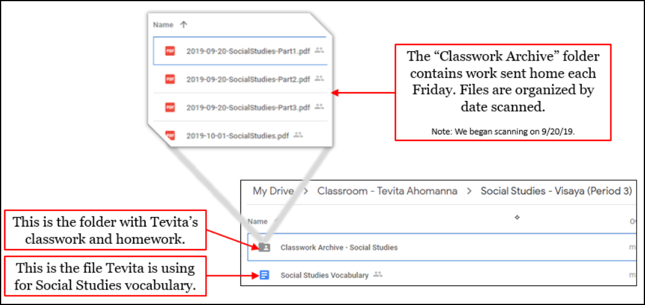

We have some concerns, and hope that in the second quarter (Q2) of the school year we can overcome some of Q1's hurdles.
- Date All Papers
Problem: Tevita is not putting the date on all his papers. This makes it very difficult for him to organize the papers so that they can be scanned in chronological order. That in turn makes life harder for Toakase and Ms.Ott to scan the papers so that Tevita has them available online. The Q1 papers are a bit of a jumbled mess because there were no dates on most of them, though we preserved the paper-clipped groupings as best we could.

Solution:
TEVITA: Put your name and date on every paper you receive, as soon as you get the paper in your hands!

MR. VISAYA: Please remind Tevita to name and date his papers until it becomes an automatic habit.
- Is the only Social Studies work Tevita did for 2 weeks merely 5 academic vocabulary words?
Problem: The only Social Studies work that came home the weeks of 9/23-9/27 and 9/30-10/4 was a worksheet with 5 Academic Vocabulary words (see Archive file: 2019-10-04-SocialStudies.pdf). I'm going to assume that Tevita did more than this in two weeks, but for some reason, the papers did not come home.

Solution:
MR. VISAYA & MR. MATSUSHIGE: Please make sure the work Tevita does during each week comes home on Friday of that week (or Thursday if one of you is unavailable on Friday). Toakase and I scan the weekly papers on Friday afternoons.
- Papers that need to be returned on Monday go in the "Return on Monday" envelope.
- Papers that Tevita can keep go in the Social Studies section of his zippered binder.
TEVITA:
- Do not take anything out of the "Return on Monday" envelope.
- Put all the papers you get back that you're allowed to keep in the Social Studies section of your binder.

- We request that in the future, Tevita use his "Social Studies Vocabulary" Google doc to record Academic Vocabulary.
Tevita is capable of learning more content when he records his academic vocabulary in either google docs or sheets. There are many benefits to this approach. He types faster than he writes and he can write more extended thoughts and better sentences if he types them because he doesn't get bogged down with the fine motor skills of handwriting. He can do Google image searches, and with teacher guidance, select an appropriate illustration for a new term. He knows how to insert the pictures into his Google docs, and he also knows how to use the outline feature with Header fonts. Working on his computer to increase his academic vocabulary, he can extend his learning using the online dictionaries (wordsmyth.net and dictionary.com) to look up words he doesn't know. I also can send him on webquests to find more information about a topic by suggesting specific web pages to read. When it comes to studying, and reviewing what's he's learned, a vocabulary list like this is very helpful.

Therefore, we request that Tevita use his computer in class when doing Academic Vocabulary work.

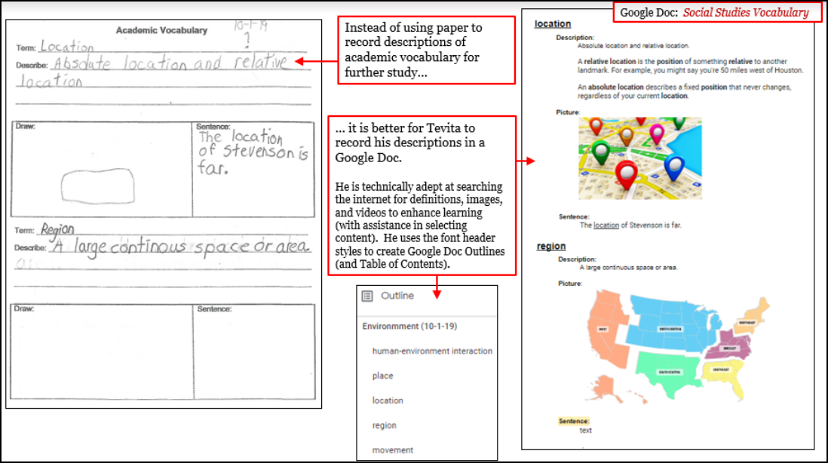
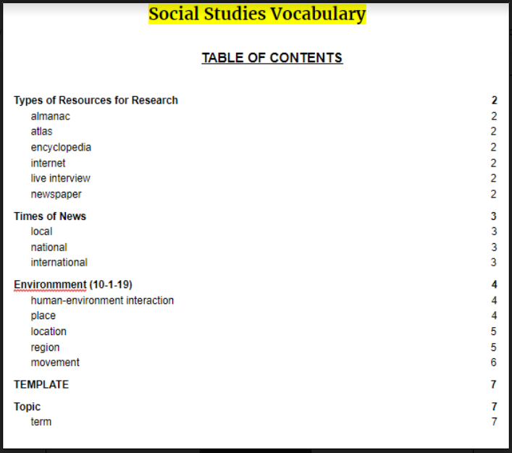

Is this acceptable to everyone? Are there any other improvements anyone else wants to make for Q2?

Mahalo,
Vanessa Ott
808 - 854 -1018

_____________________________________

10/6/19 – Schatz: DOE provides guidance and tools for reviewing instructional materials. Schools are empowered to make instructional material selections that match their school designs and communities.

From: Petra Schatz <petra.schatz@k12.hi.us>
Date: Sun, Oct 6, 2019 at 12:49 PM
Subject: Thanks you for your interest in education materials.
To: <msvott@gmail.com>
Cc: Donna Kagawa <donna.kagawa@k12.hi.us>, Iris Kim <Iris.Kim@k12.hi.us>, Andrea Hardy <andrea.hardy@k12.hi.us>

Dear Ms. Ott,

Thank you for your email inquiry dated September 20, 2019. The Hawaii Department of Education currently provides guidance and tools for reviewing high-quality instructional materials, resources for examining vetted materials and links to Open Education Resources via our Learning Design Resource Website: https://learningdesign.hawaiipublicschools.org/school-design/learning-materials.

At this time complex areas and schools are empowered to make instructional materials selections that are best matched to their school designs and communities. Your school will be able to provide you with a list of materials that are being used on your campus.

Mahalo,
Petra

Petra Schatz, Ph.D.
Educational Specialist, English Language Arts
Office of Curriculum and Instructional Design

_____________________________________

From: Vanessa Ott <msvott@gmail.com>
Date: Fri, Oct 11, 2019 at 4:43 PM
Subject: Re: Thanks you for your interest in education materials.
To: Petra Schatz <petra.schatz@k12.hi.us>
Cc: Donna Kagawa <donna.kagawa@k12.hi.us>, Iris Kim <Iris.Kim@k12.hi.us>, Andrea Hardy <andrea.hardy@k12.hi.us>

Thank you for the information. It has been helpful.

Mahalo,
Vanessa Ott
808 - 854 -1018
MsVOtt@gmail.com
_____________________________________

10/9/19 – Matsushige: Glad notebook found.

From: Ronald Matsushige <ronald.matsushige@k12.hi.us>
Date: Wed, Oct 9, 2019 at 8:02 AM
Subject: Re: Return on Monday Envelope
To: Vanessa Ott <msvott@gmail.com>
Cc: Toakase <toahuahulu@gmail.com>

Good Morning!

Sorry for the late reply, my teacher computer was being fixed until today. I'm glad Tevita found the notebook.
Have a great rest of the break!

Ronald Matsushige
_____________________________________

10/10/19 – Ott: Tevita did not bring home any Art classwork for Q1. When will the work be sent home?

From: Vanessa Ott <msvott@gmail.com>
Date: Thu, Oct 10, 2019 at 5:52 AM
Subject: No Art classwork for Q1
To: Amy Tsujioka <Amy.Tsujioka@k12.hi.us>
Cc: Ron Matsushige <Ronald.Matsushige@k12.hi.us>, Feketi (Toakase) Huahulu <huahulufeketi@gmail.com>
Aloha Ms. Tsujioka,

Tevita did not bring home any Art papers all first quarter. So, from the home side, it looks like he didn't do or learn anything in Explore Wheel during Q1. When will we be able to get his work sent home?

Mahalo,
Vanessa Ott
808 - 854 -1018
_____________________________________

10/12/19 – Ott: Improvement Plans for Q2. Requesting meetings regarding Math and Language Arts curricula to prepare for IEP.

From: Vanessa Ott <msvott@gmail.com>
Date: Sat, Oct 12, 2019 at 5:58 AM
Subject: Plans for Tevita's progress in Q2
To: Ron Matsushige <Ronald.Matsushige@k12.hi.us>, Feketi (Toakase) Huahulu <huahulufeketi@gmail.com>

Aloha Mr. Matsushige,

FYI, I added two new files to Tevita's Classroom folder and attached copies to this email for your convenience:
- Planner-Agenda-Master-2019-10-04.pdf - A compilation of Tevita's planner and classroom agendas for the last 3 weeks of school.
- Agenda-Template.pdf - A template for Tevita to write classroom agendas without having to do the repetitive work of writing the class names.
At this stage, there are 3 areas of highest concern:
- Making homework instructions in the planner clear enough for Toakase to understand.
- Would like to arrange a time to have an in-depth demonstration of the SpringBoard Language Arts curriculum.
- Would like to arrange a time to have an in-depth demonstration of the Ready Math curriculum.
- Teaching Tevita how to be an independent learner.
Re: Planner - There have been arguments and some confusion at home about what Tevita is supposed to be doing because the homework notations are often cryptic. Sometimes there's a homework notation for say, working on the adjectives in a language arts writing assignment, but the file to which it refers is locked down. Sometimes there's a notation to study for a Social Studies test, but he doesn't have the material from which to study. Sometimes Tevita says that what's written in the planner isn't homework - it's what they did in class. It would be helpful if the teachers would look at what Tevita writes in his planner and make sure the Toakase (and Tevita) will be able to understand exactly what he's supposed to be working on. While Toakase cannot help Tevita with the content of Tevita's schoolwork, she is capable of reading basic instructions in English (if the penmanship is good enough) and making sure Tevita is doing what is written down. It's a useful skill for teachers to evaluate whether or not the non-native-English-speaking-SpEd parent on the home front will be able to decipher what's written in the planner.

Re: Language Arts and Math curricula: Looking over the body of work Tevita has accomplished in Q1 for Math and Language Arts it all seems a bit disjointed, lacking direction and rigor. For example, some of the Language Arts assignments have had spelling errors and incorrect grammatical information. The Math work jumps from skill to skill with little practical application to the real world (like word problems), and there seems to be very little mathematical understanding of how these skills connect or how to visualize what the numbers mean (which was a strength in the Stepping Stones curriculum). So, I wonder, are the teachers following the Springboard and Ready curricula or making it up as they go along? We'd like a more in-depth look at the curriculum for Math and Language Arts.

Re: Teaching How to Be an Independent Learner - Tevita doesn't really know how to study on his own and be an independent learner. I would like to have a discussion to explore how we can teach Tevita to be an Independent Learner. Part of that process is making it possible for him to visually review what he did in class each day to cement it in his mind. Sending home work at the end of the week doesn't accomplish this. Tevita is more capable of doing things than he lets on; he isn't in the habit of checking and rechecking his work; he says, "I'm done," or asks for help before trying to solve something himself; he is often lazy and does not do his best instead opting for the shortest route to saying, "I'm done." I wonder how we can overcome these behaviors. I found a motivational article about self-motivation online that I rewrote so that Tevita could understand it (also attached). I emailed it to him, but he is on the mainland and I doubt he's checked his email while away, though I do see he's been making progress on writing paragraph summaries about his independent reading while in Oakland, CA.

Toakase and I available to meet any day before school unless there is a morning appointment, which is unusual. We're also available after school almost all Wednesdays, Thursdays (until 3:30), and Fridays.

Once we get these things straightened out, then it would be a good time to have the IEP meeting to set a clear plan for the rest of the school year, yes?

Mahalo,
Vanessa Ott
808 - 854 -1018

attachments:
- Planner-Agenda-Master-2019-10-04
- Agenda-Template.pdf
- How-to-be-Self-Motivated-Learner.pdf

(These files are located in Tevita’s Google Drive.)
_____________________________________

10/13/19 – Ott: Here is our availability for a meeting.

From: Vanessa Ott <msvott@gmail.com>
Date: Sun, Oct 13, 2019 at 7:44 PM
Subject: Re: Plans for Tevita's progress in Q2
To: Ron Matsushige <Ronald.Matsushige@k12.hi.us>, Feketi (Toakase) Huahulu <huahulufeketi@gmail.com>

Since my last email, something has come up and I will be off island on the dates marked in purple below.

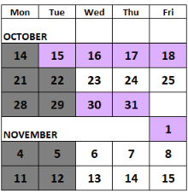

Normally, we are available to meet any morning M-F. All day Wed, Thu (until 3:30p), and Fri.

Mahalo,
Vanessa
_____________________________________

10/15/19 – Ott: Tevita wasted class time re-copying definitions because he could not find the paper (that had been scanned and stored in his Social Studies folder in Google Drive).

From: Vanessa Ott <msvott@gmail.com>
Date: Tue, Oct 15, 2019 at 5:37 AM
Subject: Fwd: Review of Tevita's Q1 Social Studies progress; plans for Q2
To: Jay Visaya <Jay.Visaya@k12.hi.us>, Tevita <AhomTevi19@rlsms.k12.hi.us>
Cc: Ron Matsushige <Ronald.Matsushige@k12.hi.us>, Feketi (Toakase) Huahulu <huahulufeketi@gmail.com>

Aloha Mr. Visaya and Tevita,

On Monday, 10/14, Tevita says he spent his class time with the substitute copying his social studies vocabulary onto a sheet of paper while his classmates worked on a poster because he could not find his vocabulary sheet. I reminded him that each week his mother and I archive his work online so that everything is available on his Google drive. The paper he was looking for is in the Classwork Archive folder in the file: 2019-10-04-SocialStudies.pdf I've attached it to this email for your convenience.

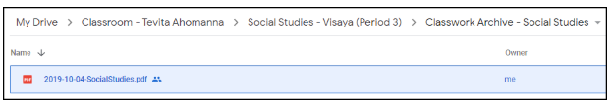

Not only that, before he left for the mainland during Fall Intersession, he spent quite a bit of time working on putting that information into his Social Studies Vocabulary Google doc (and expanding upon it) as shown in the email I sent on 10/6 (below). I reminded Tevita last night that if he can't find a piece of paper, he should look on his Google Drive because we are archiving all his papers each week.

Tevita does better learning when he can use his computer tool.

Mahalo,
Vanessa Ott
808 - 854 -1018
MsVOtt@gmail.com
freespeech4us.com/pianolessons

attachment: 2019-10-04-SocialStudies.pdf

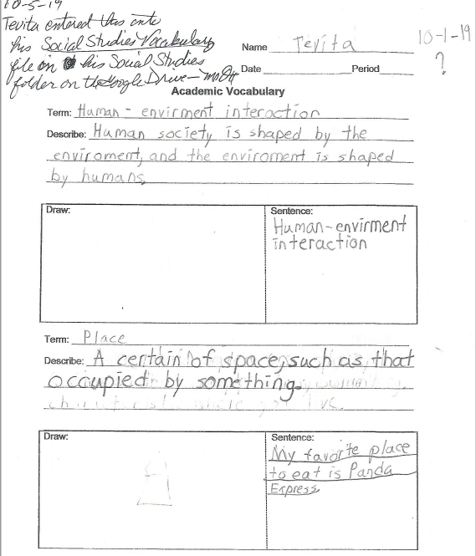
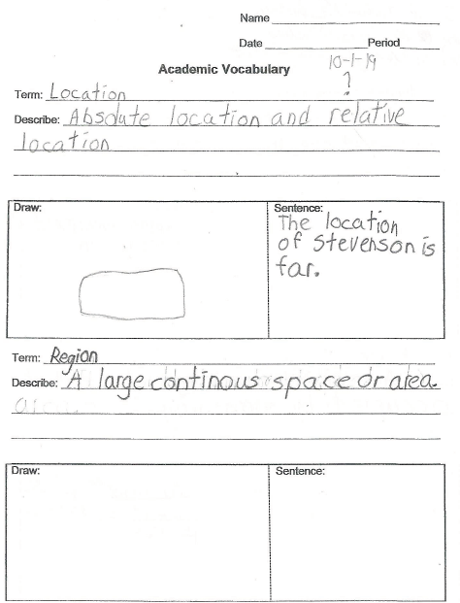
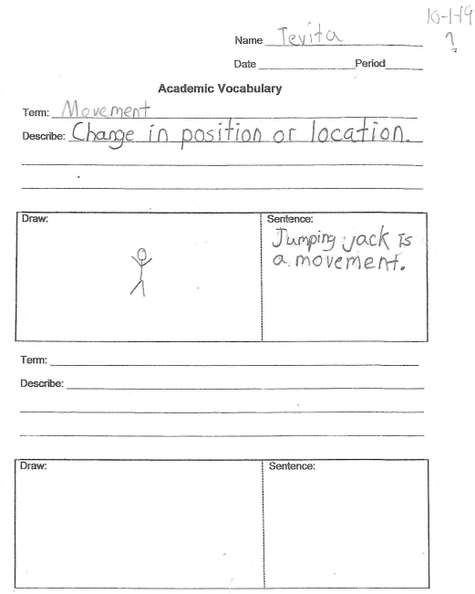

_____________________________________

10/15/19 – Visaya: Thank you for continued support. Tevita will be using newspapers and magazines for his poster.

From: Jay Visaya <jay.visaya@k12.hi.us>
Date: Tue, Oct 15, 2019 at 12:58 PM
Subject: Re: Tevita's Social Studies Vocabulary is recorded in an online document
To: Vanessa Ott <msvott@gmail.com>
Cc: Tevita <AhomTevi19@rlsms.k12.hi.us>, Ron Matsushige <Ronald.Matsushige@k12.hi.us>, Feketi (Toakase) Huahulu <huahulufeketi@gmail.com>

Thank you for your continued support. Today worked on organizing his poster while referring to his google drive. He'll be using newspapers and magazines to cut out examples of each Geography theme making a collage.

Mr. Visaya

_____________________________________

10/15/19 – Ott: What are you doing to teach Tevita to check his Math work?

From: Vanessa Ott <msvott@gmail.com>
Date: Tue, Oct 15, 2019 at 6:38 AM
Subject: Teaching Tevita to "check his work"; last night's homework
To: Blake Carrigan <Blake.Carrigan@k12.hi.us>
Cc: Ron Matsushige <Ronald.Matsushige@k12.hi.us>, Feketi (Toakase) Huahulu <huahulufeketi@gmail.com>, Tevita <AhomTevi19@rlsms.k12.hi.us>

Aloha Ms. Carrigan,

Tevita is not checking his Math work. I'm trying to teach him to do this, and have been for years, but it's not sinking in. So, I wonder what he's learning in school about how to "check his work." The best way I know how to check one's math work is, once one is finished with a worksheet to take a break, write the problems on a separate paper and rework them without looking at what you did the first time (otherwise one risks repeating any mistakes one may have made). When I do this, I find that if I get the same answer twice, it's usually right. If I get two different answers, I rework it a third time, carefully, and figure out which answer is really right.

Here's how homework review went last night. Tevita's texted me his "finished" homework:
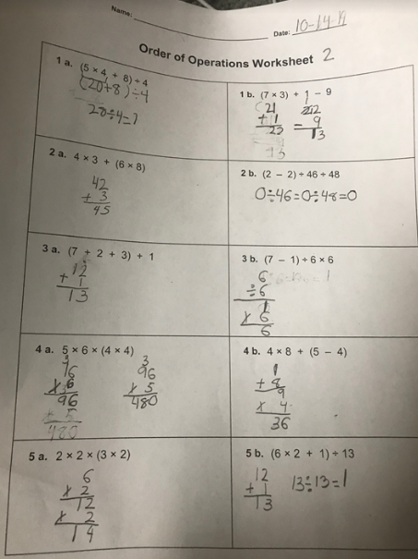

I told him to check his work by redoing each problem to find the 3 answers that were wrong. I purposely did not tell him specifically which answers were wrong so that he would know what it is to check all one's work and not rely on others to find errors. We did review the order of operations, first, and I gave him the hint that a couple of the errors had to do with not following the order of operations.

He proceeded to redo the problems on the same sheet of paper and not only repeated mistakes, he made new ones. So, I told him to write the problems on a separate sheet of paper and rework them. But he only wrote the problem number, not the problem which kind of defeated the purpose of the exercise:

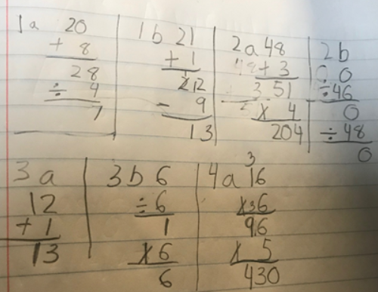

So I corrected that mistake and told him to write the actual equation and then solve the equation. This is what he came up with which is missing the boat once again:

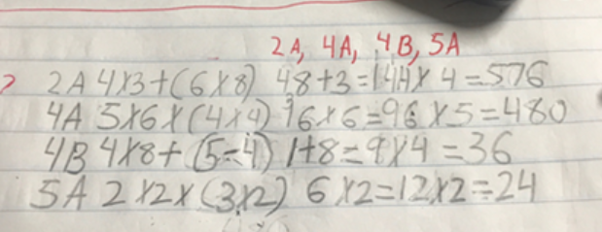

It was getting late, so I sent him the following to model how to work out problems that include several operations and that was where last night's conversation ended:

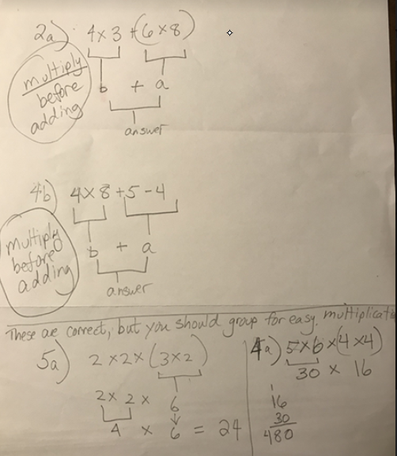

How do you teach Tevita to check his work?

Mahalo,
Vanessa Ott
808 - 854 -1018
MsVOtt@gmail.com
freespeech4us.com/pianolessons

_____________________________________

10/16/19 – Ott: The planner is for documenting homework; the agenda is for documenting classwork.

From: Vanessa Ott <msvott@gmail.com>
Date: Wed, Oct 16, 2019 at 7:23 AM
Subject: The planner is for documenting homework; the agenda is for documenting classwork.
To: Scott Kazarian <Scott.Kazarian@k12.hi.us>
Cc: Ron Matsushige <Ronald.Matsushige@k12.hi.us>, Feketi (Toakase) Huahulu <huahulufeketi@gmail.com>, Tevita <AhomTevi19@rlsms.k12.hi.us>

Aloha Mr. Kaz,

Tevita is supposed to write his homework in his planner and his classwork in his daily agenda. One function of the planner is for Tevita to know what he's supposed to do for homework. The other function is so his mom knows what he's supposed to do for homework. I asked Tevita on Monday evening why he was writing his classwork in his planner when he's supposed to be writing that in his agenda so that neither he nor his mom (a non-native English speaker) is confused about what the homework is versus what the classwork was that day. I asked him to get this straightened out with you, but apparently he's not capable of doing this, or he's too shy to question what the teacher tells him to do, or he misunderstood what you told him to do.

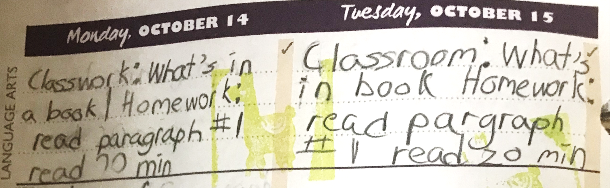

Please reiterate what we've been telling Tevita about the planner and the agenda, and make sure he writes what he did in class in the agenda, while reserving the planner only for communication between home and school plus homework assignments.

Mahalo,
Vanessa Ott
808 - 854 -1018
MsVOtt@gmail.com
freespeech4us.com/pianolessons

_____________________________________

10/16/19 – Carrigan: I will have him check his work.

From: Blake Carrigan <blake.carrigan@k12.hi.us>
Date: Wed, Oct 16, 2019 at 8:05 AM
Subject: Re: Teaching Tevita to "check his work"; last night's homework
To: Vanessa Ott <msvott@gmail.com>
Cc: Ron Matsushige <Ronald.Matsushige@k12.hi.us>, Feketi (Toakase) Huahulu <huahulufeketi@gmail.com>, Tevita <AhomTevi19@rlsms.k12.hi.us>

Vanessa,

Thank you for working with Tevita on his math homework! I have him today in class and we will be working on adding exponents into the problems we are solving. I think it is definitely effective for him to practice doing the problems more then once and to check his work that way. I will have him do it like you did in class to provide him with consistency (:

Thanks and have a great day,
Blake Carrigan

_____________________________________

10/16/19 – Ott: I’m guess Tevita is now working on plurals. Have you given him the rules? Where would we find that?

From: Vanessa Ott <msvott@gmail.com>
Date: Wed, Oct 16, 2019 at 8:08 AM
Subject: Rules for making nouns plural
To: Anna Yamana <Anna.Yamana@k12.hi.us>
Cc: Ron Matsushige <Ronald.Matsushige@k12.hi.us>, Feketi (Toakase) Huahulu <huahulufeketi@gmail.com>, Tevita <AhomTevi19@rlsms.k12.hi.us>

Aloha Ms. Yamana,

I noticed from Monday's homework assignment, that Tevita is probably working on plurals. I asked him if he knew the rules for making words plural, and he did not know what I was talking about. So I asked him to write the question in his planner and get it answered. He was supposed to write, "What are the rules for plurals?" This is what he wrote:

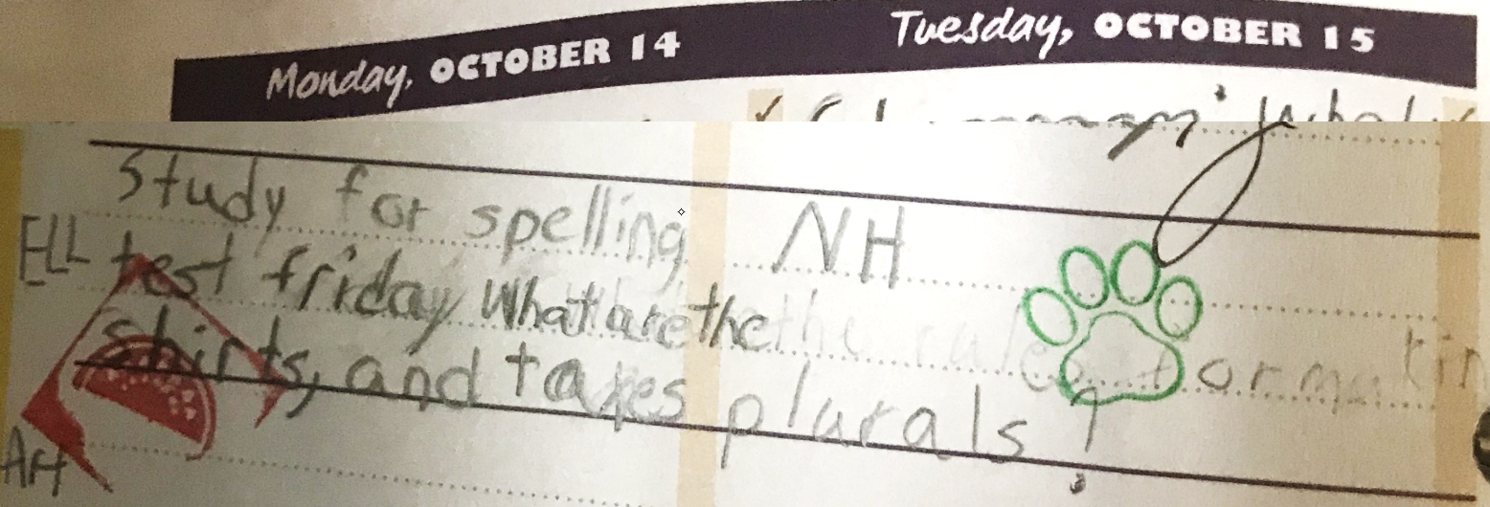

Did you give the students any information about plurals? If so, where would we find it?

Mahalo,
Vanessa Ott
808 - 854 -1018
MsVOtt@gmail.com
freespeech4us.com/pianolessons

_____________________________________

10/16/19 – Yamana: Our work on inflected endings was student-generated on a whiteboard so there is no handout.

From: Anna Yamana <anna.yamana@k12.hi.us>
Date: Wed, Oct 16, 2019 at 3:37 PM
Subject: Re: Rules for making nouns plural
To: Vanessa Ott <msvott@gmail.com>
Cc: Ron Matsushige <Ronald.Matsushige@k12.hi.us>, Feketi (Toakase) Huahulu <huahulufeketi@gmail.com>, Tevita <AhomTevi19@rlsms.k12.hi.us>

Dear Ms. Ott,

We are doing inflected ending for our spelling words; the words that Tevita recorded are those that he misspelled on the pre-test. I ask students to record missed words after every pre-test so they can practice them for the spelling test.

The next day, Tevita did indeed ask me his question, and it was related to our lesson plan. Our work was student-generated as a class on the whiteboard, so there was not any handout.

Thank you!

Anna Yamana
_____________________________________

10/17/19 – Ott: Students can do word sorts online. I’ve created samples and put them on Tevita’s drive. Do you want to partner and have me create more?

From: Vanessa Ott <msvott@gmail.com>
Date: Thu, Oct 17, 2019 at 1:44 PM
Subject: Re: Rules for making nouns plural - digitized word sorts that aren't babyish
To: Anna Yamana <anna.yamana@k12.hi.us>
Cc: Ron Matsushige <Ronald.Matsushige@k12.hi.us>, Feketi (Toakase) Huahulu <huahulufeketi@gmail.com>, Tevita <AhomTevi19@rlsms.k12.hi.us>
Aloha Ms. Yamana,

Thank you for responding. I don't know how Tevita is going to learn the rules of inflected endings if they aren't written down somewhere. If you're writing grammar "rules" on the white board, how about having Tevita write them down in a Google Doc? Tevita is a visual learner. He does not remember very well things that are told to him. If aural teaching is accompanies by visuals (such as a list of rules or having him write down the rules for later study) he is more likely to understand and remember what he has learned.

When I say, "rules" I'm using it in the context that Pearson's Words Their Way uses it. Here's the beginning of "Chapter 1, Inflected Endings" from a copy I found online (attached).

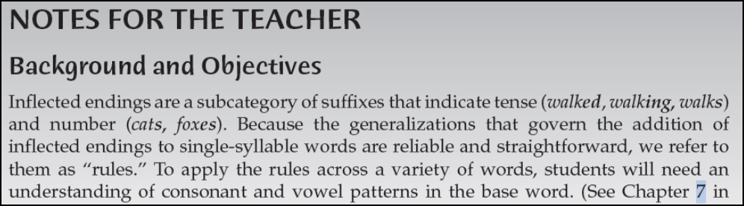

Regarding consonant and vowel patterns in base words, as of the week before Fall Intersession, I was explaining something to Tevita about suffixes, and I wrote "VCe" and "VC." He didn't have a clue what that meant. I don't see anything in his notes or classwork that explains this. So I'm wondering if he's been taught what this.

Regarding word sorts and other fine features of Words Their Way, have you considered having the students do this online with Google Sheets? I think Tevita would have a blast doing word sorts on a computer, and not think it babyish (nor tedious) like cutting out words on paper and arranging them on a table to be blown around whenever the door opens. With Ctrl+X and Ctrl+V it's easy for students to move words around, and kind of fun because it's on a computer. Try it out yourself. I put a sample google sheet word sort in a folder called "Word Sort" on Tevita's Google Drive in his ELL folder that you can access.

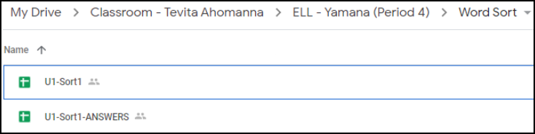

The U1-Sort1 file is what the students would receive in their Word Sort folder and looks like this:
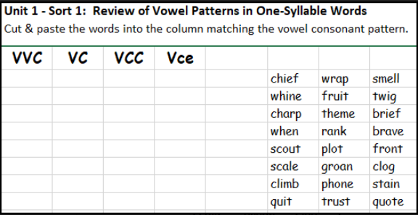

In fact, I created a Google sheet like the one above for all the word sorts (1-9) and the transfer test from Unit 1 included in the attachment to show you what's possible. I also wanted to see how long it would take to accomplish. It didn't take very long for me to do. If you'd like to partner with me, I could create the word sorts and transfer tests for your students to do online. I'm also willing to come in and help train the students how to access and use the files with keyboard shortcuts if you need an extra pair of eye/hands to do this.
What do you think?

Mahalo,
Vanessa Ott
808 - 854 -1018
MsVOtt@gmail.com
freespeech4us.com/pianolessons

attachment (22 pages): Inflected-Endings-Pearson.pdf
_____________________________________

10/17/19 – Matsushige: I will get back to you when I have more information to share with you.

From: Ronald Matsushige <ronald.matsushige@k12.hi.us>
Date: Thu, Oct 17, 2019 at 3:27 PM
Subject: Re: Plans for Tevita's progress in Q2
To: Vanessa Ott <msvott@gmail.com>
Cc: Feketi (Toakase) Huahulu huahulufeketi@gmail.com

Hi Toakase and Vanessa,
Just wanted to let you know I got the email, and am currently looking into everything you asked about. I will get back to you when I have more information to share with you!
Thank you!

Ronald Matsushige

_____________________________________

10/20/19 – Ott: Please schedule a time for us to look at Ready and Springboard curricula.

From: Vanessa Ott <msvott@gmail.com>
Date: Sun, Oct 20, 2019 at 6:39 AM
Subject: Re: Plans for Tevita's progress in Q2
To: Ronald Matsushige <ronald.matsushige@k12.hi.us>
Cc: Feketi (Toakase) Huahulu <huahulufeketi@gmail.com>

Aloha Mr. Matsushige,

Please schedule a time for us to come and get a good look at Ready Math and another time to do the same with Springboard. I am available the dates/times shown below in yellow.
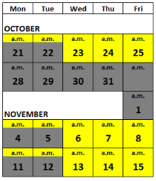
Mahalo,
Vanessa Ott

_____________________________________

10/22/19 – Ott: I do not understand the purpose of having students cut out strips of paper with Math skills problems on them and gluing them in a different order. Seems like a waste of time.

From: Vanessa Ott <msvott@gmail.com>
Date: Tue, Oct 22, 2019 at 5:05 AM
Subject: Tevita's 10-21-19 Math Homework
To: Blake Carrigan <Blake.Carrigan@k12.hi.us>
Cc: Ron Matsushige <Ronald.Matsushige@k12.hi.us>, Feketi (Toakase) Huahulu <huahulufeketi@gmail.com>, Tevita AhomTevi19@rlsms.k12.hi.us

Aloha Ms. Carrigan,

Tevita's 10-21-19 homework answers are attached if you want to print them out. He also supposedly wrote them in his Math composition book, if you want to copy them.

Tevita had difficulty with this assignment because:
- He did not know what the dot in the first problem meant. He swears you didn't teach it to him.

- He didn't understand the directions about cutting out strips and rearranging them.
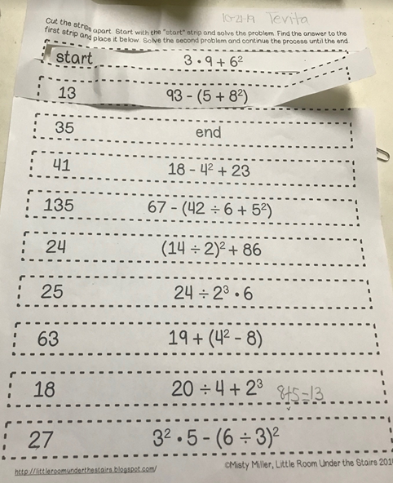

I don't understand the purpose of the cutting out and rearranging. I don't either. It seems like a huge waste of time for no pedagogical purpose, an a childish way to approach Mathematics for a 12-year-old boy. It's not even part of the Ready curriculum.

I've asked Mr. Matsushige to arrange a meeting so someone can go over the Math curriculum with me because I have concerns. That meeting still hasn't materialized yet, but I hope it happens soon, because my concerns are growing.

Mahalo,
Vanessa Ott
808 - 854 -1018

attachment: 2019-10-21-MathHomework-Ahomana.pdf

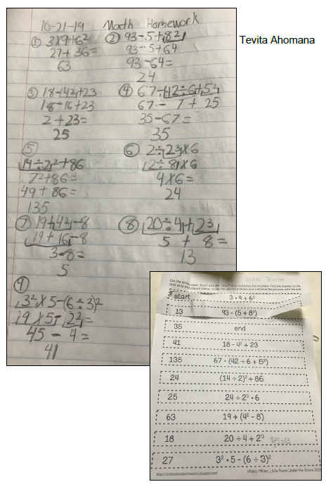
_____________________________________

10/22/19 – Ott: Here is a good article to explain the dot multiplication symbol.

From: Vanessa Ott <msvott@gmail.com>
Date: Tue, Oct 22, 2019 at 9:42 AM
Subject: Explanation of Different Multiplication and Division Symbols
To: Tevita <AhomTevi19@rlsms.k12.hi.us>
Cc: Blake Carrigan <Blake.Carrigan@k12.hi.us>, Ron Matsushige <Ronald.Matsushige@k12.hi.us>, Feketi (Toakase) Huahulu <huahulufeketi@gmail.com>

Aloha Tevita,

Here is a good article that explains the different multiplication and division symbols:

www.smartickmethod.com/blog/math/operations-and-algebraic-thinking/mutiplication/division-and-multiplication/
Mahalo,
Vanessa Ott
808 - 854 -1018
_____________________________________

10/23/19 – Carrigan: Manipulatives are effective when learning Math.

From: Blake Carrigan <blake.carrigan@k12.hi.us>
Date: Wed, Oct 23, 2019 at 8:53 AM
Subject: Re: Tevita's 10-21-19 Math Homework
To: Vanessa Ott <msvott@gmail.com>
Cc: Ron Matsushige <Ronald.Matsushige@k12.hi.us>, Feketi (Toakase) Huahulu <huahulufeketi@gmail.com>, Tevita <AhomTevi19@rlsms.k12.hi.us>

Hello,

The homework assignment you are referring to was the work Tevita missed when he was absent on Friday October 19th. I went over the assignment with Tevita thoroughly before he left class yesterday to ensure he understood the directions. We did the first problem together; he cut out the first piece, he understood how to look for his answer and next problem.

I understand that he may have had difficulty remembering what the "dot" meant. This is a new concept introduced to 6th graders, as we must replace the "x" because we will soon be adding variables.

Manipulatives are effective when used when learning math. I use manipulatives like this with all of my students to aid in the learning process.

As mentioned previously, in the resource room setting, I must supplement the Ready curriculum in order to meet Tevita's needs and his IEP goals and objectives.

Thank you,
Blake Carrigan

_____________________________________

10/24/19 – Ott: When Tevita is taught a new concept, it needs to be written down somewhere. He is not an aural learner. Manipulatives need to serve a purpose in understanding a new concept. Simply cutting out pieces of papers with hands does not make an appropriate math manipulative.

From: Vanessa Ott <msvott@gmail.com>
Date: Thu, Oct 24, 2019 at 3:53 AM
Subject: Re: Tevita's 10-21-19 Math Homework
To: Blake Carrigan <blake.carrigan@k12.hi.us>
Cc: Ron Matsushige <Ronald.Matsushige@k12.hi.us>, Feketi (Toakase) Huahulu <huahulufeketi@gmail.com>, Tevita <AhomTevi19@rlsms.k12.hi.us>

Aloha Ms. Carrigan,

When Tevita is taught a new concept, it needs to be written down in a book, or his Math Notes, or on a handout or somewhere. Telling Tevita something is not going to cement it in his mind because he is not an aural learner and this is a great area of weakness for him. He does better learning visually, and he learns really well when he can use a computer to aid in the learning process. He needs something to look at, study from, refer to. For example, adding a definition of the Leibniz dot for multiplication in his online "Math Vocabulary" Google doc would be helpful. I'm concerned that I haven't seen a Math workbook, online set of notes, or list of terms and symbols that Tevita can refer to describing the concepts he's learning. There's not hint of that in the Math papers that have been coming home in the Friday classwork envelope.

It is true that manipulatives have proven to be effective in learning new math concepts, but simply manipulating a scissors or crayons with ones hands does not turn an activity into a "math manipulative" as the term is generally applied to Math learning tools. This describes what I'm trying to express:

"Manipulatives are concrete objects that can be viewed and physically handled by students in order to demonstrate or model abstract concepts. They represent a category of mathematical tools...John van de Walle and his colleagues (2013) define a mathematical tool as, 'any object, picture, or drawing that represents a concept or onto which the relationship for that concept can be imposed'...More recently, virtual manipulative tools are available for use in the classroom as well;" From: www.hand2mind.com/resources/why-teach-math-with-manipulatives

You say that you are supplementing the Ready Math curriculum. I think all of the classwork I've seen have been "supplements" culled from sources other than i-Ready. I'm pretty sure that i-Ready is a comprehensive curriculum, much like Stepping Stones (SS), which is what Tevita used last year with great success. I would love to see what i-Ready offers that is comparable and asked Mr. Matsushige to arrange a time for us to see the curriculum components.

We have not yet had an IEP meeting to determine Tevita's Grade 6 Math goals and objectives, so it's a good time to move in that direction. Regarding Grade 6 Math goals and objectives, I know what expectations the Common Core has. I know how the IEPs have to be structured -- to fill in fields related to Grade 6 CCS. However, Tevita topped out at Grade 4 ability at the end of last school year, and I would venture to say his performance has dropped since he's not been rigorously following a structured Math curriculum. Tevita needs instruction in many of the fundamentals that he missed over the years due to his developmental delay and subsequent educational neglect in the Oakland, California and Honolulu school systems. Last year, when we jumped back in the SS curriculum to his level of capability balanced by challenge (Grade 3), and charged ahead through concepts he knew while dwelling on those with which he had difficulty, he made amazing gains in mathematical reasoning in the second half of the semester. He went from Grade 1 ability in December to Grade 4 in the last four months of the school year.

I am hoping we can get him on track with a structured approach to his Math education beginning at his current level of capability/challenge. I'll work on a needs T-chart for the IEP, and I hope to get a tour of the i-Ready curriculum soon.

Mahalo,
Vanessa Ott
808 - 854 -1018
MsVOtt@gmail.com
freespeech4us.com/pianolessons

_____________________________________

10/25/19 – Ott: Tevita was absent Friday. Please send last week’s work with this week’s work in the “Return on Monday” envelope.

From: Vanessa Ott <msvott@gmail.com>
Date: Fri, Oct 25, 2019 at 4:02 AM
Subject: Please send last week's and this week's work in envelope this week.
To: Ron Matsushige <Ronald.Matsushige@k12.hi.us>
Cc: Feketi (Toakase) Huahulu <huahulufeketi@gmail.com>, Tevita AhomTevi19@rlsms.k12.hi.us

Aloha Mr. Matsushige,

Tevita was absent from school last Friday because he and his mother attended a family funeral in California. Therefore, we did not get to scan last week's work. Please send home last week and this week's work in the Friday "Return on Monday" envelope.

Mahalo,
Vanessa Ott
808 - 854 -1018
MsVOtt@gmail.com
freespeech4us.com/pianolessons
_____________________________________

10/25/19 – Matsushige: Contents of this week’s “Return on Monday” envelope

From: Ronald Matsushige <ronald.matsushige@k12.hi.us>
Date: Fri, Oct 25, 2019 at 2:43 PM
Subject: Re: Please send last week's and this week's work in envelope this week.
To: Vanessa Ott <msvott@gmail.com>
Cc: Feketi (Toakase) Huahulu <huahulufeketi@gmail.com>, Tevita AhomTevi19@rlsms.k12.hi.us

Hi Everyone,
In the "Return on Monday" envelope this week is Tevita's Science notebook and something from ESOL class. Mr. Visaya also had Tevita take his poster to work on, and bring back on Monday, but it was too big to fit in the envelope. Mrs. Yamana said Tevita has a grammar worksheet that he needs to finish, and a Levels of Questioning flip book in his folder. The flip book he should keep in there at all times to refer to for help during other classes.
This quarter his elective wheel class has changed to Music. The Music teacher said Tevita should have some things in his binder that they worked on. Tevita does not need to bring them back.
Thank you and have a great weekend!

Ronald Matsushige
_____________________________________

10/25/19 – Ott: We would like your help teaching Tevita how to take notes in class. Per his last IEP, he should have access to a computer in every class so he can type class notes.

From: Vanessa Ott <msvott@gmail.com>
Date: Fri, Oct 25, 2019 at 6:43 AM
Subject: Per Tevita's IEP, please make sure Tevita has a computer in class to take notes.
To: Anna Yamana <Anna.Yamana@k12.hi.us>, Blake Carrigan <Blake.Carrigan@k12.hi.us>, Jay Visaya <Jay.Visaya@k12.hi.us>, Scott Kazarian <Scott.Kazarian@k12.hi.us>, Christine Asuncion <Christine.Asuncion@k12.hi.us>
Cc: Tevita <AhomTevi19@rlsms.k12.hi.us>, Ron Matsushige <Ronald.Matsushige@k12.hi.us>, Feketi (Toakase) Huahulu <huahulufeketi@gmail.com>

Aloha to Tevita's Teachers,

Tevita is ready to graduate from writing the agenda for class on paper to taking notes about content he learns in Google docs on his Google Drive. The objective remains the same: To remember what he learned in school that day and review/study outside of school what he is learning during the day. Please allow Tevita access to his computer during all his classes so that he can learn to take notes. This is part of is most current IEP (see p. 8 of the attachment).

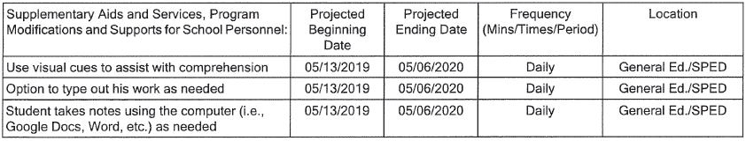

We talked about typing only important definitions and only one example in his notes - not copying everything that is written on the board. This way he can still be engaged in class and focus on what's being taught. We've been working on summarizing paragraphs in his independent reading, so he understands the concept. This is something he's getting better at, but implementation still needs improvement. I also told him to put this week's mantra up somewhere he'll see it in the morning and think of it when taking notes: "Be Quick. Understand. Ask Questions." Tevita has a tendency to not ask questions when he doesn't fully understand something.

Any guidance you can give him about how to take class notes, would be appreciated.

Mahalo,
Vanessa Ott
808 - 854 -1018

attachment: TA Final IEP 5-6-19.pdf
_____________________________________

10/28/19 – Ott: It has been 2 weeks since we requested access to curricula and have not received a response. We are very concerned about the quality of Tevita’s Math and Language Arts education

From: Vanessa Ott <msvott@gmail.com>
Date: Mon, Oct 28, 2019 at 7:04 AM
Subject: Want to schedule an IEP meeting soon so please let's take the steps to do this.
To: Katherine Balatico <katherine.balatico@k12.hi.us>, Ron Matsushige <Ronald.Matsushige@k12.hi.us>
Cc: Feketi (Toakase) Huahulu <huahulufeketi@gmail.com>

Aloha Principal Balatico and Mr. Matsushige,

It has been over two weeks since we asked to meet at the school to review the Ready Math and Springboard Language Arts curricula that Tevita is supposed to be learning. No meetings have been scheduled or even discussed. I think we have been more than sufficiently patient.

We are very concerned about Tevita's Math and Language Arts work that we've been seeing, and not seeing, as described in my 10/12/19 email below. Apparently, this year is shaping up to be very much like the beginning of last year. He has a learning disability already needing special attention, but he's further academically handicapped by a novice SpEd teacher who is not following a professionally-written curriculum. This is alarming because it's been proven that he excels with adherence to a structured, tiered curriculum developed by professional curriculum developers even if delivered by a novice teacher (2nd semester results, Grade 5), and does not advance much if at all when a novice teacher makes up the curriculum (1st semester results, Grade 5).

Please let's turn this around without further delay. We request that you:
- schedule time for us to get a comprehensive tour of the Ready and Springboard curricula;
- get the teachers on track teaching their respective curriculum; and
- arrange our first IEP meeting of the school year based on all of data we've collected thus far as soon as possible after #1 above.
Mahalo,
Vanessa Ott
808 - 854 -1018

_____________________________________

10/28/19 – Ott: Tevita’s mom will bring his Social Studies poster to school. Why did the aid tell him to make 5 circles when there are only 4 terms to illustrate?

From: Vanessa Ott <msvott@gmail.com>
Date: Mon, Oct 28, 2019 at 9:19 AM
Subject: Tevita's Mom is bringing his poster to school
To: Jay Visaya <Jay.Visaya@k12.hi.us>
Cc: Ron Matsushige <Ronald.Matsushige@k12.hi.us>, Feketi (Toakase) Huahulu <huahulufeketi@gmail.com>

Aloha Mr. Visaya,

Tevita forgot to bring his poster to school. His mom brought it to the office this morning. I hope it makes its way to your classroom this morning.

He used his internet search skills to find pictures for the poster. He put the titles and pictures into a Google doc and then used his Math skills measuring the circles he drew to decide what size to make the pictures. I taught him to use rubber cement after he cut out the printout. Please make sure Tevita is using his computer to do his classwork. He's able to do internet research and take notes on his own.

We turned the poster paper over to do this. There were 5 circles on the side he worked on in class. I asked why there were 5 circles but only 4 terms to define. He said the Teacher's Aid told him to draw 5 circles. Are we missing something?

Mahalo,
Vanessa Ott
808 - 854 -1018
_____________________________________

10/28/19 – Ott: I meant to say there were 6 circles and only 5 terms.

From: Vanessa Ott <msvott@gmail.com>
Date: Mon, Oct 28, 2019 at 9:21 AM
Subject: Re: Tevita's Mom is bringing his poster to school
To: Jay Visaya <Jay.Visaya@k12.hi.us>
Cc: Ron Matsushige <Ronald.Matsushige@k12.hi.us>, Feketi (Toakase) Huahulu <huahulufeketi@gmail.com>

I'm sorry, I meant to say he drew 6 circles in class but there were 5 terms:
- Human Environment Interaction
- Movement
- Place
- Location
- Region

Mahalo,
Vanessa Ott
808 - 854 -1018
MsVOtt@gmail.com
freespeech4us.com/pianolessons

_____________________________________

10/28/19 – Visaya: The 6th circle was for the assignment title.

From: Jay Visaya <jay.visaya@k12.hi.us>
Date: Mon, Oct 28, 2019 at 9:34 AM
Subject: Re: Tevita's Mom is bringing his poster to school
To: Vanessa Ott <msvott@gmail.com>
Cc: Ron Matsushige <Ronald.Matsushige@k12.hi.us>, Feketi (Toakase) Huahulu <huahulufeketi@gmail.com>

Morning,

Tevita dropped off his poster in the morning. Good examples of each theme. The 6th circle was optional for the title of the assignment.

Mr.V

_____________________________________

10/28/19 – Ott: I hope he remember to put his name and date on poster.

From: Vanessa Ott <msvott@gmail.com>
Date: Mon, Oct 28, 2019 at 9:35 AM
Subject: Re: Tevita's Mom is bringing his poster to school
To: Jay Visaya <jay.visaya@k12.hi.us>
Cc: Ron Matsushige <Ronald.Matsushige@k12.hi.us>, Feketi (Toakase) Huahulu <huahulufeketi@gmail.com>

I hope he put his name and date on it. Preferably in bottom right corner if he hasn't done it yet.

Mahalo,
Vanessa Ott
808 - 854 -1018

_____________________________________

10/28/19 – Visaya: Name and date is on poster.

From: Jay Visaya <jay.visaya@k12.hi.us>
Date: Mon, Oct 28, 2019 at 9:54 AM
Subject: Re: Tevita's Mom is bringing his poster to school
To: Vanessa Ott <msvott@gmail.com>
Cc: Ron Matsushige <Ronald.Matsushige@k12.hi.us>, Feketi (Toakase) Huahulu <huahulufeketi@gmail.com>

He wrote it top right (Name/date.

_____________________________________

11/1/19 – Ott: Requesting counseling services for Tevita to overcome learned helplessness and low motivation.

From: Vanessa Ott <msvott@gmail.com>
Date: Fri, Nov 1, 2019 at 8:24 AM
Subject: Requesting Counseling for Tevita
To: Ron Matsushige <Ronald.Matsushige@k12.hi.us>
Cc: <Tricia.Araki@k12.hi.us>, Katherine Balatico <katherine.balatico@k12.hi.us>

Aloha Mr. Matsushige

We are requesting counseling services for Tevita to help him overcome his learned helplessness and low motivation, which recently has started a new trend of dishonesty when questioned about his school work at home.

While researching solutions for behavior modification to help Tevita, I came across a good article on locus of control: https://www.edglossary.org/locus-of-control/

The two reform approaches described in the piece seem like they would be really helpful for Tevita, and the school counselor may have additional methods.

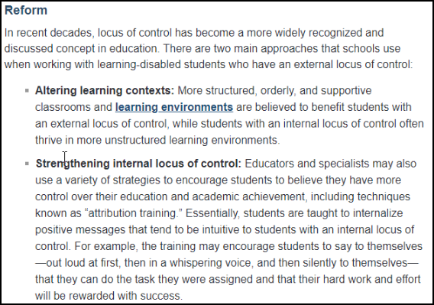

We can add a discussion of counseling services to the IEP meeting we hope to have soon. In the meantime, please make a determination whether or not Tevita will be able to work with a counselor and when that can start.

Mahalo,
Vanessa Ott for Toakase Huahulu

_____________________________________

11/1/19 – Matsushige: Contents of this week’s “Return on Monday” envelope.

From: Ronald Matsushige <ronald.matsushige@k12.hi.us>
Date: Fri, Nov 1, 2019 at 2:41 PM
Subject: Weekly Work
To: Toakase <toahuahulu@gmail.com>, Vanessa Ott <msvott@gmail.com>, Tevita <AhomTevi19@rlsms.k12.hi.us>

Hi Everyone,

This week in the "Please Return on Monday" envelope is Tevita's Science notebook, and a worksheet from ESOL class.
All his other work should be in his binder. Mr. Serra (Music) said he will have a mid-quarter quiz next week on everything they have covered so far.
Mr. Visaya said Tevita has a worksheet he can work on over the weekend. Tevita can use the notes he took by computer to help him.
Mr. Kazarian was out today, but he asked me to let you know that this week they began working on argumentative reading and writing.

Thank you and have a great weekend!

Ronald Matsushige

_____________________________________

11/1/19 – Balatico: You can find overviews of the curriculum online. Can you meet for Tevita’s IEP revision meeting on Nov 12?

From: Katherine Balatico <katherine.balatico@k12.hi.us>
Date: Fri, Nov 1, 2019 at 4:32 PM
Subject: Re: Want to schedule an IEP meeting soon so please let's take the steps to do this.
To: Vanessa Ott <msvott@gmail.com>
Cc: Ron Matsushige <Ronald.Matsushige@k12.hi.us>, Feketi (Toakase) Huahulu <huahulufeketi@gmail.com>

Good afternoon, Mrs. Ahomana --

We appreciate your concern for Tevita's schoolwork and continued growth in his English and Math classes. He earned a "B" in Math and a "A" in English on his Quarter 1 report card, and according to both of his teachers, Tevita is transitioning well into 6th grade with the supports that we all agreed to at the last meeting (the continued use of his planner, building his independence by writing down his homework, and getting each of his teachers' to sign/initial).

I've compiled below a few ways in which parents can support learning at home and listed below the resources for the Springboard and Ready Math curriculums below for you:

Springboard
https://springboard.collegeboard.org/ela
Contact information for Springboard:
877-999-7723
SpringBoard@collegeboard.org
Fax: 646-607-2881
Tech Support: SBTechSupport@collegeboard.org

Customer Service and General Inquiries:
866-630-9305

Ready Math
https://www.curriculumassociates.com/products/ready/mathematics
Phone number:
- Toll Free: (800) 225-0248
- (Mon–Thurs 8:30 a.m.–6:00 p.m. ET and Fri 8:30 a.m.–5:00 p.m. ET)
Email: info@cainc.com

In addition, I thought it might be best to invite you to see the Common Core State Standards that Tevita will be taught in Quarter 2:

In English, he can expect in Quarter 2:
Standards: 6.W.1., 6.W.4, 6.RI.1, 6.RI.6
Argumentative Essay
Debate
Reading: “Should Dodgeball be Banned in School?”/“Most Dangerous Sport of Cheerleading”/or similar
See attached parent memo for this quarter's unit

In Math, he can expect in Quarter 2:
Standards: 6.RP.A.3c, 6.NS.B.3, 6.NS.B.3, 6.NS.B.2
Student workbook homework pages
Lesson quizzes
Two question warm ups
Exit tickets
See attached parent memo for Lesson 9 (Mrs. Carrigan also sent it home with Tevita at the start of the lesson.)

Throughout the quarter to meet Tevita's needs, his teachers use a combination of the Springboard and Ready Math curriculums, as well as supplemental materials.

Are you available for Tevita's IEP revision meeting on Tuesday, November 12, 7:30-8:30 a.m.?

Thank you,
Katherine Balatico
Principal
R.L. Stevenson Middle School
Office (808) 587-4520
Fax (808) 587-4523

_____________________________________

11/3/19 – Ott: We confirm the November 12 meeting.

From: Vanessa Ott <msvott@gmail.com>
Date: Sun, Nov 3, 2019 at 6:49 AM
Subject: Re: Want to schedule an IEP meeting soon so please let's take the steps to do this.
To: Katherine Balatico <katherine.balatico@k12.hi.us>
Cc: Ron Matsushige <Ronald.Matsushige@k12.hi.us>, Feketi (Toakase) Huahulu <huahulufeketi@gmail.com>

Toakase and I confirm the requested meeting date and time:

Tuesday, November 12, 7:30-8:30 a.m.

Mahalo,
Vanessa Ott
808 - 854 -1018
MsVOtt@gmail.com
freespeech4us.com/pianolessons

_____________________________________

11/3/19 – Balatico: Out of office until 11/12/19.

From: Katherine Balatico <katherine.balatico@k12.hi.us>
Date: Sun, Nov 3, 2019 at 6:49 AM
Subject: Out of the Office Re: Want to schedule an IEP meeting soon so please let's take the steps to do this.
To: <msvott@gmail.com>

Thank you for your email. I’m out of the office until November 12.
During this time I will have limited access to email. I will do my best to respond to your email upon my return.
For immediate assistance, please contact the Stevenson Office at (808) 587-4520.
--
Thank you,
Katherine Balatico
Principal
R.L. Stevenson Middle School
Office (808) 587-4520
Fax (808) 587-4523

_____________________________________

11/4/19 – Ott to CAS: – Please enable us to purchase the Math and LA curricula RLSMS is using. Please create a clear mission, vision, and guidelines for parent engagement in your district.

From: Vanessa Ott <msvott@gmail.com>
Date: Mon, Nov 4, 2019 at 7:28 AM
Subject: Requesting CAS oversight in helping us gain access to Stevenson Middle School LA and Math curricula
To: Linell Dilwith <linell.dilwith@k12.hi.us>
Cc: Katherine Balatico <katherine.balatico@k12.hi.us>, Ron Matsushige <Ronald.Matsushige@k12.hi.us>, Feketi (Toakase) Huahulu <huahulufeketi@gmail.com>

Aloha Complex Area Superintendent Dilwith,

I am the academic "parent" of Tevita Ahomana, a Grade 5 SpEd/ELL student at Stevenson Middle School, and parental assistant for his mother. We I have asked to have a close look at the Language Arts and Math curricula that the probationary teachers at Stevenson Middle School are supposed to be using to educate Tevita. Principal Balatico has refused our request, the details of which are in the attachment: 2019-11-04-Correspondence-re-Curriculum.pdf

I'm sure you must be familiar with the current literature on parent engagement, but I've attached a selected bibliography anyway so that we have common understanding of the terms "parent involvement" and "parent engagement." Refusing to allow a parent to peruse curriculum their child is supposed to be learning is about as far below the bar for parent engagement, and even the lower bar for parent involvement, as one can get.

As supervisor for the district, we ask that you rectify the situation by:
- Enabling us to purchase our own copies of the Language Arts and Math curriculum the school is supposed to be using for learning at home; and
- Develop and implement a clear mission, vision, and guidelines for parent engagement in your district.
Mahalo,
Vanessa Ott
808 - 854 -1018

p.s. I've also attached an as-yet-unpublished article I wrote about Tevita's progress last year (pseudonym "Zed") you may find interesting. It espouses adherence to a professionally-written curriculum to help this developmentally delayed (but not incapable) student. The data in the article is about Stepping Stones. He had the same meteoric success in Language Arts diagnostics after we got the teacher following the Wonders curriculum last year.

cc: Katherine Balatico, Principal, Stevenson Middle School
Ron Matsushige, Care Coordinator, Stevenson Middle School
Toakase Huahulu, Mother of Tevita Ahomana

attachments:
- 2019-11-04-Correspondence-re-Curriculum.pdf
- Parent Engagement Selected Bibliography.pdf
- SpEd-Success-With-Stepping-Sones.pdf
_____________________________________

11/4/19 – Dilwith: Out of Office until November 14 2019.

From: Linell Dilwith <linell.dilwith@k12.hi.us>
Date: Mon, Nov 4, 2019 at 7:29 AM
Subject: Out of Office Re: Requesting CAS oversight in helping us gain access to Stevenson Middle School LA and Math curricula
To: <msvott@gmail.com>

I am out of the office until Thursday November 14, 2019. My access to email is limited. If this is an emergency, please contact the Honolulu District Office @ 808-733-4950. Thank you.
--
Linell Dilwith
Complex Area Superintendent
Kaimuki-McKinley-Roosevelt Complexes

"Don't fear failure.
Fear being in the exact same place next year as you are today." -unknown-
_____________________________________

11/5/19 – Ott: Tevita is taking same Social Studies text for the 5th or 6th time. I think he has a misunderstanding of what’s wrong because incorrect answer was not marked incorrect.

From: Vanessa Ott <msvott@gmail.com>
Date: Tue, Nov 5, 2019 at 7:24 AM
Subject: Social Studies Test
To: Jay Visaya <Jay.Visaya@k12.hi.us>
Cc: Ron Matsushige <Ronald.Matsushige@k12.hi.us>

Aloha Mr. Visaya,

I asked Tevita why he has to take the Oceans and Hawaii Islands test again. He's already taken it about five or six times, so something isn't working. He is under the impression the reason is because he spelled "Atlantic" incorrectly on the Nov. 1 version:

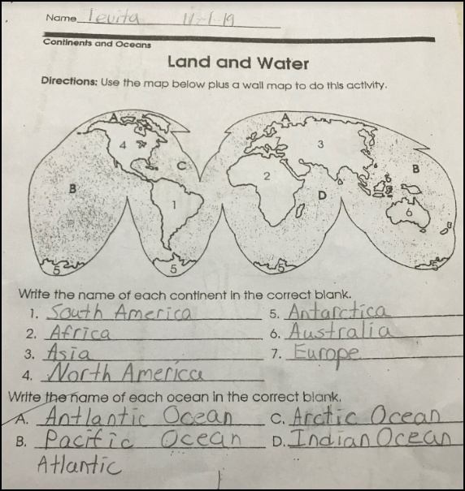

After looking that the picture above he texted to me last night, I realize that he probably doesn't understand that he mixed up the Atlantic and Arctic Oceans since only answer (A.) is marked wrong. I don't know when I'll see him, so please mark answer (C.) wrong as well to make sure he understands that answer is also incorrect. Otherwise, he'll probably get them wrong again.

Mahalo,
Vanessa Ott
808 - 854 -1018
MsVOtt@gmail.com
freespeech4us.com/pianolessons

_____________________________________

11/5/19 – Visaya: All students are taking the Geography quiz again unless they are able to get it all correct.

From: Jay Visaya <jay.visaya@k12.hi.us>
Date: Tue, Nov 5, 2019 at 7:54 AM
Subject: Re: Social Studies Test
To: Vanessa Ott <msvott@gmail.com>
Cc: Ron Matsushige <Ronald.Matsushige@k12.hi.us>

Morning,

It is a new quarter (2nd) so all students are taking the Geography quiz again unless they are able to get is all correct. A word bank is provided on the board so basically students need to remember where each continent/ocean is located. By 3rd quarter I'm hoping to only put the initial of the continents/oceans and for the students to correctly locate and write the correct ocean/continent in their proper place. By 4th quarter, hopefully they'll master everything which I've seen in the previous years.

Mr. Visaya
_____________________________________

11/5/19 – Ott: Thank you for the information, Mr. Visaya. Please remember to make it clear to Tevita what he got wrong on the test.

From: Vanessa Ott <msvott@gmail.com>
Date: Tue, Nov 5, 2019 at 8:31 AM
Subject: Re: Social Studies Test
To: Jay Visaya <jay.visaya@k12.hi.us>
Cc: Ron Matsushige <Ronald.Matsushige@k12.hi.us>

Thank you for the information.

Please remember to make it clear to Tevita what he got wrong by marking (C.) incorrect.

Mahalo,
Vanessa Ott
808 - 854 -1018
MsVOtt@gmail.com
freespeech4us.com/pianolessons

_____________________________________

11/5/19 – Ott: Tevita’s planner indicated there was a Math word problem for homework. Where is the word problem?

From: Vanessa Ott <msvott@gmail.com>
Date: Tue, Nov 5, 2019 at 7:47 AM
Subject: Math homework question - word problem
To:
Cc: Ron Matsushige <Ronald.Matsushige@k12.hi.us>, Feketi (Toakase) Huahulu <huahulufeketi@gmail.com>, Tevita <AhomTevi19@rlsms.k12.hi.us>

Aloha Ms. Carrigan,

Tevita's planner from yesterday indicated there was a word problem for him to do for homework.

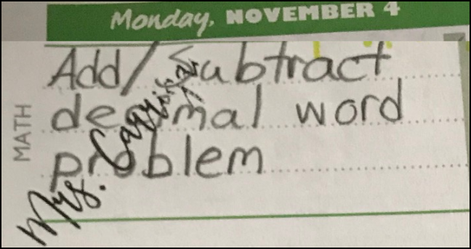

Tevita didn't know of any word problem. This is the worksheet he had:

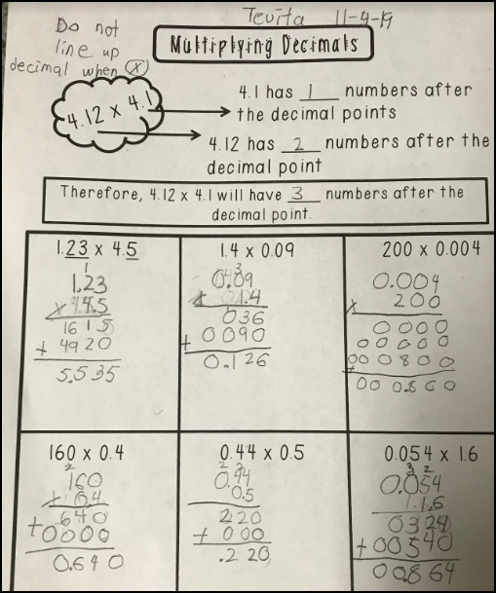

After he texted me the above pictures last night, I suggested that he check his answers using a calculator to find any errors he may have made. He seemed reluctant, but I said it was okay to check one's manual work with a calculator, and even encouraged. I don't know if he did that or not.

Was there a word problem for homework as indicated in the planner?

Mahalo,
Vanessa Ott
808 - 854 -1018
MsVOtt@gmail.com
freespeech4us.com/pianolessons

_____________________________________

11/5/19 – Ott: Tevita is having a difficult time in Music class accurately copying notes from the white board while trying to pay attention to the content.

From: Vanessa Ott <msvott@gmail.com>
Date: Tue, Nov 5, 2019 at 8:29 AM
Subject: Concerns regarding Tevita's Music education
To: Ron Matsushige <Ronald.Matsushige@k12.hi.us>
Cc: Cc: Toakase Ahomana <FeketiAhomana@gmail.com>, Malcolm_Yasuda/STVSON/HIDOE <Malcolm_Yasuda/STVSON/HIDOE@notes.k12.hi.us>, Tara_Tanaka/KAAHUMANU/HIDOE@notes.k12.hi.us, Lauren_Fuchigami/KAAHUMANU/HIDOE@notes.k12.hi.us, <Lauren_Fuchigami/KAAHUMANU/HIDOE@notes.k12.hi.us>, Katherine Balatico <katherine.balatico@k12.hi.us>

Aloha Mr. Matsushige,

Tevita says he doesn't understand what the teacher is writing on the board in Music class. I have spent time teaching him what his cryptic notes mean, so I know he's capable of understanding the content, but it takes quite awhile to figure out what the intent of the lesson is, and exactly what the teacher wants him to know.

I am concerned that Tevita is spending a lot of time copying from the board, and not being given the opportunity to pay attention to what's being said much less process the information. This is what his Music notes have looked like for the past few weeks.

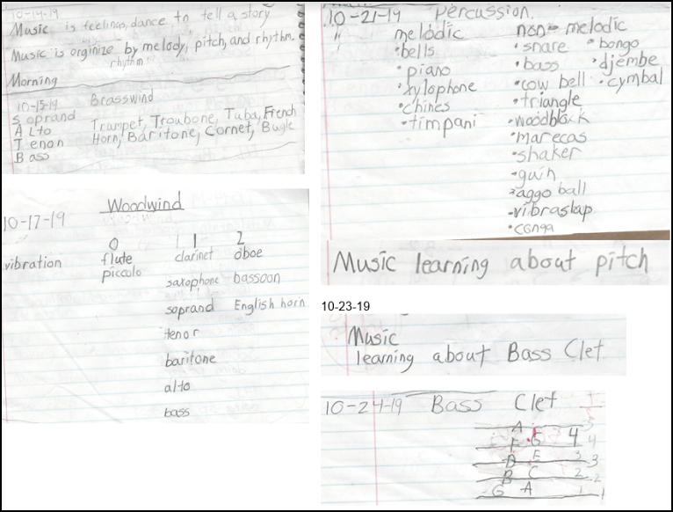
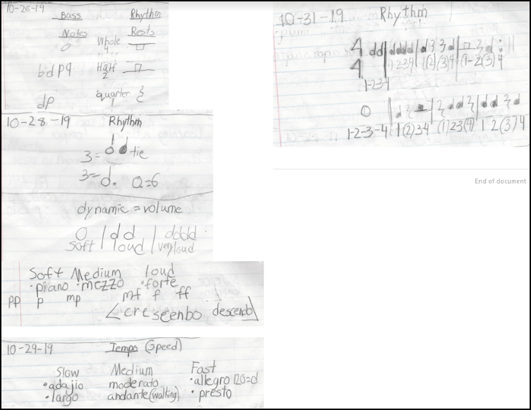

Besides the copying being a major distraction to learning the content, Tevita is not capable of drawing music notation (or copying) without errors. I have tried to supplement his music education at home, but I can't keep up. Too much information to sort out, research, and teach in my limited time with him. Tevita needs some accommodation/differentiation in the form of a professional-looking information page when he starts a new topic. For example, here are some of the things we have added to Tevita's "Music Notes" Google doc:
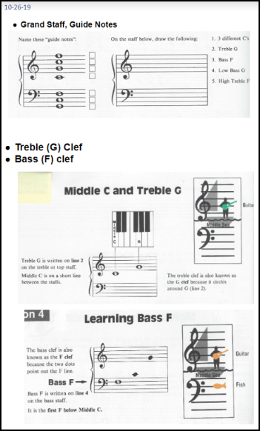
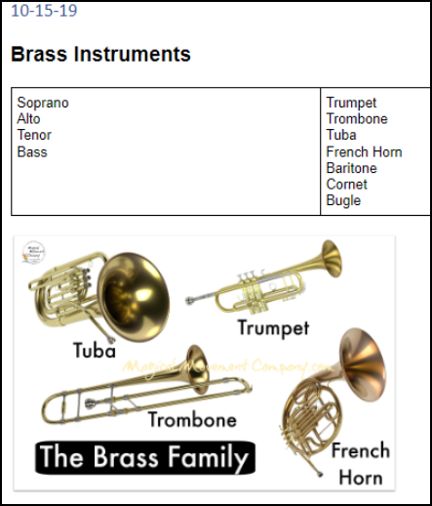

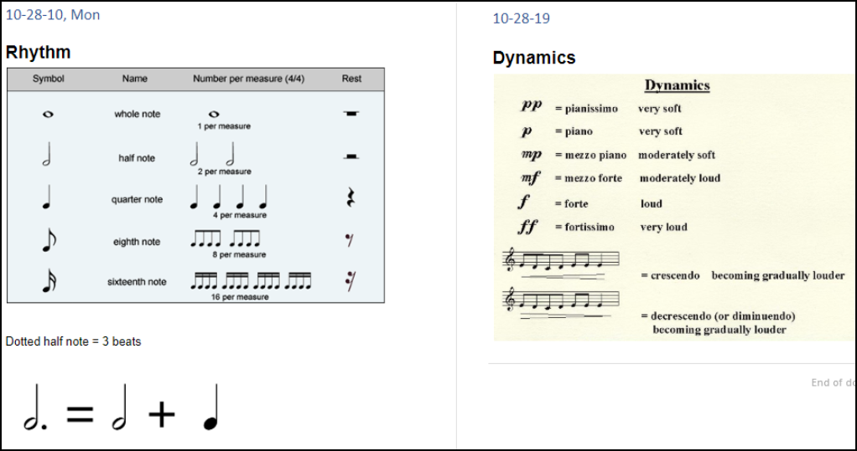

In fact, I think a music teacher should be supplying these kinds of materials to ALL of the students, but especially the SpEd kids.

I do not have the Music Teacher's full name and email address. Please provide this, and please talk to him about the problem.

I am cc:'ing Principal Balatico on this email because I think she should be aware of the Music teacher's methods, and lack of curriculum materials.
Mahalo,
Vanessa Ott
808 - 854 -1018
MsVOtt@gmail.com
freespeech4us.com/pianolessons

_____________________________________

11/8/19 – Matsushige: The music teacher will address your concerns at the 11/12 IEP meeting.

From: Ronald Matsushige <ronald.matsushige@k12.hi.us>
Date: Fri, Nov 8, 2019 at 3:15 PM
Subject: Re: Concerns regarding Tevita's Music education
To: Vanessa Ott <msvott@gmail.com>
Cc: Cc: Toakase Ahomana <FeketiAhomana@gmail.com>, Malcolm_Yasuda/STVSON/HIDOE <Malcolm_Yasuda/STVSON/HIDOE@notes.k12.hi.us>, Tara_Tanaka/KAAHUMANU/HIDOE@notes.k12.hi.us, Lauren_Fuchigami/KAAHUMANU/HIDOE@notes.k12.hi.us, <Lauren_Fuchigami/KAAHUMANU/HIDOE@notes.k12.hi.us>, Katherine Balatico <katherine.balatico@k12.hi.us>

Hi Ms. Ott,
I shared with Tevita's music teacher, Darren Serra, the issues you brought up in your email. He will be attending the IEP revision meeting this coming Tuesday morning, 11/12, at 7:30 am. He can address your concerns after we finish the IEP meeting.

Thank you!

Ronald Matsushige

_____________________________________

11/8/19 – Matsushige: Contents of this week’s “Return on Monday” envelope.

From: Ronald Matsushige <ronald.matsushige@k12.hi.us>
Date: Fri, Nov 8, 2019 at 3:13 PM
Subject: Weekly Work
To: Toakase <toahuahulu@gmail.com>, Vanessa Ott <msvott@gmail.com>, Tevita <AhomTevi19@rlsms.k12.hi.us>

Hi Everyone,

This week, the "Please Return on Monday" envelope contains Tevita's Science notebook, some math worksheets, and I accidentally put a yellow paper in there from his ELA class. Mr. Kazarian said he made a copy so it does not have to be returned. Mrs. Carrigan was at a conference for part of this week so she left instructions with her substitute to gather the work to give to me today. It's not yet graded so she needs it back.
Mrs. Yamana said she sent some things home with Tevita this week. Mr. Serra said he will be starting to teach a new category (ukulele) next week.

Thank you and have a great weekend!

Ronald Matsushige

_____________________________________

11/11/19 – Ott: To prepare for IEP meeting please send list of attendees, internet guest password.

From: Vanessa Ott <msvott@gmail.com>
Date: Mon, Nov 11, 2019 at 7:23 AM
Subject: Preparing for Tevita's IEP meeting 11/12/19
To: Ron Matsushige <Ronald.Matsushige@k12.hi.us>
Cc: Feketi (Toakase) Huahulu <huahulufeketi@gmail.com>

Aloha Mr. Matsushige,

To prepare for Tevita's 11/12/19 IEP meeting tomorrow, please:
- send a list of attendees;
- provide us with internet access guest login user name and password before 7:15 tomorrow;
- make sure we can get into the meeting room by 7:15 am so that we can set up the computer, get connected to the internet, set up name cards for video recording, etc.
Mahalo,
Vanessa Ott
808 - 854 -1018
MsVOtt@gmail.com
freespeech4us.com/pianolessons

_____________________________________

11/11/19 – Matsushige: Here is information you requested.

From: Ronald Matsushige <ronald.matsushige@k12.hi.us>
Date: Mon, Nov 11, 2019 at 12:58 PM
Subject: Re: Preparing for Tevita's IEP meeting 11/12/19
To: Vanessa Ott <msvott@gmail.com>
Cc: Feketi (Toakase) Huahulu <huahulufeketi@gmail.com>

Hi Ms. Huahulu and Ms. Ott,

Here's the list of people attending:

Katherine Balatico - Principal
Wade Okuma - Honolulu District SPED Resource Teacher
Malcolm Yasuda - Student Services Coordinator
Ronald Matsushige - Care Coordinator
Blake Carrigan - Math Teacher
Scott Kazarian - ELA Teacher
Christine Asuncion - Science Teacher
Darren Serra - Music Teacher

Internet Access:
Guest account: doe-guest-148
Password: 148M$1$gu3$t

The meeting will in be in the same room as last time (Room 100A), and will be open by 7:15 am.

Thank you and see you tomorrow!

Ronald Matsushige

_____________________________________

11/12/19 – Ott: Needs charts and data for today’s IEP meeting.

From: Vanessa Ott <msvott@gmail.com>
Date: Tue, Nov 12, 2019 at 6:33 AM
Subject: IEP meeting Needs Chart and diagnostic data
To: Ron Matsushige <Ronald.Matsushige@k12.hi.us>
Cc: Feketi (Toakase) Huahulu <huahulufeketi@gmail.com>

Aloha Mr. Matsushige,

Attached is a Needs Chart and relevant diagnostic data for today's meeting.

Mahalo,
Vanessa Ott
808 - 854 -1018
MsVOtt@gmail.com
freespeech4us.com/pianolessons

Family Engagement
Tevita’s Strengths Are He…  - Has a parent and a home tutor very willing to work with the school.  - Is able, along with his home school team members, capable of utilizing internet-based communications media. |  | Tevita Needs…  - All of the educators in his current life at school and home to collaborate so as to enhance his learning progress as much as possible.
Questions
- Why aren’t the parent and the home tutor allowed to have access to the ELA and Math curricula?
- Why can’t we set up regular times to come to the classroom to see his all of his work? For example, not one piece of work from Explore Wheel came home all 1st Quarter.
Comments

Larry Ferlazzo: The most effective family engagement initiatives build upon and transform families’ strengths—their funds of knowledge— in ways that connect families and schools meaningfully to enrich student learning.21 This approach does not attempt to replicate and transmit school values and activities to the home; rather, it reframes relationships by creating programs, initiatives, and strategies with instead for families.

Global Family Research Project: To create the kinds of school-family partnerships that raise student achievement, improve local communities, and increase public support, we need to understand the difference between family involvement and family engagement. One of the dictionary definitions of involve is "to enfold or envelope," whereas one of the meanings of engage is "to come together and interlock." Thus, involvement implies doing to; in contrast, engagement implies doing with.
A school striving for family involvement often leads with its mouth—identifying projects, needs, and goals and then telling parents how they can contribute. A school striving for parent engagement, on the other hand, tends to lead with its ears—listening to what parents think, dream, and worry about. The goal of family engagement is not to serve clients but to gain partners.
Higher Expectations & More Rigorous Study
Tevita’s Strengths Are He…  - Has ability to learn when challenged at his level of capability. | Tevita Needs  - To be challenged in his studies.  - Do more work at home so he may progress.  - Be provided with rigorous curriculum.
Comments
- Concerned that because he is not in any academic inclusion classes, he’s not being pushed to excel.
- His work has not progressed very much and we know that when challenged appropriately, he performs well.
- Concerned about the childish and time-consuming drawing, coloring, cutting, and gluing assignments done in class that don’t have relevance to the standard being taught.

Curriculum
Tevita’s Strengths Are He…  - Learns well with a structured, progressive curriculum and support at home. | Tevita Needs…  - To follow professionally-written, structured LA and Math curricula beginning at his level of capability and progressing as quickly forward as possible, skimming concepts he knows, and delving into concepts needed to fill the holes in his knowledge base.  - To practice skills learned in class at home.  - A collaborative partnership between home and school to move him through the curricula as quickly as possible.
Questions
- Why aren’t the parent and the home tutor allowed to have access to the ELA and Math curricula?
- Why can’t we set up regular times to come to the classroom to see his all of his work? For example, not one piece of work from Explore Wheel came home all 1st Quarter.
Comments
See data on next 3 pages. The data shows the remarkably positive effect that following structured curricula at school with support “at home” had on Tevita’s progress in the 2nd semester of last school year.

SY 2018 – 2019
In the 1st semester of SY 2018-19, Tevita did not make much progress in LA and Math. The teachers were not following a structured, progressive curriculum at is level. In the 2nd semester, after following the Wonders and Stepping Stones curricula and getting support at home for his learning, he showed remarkable progress.

Math & Reading – Growth: SY 2018 - 2019

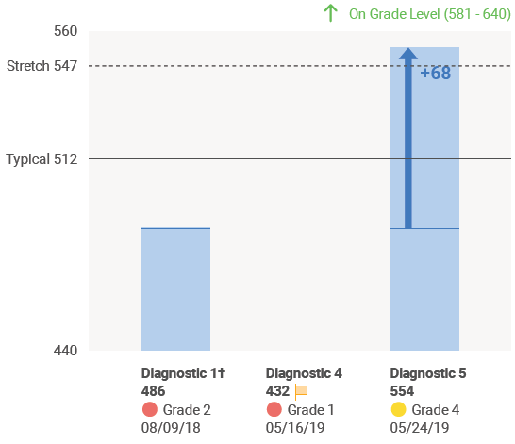
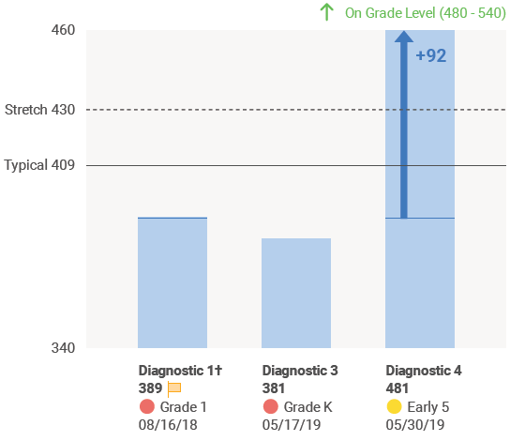
i-Ready Growth Diagnostics
SY 2018-2019
Tevita Ahomana
MATH Growth SY 2018-2019
READING Growth SY 2018-2019
5-16-19
Distracted
Testing
Environment
5-17-19
Distracted
Testing
Environment
5-24-19
Quiet
Testing
Environment
5-30-19
Quiet
Testing
Environment

SY 2019 – 2020
Reading – compare May 2019 to September 2019

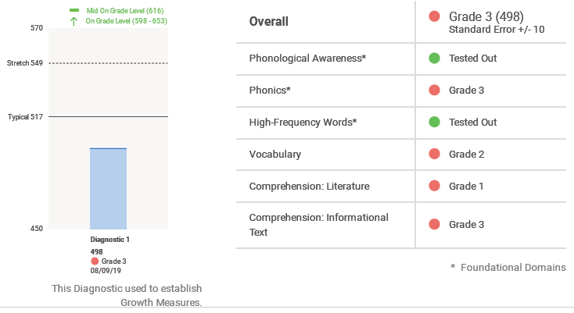
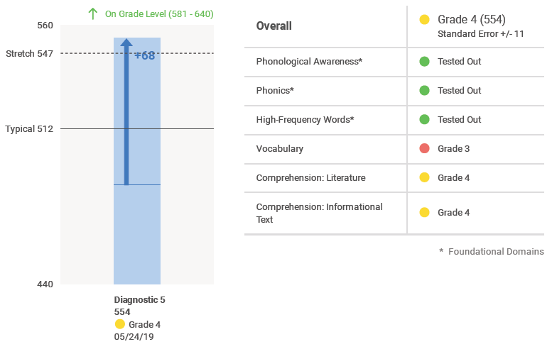
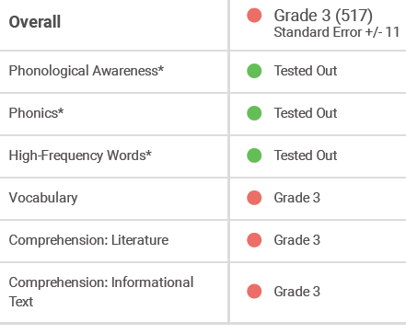
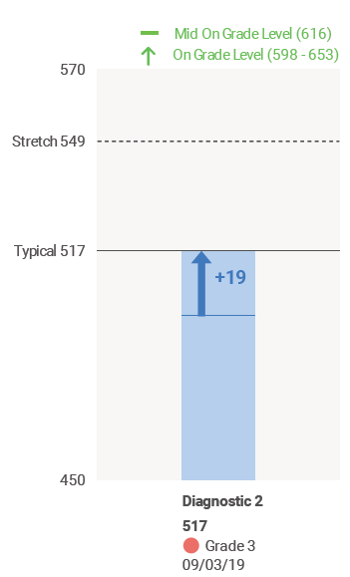
i-Ready Reading Diagnostics
Tevita Ahomana
End of SY 2018 - 2019
Beginning of SY 2019 - 2020

From 5/24/19 to 9/3/19, Tevita’s i-Ready Reading overall diagnostic score fell 37 points.

SY 2019 – 2020
Math – compare May 2019 to September 2019
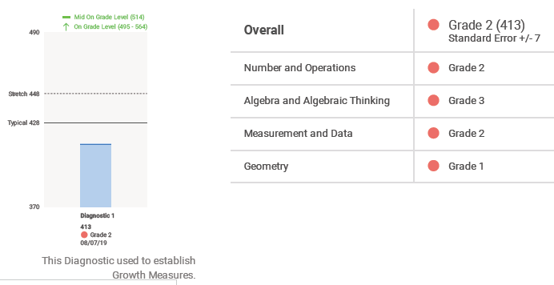
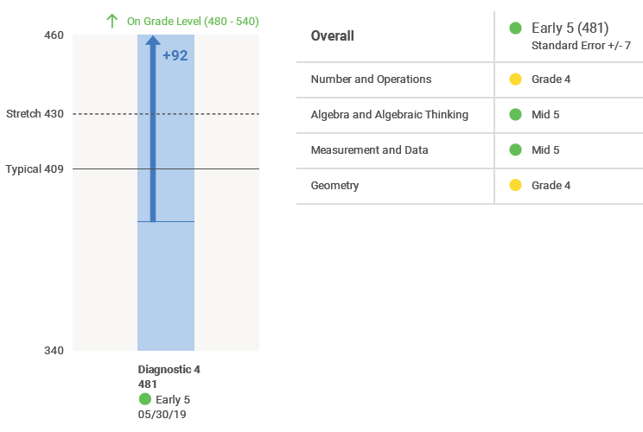
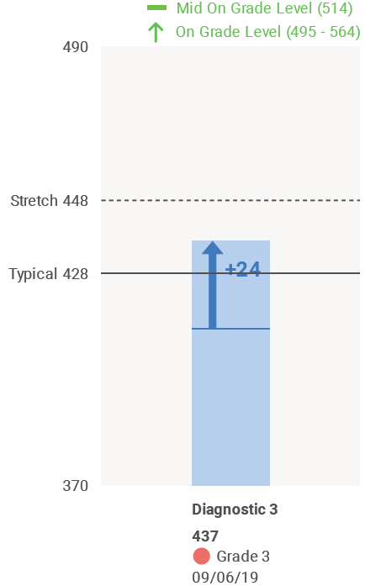
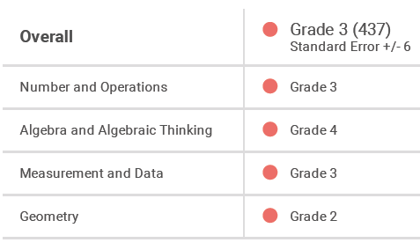
i-Ready Math Diagnostics
Tevita Ahomana
End of SY 2018 - 2019
Beginning of SY 2019 - 2020
From 5/30/19 to 9/6/19, Tevita’s i-Ready Math overall diagnostic score fell 44 points.

_____________________________________

11/12/19 – MEETING @ 7:30 – 8:30 am
Location: RLSMS conference room

Attendees:
- Katherine Balatico - Principal
- Wade Okuma - Honolulu District SPED Resource Teacher
- Malcolm Yasuda - Student Services Coordinator
- Ronald Matsushige - Care Coordinator
- Blake Carrigan - Math Teacher
- Darren Serra - Music Teacher
- Vanessa Ott, Tutor & Parent Assistant
- Feketi Huahulu, Parent
- Tevita Ahomana, Student
_____________________________________

11/13/19 – Huahulu: When Vanessa speaks, she speaks for me, the parent. We have to have the freedom to talk about Tevita’s learning disabilities with him.

From: Toakase Huahulu <toahuahulu@gmail.com>
Date: Wed, Nov 13, 2019 at 4:34 PM
Subject: Vanessa speaks for me, the parent
To: Katherine Balatico <Katherine.Balatico@k12.hi.us>, <Malcolm.Yasuda@k12.hi.us>

Hello,

I want to say something about what Mr. Yasuda said to Vanessa after the IEP meeting on Tuesday morning.
I think maybe Mr. Yasuda thought Tevita was crying because Vanessa asked him about his bad memory. I asked Tevita why he cried. He said he was ashamed for saying he didn’t want to do his homework. He wasn’t crying because Vanessa said he has a bad memory. I asked Tevita if it’s ok for him to go to IEP meetings. Yes, he wants to hear what we have to say about him. Whenever we have an IEP he has to come.
Vanessa has not said anything that hurts Tevita. She did not say he was slow. Mr. Yasuda said that. Tevita said he was fine at the meeting. It’s okay to talk about his disability in front of him. We have to talk about his disability with him so we can talk about how to help him, too
I want you to know when Vanessa speaks, she speaks for me, the parent.

Thank you,
Toakase (Feketi) Huahulu

_____________________________________

11/14/19 – Matsushige: New IEP Goal for approval.

From: Ronald Matsushige <ronald.matsushige@k12.hi.us>
Date: Thu, Nov 14, 2019 at 10:25 AM
Subject: New Summary goal
To: Toakase <toahuahulu@gmail.com>, Vanessa Ott <msvott@gmail.com>

Good Morning!
I have attached the new goal for writing summaries that we spoke about during the IEP meeting. Please take a look at it, and let me know if you have any questions. If it looks good, I will add it to the IEP, and send home a finalized version of the IEP.

Thank you!

Ronald Matsushige

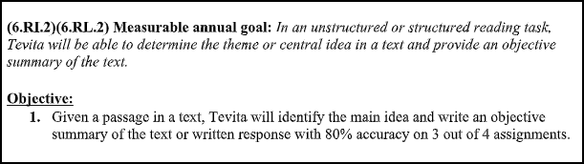

_____________________________________

11/14/19 – Ott: If that’s your best offer, we will purchase the student workbooks, though we prefer to purchase teachers’ editions of curriculum.

From: Vanessa Ott <msvott@gmail.com>
Date: Thu, Nov 14, 2019 at 8:58 PM
Subject: We would like to take advantage of your offer and purchase student workbooks for LA and Math curricula Tevita is using
To: Katherine Balatico <katherine.balatico@k12.hi.us>, Ron Matsushige <Ronald.Matsushige@k12.hi.us>
Cc: Feketi (Toakase) Huahulu <huahulufeketi@gmail.com>

Aloha Principal Balatico and Mr. Matsushige,

Although we would prefer to purchase digital teacher editions of the LA and Math curricula Tevita is using to enable us to follow what the teachers are doing and be better equipped to supplement his education at home, we will take you up on your limited offer to purchase the student workbooks Tevita is using for Language Arts and Math -- if that's the best you can do at this time.

Note that per the agreement at the 11/12/19 IEP meeting, you will investigate and discover if there is an online version of the i-Ready Math curriculum for students that we can purchase instead of a printed version. We ask that you also find out if there is digital Student Edition of the Language Arts Springboard curriculum

Please let us know how much remuneration to indicate on the check. I assume we make the check out to Robert Louis Stevenson Middle School.

Mahalo,
Vanessa Ott
808 - 854 -1018
MsVOtt@gmail.com
freespeech4us.com/pianolessons

_____________________________________

11/15/19 – Matsushige: Weekly Work

From: Ronald Matsushige <ronald.matsushige@k12.hi.us>
Date: Fri, Nov 15, 2019 at 4:14 PM
Subject: Weekly Work
To: Toakase <toahuahulu@gmail.com>, Vanessa Ott <msvott@gmail.com>, Tevita <AhomTevi19@rlsms.k12.hi.us>

Good afternoon everyone,
This week's "Return on Monday" envelope contains Tevita's Science notebook, a Social Studies assignment (puts together a puzzle of a picture, then writes about it), and some Math worksheets (one Quiz and two assignments that Tevita needs to show his work on).

Thank you very much, and have a great weekend!

Ronald Matsushige

_____________________________________

11/17/19 – Ott: The data does not support your claims that Tevita is learning the ReadyMath curricululm

From: Vanessa Ott <msvott@gmail.com>
Date: Sun, Nov 17, 2019 at 2:43 AM
Subject: Data Analysis of Tevita's i-Ready Math work
To: Blake Carrigan <Blake.Carrigan@k12.hi.us>
Cc: Ron Matsushige <Ronald.Matsushige@k12.hi.us>, Feketi (Toakase) Huahulu <huahulufeketi@gmail.com>, Katherine Balatico <katherine.balatico@k12.hi.us>

Aloha Ms. Carrigan,

I didn't believe the claims that Tevita was learning the i-Ready curriculum because that's not what we've been seeing at home. So, I looked at all the work Tevita has brought home this year up to November 8th which been scanned and put on his Google drive. 92% of the pages archiving his work up to 11/8/19 is NOT from the i-Ready curriculum! That would indicate that you are using supplements way more than the curriculum. As we know, though, data doesn't always tell the whole story.

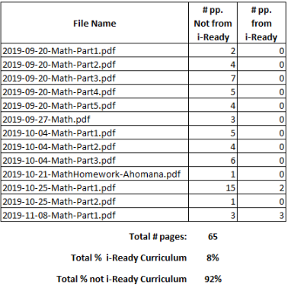

This weekend, we spent a lot of time discussing Tevita's Math work and what's he's been learning, Trying to pull out of information out of a kid with a less than optimum memory for such things can be difficult. Tevita mentioned that there is a box, or a file, or something in your class where he's been putting some of his papers. If that's true, please let us know what's been going on, and please discourage Tevita from putting his papers in a box in your classroom. Why does he even have a place to file away his papers in the classroom when all his papers should be coming home? Please tell him to put his finished papers in his binder to bring home so we can scan them all, and put them in his classwork archives online.

Perhaps when we get to see all his Math work we will understand why Principal Balatico keeps claiming you're following the i-Ready curriculum when that's not what we're seeing at home, and our data indicates otherwise.
Mahalo,
Vanessa Ott
808 - 854 -1018
MsVOtt@gmail.com
freespeech4us.com/pianolessons

_____________________________________

11/18/19 – Balatico: Workbooks can be purchased at school office. Here are Tevita’s login and passwords to access curriculum.

From: Katherine Balatico <katherine.balatico@k12.hi.us>
Date: Mon, Nov 18, 2019 at 8:03 PM
Subject: Re: We would like to take advantage of your offer and purchase student workbooks for LA and Math curricula Tevita is using
To: Vanessa Ott <msvott@gmail.com>
Cc: Feketi (Toakase) Huahulu <huahulufeketi@gmail.com>, Ronald Matsushige <Ronald.Matsushige@k12.hi.us>, Julia Smith <Julia.Smith@k12.hi.us>, Katherine Balatico <10005186@k12.hi.us>

Ms. Ott -

These are the workbooks that you can purchase at the Front Office. When you come to the office, please ask to see our curriculum coordinator, Julia Smith, for assistance.

For SpringBoard:
Workbook: $19.95

For ReadyMath:
Instruction Book (classwork): $13.00
Practice and Problem Solving Book (homework): $9.00

Tevita's login credentials for Springboard are:
Clever login and password:
login: 1281600637
password: 06232007
Springboard password: !QAZxsw2
With this, he has access to the SpringBoard student textbook materials.

According to the ReadyMath company, there is no online student version at this time.

Thank you,
Katherine Balatico
Principal
R.L. Stevenson Middle School
Office (808) 587-4520
Fax (808) 587-4523
_____________________________________

11/21/19 – Ott: ASAP after next round of diagnostic testing, we request an IEP meeting to discuss his progress and address concerns about curriculum.

From: Vanessa Ott <msvott@gmail.com>
Date: Thu, Nov 21, 2019 at 6:33 AM
Subject: Re: New Summary goal
To: Ronald Matsushige <ronald.matsushige@k12.hi.us>
Cc: Toakase <toahuahulu@gmail.com>

Mr. Matsushige,

Please add the standard about writing summaries to the IEP, and send me a digital copy of the revised IEP. Toakase will keep the printed copy you supply.

As I mentioned in our phone conversation, we would like to have another IEP meeting before the end of the school year after we've gotten it straightened out what he's doing with the LA, Math, and Social Studies curriculum. The objective is to update the IEP to address Tevita's needs for regular curriculum routines similar to the section that was in there last year about the Stepping Stones curriculum. However, we did not think it appropriate to segregate these needs in a section called "Parental Concerns" and voiced our objection last year. We hope that this year, Tevita's curriculum needs will be included in the body of the IEP.

As soon as possible after the next round of i-Ready testing and before the next IEP meeting, we would like to meet with Tevita and his Math and Language Arts data teams (separate meetings for Tevita can only handle one at a time) to discuss his results. Since you know when he'll be taking each test, can we please schedule these two meetings now and get them on the participants' calendars?

Mahalo,
Vanessa Ott & Toakase Huahulu

_____________________________________

11/21/19 – Carrigan: The Ready curriculum is being used as a supplement.

From: Blake Carrigan <blake.carrigan@k12.hi.us>
Date: Thu, Nov 21, 2019 at 7:11 AM
Subject: Re: Data Analysis of Tevita's i-Ready Math work
To: Vanessa Ott <msvott@gmail.com>
Cc: Ron Matsushige <Ronald.Matsushige@k12.hi.us>, Feketi (Toakase) Huahulu <huahulufeketi@gmail.com>, Katherine Balatico <katherine.balatico@k12.hi.us>

Good morning Vanessa,

The papers you are referring to is where Tevita turns in his work to be graded. These papers are being sent home on Friday afternoons with him.

The Ready curriculum is being used as a supplement in the classroom and used to help guide pacing and instruction. I use supplemental material to make the concepts more appropriate for Tevita and all of my students. The Ready curriculum that you are seeing being sent home is only the paper assignments and worksheets we are doing in class. Many of the things we do in class involves hands-on learning, manipulatives, and working one to one with the material. I do not require students to use worksheets/papers every time we do something. We use whiteboards and other tools for learning in class. During this time, I pull questions from the curriculum and work through the concepts with the students.

Tevita has access to iReady for math and reading. He can use this at home anytime to complete lessons that are at Tevita's level. These lessons teach a concept and test the student on the skill at the end of the lesson. This is an excellent tool to use at home for extra practice! Also, if you would like, I can assign Teacher Assigned lessons to Tevita for him to work on at home based upon the skills we are working on in class.

I hope this answers some of your questions. Also, I am able to meet with you tomorrow morning at 7:15. Please let me know if that works for you.

Thank you,
Blake Carrigan

_____________________________________

11/21/19 – Ott: Thank you we will see you tomorrow @ 7:30.

From: Vanessa Ott <msvott@gmail.com>
Date: Thu, Nov 21, 2019 at 1:36 PM
Subject: Re: Data Analysis of Tevita's i-Ready Math work
To: Blake Carrigan <blake.carrigan@k12.hi.us>
Cc: Ron Matsushige <Ronald.Matsushige@k12.hi.us>, Feketi (Toakase) Huahulu <huahulufeketi@gmail.com>, Katherine Balatico <katherine.balatico@k12.hi.us>

Yes, thank you. We'll see you tomorrow, Friday 11/22 @ 7:30.

Mahalo,
Vanessa Ott
808 - 854 -1018
MsVOtt@gmail.com
freespeech4us.com/pianolessons

_____________________________________

11/22/19 – Ott: I misread the time you wrote. We’ll be there @ 7:15.

From: Vanessa Ott <msvott@gmail.com>
Date: Fri, Nov 22, 2019 at 6:19 AM
Subject: Re: Data Analysis of Tevita's i-Ready Math work
To: Blake Carrigan <blake.carrigan@k12.hi.us>
Cc: Ron Matsushige <Ronald.Matsushige@k12.hi.us>, Feketi (Toakase) Huahulu <huahulufeketi@gmail.com>, Katherine Balatico <katherine.balatico@k12.hi.us>

I misread the time. We'll be there at 7:15 am.

Mahalo,
Vanessa Ott
808 - 854 -1018
MsVOtt@gmail.com
freespeech4us.com/pianolessons

_____________________________________

11/22/19 – MEETING @ 7:30 – 7:55 am

Location: Ms. Carrigan’s Math classroom

Attendees:
- Malcolm Yasuda - Student Services Coordinator
- Blake Carrigan - Math Teacher
- Vanessa Ott, Tutor & Parent Assistant
- Feketi Huahulu, Parent
- Tevita Ahomana, Student

11/22/19 – Matsushige: I will discuss a meeting with Principal Balatico.

From: Ronald Matsushige <ronald.matsushige@k12.hi.us>
Date: Fri, Nov 22, 2019 at 2:30 PM
Subject: Re: New Summary goal
To: Vanessa Ott <msvott@gmail.com>
Cc: Toakase <toahuahulu@gmail.com>

Good afternoon Toakase and Vanessa,

I added the summary goal into the IEP, and finalized it. I am sending a copy home with Tevita today. I am also attaching a digital copy to this email.

I will speak with Principal Balatico about the meetings to discuss the next iReady results, and get back to you with more information.

Thank you!

Ronald Matsushige

_____________________________________

11/27/19 – Matsushige: We can schedule meetings with Math and Language Arts teachers to discuss i-Ready results.

From: Ronald Matsushige <ronald.matsushige@k12.hi.us>
Date: Wed, Nov 27, 2019 at 1:58 PM
Subject: Re: New Summary goal
To: Vanessa Ott <msvott@gmail.com>
Cc: Toakase <toahuahulu@gmail.com>

Good afternoon Toakase and Vanessa,

We can definitely schedule a meeting. You can meet with Tevita’s math and language arts teachers (separately) to discuss his iReady test results. I will speak to them, and see when they are available for a meeting.

Thank you!

Ronald Matsushige

Attachment: TA IEP Revision.pdf
_____________________________________

11/19/19 – Ott: What is Tevita’s user name for Springboard?

From: Vanessa Ott <msvott@gmail.com>
Date: Tue, Nov 19, 2019 at 5:00 AM
Subject: Cannot log into Springboard
To: Katherine Balatico <katherine.balatico@k12.hi.us>
Cc: Feketi (Toakase) Huahulu <huahulufeketi@gmail.com>, Ronald Matsushige <Ronald.Matsushige@k12.hi.us>, Katherine Balatico <10005186@k12.hi.us>

Aloha Principal Balatico,

I could log into Springboard Clever, but didn't see anything useful there except links to other applications. Is there another purpose for Clever?

I tried to log into Springboard, but it doesn't recognize the user name. If it's different than the Clever user name, then you forgot to provide the user name for Springboard. I went to springboard.collegeboard.org/ela and tried to log in with:
user name: 1281600637
pswd: !QAZxsw2

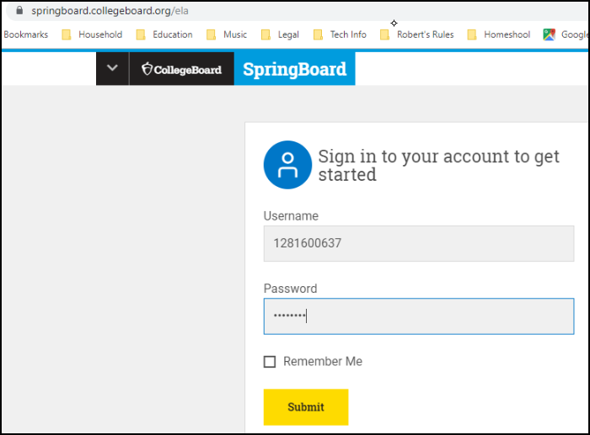

The system does not recognize the user name.
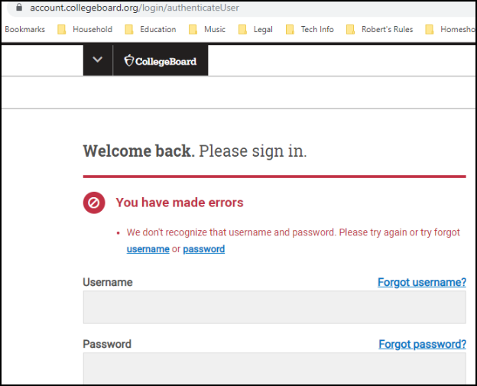

So, what exactly is Tevita's username for Springboard?

Mahalo,
Vanessa Ott
808 - 854 -1018
MsVOtt@gmail.com
freespeech4us.com/pianolessons

_____________________________________

11/19/19 – Ott: Forwarding previous email to Julia Smith.

From: Vanessa Ott <msvott@gmail.com>
Date: Tue, Nov 19, 2019 at 8:59 AM
Subject: Fwd: Cannot log into Springboard
To: <Julia.Smith@k12.hi.us>, Katherine Balatico <katherine.balatico@k12.hi.us>
Cc: Ron Matsushige <Ronald.Matsushige@k12.hi.us>, Feketi (Toakase) Huahulu <huahulufeketi@gmail.com>

Perhaps the earlier email should have been directed to Julia Smith.

_____________________________________

11/19/19 – Balatico: To log into Springboard, log into Clever first.

From: Katherine Balatico <katherine.balatico@k12.hi.us>
Date: Tue, Nov 19, 2019 at 2:16 PM
Subject: Re: Cannot log into Springboard
To: Vanessa Ott <msvott@gmail.com>

Ms. Ott --

In order to log into Springboard, you must first log into Clever. Once you get to the Clever page, click on the app labelled "Springboard." It should redirect you to Springboard. If it asks for a password, the password is !QAZxsw2

The Infinite Campus username for Tevita's mother is fahomana
We cannot see passwords, so his has been reset the password to stevenson148
Mom will then be directed to change the password when she logs in.

Thank you,
Katherine Balatico
Principal
R.L. Stevenson Middle School
Office (808) 587-4520
Fax (808) 587-4523

_____________________________________

11/21/19 – Ott: Please explain the Social Studies assignment. What is the purpose in cutting up the picture? Please send a digital copy of the picture.

From: Vanessa Ott <msvott@gmail.com>
Date: Thu, Nov 21, 2019 at 5:01 AM
Subject: Problem Based Learning project
To: Jay Visaya <Jay.Visaya@k12.hi.us>
Cc: Tevita <AhomTevi19@rlsms.k12.hi.us>, Ron Matsushige <Ronald.Matsushige@k12.hi.us>, Feketi (Toakase) Huahulu <huahulufeketi@gmail.com>

Aloha Mr. Visaya,

We scanned Tevita's PBL papers and put them in his Social Studies folder with filename:

2019-11-20-SocialStudies-PBL-in-progress

Tevita no longer has the puzzle pieces of the picture. It is difficult for us to support him at home on this project without the picture. Please email us a digital copy of the picture so Tevita can insert it into the file. Please explain the pedagogical purpose in cutting up the picture.

Also, please explain what you're looking for to complete the third column "Learning Issues/Ideas - What should we do?" Tevita does not understand what he's supposed to do and neither do I. How is he supposed to answer his questions about the picture if there is no information and only a picture that's all cut up?

Toakase and I would like to meet with you and Tevita in your classroom as soon as possible. We want to discuss his social studies curriculum, the test he keeps taking over and over, and this assignment. In the next week, we are available every morning, and Wednesday, Thursday, and Friday after school.

Mahalo,
Vanessa Ott
808 - 854 -1018
MsVOtt@gmail.com
freespeech4us.com/pianolessons

_____________________________________

11/21/19 – Ott: We would like to meet with you and Tevita in your classroom to discuss where he is in the Math curriculum.

From: Vanessa Ott <msvott@gmail.com>
Date: Thu, Nov 21, 2019 at 6:44 AM
Subject: Requesting a meeting in your classroom
To: Blake Carrigan <Blake.Carrigan@k12.hi.us>
Cc: Ron Matsushige <Ronald.Matsushige@k12.hi.us>, Tevita <AhomTevi19@rlsms.k12.hi.us>, Feketi (Toakase) Huahulu <huahulufeketi@gmail.com>

Aloha Ms. Carrigan,

Toakase and I would like to meet with you and Tevita in your classroom. The objective is to discuss where he is in the Math curriculum, and how we move forward and work together to optimize his learning. We have had a very difficult time supporting him at home and want to iron out wrinkles in that process. It's important to meet in your classroom so Tevita can show and explain how his process works there.

We are available every morning before school and after school on Wednesdays, Thursdays (must end by 4:00), and Fridays unless there is another uncommon appointment scheduled which happens, but rarely.

Mahalo,
Vanessa Ott
808 - 854 -1018
MsVOtt@gmail.com
freespeech4us.com/pianolessons

_____________________________________

11/21/19 – Visaya: The purpose of the cut-up puzzle is to spark interest in the assignment. As for geography test, I have him continue to do it to retain the information.

From: Jay Visaya <jay.visaya@k12.hi.us>
Date: Thu, Nov 21, 2019 at 9:34 AM
Subject: Re: Problem Based Learning project
To: Vanessa Ott <msvott@gmail.com>
Cc: Tevita <AhomTevi19@rlsms.k12.hi.us>, Ron Matsushige <Ronald.Matsushige@k12.hi.us>, Feketi (Toakase) Huahulu <huahulufeketi@gmail.com>

Aloha Ms. Ott,

Tevita forgot the envelope of puzzle pieces on his desk and it is for him to keep. The whole idea of the puzzle is to create/spark an interest leading up to the assignment (PBL). This assignment is a prelude/mini lesson as we make our way towards World Culture/Geography particularly Mesopotamia.

I had a written explanation on the 3rd column which Tevita should have shared with you. If not, referring back to the puzzle, what else besides what's displayed in the picture can be included as other issues. There can be more than one issue. As an example, could the puzzle depict air or noise pollution? The whole idea for PBL is for the students to develop their critical thinking skills.

As for the Geography test, Tevita has passed the test but I do have him continue taking it to help him retain the information since 2nd semester I'll be taking the word bank off the board but leaving the initials of the countries,oceans, islands. By 4th quarter, the hope is to eliminate all aids and have students take the test on their own.

Currently, we have just started working on the Geography of Mesopotamia.and hope to cover the following themes in the next weeks: History, Economics, Political Science, and Cultural Anthropology. Within these themes, I usually give an exit pass/quiz at the end of each week on what the students have covered for that week.

Mr. Visaya
_____________________________________

11/21/19 – Ott: Would like to meet in Mr. Kaz’s classroom to discuss Language Arts curriculum.

From: Vanessa Ott <msvott@gmail.com>
Date: Thu, Nov 21, 2019 at 6:46 AM
Subject: We request a meeting in your classroom
To: Scott Kazarian <Scott.Kazarian@k12.hi.us>
Cc: Ron Matsushige <Ronald.Matsushige@k12.hi.us>, Tevita <AhomTevi19@rlsms.k12.hi.us>, Feketi (Toakase) Huahulu <huahulufeketi@gmail.com>

Aloha Mr. Kaz,

Toakase and I would like to meet with you and Tevita in your classroom. The objective is to discuss where he is in the Language Arts curriculum, and how we move forward and work together to optimize his learning. We have had a very difficult time supporting him at home and want to iron out wrinkles in that process. It's important to meet in your classroom so Tevita can show and explain how his process works there.

We are available every morning before school and after school on Wednesdays, Thursdays (must end by 4:00), and Fridays unless there is another uncommon appointment scheduled which happens, but rarely.

Mahalo,
Vanessa Ott
808 - 854 -1018
MsVOtt@gmail.com
freespeech4us.com/pianolessons

_____________________________________

11/21/19 – Kazarian: I will check with Mr. Matsushige and get back to you.

rom: Scott Kazarian <scott.kazarian@k12.hi.us>
Date: Thu, Nov 21, 2019 at 7:21 AM
Subject: Re: We request a meeting in your classroom
To: Vanessa Ott <msvott@gmail.com>
Cc: Ron Matsushige <Ronald.Matsushige@k12.hi.us>, Tevita <AhomTevi19@rlsms.k12.hi.us>, Feketi (Toakase) Huahulu <huahulufeketi@gmail.com>

Thanks for the message Ms. Ott. I always enjoy getting together with Tevita's team and love how invested in his success you all are! Let me connect with Mr. Matsushige and get back to you.

Mahalo!

SK :)

Scott Kazarian
English Language Arts | Stevenson Middle School
Scott.Kazarian@k12.hi.us | (808) 729-8329

_____________________________________

11/21/19 – Tevita: I don’t remember having an explanation on the Problem Based Learning worksheet.

From: Tevita Ahomana <ahomtevi19@rlsms.k12.hi.us>
Date: Thu, Nov 21, 2019 at 5:37 PM
Subject: Re: Problem Based Learning project
To: Jay Visaya <jay.visaya@k12.hi.us>

Mr.Visaya,

I don't remember having an explanation on my PBL worksheet.

_____________________________________

11/22/19 – Asuncion: Tevita has a Science assignment to complete.

From: Christine Asuncion <christine.asuncion@k12.hi.us>
Date: Fri, Nov 22, 2019 at 1:05 PM
Subject: Re: Interdependence worksheet
To: Vanessa Ott <msvott@gmail.com>
Cc: Ron Matsushige <Ronald.Matsushige@k12.hi.us>, Feketi (Toakase) Huahulu <huahulufeketi@gmail.com>

Good afternoon,

I just wanted to let you know that I am sending Tevita home with his notebook and that he needs to finish his assignment. He has 3 more questions that he needs to answer. I am attaching the answer key so that you can assist him.

Thanks,
Mrs. Asuncion

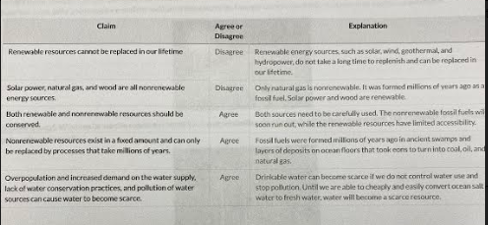
_____________________________________

11/22/19 – Matsushige: Friday take home work.

From: Ronald Matsushige <ronald.matsushige@k12.hi.us>
Date: Fri, Nov 22, 2019 at 2:51 PM
Subject: Friday take home work
To: Toakase <toahuahulu@gmail.com>, Vanessa Ott <msvott@gmail.com>, Tevita AhomTevi19@rlsms.k12.hi.us

Hi Everyone,

This week the “Please Return…” envelope contains Tevita’s Science notebook, as well as an assignment for him to work on. I believe Mrs. Asuncion sent you more details about it.
There is also an assignment from Social Studies that Tevita works on in class. He does not have to work on it this weekend. Mr. Visaya just sent it home so you could see what he’s currently working on in class.

Anything else should be in his binder.

Thank you and have a nice weekend!

Ronald Matsushige

_____________________________________

11/23/19 – Ott: Tevita doesn’t understand a lot of the words in the Science article, so he’s been copying answers from “a friend” without understanding. Tevita is timid about asking questions.

From: Vanessa Ott <msvott@gmail.com>
Date: Sat, Nov 23, 2019 at 10:02 AM
Subject: Re: Interdependence worksheet
To: Christine Asuncion <christine.asuncion@k12.hi.us>
Cc: Ron Matsushige <Ronald.Matsushige@k12.hi.us>, Feketi (Toakase) Huahulu <huahulufeketi@gmail.com>

Thank you, Ms. Asuncion,

FYI, I told Tevita to finish the assignment, and he confessed that he hadn't even written the first three answers. He'd copied them from a friend. He didn't understand the article, didn't know what "renewable" meant, etc.

We discussed why it does him no good to tackle difficult assignments by copying answers from others. I put it in terms he could understand. Not doing his own work is like wanting to get bigger muscles, having your friend do the reps with the weights, and expecting that your muscles will grow. A big barrier at this stage of preadolescence is he's ashamed to ask questions in front of other students because he has so many questions. He opts for sitting quietly and politely in silence. So, we also discussed strategies for him to work at his level and also be able to do the assignments independently.

He said that first you read the article with the class. Since he doesn't understand a lot of the words, he doesn't get much out of a first read through. I told him to follow in the text as you read, and circle all the words he doesn't know while you're reading. Then, while many other students are charging down the finish line and answering the assignment questions, he should go look up all the words he doesn't know, and then re-read the article for understanding. This will take him hours to do, and he'll have to finish as homework (which means bringing home the reading material,) but I feel confident that once it becomes a habit this will increase his vocabulary overall and the process will go faster.

I hope you agree that this is a good approach to overcoming the problem (he's not at the reading level of the article). If you have other ideas, let us know.

Tevita feels intimidated by his lack of knowledge compared to his peers and shies away from drawing attention to himself. So, he does not ask questions even though he often doesn't understand. He needs encouragement/approval/authority to do something a little different than his classmates are doing (like looking up word definitions online and re-reading an article while others are completing the assignment). So, could you remind him before class starts to circle words he doesn't know look, look them up online, re-read the article, and finish "reading for understanding" for homework (putting assignment in planner so he doesn't forget and mom knows). When the class starts the assignment, it might actually be helpful to mention to Tevita within earshot of his classmates that you want him to be doing the vocabulary building so other kids don't wonder why he's not working on the assignment right away -- or something that gives Tevita the permission to approach the assignment the way he needs to which will most likely be a different approach than other students'.

Also, it would be helpful to let Tevita bring home a reading packet as soon as he gets it, not just on Fridays. I think with his Mom's help, he's responsible enough to keep his papers in his zippered binder (in the Science section), and bring them back and forth from home to school each day, but if you still have reservations about letting incomplete assignment packets come home during the week, perhaps Tevita can get an extra copy which he can use to circle the words, look them up, and re-read for understanding at home as soon as a lesson packet is introduced.

What do you think?

Mahalo,
Vanessa Ott
808 - 854 -1018
MsVOtt@gmail.com
freespeech4us.com/pianolessons

_____________________________________

11/23/19 – Asuncion: Tevita can watch Brain Pop at home to increase understanding.

From: Christine Asuncion <christine.asuncion@k12.hi.us>
Date: Sat, Nov 23, 2019 at 12:28 PM
Subject: Re: Interdependence worksheet
To: Vanessa Ott <msvott@gmail.com>
Cc: Ron Matsushige <Ronald.Matsushige@k12.hi.us>, Feketi (Toakase) Huahulu <huahulufeketi@gmail.com>

Good afternoon all,
As I was going over the article I was having the students highlight or underline the key terms or important facts. Some of them did it and others didn't even though I kept on mentioning it to them. We also watched Brain Pop and I think that this is a good thing for Tevita to do on his own as a review at home. If he logs onto to Brain Pop
User name: stevensonms and Password:148 he can go onto the Science section and watch the fossil fuels and natural resources video or any other video on the topics that we are working on to help him to learn the terms. He can also take the quiz. They also have different subject areas that he can watch videos on to help him.

Tevita always comes into the class and gets a computer and does what he needs to do before we start the lesson and the other students are aware of his routine already. As for this assignment he didn't finish it on Thursday and I forgot to remind him to take his book home on Thursday since we don't have class on Friday. Sorry! I will try my best to remember to send it home earlier.

Take a look at the Brain Pop and let me know your thoughts on it.

Thanks,
Christine Asuncion

_____________________________________

11/23/19 – Ott: Tevita, read what Ms. Asuncion wrote.

From: Vanessa Ott <msvott@gmail.com>
Date: Sat, Nov 23, 2019 at 3:18 PM
Subject: Fwd: Interdependence worksheet
To: Tevita <AhomTevi19@rlsms.k12.hi.us>, Feketi (Toakase) Huahulu <huahulufeketi@gmail.com>

Tevita, read what I wrote to Ms. Asuncion and her response. Log into Brian Pop and review what you learned this week. I want you to show it to your mom and show me next time I see you.

Mahalo,
Vanessa Ott
808 - 854 -1018
MsVOtt@gmail.com
freespeech4us.com/pianolessons

_____________________________________

11/25/19 – Ott to CAS: Request CAS oversight in problems at RLSMS: student not learning school approved curriculum; no family engagement to improve outcomes.

From: Vanessa Ott <msvott@gmail.com>
Date: Mon, Nov 25, 2019 at 6:37 AM
Subject: Re: Requesting CAS oversight in helping us gain access to Stevenson Middle School LA and Math curricula
To: Linell Dilwith <linell.dilwith@k12.hi.us>
Cc: Katherine Balatico <katherine.balatico@k12.hi.us>, Ron Matsushige <Ronald.Matsushige@k12.hi.us>, Feketi (Toakase) Huahulu <huahulufeketi@gmail.com>, Malcolm Yasuda <Malcolm.Yasuda@k12.hi.us>, Blake Carrigan <Blake.Carrigan@k12.hi.us>

Aloha Complex Area Superintendent Dilwith,

We are following up on the email I sent to you three weeks ago with the same subject header as this one. We respectfully ask that you and your office provide oversight into brewing problems at Robert Louis Stevenson Middle School concerning SpEd curriculum and family engagement. We have tried to resolve these issues at the LEA/school level without success. I believe that a successful resolution will provide valuable data for your Complex Area regarding the achievement gaps of SpEd/ELL students as well as help this particular student. He does need immediate assistance from policy makers outside the school to rectify a problem that is becoming a crisis.

Concerning Tevita’s SpEd Math education at RLSMS in Grade 6, this is the educational plan that we want, but haven’t been able to get:
- Tevita will be taught the i-Ready Math curriculum using supplemental differentiation materials supplied by the curriculum. Only after the i-Ready materials have been exhausted will materials outside the curriculum be used.
- Tevita will begin his course of study in i-Ready Mathematics at the level where he is challenged, but has the competency to do the work. This level will be determined by his next round of i-Ready Math diagnostics in December. Let’s use the data, not just collect it. We estimate his competency/challenge level is beginning Grade 4 Mathematics, based on the i-Ready diagnostic from the beginning of the year.
- Tevita will follow a rigorous course of study aimed at progressing through the curriculum in an orderly fashion as designed by the curriculum developers (i.e., page by page, lesson by lesson).
- The classroom teacher and the home teachers will partner together to coordinate learning at school with learning at home to push Tevita through the pages of the curriculum as quickly as he is able to progress. That means the teacher, the home tutors, and the student rigorously and collaboratively work through the professionally-written curriculum chosen by the school starting at the student’s level of competency/challenge and moving forward rigorously. The ultimate goal is for Tevita to someday catch up to his grade-level peers.

This, of course, requires the home team have access to i-Ready teacher materials including the differentiation materials, which is what I wrote to you about on November 4th. We want to purchase the Ready Teacher Toolbox which provides differentiation and core curriculum materials K-8, but we must go through the DOE to make the purchase. Principal Balatico has denied our request. So, achieving the above common-sense approach to SpEd Mathematics education at RLSMS also requires a change in mindset. Fortunately, that doesn’t cost anything. We want to be respected as equal partners in Tevita’s education. [1]

I’m sure that Tevita is not the only student who would benefit from the changes I propose; I suggest you could use him as a test case, and compare the diagnostic growth he has shown in the first semester (learning from teacher “supplements”) with the diagnostic growth I hypothesize we will see in the coming semester if he is taught using the above model. Also, a comparison of the growth Tevita will undoubtedly experience in the second semester (if we follow the above plan) to the growth his SpEd Math classmates who don’t experience this kind of curriculum change in the second semester, will provide valuable data and perhaps suggest new successful approaches to SpEd education in your Complex Area.

What we’ve experienced so far this year is diametrically opposed to the model above. Tevita’s Math education and family engagement this year has looked like this:
- Tevita is not learning the i-Ready curriculum. Over 90% of his work this year has been skills worksheets pulled from myriad sources that provide absolutely no critical thinking skills. Rote skill after rote skill with no deep understanding of the concepts. He’s doing decimal division and multiplication and wasn’t taught what a decimal even is! We haven’t seen any word problems. We’ve seen only a small handful of Math definitions over the past four months. Sadly, our complaints have been met with untrue claims from the Principal that the teacher is using the curriculum and supplementing it as needed for this SpEd student. “Using” versus actually teaching is a semantic evasion of the truth. The teacher isn’t teaching the i-Ready curriculum at all! Either the entire 6th Grade is not being taught with a professionally-written curriculum or this treatment is reserved for SpEd students which is discriminatory. Either way, all the students should be taught using professional curricula and professional teaching tools, but that’s not happening – at least not for Tevita.
- It’s not uncommon for the “supplemental” materials given to Tevita to be intellectually insulting, such as having a 12-year-old color pictures and do cut-outs of problems which have no pedagogical purpose in furthering his Math education. Complaints about this have been met with false claims that these childish activities are math manipulatives. I’m sorry, but they don’t meet the criteria of the definition of a math manipulative. Note that irrelevant, time-consuming activities like these would not be an issue if Tevita was being taught the i-Ready curriculum. This SpEd student, and no doubt others like him, learns best when he is taught a professionally-written curriculum as it was intended to be taught (progressively, page by page, concept by concept, with all the word problems and pictures possible).
- It has been extremely difficult to assist Tevita at home with what he is learning in school. At our last meeting, Principal Balatico frankly stated that she saw no room for improvement in family engagement. We strongly disagree. Outside of school, Tevita has access to Vanessa Ott (an experienced teacher and close family friend) in addition to other tutors his mother has hired from time to time. A successful family engagement plan builds on family strengths to implement solutions for providing high-quality learning opportunities outside of school. Instead, we rarely know what he’s doing in Math class until the end of the week, and when we find out, it’s woefully disappointing.

If all of Tevita’s Math teachers (school and home) had access to the teacher resources and Tevita was progressively following the i-Ready curriculum so that everyone was on the same page, that would provide the highest quality education experience possible for no additional outlay of DOE funds. All that’s needed is a change in mindset.

Principal Balatico’s reasoning for not allowing us to purchase an i-Ready Math Teacher Toolkit is because that will give us access to assessments. We interpret that as disrespectful to assume that we will do anything illegal or unethical with these assessments. We’d be willing to comply with any requests the school may have concerning that small portion of the Teacher Toolkit that we’re not even interested in seeing. At home, we assess Tevita’s performance by simply observing what he can and cannot do. Giving the teachers at home access to the Toolkit is the best way for those at home to help him learn the curriculum – that is, whenever they start teaching it to him.

Don’t just take my word for what’s been happening. You can see for yourself if you want to take the time. We gladly will share Tevita’s Google drive where there are scanned archives of all his work since the beginning of the year. If you want to understand how hard we have been trying to foster a better home-to-school partnership to further Tevita’s education, look over the 6-page annotated table of contents in the attachment (chronologically-arranged emails with the RLSMS from 8/9/19 to 11/13/19), or read all 120+ pages to get a real feel for our frustration. We are spending far too much time trying to convince Principal Balatico to empower us to work collaboratively with the teachers at school. We would rather spend our energy helping Tevita learn, but we’re just spinning our wheels at the LEA.

A change in mindset has to come from outside the school, apparently. Therefore, we ask that you intervene and empower us to implement the above plan for SpEd family engagement and Tevita’s Math education.

Mahalo,

Vanessa Ott & Feketi Huahulu
808-854-1018

attachments: (1) Correspondence-RLSMS-2019-11-13.pdf

cc: Katherine Balatico, RLSMS Principal
Feketi Huahulu, Mother of Tevita Ahomana
Malcom Yasuda, RLSMS Student Services Coordinator
Blake Carrigan, RLSMS Grade 6 SpEd Math Teacher
Ronald Matsushige, RLSMS Care Coordinator

________________________________________________________________

[1] Meeting the Challenge Through Changing Mindsets and Cocreation [2]

Meeting the challenge laid out in this paper [authentic family engagement] requires a commitment to ensuring that all families…can build equitable learning pathways for their children—pathways that include high-quality schools as well as out-of-school learning opportunities.
This demands a major shift in mindset, from one of devaluing and doing to and for families to one of valuing and cocreating with them: asking questions, listening, empowering, sharing perspectives and information, partnering, codesigning, implementing, and assessing new approaches and solutions, and supporting parent leadership and advocacy for educational equity and change. It means building on family strengths and working with families to cocreate and dive deeper into their beliefs, norms, and practices.
[p 12] [PDF p. 15]

[2] Joining Together to Create a Bold Vision for Next Generation Family Engagement Engaging Families to Transform Education; A Report Prepared by Global Family Research Project for Carnegie Corporation of New York; October 2018.

_____________________________________

11/25/19 – Kazarian: Are there any specific questions you want answered when we meet?

From: Scott Kazarian <scott.kazarian@k12.hi.us>
Date: Mon, Nov 25, 2019 at 10:06 AM
Subject: Re: We request a meeting in your classroom
To: Vanessa Ott <msvott@gmail.com>
Cc: Ron Matsushige <Ronald.Matsushige@k12.hi.us>, Tevita <AhomTevi19@rlsms.k12.hi.us>, Feketi (Toakase) Huahulu <huahulufeketi@gmail.com>

Good Morning Ms. Ott. I hope you had a great weekend. I had a chance to connect with Tevita's care team and we're wondering if you had specific questions you'd like answered during that time together.

SK :)

Scott Kazarian
English Language Arts | Stevenson Middle School
Scott.Kazarian@k12.hi.us | (808) 729-8329

_____________________________________

11/25/19 – Ott: Want to discuss why Tevita isn’t learning the Springboard curriculum.

From: Vanessa Ott <msvott@gmail.com>
Date: Mon, Nov 25, 2019 at 1:39 PM
Subject: Re: We request a meeting in your classroom
To: Scott Kazarian <scott.kazarian@k12.hi.us>
Cc: Ron Matsushige <Ronald.Matsushige@k12.hi.us>, Tevita <AhomTevi19@rlsms.k12.hi.us>, Feketi (Toakase) Huahulu <huahulufeketi@gmail.com>

I want to discuss why he's not learning the Springboard curriculum.

Mahalo,
Vanessa Ott
808 - 854 -1018
MsVOtt@gmail.com
freespeech4us.com/pianolessons

_____________________________________

11/26/19 – Kazarian: I will get back to you.

From: Scott Kazarian <scott.kazarian@k12.hi.us>
Date: Tue, Nov 26, 2019 at 10:11 AM
Subject: Re: We request a meeting in your classroom
To: Vanessa Ott <msvott@gmail.com>
Cc: Ron Matsushige <Ronald.Matsushige@k12.hi.us>, Tevita <AhomTevi19@rlsms.k12.hi.us>, Feketi (Toakase) Huahulu <huahulufeketi@gmail.com>

Great. Thanks for the reply. I'll let the team know and get back to you.

Happy Thanksgiving

SK :)

Scott Kazarian
English Language Arts | Stevenson Middle School
Scott.Kazarian@k12.hi.us | (808) 729-8329

_____________________________________

11/26/19 – Ott: We would like to meet in Mr. Visaya’s classroom to discuss Tevita’s Social Studies curriculum.

From: Vanessa Ott <msvott@gmail.com>
Date: Tue, Nov 26, 2019 at 10:28 AM
Subject: Fwd: Problem Based Learning project
To: Jay Visaya <Jay.Visaya@k12.hi.us>
Cc: Ron Matsushige <Ronald.Matsushige@k12.hi.us>, Feketi (Toakase) Huahulu <huahulufeketi@gmail.com>, Katherine Balatico <katherine.balatico@k12.hi.us>

Aloha Mr. Visaya,

Toakase and I would like to meet with you and Tevita in your classroom. We want to discuss his social studies curriculum. Next week, we are available every morning Monday 12/2 through Thursday 12/5, as well Wednesday 12/4 after school, and Thursday 12/5 after school until 4:00 pm.

Mahalo,
Vanessa Ott & Toakase Huahulu
808 - 854 -1018

_____________________________________

11/26/19 – Visaya: I will get back to you about a meeting.

From: Jay Visaya <jay.visaya@k12.hi.us>
Date: Tue, Nov 26, 2019 at 1:06 PM
Subject: Re: Problem Based Learning project
To: Vanessa Ott <msvott@gmail.com>
Cc: Ron Matsushige <Ronald.Matsushige@k12.hi.us>, Feketi (Toakase) Huahulu <huahulufeketi@gmail.com>, Katherine Balatico <katherine.balatico@k12.hi.us>

Aloha,

I'm awaiting confirmation for another meeting next week and I do have a workshop on Monday so Monday is no good for me. As soon as I get confirmation I'll get back to you.

Thank you,
Mr. Visaya

_____________________________________

11/27/19 – Kim: It is my understanding the school has offered parent/teacher meetings. CAS Dilwith will not provide oversight.

From: Stuart Kim <stuart.kim@k12.hi.us>
Date: Wed, Nov 27, 2019 at 4:22 PM
Subject: Requesting CAS oversight in helping us gain access to Stevenson Middle School LA and Math curricula
To: <msvott@gmail.com>, <huahulufeketi@gmail.com>
Cc: Katherine Balatico <katherine.balatico@k12.hi.us>, Linell Dilwith <Linell.Dilwith@k12.hi.us>

Ms. Ott,

On behalf of Complex Area Superintendent Linell Dilwith, I am responding to your email dated November 25, 2019. We acknowledge you have academic concerns for Tevita, specifically in the ReadyMath program. For clarification purposes, ReadyMath is the curriculum that the school uses for math, while iReady is a universal screener.

It is my understanding that Principal Balatico and Tevita's teachers have made efforts to address your concerns on multiple occasions. So that the school can continue to meet his individualized needs, the school welcomes your input in all matters. It is my understanding that the school has offered parent/teacher meetings to talk about Tevita's progress and that Ms. Huahulu has picked up additional student workbooks for Springboard and ReadyMath. While the school has looked into your request for online resources/access to Springboard and provided you Tevita's Springboard account credentials, there is no online version for ReadyMath at this time. The school is not able to sell Teacher Editions of curriculum series, but the school has also provided you with contact information for Springboard and ReadyMath resources. As agreed, Tevita's teachers will continue to use the Stevenson student planner and send home classwork and homework daily.

As mentioned in her previous communication, CAS Dilwith will not provide oversight of the decisions made by an IEP team nor will she provide oversight for school level curriculum decisions. You are encouraged to continue to work with the school. Ms. Huahulu is welcome to ask the school to convene an IEP meeting to discuss any concerns.

Thank you,
Stuart Kim
District Educational Specialist, Special Education
Kaimuki-McKinley-Roosevelt Complex Area

_____________________________________

11/28/19 – Ott to Office of Curriculum and ID: What are requirements that a school follow a selected curriculum? Are there any requirements for the vetting process to adopt adapted materials?

From: Vanessa Ott <msvott@gmail.com>
Date: Thu, Nov 28, 2019 at 3:14 PM
Subject: Fwd: Thanks you for your interest in education materials.
To: Petra Schatz <petra.schatz@k12.hi.us>
Cc: Donna Kagawa <donna.kagawa@k12.hi.us>, Iris Kim <Iris.Kim@k12.hi.us>, Andrea Hardy <andrea.hardy@k12.hi.us>, Feketi (Toakase) Huahulu <huahulufeketi@gmail.com>

Aloha Ms. Schatz,

Thank you for your 10/6 email (copied below). I have read the information page about educational materials, but still have many questions. I'm sorry to bother you with these questions, but the Principal and CAS have resisted assistance in this matter, and the Learning Materials web page does not yet provide enough clarity on the issue.

I'm aware of the history of the BOE/DOE mandated curriculum which was recently changed to allow for more flexibility in instructional material selection at the school level. The Learning Materials page states, "Going forward, schools will hold the primary responsibility for selecting and enacting all instructional materials, " and alludes to "HIDOE adopted core instructional programs," but doesn't state that schools must select one of these programs or that they even have to teach a particular curriculum once selected. So, we wonder:
- Are there any requirements at all that a school select a HIDOE adopted core instructional program or OEM curriculum that has been peer-reviewed and vetted?
- Are there any requirements a school teach the selected criteria? Is that what "enacted" means?
- Are there any requirements for the vetting process to adopt adapted materials?
If there are no requirements, that would explain what's happening. We've been told that the local school has chosen the ReadyMath Mathematics curriculum and Springboard Language Arts curriculum as its core instructional programs. From the Learning Materials page, I understand that, "In some cases, materials may not be fully aligned [to standards], but could be selected with the understanding that teachers would need to adapt the materials accordingly. In these cases, review tools can be used to guide the adaptation process."

I help a Tongan mother, Feketi Huahulu, and her son navigate the complexities of DOE systems, but I can't explain to her why her son isn't being taught either of these programs because I don't understand this myself. From the Learning Materials page I have a vague sense that there's supposed to be a vetting process for adapting core instructional programs, and there's supposed to be some kind of peer review, but it's not clear how far one can stretch the concept of "adapting the materials accordingly" before there is so much adaptation that the core instructional program isn't even being taught to the student. And, it's not clear what to do if the student isn't being taught the curriculum, the Principal is unresponsive to parent concerns about this, and the CAS refuses to address the lack of rigorous curriculum instruction claiming it's the Principal's responsibility.

The school's rationalizations for not enacting the selected instructional materials in this student's case seem to be related to the fact that he's identified as needing Special Education services. In spite of his developmental delay and ADD, he's quite capable of learning either of these rigorous, core instructional programs, but the school is not enacting them, meaning they won't teach him these curricula. So this raises several questions about the adapted materials vetting process.
- Are there any requirements that adapted materials be vetted or is it merely a suggestion to schools that they do this?
- What are the minimal requirements of a vetting process, e.g., are current, tenured, classroom teachers in the same subject area part of the process?
- Do adaptations to the selected curriculum have to be documented in the school's academic and financial plan?
- Does a parent have the right to see documentation concerning who was involved in the vetting process for adaptations to selected curriculum, rationale for the adaptations, and what the adapted curriculum is actually going to be?
- What does a parent do when her child is not being taught a core instructional program and neither the Principal nor the Complex Area Superintendent are willing to address the matter? What is the next level of appeal?
As far as we can tell, the vetting process for adapting the curriculum at this student's school consists of rubber-stamping whatever the Math and Language Arts teachers come up with. While I mean no disrespect to these teachers who I think are trying to do the right thing, this vetting process is troubling because these are two very inexperienced teachers. The Language Arts teacher is working under an Emergency Hire Permit, and as far as I can tell, he has no formal education nor experience in the field of teaching Language Arts in a public school. He has a Bachelor of Science, Business Administration (2003) and Masters of Divinity, Pastoral/General Ministries (2011). The Math teacher is in her second year of a Provisional License. She has a Bachelor of Science, Teaching Special Education (2017). Apparently, them Principal considers them to be curriculum development experts. They are not. The extremely low quality of instructional materials for this student this year has been alarming.

While I have known teachers new to public school teaching who are capable of creating their own curriculum that rivals or even surpasses what a HIDOE adopted core instructional program provides, these two novice teachers' adapted curriculum does not come close to what Springboard and ReadyMath offer. We want Feketi's son to be taught the school selected curriculum but we can't seem to make that happen, and we don't understand why.

Has the pendulum swung to far in the other direction so that now there are no requirements or oversight of curriculum instruction and selection? I just don't understand how improvements in curriculum flexibility can be interpreted to mean a school doesn't have to teach a selected curriculum, or a professionally-written curriculum. Is that really true, or is there some misunderstanding?

Mahalo,
Vanessa Ott & Feketi Huahulu
808 - 854 -1018

_____________________________________

11/30/19 – Ott: To be clear, it is our understanding CAS is refusing to meet with parent regarding complaints of Principal’s decisions because student is a SpEd student.

From: Vanessa Ott <msvott@gmail.com>
Date: Sat, Nov 30, 2019 at 6:09 AM
Subject: Per BOE Policy304-5, the unresolved matter will be referred to the Office of the Superintendent.
To: Linell Dilwith <linell.dilwith@k12.hi.us>
Cc: Feketi (Toakase) Huahulu <huahulufeketi@gmail.com>, Katherine Balatico <katherine.balatico@k12.hi.us>, Stuart Kim <Stuart.kim@k12.hi.us>

Aloha Superintendent Dilwith,

We received Mr. Kim’s response stating, “CAS Dilwith will not provide oversight of the decisions made by an IEP team nor will she provide oversight for school level curriculum decisions.”

We want to be sure there are no misunderstandings. You are refusing to meet with Tevita Ahomana’s parent and home tutor to study the facts involved in our complaints that the school is (1) not teaching Tevita the school selected curriculum, and (2) refuses to engage in authentic family engagement with the parent and home tutors. The specific actions taken by the Principal (not the IEP Team) that we protest, and you refuse to consider for reversal, are to deny these requests:

• The student will be taught using the school “selected” and vetted Language Arts and Math curricula.
• The school will allow the parent to purchase teacher resource materials for the selected curriculum being taught so that tutors at home are able to follow and assist the student with learning at home.

Even though BOE Policy 304-5 states that the CAS is the next level of appeal for a matter unresolved at the school level, you refuse to study the matter further, nor meet with the parties involved to hear all the facts, evidence, and further explanations, so that you may clarify issues, dispense with hearsay, and act in accordance with research-based educational processes much needed by the student being denied them. You also refuse to consider our allegations that the Principal’s decisions are not aligned with BOE Policies 101-6, 101-14, 101-15, 102-2, 102-3, 102-14, 105-4, 304-1, E-1, and E-2.

Therefore, the matter continues to remain unresolved, so our only recourse for corrective action unless you change your mind soon, is to take the next step described in BOE Policy 304-5 and appeal to the office of the Superintendent to resolve the matter.

Mahalo,
Vanessa Ott & Feketi Huahulu
808-854-1018

_____________________________________

11/30/19 – Ott: Mr. Kim’s understandings in his 11/27 email are based on hearsay and not facts.

From: Vanessa Ott <msvott@gmail.com>
Date: Sat, Nov 30, 2019 at 5:41 PM
Subject: Facts, not hearsay
To: Stuart Kim <Stuart.kim@k12.hi.us>
Cc: Linell Dilwith <linell.dilwith@k12.hi.us>, Katherine Balatico <katherine.balatico@k12.hi.us>, Feketi (Toakase) Huahulu <huahulufeketi@gmail.com>

Aloha Mr. Kim

Your 11/27/19 email contained some incorrect information, so we think it's important to set the record straight. We'll stick to the facts instead of hearsay and cultural opinions about what is and is not welcoming. The facts iterated below are documented in the correspondence records I sent to Superintendent Dilwith with our 11/25/19 email.

You wrote, "the school welcomes your input in all matters." That is a subjective judgement and not one that we agree with. While welcoming may be the school's intent, a courteous veneer does not mean our input is gladly received and admitted as an actionable item which is what we would consider "welcoming our input."

The facts are that since August, we've asked numerous times to meet with teachers in their classrooms and have only been given that opportunity once, with the Math teacher, on 11/22. Other than that meeting, we've been permitted only two meetings with multiple teachers (one of them being an IEP revision meeting) that lasted about an hour each, and our primary concerns abut the lack of rigorous curriculum and family engagement weren't addressed in in those meetings. We have asked that Tevita be taught the school-selected ReadyMath and Springboard curricula, but that request has not been fulfilled which is evident from the work he has (and has not) been doing (facts). We requested counseling services for Tevita on 11/1/19 and received no response. While we agree that we were greeted with courtesy (one definition of welcoming), it is not accurate to characterize our input as being welcomed if one uses the definition, "gladly and cordially received or admitted."

You wrote, "It is my understanding that the school has offered parent/teacher meetings to talk about Tevita's progress." The word "offer" means to propose or put forward. In truth, the school did not propose meetings to talk about Tevita's progress. We requested meetings, and the school has responded with less than 3 hours of meeting time total with teachers this entire semester.

You wrote, "Ms. Huahulu has picked up additional student workbooks for Springboard and ReadyMath." Perhaps you are not aware of the specifics. The Principal allowed us to purchase student workbooks for curricula he isn't even being taught! That's $42 for books that are sitting on a shelf, useless, because the teachers aren't teaching the curriculum in these workbooks. So we wonder what was the purpose in selling us these books? The only purpose it has served so far is so that you can say Ms. Huahulu picked up (i.e., purchased) schoolbooks recommended by the Principal. They're useless, but th Principal said we could buy them.

You wrote, "The school is not able to sell Teacher Editions of curriculum series." There is no truth to this statement. The school is able to "sell" to a parent curriculum materials that it purchases from Curriculum Associates and other software vendors. The fact that Ms. Huahulu just purchased a SpringBoard Workbook, and ReadyMath Instruction Book and Practice Problem Solving Books is evidence that this can be done. Therefore, it is more accurate to say the Principal will not allow the parent and home tutor to have access to Teacher Editions of curriculum series even if they pay for the licenses. Although we have our suspicions, we won't speculate why that is the truth, but the facts are the facts, and your statement misrepresents the truth.

We hope this clarifies any misunderstandings. A full read of all the correspondence I sent should make the facts clearer, too.

In closing, we would like to comment on this statement, "CAS Dilwith will not provide oversight of the decisions made by an IEP team." The parent and representatives of her choosing are supposed to be considered part of the IEP team, yet decisions are made with which we strongly disagree for research and evidenced-based reasons. So IEP "Team" is a misnomer for we don't consider what's happening to be "teamwork" as defined by the dictionary (cooperative or coordinated effort on the part of a group of persons acting together as a team or in the interests of a common cause). It is more accurate to say that decisions are made by the school's IEP group, and we can either take it or leave it. Period. Doesn't matter what we say nor what facts and evidence we produce.

Mahalo,
Vanessa Ott & Feketi Huahulu
808-854-1018

_____________________________________

11/30/19 – Dilwith: Out of office until 12/2.

From: Linell Dilwith <linell.dilwith@k12.hi.us>
Date: Sat, Nov 30, 2019 at 6:10 AM
Subject: Out of Office Re: Per BOE Policy304-5, the unresolved matter will be referred to the Office of the Superintendent.
To: <msvott@gmail.com>

I am out of the office until Monday December 2, 2019. If this is an emergency, please contact the Honolulu District Office @ 808-733-4950. Thank you.
--
Linell Dilwith
Complex Area Superintendent
Kaimuki-McKinley-Roosevelt Complexes

"Don't fear failure.
Fear being in the exact same place next year as you are today."
-unknown-

_____________________________________

12/2/19 – Kazarian: Principal Balatico will join us for a meeting on Tuesday 12/3.

From: Scott Kazarian <scott.kazarian@k12.hi.us>
Date: Mon, Dec 2, 2019 at 8:51 AM
Subject: Re: We request a meeting in your classroom
To: Vanessa Ott <msvott@gmail.com>
Cc: Ron Matsushige <Ronald.Matsushige@k12.hi.us>, Tevita <AhomTevi19@rlsms.k12.hi.us>, Feketi (Toakase) Huahulu <huahulufeketi@gmail.com>

Good morning Ms. Ott. I hope your weekend was enjoyable.

Ms. Balatico is able to join us Tuesday morning 12/3 at 7:30am if that works for you.

Let me know.

SK :)

Scott Kazarian
English Language Arts | Stevenson Middle School
Scott.Kazarian@k12.hi.us | (808) 729-8329

_____________________________________

12/2/19 – Araki: Regarding 11/1 email, I am 6th grade counselor. I will call Tevita in this week.

From: Tricia Araki <tricia.araki@k12.hi.us>
Date: Mon, Dec 2, 2019 at 12:27 PM
Subject: Re: Requesting Counseling for Tevita
To: Vanessa Ott <msvott@gmail.com>
Cc: Ron Matsushige <Ronald.Matsushige@k12.hi.us>, Katherine Balatico <katherine.balatico@k12.hi.us>

Aloha Ms. Ott,

I am Tricia Araki, the 6th grade counselor. I am happy to periodically check in with Tevita. I will call him in sometime this week.

Mahalo,
Tricia Araki

_____________________________________

12/3/19 – Ott: How does counseling work? Will the parent receive a summary of outcomes when you meet with her son?

From: Vanessa Ott <msvott@gmail.com>
Date: Tue, Dec 3, 2019 at 3:42 AM
Subject: Re: Requesting Counseling for Tevita
To: Tricia Araki <tricia.araki@k12.hi.us>
Cc: Ron Matsushige <Ronald.Matsushige@k12.hi.us>, Katherine Balatico <katherine.balatico@k12.hi.us>, Feketi (Toakase) Huahulu <huahulufeketi@gmail.com>

Aloha Tricia,

Thank you for responding to our request for counseling services for Tevita. How does this work? Do you meet with the parent to start? Does the parent receive a summary of outcomes and next steps after you meet with Tevita?

Mahalo,
Vanessa Ott & Toakase Huahulu
808 - 854 -1018

_____________________________________

12/3/19 – Ott: Following up on 11/22/19 meeting. You were going to consider and discuss our requests and get back to me.

From: Vanessa Ott <msvott@gmail.com>
Date: Tue, Dec 3, 2019 at 4:48 AM
Subject: Follow up re: 11/22 meeting - ReadyMath differentiation
To: Blake Carrigan <Blake.Carrigan@k12.hi.us>
Cc: Feketi (Toakase) Huahulu <huahulufeketi@gmail.com>, Malcolm Yasuda <Malcolm.Yasuda@k12.hi.us>, Katherine Balatico <katherine.balatico@k12.hi.us>, Ron Matsushige <Ronald.Matsushige@k12.hi.us>

Aloha Ms. Carrigan,

If we recall correctly, the outcome of our 11/22/19 meeting was that you were going to consider and discuss with others our requests that:
- Tevita be taught the ReadyMath curriculum starting at his data-defined level of competency (perhaps this will be Grade 4 after the next round of diagnostic assessments), and proceed forward from there; and
- You work collaboratively with the parent and home tutor to move Tevita forward through the curriculum as quickly as he is able to grasp the concepts and move on.
I want to clear up a misunderstanding from 11/22. At the meeting, you stated that the school did not have access to ReadyMath curriculum below Grade 6. I have since learned that if you have a Ready Teacher Toolbox, you do have access to curriculum below Grade 6. The Toolbox is the intended method of differentiating/supplementing the ReadyMath curriculum. See: https://www.curriculumassociates.com/solutions/differentiating-instruction

Here's a description of the Ready Teacher Toolbox
https://www.curriculumassociates.com/products/ready/teacher-toolbox

Teaching a classroom of students who are all at different levels can be challenging work. The Ready Teacher Toolbox was designed to make that job a little easier by giving teachers quick access to our complete set of Ready Mathematics, Ready Reading, and Ready Writing K–8 instructional and support resources in one easy-to-use online platform. Think of it as an online archive from which teachers can draw relevant, standards-based resources to introduce new concepts, reteach standards, or help students learn prerequisite skills from earlier grade levels. Designed to support all Ready programs as well as i-Ready®, Teacher Toolbox ensures that teachers have the tools they need to implement whole class, small group, and individualized instruction that meet the needs of all learners at all levels.

If you don't have a Ready Teacher Toolbox license, you will recall that we have offered to purchase one for Tevita's instruction that we can use at home, too.

Also, since our last meeting I've become acquainted with the DOE web page that describes how instructional materials are supposed to be chosen:
https://learningdesign.hawaiipublicschools.org/school-design/learning-materials

It's my understanding that there is supposed to be an adaptation process for changes to school-selected curriculum and the DOE recommends review tools to guide the process. See: https://learningdesign.hawaiipublicschools.org/school-design/learning-materials Concerning all the supplements (i.e., adaptations to the ReadyMath curriculum), I was wondering what the adaptation review process looks like at RLSMS? Is there one? IMHO, it seems like a lot of extra work to create, peer review, and adapt differentiation materials when there's so much differentiation material already in the Ready Teacher Toolkit. Then again, if there's no formal adaptation process at the school, that would make for less work.

Anyway, we look forward to your response to the requests we made at the 11/22 meeting.

Mahalo,
Vanessa Ott & Toakase Huahulu
808 - 854 -1018

_____________________________________

12/3/19 – Ott: We will be there for tomorrow’s meeting.

From: Vanessa Ott <msvott@gmail.com>
Date: Tue, Dec 3, 2019 at 3:51 AM
Subject: Re: We request a meeting in your classroom
To: Scott Kazarian <scott.kazarian@k12.hi.us>
Cc: Ron Matsushige <Ronald.Matsushige@k12.hi.us>, Tevita <AhomTevi19@rlsms.k12.hi.us>, Feketi (Toakase) Huahulu <huahulufeketi@gmail.com>

We will be there.
Mahalo,
Vanessa & Toakase

_____________________________________

12/3/19 – Kazarian: We cannot meet this morning. Need to reschedule.

From: Scott Kazarian <scott.kazarian@k12.hi.us>
Date: Tue, Dec 3, 2019 at 5:41 AM
Subject: Re: We request a meeting in your classroom
To: Vanessa Ott <msvott@gmail.com>
Cc: Ron Matsushige <Ronald.Matsushige@k12.hi.us>, Tevita <AhomTevi19@rlsms.k12.hi.us>, Feketi (Toakase) Huahulu <huahulufeketi@gmail.com>

Good morning ms. Ott. We will not be able to meet this morning. We will need to reschedule. I will get some date options that are more than a days notice so we can coordinate more effectively.

Mahalo!
Sk :)
Scott Kazarian
English Language Arts | Stevenson Middle School
Scott.Kazarian@k12.hi.us | (808) 729-8329

_____________________________________

12/3/19 – Ott: More advance notice is helpful, but we can often accommodate meetings with less than 12-hours notice.

From: Vanessa Ott <msvott@gmail.com>
Date: Tue, Dec 3, 2019 at 5:52 AM
Subject: Re: We request a meeting in your classroom
To: Scott Kazarian <scott.kazarian@k12.hi.us>
Cc: Ron Matsushige <Ronald.Matsushige@k12.hi.us>, Tevita <AhomTevi19@rlsms.k12.hi.us>, Feketi (Toakase) Huahulu <huahulufeketi@gmail.com>

Aloha Mr. Kaz,

Thank you. More advance notice is helpful for Toakase and I, but often less than 24-hours notice can be accommodated because we're available almost every day in the morning -- except not on this coming Friday, Dec. 6th. I'm having carpel tunnel surgery starting early that morning.

Mahalo,
Vanessa

_____________________________________

12/4/19 – Araki: Counseling sessions are confidential, but I can email the mom to let her know when I’ve met with Tevita.

From: Tricia Araki <tricia.araki@k12.hi.us>
Date: Wed, Dec 4, 2019 at 1:41 PM
Subject: Re: Requesting Counseling for Tevita
To: Vanessa Ott <msvott@gmail.com>
Cc: Katherine Balatico <Katherine.Balatico@k12.hi.us>, Ronald Matsushige <Ronald.Matsushige@k12.hi.us>

Aloha Ms. Ott,

Thank you for your email. I will check in with Tevita periodically starting sometime this week. I look forward to hearing from him regarding the concerns you've raised. Counseling sessions are confidential, but I can email you on the days I see Tevita to let mom know that we've met.

Mahalo,
Tricia Araki

_____________________________________

12/4/19 – Dilwith: Since I am not on Tevita’s IEP Team, I am prohibited from making IEP decisions. Contact CollegeBoard and Curriculum Associates to purchase curriculum materials. Stevenson school has been more than responsive to your inquiries about Tevita’s education. I have directed Honolulu District's Education Specialist Stuart Kim and Resource Teacher Wade Okuma to consult on Tevita's case each week.

From: Linell Dilwith <linell.dilwith@k12.hi.us>
Date: Wed, Dec 4, 2019 at 5:00 PM
Subject: Re: Per BOE Policy304-5, the unresolved matter will be referred to the Office of the Superintendent.
To: Vanessa Ott <msvott@gmail.com>
Cc: Feketi (Toakase) Huahulu <huahulufeketi@gmail.com>, Katherine Balatico <katherine.balatico@k12.hi.us>, Stuart Kim <Stuart.kim@k12.hi.us>

December 4, 2019
Vanessa Ott
2825 S. King Street
Honolulu, Hawaii 96826
RE: Tevita Ahomana
Ms. Ott;
This email is to acknowledge and respond to your email dated November 28, 2019. I have directed Honolulu District's Education Specialist Stuart Kim and Resource Teacher Wade Okuma to consult on Tevita's case each week to help ensure that the school is providing Tevita the educational opportunities that he deserves in accordance with his IEP.
As you know, Individuals with Disabilities Education Improvement Act of 2004 (IDEA), prohibits the development of the IEP to be determined outside the IEP team. Since, I am not a member of the IEP team, I am prohibited from making IEP team decisions. I am confident that the IEP team, including you and Mrs. Ahomana will determine an appropriate program for Tevita.
In response to your request to purchase teacher edition materials, my response is the same as Principal Balatico's response. Please contact the vendors, CollegeBoard and Curriculum Associates to purchase teacher edition materials. No one at the Department of Education is authorized to sell copy-written materials. A word of caution about a student who has access to teacher edition materials. When a student has access to teacher materials, there is no certainty the student will internalize the material on their own or learn the process on their own to carry those skills through high school, college and the workplace. There have been instances where students with access to teacher edition materials were not providing their own answers nor working through the exercises to develop their own skills. In the end, when they were tested, it was discovered too late that their skills had not been developed while they had access to the answers.
In response to your concern regarding family engagement, the Stevenson Middle school team has been more than responsive to your weekly inquiries regarding Tevita’s educational programming and IEP. They have engaged in numerous email correspondence and facilitated three (3) face to face meetings. Under Principal Balatico's leadership, the school also arranged and facilitated a meeting with all of Tevita's seven (7) teachers. Individual teachers have also agreed to and continue to communicate with you weekly, and per your request you have been provided with access to Tevita's Springboard student account credentials so you could have access to his curriculum. These efforts have been made to provide additional opportunities for parent involvement and collaboration in monitoring Tevita’s educational programming and progress. The school has addressed every concern you have brought forward, evidenced in email threads and meeting documentation.
The school is agreeable and welcomes your involvement while in an IEP meeting. As you know, methodology and the implementation of the IEP is the responsibility of the school personnel and I will be holding them accountable for the delivery of FAPE. Because you and Mrs. Ahomana are not responsible for the delivery of the IEP, I will not be holding either of you accountable for the delivery of the IEP. Please allow the school personnel to do their very best for Tevita. If you are looking for ways to support the school personnel so they can concentrate all their energy and time on the delivery of the IEP in the general curriculum, I would ask you to concentrate on Tevita’s homework while at home so he will be ready and able to meet the rigorous needs of a middle school day.

I will be contacting the Mediation Center of the Pacific to see if they would be willing to mediate any pending issues you may have about Tevita’s delivery of FAPE. I encourage you to give them your participation so we can make the most of their free services. In addition, please feel free to contact Educational Specialist, Taren Taguchi, IDEA Complaints Management Program, Monitoring and Compliance Branch, Office of the Deputy Superintendent at Cell: 808-853-0261or email at taren.taguchi@k12.hi.us. DES Kim can be reached through his email at Stuart.kim@k12.hi.us. Thank you for your dedication to supporting students with disabilities.

Linell Dilwith
Complex Area Superintendent
Kaimuki-McKinley-Roosevelt Complexes

"Don't fear failure.
Fear being in the exact same place next year as you are today."
-unknown-

_____________________________________

12/4/19 – Ott: The legal right to confidentiality belongs to the parents of minors. We ask that you not proceed with counseling unless a reasonable level of family engagement and information sharing is going to be part of the process.

From: Vanessa Ott <msvott@gmail.com>
Date: Wed, Dec 4, 2019 at 10:28 PM
Subject: Re: Requesting Counseling for Tevita
To: Tricia Araki <tricia.araki@k12.hi.us>
Cc: Katherine Balatico <Katherine.Balatico@k12.hi.us>, Ron Matsushige <Ronald.Matsushige@k12.hi.us>, Feketi (Toakase) Huahulu <huahulufeketi@gmail.com>

Aloha Ms. Araki,

Your response was surprising. Doesn't the legal right to confidentiality usually belong to the parents and guardians of minors and not to the minors themselves?

While we have requested counseling services for Tevita, his mother is not going to consent to counseling services if she is not going to be engaged in the process nor informed of the outcomes of your sessions with her son and the the advice you are dispensing. It would be a good idea start with a conversation with the parent to find out what her concerns are. If the school cannot provide this level of counseling services, we are concerned that it will do more harm than good.

We ask that you not proceed unless a reasonable level of family engagement and information sharing is going to be part of the process.

Mahalo,
Vanessa Ott
808 - 854 -1018

attachment: ethics_october-2017_minor-privacy.pdf

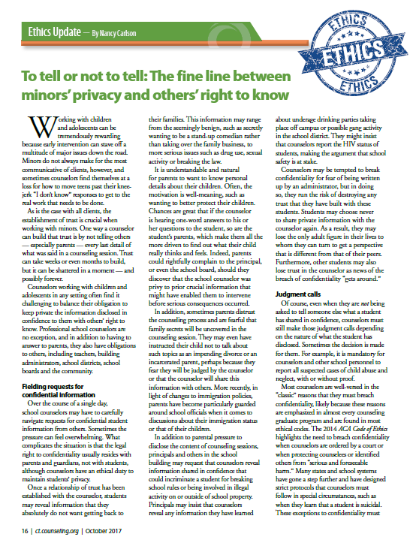
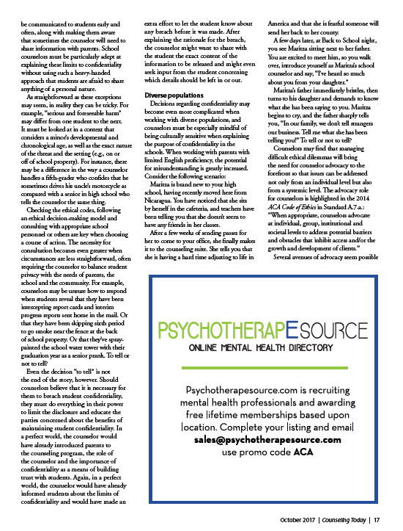
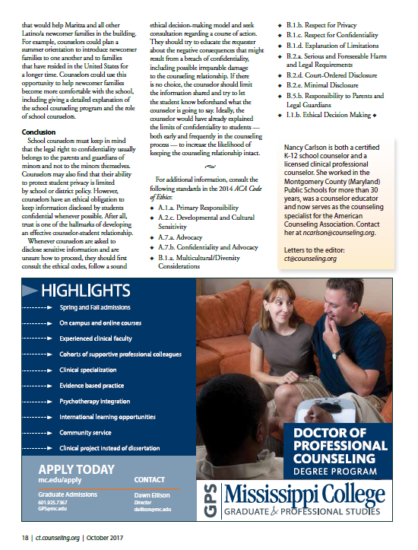
_____________________________________

12/5/19 – Ott to Taguchi: We’ve been instructed that our next step to ensure the DOE provides a FAPE is to contact you concerning our complaints.

From: Vanessa Ott <msvott@gmail.com>
Date: Thu, Dec 5, 2019 at 12:39 AM
Subject: Request a meeting to submit a complaint
To: <taren.taguchi@k12.hi.us>

Aloha,

We have been instructed that our next step to ensure that the DOE provides FAPE for Tevita Ahomana (student ID: 1281600637) is to contact you. We have several complaints about the substandard education he is receiving.

I am the parent's interpreter and assistant. Attached is a copy of the signed letter on record with Robert Louis Stevenson Middle School authorizing my involvement.

We request a meeting with you to discuss our concerns.

Mahalo,
Vanessa Ott & Feketi Huahulu (Formerly Feketi Ahomana)
808 - 854 -1018

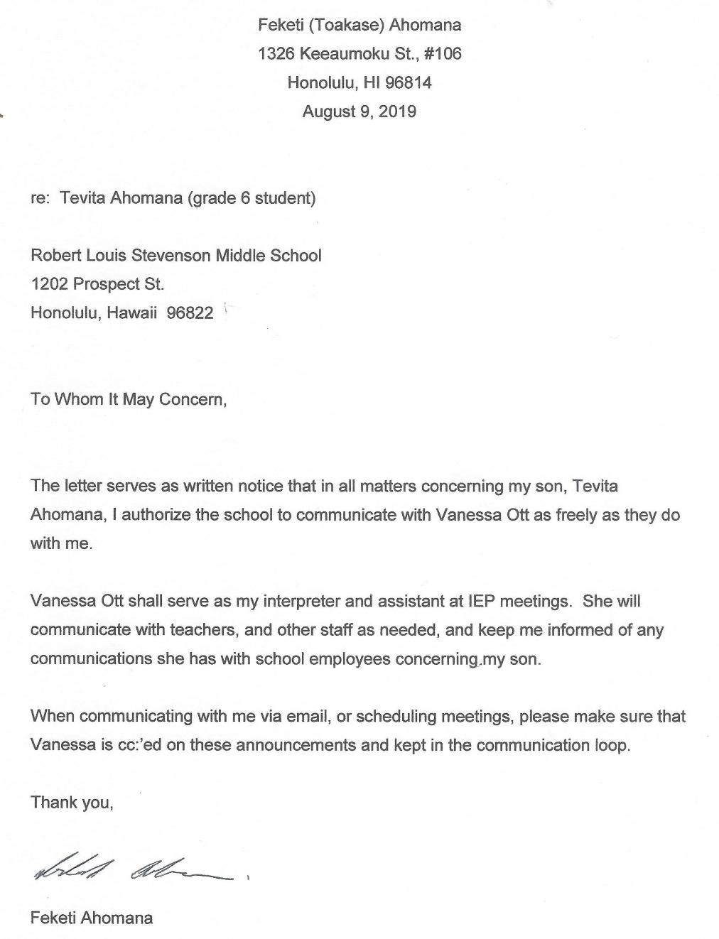
_____________________________________

12/5/19 – Taguchi to Ott: FERPA prohibits me from releasing confidential information about a student’s educational record without written permission from the parent. Consent form is attached.

From: Taren Taguchi <taren.taguchi@k12.hi.us>
Date: Thu, Dec 5, 2019 at 11:25 AM
Subject: Re: Request a meeting to submit a complaint
To: Vanessa Ott <msvott@gmail.com>

Aloha Ms. Ott,

I hope you're having a good Thursday.

Thank you for your correspondence. As you know, Family Educational Rights and Privacy Act prohibits me from releasing confidential information about a student's educational record without written permission from the parent. You probably already know that you may file a third party state written complaint, but the results or report will not be sent to you. The results will be sent to the parents. You are welcome to file a third party complaint and I've attached the form. I suggest you discuss the parent's options in filing a state written complaint versus using other means of dispute resolution. Ask the parent to send me their email address. There have been several parents who were disappointed with the process because they were unaware of the limitations of state written complaint to resolve disputes as to noncompliance. I'm also attaching the DOE's form: Consent to Release Information to be signed by the parent. Please specify what information can be released. Also, this form gives the recipient access to the records, but is not for representation.

Here are the websites:

Written complaint form (You are not required to use the form but it's helpful to get your thoughts organized)
Takes 60 days to complete an investigation.
http://www.hawaiipublicschools.org/DOE%20Forms/Special%20Education/WrittenComplaint.pdf

State Complaint Procedures:
http://www.hawaiipublicschools.org/DOE%20Forms/Special%20Education/StateCompliantProcedures.pdf

Mahalo,
Taren Taguchi, Educational Specialist
IDEA Complaints Management Program
Monitoring and Compliance Branch
Office of the Deputy Superintendent
Hawaii Department of Education
P.O. Box 2360
Honolulu, HI 96804
Cell: 808-853-0261
taren.taguchi@k12.hi.us

_____________________________________

12/5/19 – Ott: I’m sorry if you misunderstood. Parent wants to file a complaint and I am helping her. Will you arrange a time to speak with us?

From: Vanessa Ott <msvott@gmail.com>
Date: Thu, Dec 5, 2019 at 3:39 PM
Subject: Re: Request a meeting to submit a complaint
To: Taren Taguchi <taren.taguchi@k12.hi.us>
Cc: Feketi (Toakase) Huahulu <huahulufeketi@gmail.com>

I'm sorry if you misunderstood. The parent wants to file a complaint and I am helping her do that because she is not proficient in English. The CAS instructed us to take the complaint to you.

So, will you please arrange a time to speak with us about Ms. Huahulu's complaints?

Mahalo,
Vanessa Ott
808 - 854 -1018
_____________________________________

12/5/19 – Ott to Kim and Okuma: Per CAS’s directive, when do you want to schedule weekly consultations?

From: Vanessa Ott <msvott@gmail.com>
Date: Thu, Dec 5, 2019 at 8:12 PM
Subject: When and where will we be meeting to consult each week?
To: Wade Okuma <Wade.Okuma@k12.hi.us>, Stuart Kim <Stuart.kim@k12.hi.us>
Cc: Feketi (Toakase) Huahulu <huahulufeketi@gmail.com>, Katherine Balatico <katherine.balatico@k12.hi.us>

Aloha Mr. Kim and Mr. Okuma,

Per CAS Dilwith's 12/4/19 email, when do you want to schedule our weekly consultation on Tevita's case? We are available in the mornings M-F and in the afternoons on W, Th (until 3pm), and Friday, though not during the times Toakase drops off or picks up Tevita from school. Shall we come to the District Offices to meet with you?

Mahalo,
Vanessa Ott & Toakase Huahulu
808-854-1018

_____________________________________

12/6/19 – Matsushige: Friday take home work.

From: Ronald Matsushige <ronald.matsushige@k12.hi.us>
Date: Fri, Dec 6, 2019 at 3:38 PM
Subject: Work in the envelope
To: Toakase <toahuahulu@gmail.com>, Vanessa Ott <msvott@gmail.com>, Tevita <AhomTevi19@rlsms.k12.hi.us>

Hi Everyone!

The "Return on Monday" envelope contains Tevita's Science notebook this week. Anything else should be in his binder.

Thank you and have a great weekend!

Ronald Matsushige

_____________________________________

12/8/19 – Ott: Waiting for response to 11/28 email.

From: Vanessa Ott <msvott@gmail.com>
Date: Sun, Dec 8, 2019 at 4:43 AM
Subject: Fwd: Thanks you for your interest in education materials.
To: Petra Schatz <petra.schatz@k12.hi.us>
Cc: Donna Kagawa <donna.kagawa@k12.hi.us>, Iris Kim <Iris.Kim@k12.hi.us>, Andrea Hardy <andrea.hardy@k12.hi.us>, Feketi (Toakase) Huahulu <huahulufeketi@gmail.com>

Aloha,

It has been five working days since I sent the email (below) on 11/28/19, but we have not received a response. Hawaii Administrative Rule §8-5-8 specifies that we should have received either the answers to our questions within 3 working days or some communication about a mutually agreeable time when we will get the answers.

Mahalo,
Vanessa Ott & Feketi Huahulu
808 - 854 -1018
MsVOtt@gmail.com

_____________________________________

12/8/19 – Ott: Please send recent i-Ready Math and Language Arts diagnostic results and schedule and IEP revision meeting.

From: Vanessa Ott <msvott@gmail.com>
Date: Sun, Dec 8, 2019 at 6:17 AM
Subject: Please Email Tevita's LA and Math Diagnostics & schedule IEP meeting(s) before the end of the semester.
To: Ron Matsushige <Ronald.Matsushige@k12.hi.us>
Cc: Feketi (Toakase) Huahulu <huahulufeketi@gmail.com>, Katherine Balatico <katherine.balatico@k12.hi.us>

Aloha Mr. Matsushige,

Please email Tevita's latest diagnostic reports for LA and Math as soon as possible.

Please arrange another IEP meeting (or 2 if necessary) to discuss
- results of the diagnostic tests,
- Family Engagement,
- Lack of High Expectations and Rigor in Curriculum,
- ensuring Tevita has access to a computer to take notes in all classes and teachers encourage its use; and
- problems we've encounter with home-to-school connections.
Please allow enough time to sufficiently discuss these concerns. Our two previous 1-hour meetings both ended with issues being unaddressed. For example, Mr. Kaz didn't even come to the November IEP meeting. In September, the meeting ended before we could discuss the lack of rigor in the Tevita's lessons.

Also, since the descriptions of what Family Engagement is, as understood by Education professionals in the year 2019, and the ideals set forth in BOE Policy 101-14 differ so much from our experience we would like to know what the Family Engagement plan for the school looks like. All we found is the following entry in the 2017-2020 Academic Plan:
- Desired Outcome: Increase school climate to 84% as evidenced by the Strive HI report.
- Enabling Activity: Collaborate with community partners on family engagement activities to strengthen family connectedness and also the connection to school and the community.
- Interim Measures of Progress: 2017-2020 Increase in the number of families that participate in each family engagement activity as evidenced by artifacts such as but not limited to sign-in sheets, meeting notes/minutes, etc.. 100% of the feedback from families will reflect positive responses when asked about the value of the activities that are provided to families as evidenced by surveys and/or evaluations.
However, the Strive HI report does not provide any school climate measures to assess parent perspectives. I think the phrase "family involvement" is more accurate than "family engagement" given my research. And, we do not recall being given a survey to evaluate the meetings we've had.

Please send us the school's family engagement plan, or at least whatever research you are using on the subject to derive your definitions of family engagement so we can all use the same definitions and models in our discussion.

Mahalo,
Vanessa Ott
808 - 854 -1018

_____________________________________

12/9/19 – Asuncion: Here is the worksheet Tevita missed today because he wasn’t in class due to testing.

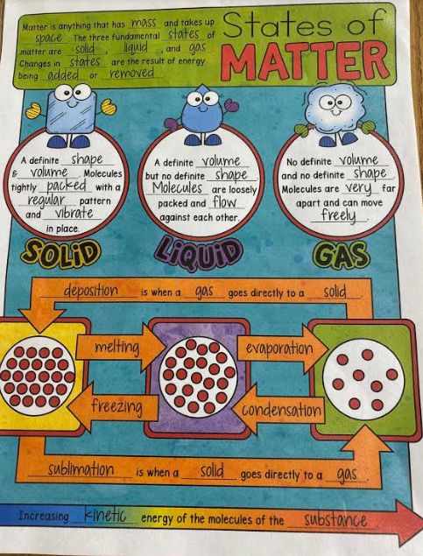
From: Christine Asuncion <christine.asuncion@k12.hi.us>
Date: Mon, Dec 9, 2019 at 2:20 PM
Subject: Re: Interdependence worksheet
To: Vanessa Ott <msvott@gmail.com>
Cc: Ron Matsushige <Ronald.Matsushige@k12.hi.us>, Feketi (Toakase) Huahulu <huahulufeketi@gmail.com>

Good afternoon,
I just wanted to let you know that I sent Tevita home with work to do since he wasn't in class today due to testing. He has the worksheet and I am attaching the sheet for him to copy.

Thanks,
Mrs. Asuncion

_____________________________________

12/9/19 – Ott: Please cc: Tevita in correspondence regarding his assignments.

From: Vanessa Ott <msvott@gmail.com>
Date: Mon, Dec 9, 2019 at 6:47 PM
Subject: Re: Interdependence worksheet
To: Christine Asuncion <christine.asuncion@k12.hi.us>
Cc: Ron Matsushige <Ronald.Matsushige@k12.hi.us>, Feketi (Toakase) Huahulu <huahulufeketi@gmail.com>, Tevita <AhomTevi19@rlsms.k12.hi.us>

Thank you, Ms. Asuncion. I forwarded your email to Tevita. In the future, please feel free to include Tevita in the recipient list for your correspondence. His email is: AhomTevi19@rlms.k12.hi.us

Mahalo,
Vanessa Ott
808 - 854 -1018
MsVOtt@gmail.com
freespeech4us.com/pianolessons

From: Christine Asuncion <christine.asuncion@k12.hi.us>
Date: Tue, Dec 10, 2019 at 9:07 AM
Subject: Re: Interdependence worksheet
To: Vanessa Ott <msvott@gmail.com>
Cc: Ron Matsushige <Ronald.Matsushige@k12.hi.us>, Feketi (Toakase) Huahulu <huahulufeketi@gmail.com>, Tevita <AhomTevi19@rlsms.k12.hi.us>

Will do, thank you!

_____________________________________

12/10/19 – Ott: Following up on CAS 12/4 email. We’ve received no response from Kim or Okuma about consultations. We can only purchase Curriculum Associates curriculum materials through the DOE. Following a professional curriculum and family engagement are proven practices that aren’t being implemented.

From: Vanessa Ott <msvott@gmail.com>
Date: Tue, Dec 10, 2019 at 6:53 AM
Subject: Fwd: Per BOE Policy304-5, the unresolved matter will be referred to the Office of the Superintendent.
To: Linell Dilwith <linell.dilwith@k12.hi.us>
Cc: Feketi (Toakase) Huahulu <huahulufeketi@gmail.com>, Katherine Balatico <katherine.balatico@k12.hi.us>, Stuart Kim <Stuart.kim@k12.hi.us>, Wade Okuma <Wade.Okuma@k12.hi.us>

Aloha Superintendent Dilwith,

Following up on your 12/4/19 email:

1) You wrote, "I have directed Honolulu District's Education Specialist Stuart Kim and Resource Teacher Wade Okuma to consult on Tevita's case each week to help ensure that the school is providing Tevita the educational opportunities that he deserves in accordance with his IEP."

We wrote to Mr. Kim and Mr. Okuma on 12/5 asking when we could consult with them (see email below). We have not received any response.

2) You wrote, "Since, I am not a member of the IEP team, I am prohibited from making IEP team decisions."

That's easily overcome. You could join the IEP Team.

3) You wrote, "Please contact the vendors, College Board and Curriculum Associates to purchase teacher edition materials. No one at the Department of Education is authorized to sell copy-written materials."

3(a) We did contact Curriculum Associates in September. Curriculum Associates does not sell to individuals, only schools. So, if a parent in Hawaii wants to purchase a copy of anything made by Curriculum Associates they have to purchase it from the school.

3(b) We purchased copies of the student workbooks, so your statement about DOE schools not being authorized to sell copy-written materials isn't quite true.

3(c) The request to purchase the C.A. Teacher Toolbox is because the school would not make arrangements for us to come to the school and look at the materials. Also, it would be extremely helpful for his education for the home tutor to have access to differentiated material aligned with the curriculum he's supposed to be learning in school.

3(d) OK, don't sell us a Toolbox license. Give us one, instead, as part of his IEP. Too much money? We'll make an equivalent donation to the school.

4) You wrote, "There have been instances where students with access to teacher edition materials were not providing their own answers nor working through the exercises to develop their own skills."

The student will not have access to teacher materials. Don't know why you think that. We want the teacher materials for the home tutor who, BTW, has more teaching experience than the Math and Language Arts teachers combined.

5) You wrote, "The school is agreeable and welcomes your involvement while in an IEP meeting."

I'm not sure about the purpose above statement, but it seemed odd because we've been trying to explain that we don't feel welcomed and involved, at least not by our perception of those words. We do have our differences about what welcoming, involved, and engaged actually mean. Regardless, I wanted to remind everyone that it's Ms. Huahulu's legal right to include me in the IEP Team, and the school being agreeable or disagreeable to my inclusion is irrelevant. See IDEA 300.321(a)(6):

The public agency must ensure that the IEP Team for each child with a disability includes—(6) At the discretion of the parent or the agency, other individuals who have knowledge or special expertise regarding the child, including related services personnel as appropriate.

We look forward to some kind of mediation or oversight into this matter so that our concerns will be addressed with at least a reasonable compromise, and not brushed aside. You concluded your correspondence with advice on how we can best support Tevita's education. As you pointed out, you're not part of the IEP Team. You've not heard our side of the story. We don't think your recommendations are what's best for Tevita's education. Please join the IEP Team and let's discuss it. The best, research-proven approach is:
- Follow the school-approved, professionally-written curriculum, and
- Engage the parent and home tutor in teaching Tevita the curriculum,
Sadly, that's not happening, which is just unfathomable from our perspective. We look forward to impartial oversight by a qualified mediator.

Mahalo,
Vanessa Ott & Feketi Huahulu
808 - 854 -1018

_____________________________________

12/10/19 – Dilwith: Out of office until 12/16/19.

From: Linell Dilwith <linell.dilwith@k12.hi.us>
Date: Tue, Dec 10, 2019 at 6:53 AM
Subject: Out of Office Re: Fwd: Per BOE Policy304-5, the unresolved matter will be referred to the Office of the Superintendent.
To: <msvott@gmail.com>

I am out of the office until 12/16/19. If this is an emergency, please contact the Honolulu District Office @ 808-733-4950. Thank you.

Linell Dilwith
Complex Area Superintendent
Kaimuki-McKinley-Roosevelt Complexes

"Don't fear failure.
Fear being in the exact same place next year as you are today."
-unknown-
_____________________________________

12/10/19 – Ott: i-Ready testing was last week. Why was Tevita pulled from Science class yesterday to do more testing?

From: Vanessa Ott <msvott@gmail.com>
Date: Tue, Dec 10, 2019 at 7:00 AM
Subject: Re: Please Email Tevita's LA and Math Diagnostics & schedule IEP meeting(s) before the end of the semester.
To: Ron Matsushige <Ronald.Matsushige@k12.hi.us>
Cc: Feketi (Toakase) Huahulu <huahulufeketi@gmail.com>, Katherine Balatico <katherine.balatico@k12.hi.us>

Aloha Mr. Matsushige,

I thought i-Ready testing concluded last week. Why did Tevita miss Science class yesterday to do more i-Ready testing? Isn't there another time he can do this, like before or after school so that he doesn't miss is classes? Are other students pulled out of class for testing? When will he be finished testing?

Please clarify.

Mahalo,
Vanessa Ott
808 - 854 -1018

_____________________________________

12/10/19 – Ott to Taguchi: Will you arrange a time to meet with us or is there someone else we should contact?

From: Vanessa Ott <msvott@gmail.com>
Date: Tue, Dec 10, 2019 at 3:05 PM
Subject: Re: Request a meeting to submit a complaint
To: Taren Taguchi <taren.taguchi@k12.hi.us>
Cc: Feketi (Toakase) Huahulu <huahulufeketi@gmail.com>

Aloha Ms. Taguchi,

Complex Area Superintendent wrote to us, "Please feel free to contact Educational Specialist, Taren Taguchi, IDEA Complaints Management Program, Monitoring and Compliance Branch, Office of the Deputy Superintendent at Cell: 808-853-0261 or email at taren.taguchi@k12.hi.us."

If you are indeed the next person we should talk to, please arrange a time for a meeting.

If you are not the person we should schedule a meeting with, please tell us who we should contact.

Mahalo,
Vanessa Ott & Feketi Huahulu
808 - 854 -1018

_____________________________________

12/10/19 – Huahulu: Signed letter hand-delivered to school authorizing Vanessa Ott’s involvement in all matters concerning her son.

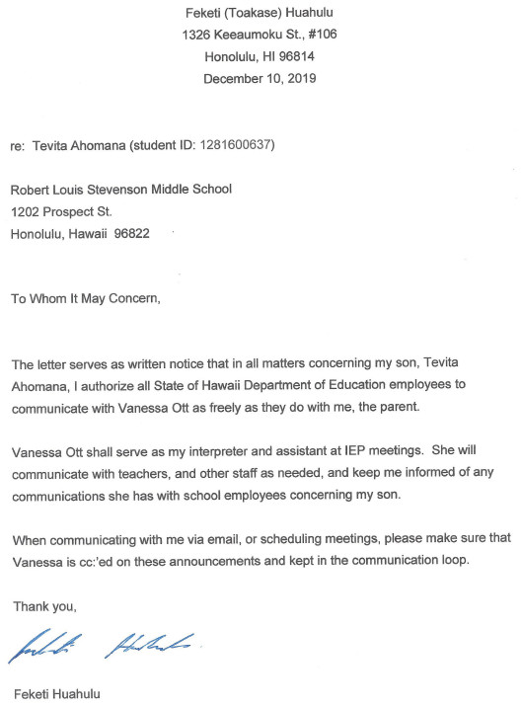
Note: This is the same letter submitted to the school on 8/9/19 except this one is signed with mother’s current last name, Huahulu.
_____________________________________

12/11/19 – Nagamine: Responding to 11/28/19 email from Ott. We will send information by Friday 12/13/19.

From: Lisa Nagamine <lisa.nagamine@k12.hi.us>
Date: Wed, Dec 11, 2019 at 4:07 AM
Subject: Re: Thanks you for your interest in education materials.
To: Vanessa Ott <msvott@gmail.com>

Dear Ms. Ott,
Thank you for your inquiry regarding the educational materials. I apologize for the delay. We will be sending the information to you by Friday, December 13, 2019.

Thank you,

Lisa Nagamine
Hawaii Department of Education
Office of Curriculum and Instructional Design
Interim Curriculum Innovation Branch Director
Diamond Head Annex
475 22nd Avenue, Building 302, Room 223
Honolulu, HI 96816
Cell: 1(808)383-6213 (Texting is best)
Work Office: (808)305-9700
DOE Email: lisa.nagamine@k12.hi.us

_____________________________________

12/11/19 – S.Kim: Mr. Okuma and myself [sic] will be providing support to RLSMS. You should continue to work with the school.

From: Stuart Kim <stuart.kim@k12.hi.us>
Date: Wed, Dec 11, 2019 at 11:58 AM
Subject: Fwd: Per BOE Policy304-5, the unresolved matter will be referred to the Office of the Superintendent.
To: <huahulufeketi@gmail.com>
Cc: Linell Dilwith <Linell.Dilwith@k12.hi.us>, Katherine Balatico <katherine.balatico@k12.hi.us>, msvott@gmail.com

Aloha Ms. Huahulu,
This is in response to an email sent by your private tutor. For clarification purposes, Mr. Okuma and myself will be providing support to Stevenson Middle School. I encourage you to continue to work with the school. They can best address your concerns.
Thank you,
Stuart Kim

_____________________________________

12/11/19 – Ott to Taguchi: Attached is parent’s signed HAR form. What is the next step?

From: Vanessa Ott <msvott@gmail.com>
Date: Wed, Dec 11, 2019 at 6:08 PM
Subject: Re: Request a meeting to submit a complaint
To: Taren Taguchi <taren.taguchi@k12.hi.us>
Cc: Feketi (Toakase) Huahulu huahulufeketi@gmail.com

Attached is parent's signed form.

Parent's email is in recipient list.

What is the next step?

Mahalo,
Vanessa Ott
808 - 854 -1018

attachment: HAR34Consent-TAhomana-signed.pdf

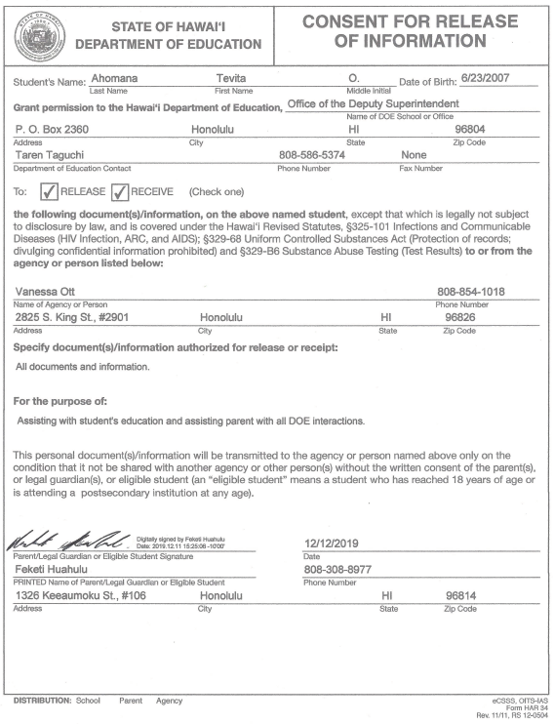

_____________________________________

12/12/19 – Taguchi to Ott: I sent you links for information how to file a complaint. The State written complaint must have a wet signature and a hard copy sent to the DOE

From: Taren Taguchi <taren.taguchi@k12.hi.us>
Date: Thu, Dec 12, 2019 at 4:35 PM
Subject: Re: Request a meeting to submit a complaint
To: Vanessa Ott <msvott@gmail.com>

Hi Vanessa,

Hope you're doing well.

Could you scroll to the beginning of this email. I attached the link for a state written complaint. You can make a 3rd party state written complaint. No meeting is necessary. Also attached is the regulations about the state written complaint. Forgive me if I'm repeating myself, but I write a lot of emails every day. Anyone or agency may submit a state written complaint as a third party, but they will not receive the results. The parent will get a copy of the results. In addition, parents are often confused about the limitations of the investigation of the state written complaint. Since you're a lawyer, I know you know the difference between the state written complaint and the due process hearing request. School says mediation is pending, so possibly your issues will be resolved. Often mediation will delay the investigation for the state written complaint. The state written complaint must have a "wet" signature hard copy sent to the PO box address. Have a good day.
Mahalo,
Taren Taguchi, Educational Specialist
IDEA Complaints Management Program
Monitoring and Compliance Branch
Office of the Deputy Superintendent
Hawaii Department of Education
P.O. Box 2360
Honolulu, HI 96804
Cell: 808-853-0261
taren.taguchi@k12.hi.us

_____________________________________

12/12/19 – Ott: When are we going to receive recent diagnostic data and have a meeting to discuss?

From: Vanessa Ott <msvott@gmail.com>
Date: Thu, Dec 12, 2019 at 6:18 AM
Subject: When are we going to receive recent diagnostic data and have a meeting to discuss?
To: Ron Matsushige <Ronald.Matsushige@k12.hi.us>
Cc: Feketi (Toakase) Huahulu <huahulufeketi@gmail.com>, Katherine Balatico <katherine.balatico@k12.hi.us>, Stuart Kim <Stuart.kim@k12.hi.us>, Wade Okuma <Wade.Okuma@k12.hi.us>

Aloha Mr. Matsushige,

When are we going to receive a copy of Tevita's recent i-Ready Math and Language Arts diagnostics.

When are we going to have meetings with the Math and Language Arts teachers to discuss the data?

Mahalo,
Vanessa Ott & Feketi Huahulu

_____________________________________

12/12 /19 – Taguchi to Huahulu: Thank you for your email address. When you answer the following questions, I will send you important information.

From: Taren Taguchi <taren.taguchi@k12.hi.us>
Date: Thu, Dec 12, 2019 at 3:08 PM
Subject: Department of Education
To: <huahulufeketi@gmail.com>

Aloha,

I hope you are having a good day. Thank you for giving me this email address. If I typed this email address correctly and if you agree to have confidential information sent to this email address, please answer the following questions:

1. Student's first and last name

2. Student's date of birth

3. Student's home school

When I receive a reply with the correct answers, I will send you important information. Have a good day.
Mahalo,
Taren Taguchi, Educational Specialist
IDEA Complaints Management Program
Monitoring and Compliance Branch
Office of the Deputy Superintendent
Hawaii Department of Education
P.O. Box 2360
Honolulu, HI 96804
Cell: 808-853-0261
taren.taguchi@k12.hi.us

_____________________________________

12/12/19 – Huahulu to Taguchi: Here are the answers you requested.

From: Feketi - Toakase Huahulu <huahulufeketi@gmail.com>
Date: Thu, Dec 12, 2019 at 3:48 PM
Subject: Re: Department of Education
To: Taren Taguchi <taren.taguchi@k12.hi.us>

See my answers below.

On Thu, Dec 12, 2019 at 3:08 PM Taren Taguchi <taren.taguchi@k12.hi.us> wrote:
Aloha,

I hope you are having a good day. Thank you for giving me this email address. If I typed this email address correctly and if you agree to have confidential information sent to this email address, please answer the following questions:

1. Student's first and last name

Tevita Ahomana

2. Student's date of birth

June 23, 2007

3. Student's home school

Robert Louis Stevenson Middle School

_____________________________________

12/12/19 – Taguchi to Huahulu: Is Vanessa Ott an attorney? Please send a paper copy of HAR 34 with a wet signature. The state written complaint is limited to investigations of noncompliance of IDEO

From: Taren Taguchi <taren.taguchi@k12.hi.us>
Date: Thu, Dec 12, 2019 at 4:55 PM
Subject: Re: Department of Education
To: Feketi - Toakase Huahulu <huahulufeketi@gmail.com>

Aloha Ms. Huahulu,

Thank you for your speedy reply. Thank you for taking my call today. I wanted to make sure to make a connection with you and ask if Ms. Vanessa Ott is an attorney? I received this document with your signature, but it is not a "wet" signature, so wanted to make sure you agreed to this release. Do you agree to let Vanessa Ott see your child's records?

In addition, I like to share a list of websites with parents so they have all the information. If you have any questions, please call me. My services are free. Vanessa said you are interested in filing a state written complaint. Just wanted to let you know that the state written complaint is limited to investigations of noncompliance of IDEA.

1. Procedural Safeguards Notice (in 14 languages)
http://www.hawaiipublicschools.org/DOE%20Forms/Special%20Education/Procedural%20Safeguards/ProceduralSafeguards.pdf

2. Special Education website
http://www.hawaiipublicschools.org/TeachingAndLearning/SpecializedPrograms/SpecialEducation/Pages/home.aspx

3. Mediation brochure
http://www.hawaiipublicschools.org/DOE%20Forms/Special%20Education/Mediation.pdf

4. Mediation form: (usually the school will fill this out, but you can fill it out and send it to the Mediation Center of the Pacific)
http://www.hawaiipublicschools.org/DOE%20Forms/Special%20Education/AlternativeDisputeResolutionForm.pdf

5. Written complaint form (You are not required to use the form but it's helpful to get your thoughts organized)
Takes 60 days to complete an investigation.
http://www.hawaiipublicschools.org/DOE%20Forms/Special%20Education/WrittenComplaint.pdf

6. State Complaint Procedures:
http://www.hawaiipublicschools.org/DOE%20Forms/Special%20Education/StateCompliantProcedures.pdf

7. Due Process Hearing Request. (You are not required to use this form, but I think it's to your advantage)
Takes an average of 4 months to complete and 85% of parents are represented by an attorney)
To find free/reduced representation, please consult the Procedural Safeguards Notice, last page (#1 of this email)
http://www.hawaiipublicschools.org/DOE%20Forms/Special%20Education/RequestforDueProcessHearing.pdf

8. A Parent’s Guide to Partnership in Special Educationhttp://spinhawaii.org/education-parent-guide/
9. US Department of Education Dispute Resolution Procedures
https://www2.ed.gov/policy/speced/guid/idea/memosdcltrs/acccombinedosersdisputeresolutionqafinalmemo-7-23-13.pdf

10. The Center for Appropriate Dispute Resolution in Special Education
http://www.cadreworks.org/

11. The Code of Federal Regulations for IDEA
https://www.ecfr.gov/cgi-bin/text-idx?tpl=/ecfrbrowse/Title34/34cfr300_main_02.tpl

12. Hawaii Administrative Rules (HAR) Title 8, Chapter 60
http://boe.hawaii.gov/policies/AdminRules/Pages/AdminRule60.aspx

Mahalo,
Taren Taguchi, Educational Specialist
IDEA Complaints Management Program
Monitoring and Compliance Branch
Office of the Deputy Superintendent
Hawaii Department of Education
P.O. Box 2360
Honolulu, HI 96804
Cell: 808-853-0261
taren.taguchi@k12.hi.us

_____________________________________

12/12/19 – Huahulu to Taguchi: Vanessa helps me. She is my interpreter. I want her to be involved in everything. Please communicate with Vanessa and send copies to me.

From: Feketi - Toakase Huahulu <huahulufeketi@gmail.com>
Date: Thu, Dec 12, 2019 at 5:29 PM
Subject: Re: Department of Education
To: Taren Taguchi <taren.taguchi@k12.hi.us>
Cc: Vanessa Ott <msvott@gmail.com>

Hello,

I'm sorry my English is not good. That is why Vanessa helps me. She is my interpreter. I want Vanessa to be involved in everything that has to do with Tevita's education. I signed the release.

Please include Vanessa Ott in all correspondence about my son's education. She always includes me in emails and explains everything that is happening. She is not an attorney, but is my interpreter and my friend, I trust her.

Please communicate with Vanessa Ott and send copies to me. If you have questions, ask her, and if you want to talk, please call her at her phone number -- 808-854-1018. I don't check my email every day. Vanessa does, and she explains it all to me.

Thank you,
Toakase Huahulu

________________________

12/12/19 – Balatico to Huahulu: Communicate only with me. I have instructed teachers and counselors to ignore any communication from you or Vanessa Ott that does not come through me. Ms. Ott is not a licensed attorney, nor is she a trained advocate in a public agency.

From: Katherine Balatico <katherine.balatico@k12.hi.us>
Date: Thu, Dec 12, 2019 at 10:09 PM
Subject: Fwd: Follow up re: 11/22 meeting - ReadyMath differentiation
To: Feketi (Toakase) Huahulu <huahulufeketi@gmail.com>

Aloha Mrs. Ahomana,

I hope you're having a good week. I wanted to touch bases with you about our communications with your son’s private tutor, Vanessa. You are welcome to share this information with anyone you wish. However, the Department of Education is prohibited from releasing any educational records about your son to anyone without written consent. We will be happy to release specified information to a third party as soon as we receive a “Consent to Release Information” form signed by you.

The tutor you hired seems to be the family’s voice in bringing up issues about Tevita’s education. We understand that the tutor is not a licensed attorney, nor is she a trained advocate in a public agency. We would like to confirm that you share these issues as well by sharing the information with you. In addition, we would like to share a little about Individuals with Disabilities Education Improvement Act of 2004 (IDEA) and our responsibility to provide Tevita with a Free Appropriate Public Education (FAPE) through the delivery of the Individualized Education Program (IEP) in the Least Restrictive Environment (LRE).

As you may know, the school is solely responsible to provide FAPE to Tevita. While you are a vital member of the IEP team, the IEP team does not deliver the services to Tevita. The delivery of FAPE is the responsibility of the school. You are welcome to provide input on the delivery of FAPE, and after careful consideration, the school has the ultimate responsibility and must make decisions on the implementation of the IEP. That means that the school cannot hold the parents responsible to teach their children while at school. I am confident that the staff at Stevenson Middle are trained to deliver FAPE to Tevita through the delivery of the IEP in the LRE. I hope you will continue to be an active participant through the IEP process.
Since the start of the 2019-2020 school year, your private tutor, Vanessa has shown a strong interest in Tevita’s education at Stevenson. While we welcome any concerns you may have about the delivery of FAPE to Tevita, we have explained to your tutor that the delivery of the IEP is the sole responsibility of the Department of Education. The choosing of a curriculum or methodology is the responsibility of the school and not the IEP team. The school has about 1800 minutes per week to provide direct instruction to Tevita. The tutor has contacted the school on average 7 times per week for a total of 63 contacts for nine weeks of school (111 contacts since the start of the school year). While we encourage all parents to bring any moral support to the IEP meetings or to help them navigate the educational system, we must draw the line when the communications may impede the school’s ability to deliver direct instruction to your son.
Each response removed Tevita’s teachers from preparation and instruction. Teachers spent at least 111 hours to read, research, and draft a response. This is over 6,660 minutes, which equates to 148 periods that the teachers could use to plan for instruction. The staff at the school are overwhelmed with the numerous amounts of duplicative communications and the amount of time it takes to respond to these communications.

I would like to prevent any confusion in our communication. In order to streamline and get a response to you faster, please make all your concerns known to me alone. If you send any contact (email, phone call, text) to anyone other than me, my teachers and counselors will be instructed to ignore the contact and focus on their classrooms and student supports. Please instruct anyone acting on your behalf to do the same. We are focused on Tevita’s education and feel impeded by the numerous repetitive communications sent to multiple recipients requiring multiple responses.

In regards to Ms. Ott’s December 3, 2019 email about Tevita’s ReadyMath instruction, I want to reassure you that his teacher is working with him on grade 6 math standards and will continue to do so with grade 6 ReadyMath, scaffolding, and with supplemental learning resources.

We feel our communication is not efficient and am asking for the services of the Mediation Center of the Pacific. They will be contacting you within the next week to discuss a time and place to meet to discuss the communications we received. They are not employees of the Department of Education, and they will be impartial. The service is free to the schools and to you. Please be open and candid with the Mediation Center of the Pacific so we can meet and resolve these issues as soon as possible.

The work Ms. Ott does with Tevita is invaluable. The family's participation in Tevita’s education remain vital in his success, so we do not want to miss any of your communication or provide different answers for the same issues. Please inform anyone speaking on your behalf who is not a licensed attorney, to include you in the email or have you present when meeting with me. Please support the school by not communicating with anyone but me.

Thank you for your kokua,
Katherine Balatico
Principal
R.L. Stevenson Middle School
Office (808) 587-4520
Fax (808) 587-4523

_____________________________________

12/13/19 – Taguchi to Huahulu: Your English is perfect.

From: Taren Taguchi <taren.taguchi@k12.hi.us>
Date: Fri, Dec 13, 2019 at 8:08 AM
Subject: Re: Department of Education
To: Feketi - Toakase Huahulu <huahulufeketi@gmail.com>

Hi Ms. Huahulu,

Your English is perfect. Thank you for your speedy reply.

Have a great day.

_____________________________________

12/13/19 – Matsushige: Tevita’s Friday take home work.

From: Ronald Matsushige <ronald.matsushige@k12.hi.us>
Date: Fri, Dec 13, 2019 at 8:35 PM
Subject: Weekly work
To: Toakase <toahuahulu@gmail.com>, Vanessa Ott <msvott@gmail.com>, Tevita <AhomTevi19@rlsms.k12.hi.us>

Hi Everyone,
This week in the envelope is Tevita's Science notebook, math homework, and an ESOL quiz he took. Tevita should also have some work for Social Studies and ELA in his binder.

Have a nice weekend!

Ronald Matsushige

_____________________________________

12/13/19 – Nagamine: The responsibility for developing and delivering the instructional program shall rest primarily with the schools.

From: Lisa Nagamine <lisa.nagamine@k12.hi.us>
Date: Fri, Dec 13, 2019 at 9:01 PM
Subject: Re: Thanks you for your interest in education materials.
To: Vanessa Ott <msvott@gmail.com>

Dear Ms. Ott,
Good evening! Thank you for being patient. Here is DOEʻs responses to your questions.
- Are there any requirements at all that a school select a HIDOE adopted core instructional program or OEM curriculum that has been peer-reviewed and vetted?
The requirement is that schools adhere to the BOE Policy.
The responsibility for developing and delivering the instructional program rests primarily with the schools. (See Policy 105-2). Thus, the school selects the instructional program which could include OEM instructional materials. The instructional materials selected must be aligned to the statewide content and performance standards.
When a school offers a curriculum, the requirement is the curricula must include the following (BOE Policy 105-3):
- Academic courses, subjects, and/or units of study;
- Relevant instructional activities and materials;
- Specific learner outcomes or expectations that result in student attainment of grade-level benchmarks or learning outcomes that result in meeting expectations for high school graduation;
- A timeframe in which outcomes are expected to be achieved;
- Assessment tools and methods, including collection and analysis of student growth and attainment of outcomes and benchmarks;
- Planned, systematic co-curricular activities and student academic support services, such as counseling and guidance; and
To the extent reasonably possible, all schools shall offer curricula that is culturally relevant and reflective of the community that it serves.
- Are there any requirements a school teach the selected criteria? Is that what "enacted" means?
Iʻm not sure what is meant by “teach the selected criteria?
The responsibility for developing and delivering the instructional program shall rest primarily with the schools. (See Policy 105-2)
Enacted means something that is being put into practice (Oxford Dictionary)
- Are there any requirements for the vetting process to adopt adapted materials?
The requirement is that curriculum and instructional materials must be aligned with the applicable statewide content and performance standards. (BOE Policy 102-3 and 105-4)
- Are there any requirements that adapted materials be vetted or is it merely a suggestion to schools that they do this?
The requirement is that the curriculum and instructional materials must be aligned with the applicable statewide content and performance standards. (BOE Policy 102-3 and 105-4) Thus, prior to the selection of instructional materials, schools are responsible to determine alignment with the applicable statewide content and performance standards.
- What are the minimal requirements of a vetting process, e.g., are current, tenured, classroom teachers in the same subject area part of the process?
There are no requirements regarding specific staff who are involved in the vetting process should the school decide to do so
- Do adaptations to the selected curriculum have to be documented in the school's academic and financial plan?
Adaptations to the selected curriculum do not have to be documented in the schoolʻs academic and financial plan.
- Does a parent have the right to see documentation concerning who was involved in the vetting process for adaptations to selected curriculum, rationale for the adaptations, and what the adapted curriculum is actually going to be?
Schools should be able to explain the process however, staff are not required to produce documentation for the decision that informed the vetting process. Parents may request information on the curriculum and materials used for instruction of their child.
- What does a parent do when her child is not being taught a core instructional program and neither the Principal nor the Complex Area Superintendent are willing to address the matter? What is the next level of appeal?
The CAS reports to the Deputy Superintendent.

Sincerely,

Lisa Nagamine
Hawaii Department of Education
Office of Curriculum and Instructional Design
Interim Curriculum Innovation Branch Director
Diamond Head Annex
475 22nd Avenue, Building 302, Room 223
Honolulu, HI 96816
Cell: 1(808)383-6213 (Texting is best)
Work Office: (808)305-9700
DOE Email: lisa.nagamine@k12.hi.us

_____________________________________

12/14/19 – Huahulu: I prefer that Tevita not be pulled out of class to take diagnostic tests. Tevita is supposed to have a computer in class to take notes, but substitute denied him access.

From: Feketi - Toakase Huahulu <huahulufeketi@gmail.com>
Date: Sat, Dec 14, 2019 at 3:29 PM
Subject: I have concerns re: i-Ready testing and Tevita's access to a computer
To: Katherine Balatico <katherine.balatico@k12.hi.us>
Cc: Vanessa Ott <msvott@gmail.com>

Hello Principal Balatico,

Tevita told me last week (12/2-12/6) he took i-Ready Math and Reading tests. On Tuesday (12/10) he missed Science class because he was pulled out to take more i-Ready tests. On Friday (12/13) he missed Music class because he was pulled out to take more i-Ready tests. I don't want Tevita to miss classes to retake tests. If you want him to retake tests, I prefer that we make arrangements to do this before or after school so he doesn't miss any classes.

Is Tevita finished with December's round of i-Ready testing?

When am I going to get copies of Tevita's recent i-Ready test results?

Tevita told me that the substitute in his Math class on Friday 12/13 would not let him use his computer to take notes. His IEP says he's supposed to have a computer to take notes. The substitutes for all his teachers should be informed of this to make sure his IEP is followed appropriately.

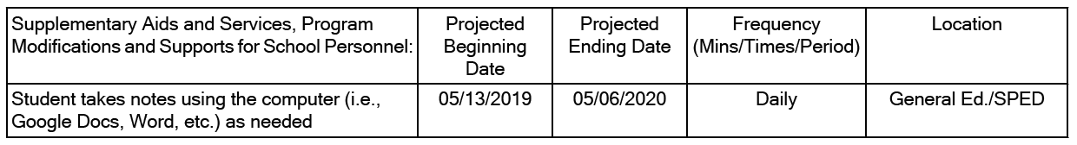

Are you going to make sure that the teachers' substitute plans include this information?

Thank you,
Feketi Huahulu
_____________________________________

12/14/19 – Ott: Mr. Matsushige is using an incorrect email address for Tevita’s mother.

From: Vanessa Ott <msvott@gmail.com>
Date: Sat, Dec 14, 2019 at 4:03 PM
Subject: Mr. Matsushige is using the incorrect email address for Tevita's mother
To: Katherine Balatico <katherine.balatico@k12.hi.us>
Cc: Feketi (Toakase) Huahulu <huahulufeketi@gmail.com>

Per your request that we communicate only with you, please inform Mr. Matsushige that he is not using the correct email address for Tevita's mother. He should use:

huahulufeketi@gmail.com

Mahalo,
Vanessa Ott & Feketi Huahulu
808 - 854 -1018
_____________________________________

12/13/19 – Huahulu: Please email me Tevita's i-Ready Math and Language Arts scores.

From: Feketi - Toakase Huahulu <huahulufeketi@gmail.com>
Date: Fri, Dec 13, 2019 at 10:30 AM
Subject: Re: Follow up re: 11/22 meeting - ReadyMath differentiation
To: Katherine Balatico <katherine.balatico@k12.hi.us>
Cc: Vanessa Ott <msvott@gmail.com>

Please email me Tevita's i-Ready Math and Language Arts scores.

Thank you,
Toakase Huahulu
_____________________________________

12/15/19 – Huahulu to Balatico: Please change incorrect information in Tevita’s IEP to read, “Mother has chosen Vanessa Ott, a family friend, to be her interpreter and speak for her as needed for future meetings at Stevenson Middle School and with other DOE personnel.”

From: Feketi - Toakase Huahulu <huahulufeketi@gmail.com>
Date: Sun, Dec 15, 2019 at 5:51 AM
Subject: Fwd: Follow up re: 11/22 meeting - ReadyMath differentiation
To: Katherine Balatico <katherine.balatico@k12.hi.us>
Cc: Vanessa Ott <msvott@gmail.com>

Hello Principal Balatico,

I sent a response to your email below, but I cannot find it in my sent mailbox, so I am sending another response. I apologize if you get two responses with the same content.

My name is Feketi Huahulu. Informally, I am known as Toakase. Formally, I am "Ms. Huahulu" not "Mrs. Ahomana."

I have mailed HAR Form 34 to the Office of the Superintendent. A copy is attached.

You wrote, "The tutor you hired seems to be the family’s voice in bringing up issues about Tevita’s education." Part of that is incorrect. I did not hire Vanessa Ott to be Tevita's tutor. She volunteered. In the two and a half years I have known her, she has never accepted any money for tutoring Tevita or for acting as my interpreter and assistant. I do want her to be the family’s voice in bringing up issues about Tevita’s education and I've stated this many times in writing and verbally. She always consults with me, explains what is going on, and includes me in correspondence. She helps me with communication.

After looking over Tevita’s current IEP, we noticed some inaccurate information:

I never declined the use of an interpreter. I have always stated in writing and verbally that I have chosen Vanessa Ott to be my interpreter. I have only declined the use of a DOE-appointed interpreter. Therefore, I would like the IEP corrected as soon as possible so that it reads:

Mother has chosen Vanessa Ott, a family friend, to be her interpreter and speak for her as needed for future meetings at Stevenson Middle School and with other DOE personnel.

Thank you,
Feketi Huahulu

attachment: HAR34Consent-TAhomana-signed.pdf
_____________________________________

12/15/19 – Huahulu/Ott to Taguchi: Ms. Huahulu’s English is not perfect. She wants me to assist with matters involving English. Is there a form we can sign to put this issue to rest once and for all?

From: Feketi - Toakase Huahulu <huahulufeketi@gmail.com>
Date: Sun, Dec 15, 2019 at 6:46 AM
Subject: Re: Department of Education
To: Taren Taguchi <taren.taguchi@k12.hi.us>
Cc: Vanessa Ott <msvott@gmail.com>, <huahulufeketi@gmail.com>

Hello Ms. Taguchi,

I am writing on behalf of Ms. Huahulu because her English is not perfect. I helped her write the previous email she sent responding to your questions.

HAR Form 34 with a wet signature is in the mail. You should receive the paper copy early this coming week. A digital copy is attached.

For more than two years, at Ms. Huahulu's request, I have voluntarily served as her interpreter and personal assistant, and as an educational advocate for her son, Tevita. Even though I am not an attorney, I'm pretty sure she has the right to designate me as her interpreter, to speak for her at meetings we both attend, and to write letters on her behalf because she is kept informed and aware of everything that is going on. That is what she wants, and she has expressed this desire many times over the years in writing and verbally with DOE personnel, and yet it still continues to be an issue.

Is there a Form that she can sign to put this issue to rest once and for all?

I have read through the documentation you sent. Thank you for the comprehensive list of links. I do have a questions about mediation. In reading the Procedural Safeguards, it became apparent that there are no time limits specified with regard to mediation like there are with a resolution meeting and due process hearing. Therefore, I do not see any benefit to mediation because it seems like mediation will delay a due process hearing. Tevita's education is at a crisis, and we can't afford any more delays. With each passing day his achievement gap compared to his peers grows wider. So we are inclined to refuse mediation. There are other reasons, too. For example, we are hesitatnt to put a lot of time into a process the results of which are secret.

Are there any negative repercussions for refusing mediation and requesting a resolution meeting instead?

Thank you,
Vanessa Ott & Feketi Huahulu
808-854-1018

_____________________________________

12/15/19 – Taguchi: Out of the office through 1/2/20.

From: Taren Taguchi <taren.taguchi@k12.hi.us>
Date: Sun, Dec 15, 2019 at 6:46 AM
Subject: Out of office Re: Department of Education
To: <huahulufeketi@gmail.com>

Thank you for your email. I will be out of the office from December 13, 2019 through January 2, 2020. While on leave, I will be checking email every few days, but my response time may be delayed. Please do not hesitate to call me and leave a detailed message (student's name, school). I will be checking voicemail as well. I welcome your calls.
Mahalo,
Taren Taguchi, Educational Specialist
IDEA Complaints Management Program
Monitoring and Compliance Branch
Office of the Deputy Superintendent
Hawaii Department of Education
P.O. Box 2360
Honolulu, HI 96804
Cell: 808-853-0261
taren.taguchi@k12.hi.us

_____________________________________

12/15/19 – Taguchi to Huahulu: I will not use your email address to communicate with you anymore because someone is pretending to be you.

From: Taren Taguchi <taren.taguchi@k12.hi.us>
Date: Sun, Dec 15, 2019 at 5:39 PM
Subject: Re: Department of Education
To: Feketi - Toakase Huahulu <huahulufeketi@gmail.com>

HI Ms. Huahulu,

I think there was some confusion.

I was writing to you and you wrote back to me, but now the tutor says she was writing the email, claiming to be you. In addition, we will be happy to hire a licensed interpreter. Does the tutor speak your language? What language do you speak? This email address does not sound authentic if people are claiming to be you. I will not be corresponding via email again because I do not trust this communication when someone admitted they were pretending to be you.

You have the state written complaint form and the due process hearing request form. If you would like to file a complaint, please do so, but I need a "wet" signature for the complaint, not just an electronic signature. I will be checking your street address to ensure that you are living at this address to ensure that you are receiving this information.

Good luck in your endeavors.
Mahalo,
Taren Taguchi, Educational Specialist
IDEA Complaints Management Program
Monitoring and Compliance Branch
Office of the Deputy Superintendent
Hawaii Department of Education
P.O. Box 2360
Honolulu, HI 96804
Cell: 808-853-0261
taren.taguchi@k12.hi.us

_____________________________________

From: MCP <mcp@mediatehawaii.org>
Date: Mon, Dec 30, 2019 at 9:44 AM
Subject: case #820
To: msvott@gmail.com <msvott@gmail.com>

Aloha Ms. Vanessa Ott,

We here at the mediation center of the pacific, understand your concerns regarding the issues in this case. I have attached our brochure and additional information to prepare for the S.P.E.D. Mediation. I will give you a call later on today just to follow-up; at which time you and Ms. Feketi can determine, if you are interested in moving forward with the mediation process.

Once again thank you for your time and consideration.
Sincerely

Client Services Department
The Mediation Center of the Pacific, Inc.
245 N. Kukui St., Ste 206
Honolulu, HI 96817
Ph: (808) 521-6767 | Fax: (808) 538-1454
www.mediatehawaii.org
Hours of Operations: 08:30 AM - 04:30 PM

Note: CAS Dilwith was responding to an Ott’s email dated November 30, 2019.

