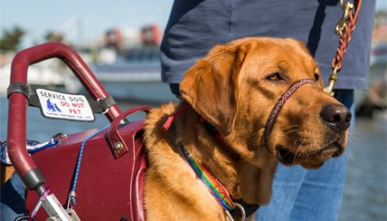
Welcomes
Service Dogs
Put Establishment’s Logo Here

A Service Animal Is: | A Service Animal Is Not:
- A housebroken dog trained to do work or perform tasks for a person with a disability.  - Required to be under the control of its handler, and harnessed, leashed, or tethered. | - An animal whose sole function is to provide emotional support.  - A dog that is a service animal in training.  - A pet. Do not pet a service dog! Service dogs are working and need to focus on the needs of their handlers.
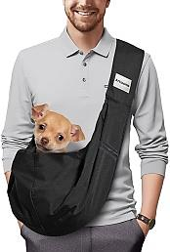
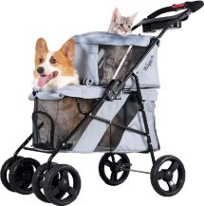
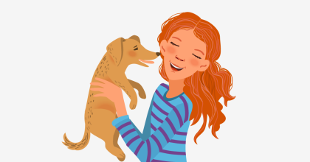
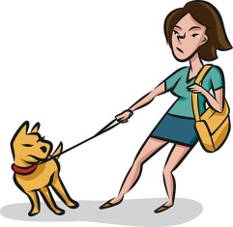

It hurts people who really need their service dog with them when others attempt to take their emotional support animals and pets where they are not allowed.

Staff may ask: (1) Is the dog a service animal required because of a disability? (2) What work or task has the dog been trained to perform?

Under the Americans with Disabilities Act (ADA), only dogs and miniature ponies trained to do work or perform tasks for people with disabilities qualify as a service animal. See: ada.gov/service_animals_2010.htm
Service animals do not need to be harnessed, leashed, or tethered if the individual’s disability prevents using these devices or these devices interfere with the service animal's safe, effective performance of tasks. In that case, the individual must maintain control of the animal through voice, signal, or other effective controls. Service animals do not ride in carts, bags, or baby harnesses. Service dogs do not tug on their leashes unless warning their handlers of a problem.
Staff cannot ask about the person’s disability, require medical documentation, require a special identification card or training documentation for the dog, or ask that the dog demonstrate its ability to perform the work or task.

