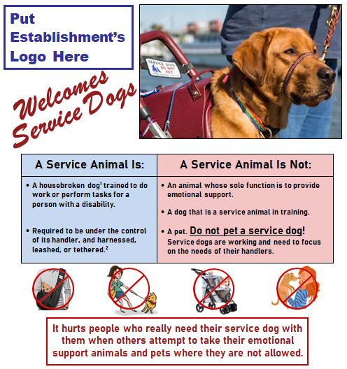  FREE!  Service Animal Poster  for  Your Public Business  FreeSpeech4US.com/ADA | FREE!  Service Animal Poster  for  Your Public Business  FreeSpeech4US.com/ADA
FREE!  Service Animal Poster  for  Your Public Business  FreeSpeech4US.com/ADA | FREE!  Service Animal Poster  for  Your Public Business  FreeSpeech4US.com/ADA
FREE!  Service Animal Poster  for  Your Public Business  FreeSpeech4US.com/ADA | FREE!  Service Animal Poster  for  Your Public Business  FreeSpeech4US.com/ADA
FREE!  Service Animal Poster  for  Your Public Business  FreeSpeech4US.com/ADA | FREE!  Service Animal Poster  for  Your Public Business  FreeSpeech4US.com/ADA
FREE!  Service Animal Poster  for  Your Public Business  FreeSpeech4US.com/ADA | FREE!  Service Animal Poster  for  Your Public Business  FreeSpeech4US.com/ADA
_________________________________________________________________

Instructions for Printing

- Print only page 1 of the document on card stock.

- Do not print “All pages” or you will print these instructions, too.

- One copy of page 1 yields 10 business cards.

_________________________________________________________________

Instructions for Cutting

Standard Business cards size:
3.5” (Width)
2” (Height)

- The cards on p. 1 are embedded in a table (2 columns x 5 rows). The table gridlines are not visible so they will not print.

- After printing page 1:

- Cut ½ inch (0.5) from top and bottom.

- Cut ¾ inch (0.75) from left and right sides.

- You now have a piece of card stock measuring 7” (W) x 10” (H)

- Cut 2 columns – 3.5” Width

- Cut 5 rows – 2” Height

_________________________________________________________________

